**The 2015-2016 Drought in South Africa**

**National Outcome Forecast Analysis**

**Analysis of Fourteen Livelihood Zones in Limpopo, KwaZulu-Natal and Free State Provinces, with a Synthesis for the Remainder of the Country**



Financed by:

The South Africa Vulnerability Assessment Committee (SAVAC) is comprised of:

* Department of Social Development;
* Office of the President,;
* Department of Health;
* Statistics South Africa
* University of Pretoria;
* University of KwaZulu Natal;
* Provincial Departments of Agriculture;
* OXFAM;
* FAO,
* UN Partners (UNDP, UNICEF, UNFPA, UNAIDS, FAO)
* Botswana Council of Non-Governmental Organisations (BOCONGO)

The SAVAC is led by the Department of Agriculture, Forestry and Fisheries with technical support from the SADC Regional Vulnerability Assessment and Technical Assistance Team

|  |  |  |
| --- | --- | --- |
| **Enquiries: please contact SAVAC Secretariat**  Department of Agriculture, Forestry and Fisheries | Postal and courier address:  XA-GF-02, Private Bag X250 Pretoria, 001  South Africa  Physical address:  20 Agriculture Place, Steve Biko Street, Arcadia, 0083 | Tel. +27 (0)123196736  Fax. +27 (0)123196694  Email: [MolateloMAM@daff.gov.za](mailto:MolateloMAM@daff.gov.za) |

##### This paper was researched and written by Charles Rethman

Contact: [rethman@telkomsa.net](mailto:rethman@telkomsa.net), +27 21 6861510 (office), +27 71 6735502 (cell)

Data and the entire analysis are available on Github:

<https://github.com/CharlesRethman/HEA-Analysis-ZA-2016>

## Acknowledgements

The South Africa Vulnerability Assessment Committee (SAVAC) and the participating consultant would sincerely like to extend their gratitude to the Republic of South Africa Government, through the Department of Agriculture, Forestry and Fisheries for providing coordination and oversight in additional to material support of transport, financial resources, office equipment and stationary and for this exercise.

The author and SAVAC would also want to extend its gratitude to all agencies and government departments, who willingly met with the author and discussed the information at their disposal. In particular, the author thanks Mr Molatelo Mamadi and Ms Thulile Dlamini in DAFF for their support during this process, Mr Christo Joubert at NAMC and Ms Tracy Davids at BFAP for their assistance. Dr Johan Malherbe of ARC-ISCW was helpful in providing some of the SPI data and quaternary drainage shape files.

Thanks are also due to provincial governments, who provided data and participated in all programmes leading up to this exercise, such as the baselines assessments.

The author and SAVAC also thanks the SADC Regional Vulnerability Assessment and Analysis (RVAA) programme through the Programme Management Unit (PMU) for funding the exercise and making it possible.

## Glossary of Terms and Abbreviations

Items in *italics* refer to definitions elsewhere in the list:

ARC Agricultural Research Council

ARC-ISCW *ARC* – Institute for Soil, Climate and Water

ASI Agricultural stress index

Baseline A description of a *livelihood zone*, its *wealth breakdown* and the *livelihood strategies* households can employ to survive

BSS *Baseline* storage spreadsheet

CEC Crop Estimates Committee

Consumption year A period lasting from the beginning of the harvest one year until just before the next harvest (the following year). In the summer rainfall parts of South Africa, the consumption year usually runs from April one year to March the next. A consumption year is sometimes also called the ‘agricultural marketing year’.

CPI Consumer price index

CRS Coordinate reference system (same as *SRS*)

DAFF Department of Agriculture, Forestry and Fisheries

EA Enumeration areas, geographical areas used in the census for counting the population. An EA is defined as an area that can theoretically be covered by one enumerator in one day during the census, although in practice and EA may require more than one day for coverage

ESA Enumeration small areas, the smallest geographical units for which population data from the national census are made available. ESAs are derived by combining EAs so as to ensure that EA data cannot reveal individual data on households and violate privacy laws

FAO United Nations Food and Agriculture Organization

FAO-GIEWS *FAO* – Global Information and Early Warning System

FEWSNET United States Famine Early Warning System Network

Food energy deficit A deficit in reaching the average minimum daily food energy requirement (which is 8800 kJ), using the cheapest diet, a *simple starch diet*.

FPL Food poverty Line, a *poverty threshold* devised by *Statistics SA* that consists of a basket of diverse (but necessarily healthy) food stuffs whose energy content equates to 8800 kilojoules (kJ) per person per day. The FPL is higher than the cost of 8800 kJ of a *simple starch diet* (which may include a very small addition of legumes and cooking oil only) because it contains a variety of other more expensive food items, which are, based on food consumption surveys, considered reasonable for use as the minimum household expenditure

GIS Geographic information system

kcal, cal, Cal Kilocalorie (kcal), a non-official unit of energy, in common use for food energy by nutritionists in many countries. It is easily confused with the Calorie (Cal), or ‘large’ calorie, which is also 1,000 calories (cal).

KJ, J Kilojoule, derived from the official SI unit of energy, the joule (J), and adopted by the South African Bureau of Standards (SABS). In practical use in this report for food energy, rather than kilocalories (kcal). 1 kJ = 1,000 J = 0.2388459 kcal, or 1 kcal = 4.1868 kJ

LBPL Lower Bound Poverty Line, a *poverty threshold* expressed as an income level that includes food purchases from the food poverty line, as well as a minimum of non-food goods and services to assist in determining a standard of living

Livelihood The sum of the ways in which people obtain food and the goods and services that they need for a defined standard of living

Livelihood strategies The different ways that people can obtain food and income to meet their minimum needs, as well as the priorities for their expenditure

LZ Livelihood zone, a geographical area where people broadly share the same patterns of *livelihood*; due to geographical factors that determine their sources of food, income and their expenditures

MT Metric tons

NAMC National Agriculture Marketing Council

NIDS National Income Dynamics Survey

NOFA National outcome forecast analysis

NVAC National Vulnerability Assessment Committee

OFA Outcome forecast analysis

Poverty threshold An income or consumption threshold below which people are considered to have insufficient means to meet all the most immediate needs as well as the investments they must make to progress out of poverty

Response analysis Analysis of the *response strategies* that includes checking their impact on household assets (the degree of destructiveness of the response strategies) and the impact of the hazard on them as well.

Response strategies In the context of this report, response strategies are *livelihood strategies* that can be expanded or adapted to increase access to the minimum food, goods and services households need in order to reach their defined *poverty thresholds*. Examples of response strategies are: seeking additional employment, requesting help from kin, or switching expenditure to the most essential goods and services. However, strategies like reducing food intake are not considered ‘response’ strategies in this analysis as they will not help the household reach its appropriate *poverty threshold*; rather, these strategies may be termed ‘coping strategies’.

RFA Rainfall anomaly

RSA The Republic of South Africa

RVAA Programme The (SADC) Regional Vulnerability Assessment and Analysis Programme

RVAC Regional Vulnerability Assessment Committee

SA South Africa (abbreviation for the *Republic of South Africa*)

SABS South African Bureau of Standards

SADC The Southern African Development Community

SASSA South Africa Social Security Agency

SAVAC South African Vulnerability Assessment Committee

Scenario A scenario is a group of assumptions made for various unknown future variables that influence the analysis. Key variables that are usually assumed in a scenario are: the coming agricultural season weather conditions, the timing of the coming seasons, prices for all commodities in future and the availability or otherwise of jobs and casual labour.

SI International System of Units (French: Système international d'unités, SI)

Simple starch diet In this document a simple starch diet is one often used to determine households’ food energy threshold, i.e., a diet of starches that will supply (for the short term) the minimum energy needed to survive. Starches are the cheapest kilojoules and hence the simple starch threshold is often lower than the *food poverty line* (*FPL*). The ‘starch basket’ for South Africa consists of a mixture of primarily maize meal, together with some rice, wheat flour, potatoes and sweet potatoes. Although a minimum threshold based on the simple starch diet is used in this analysis, the *FPL*, *LBPL* and *UBPL* are also used because the author wishes to inform broader issues on poverty and inequality, especially the impact of the drought on increasing poverty and inequality, which is topical in South Africa.

SPI Standard precipitation index

SQL Structured query language

*SRS* Spatial reference system (same as *CRS*)

Stats SA Statistics South Africa, the legally mandated government agency for collecting and analysing key national statistics for South Africa

SZAS Single zone analysis spreadsheet

UBPL Upper Bound Poverty Line. The highest absolute poverty line determined by *Stats SA*; it consists of the same basket of goods and services as the *LBPL* but with additional non-food components. The numbers or proportions of households below the UBPL is reported for statements on general poverty, while the FPL is used for acute or extreme poverty.

VCI Vegetation condition index

VHI Vegetation health index

Wealth breakdown The process of subdividing a *livelihood zone*’s households into *wealth groups*

Wealth group A group of households within the same *livelihood zone* who share similarities in terms of their assets and resources and similar access to food, goods and services

Figure 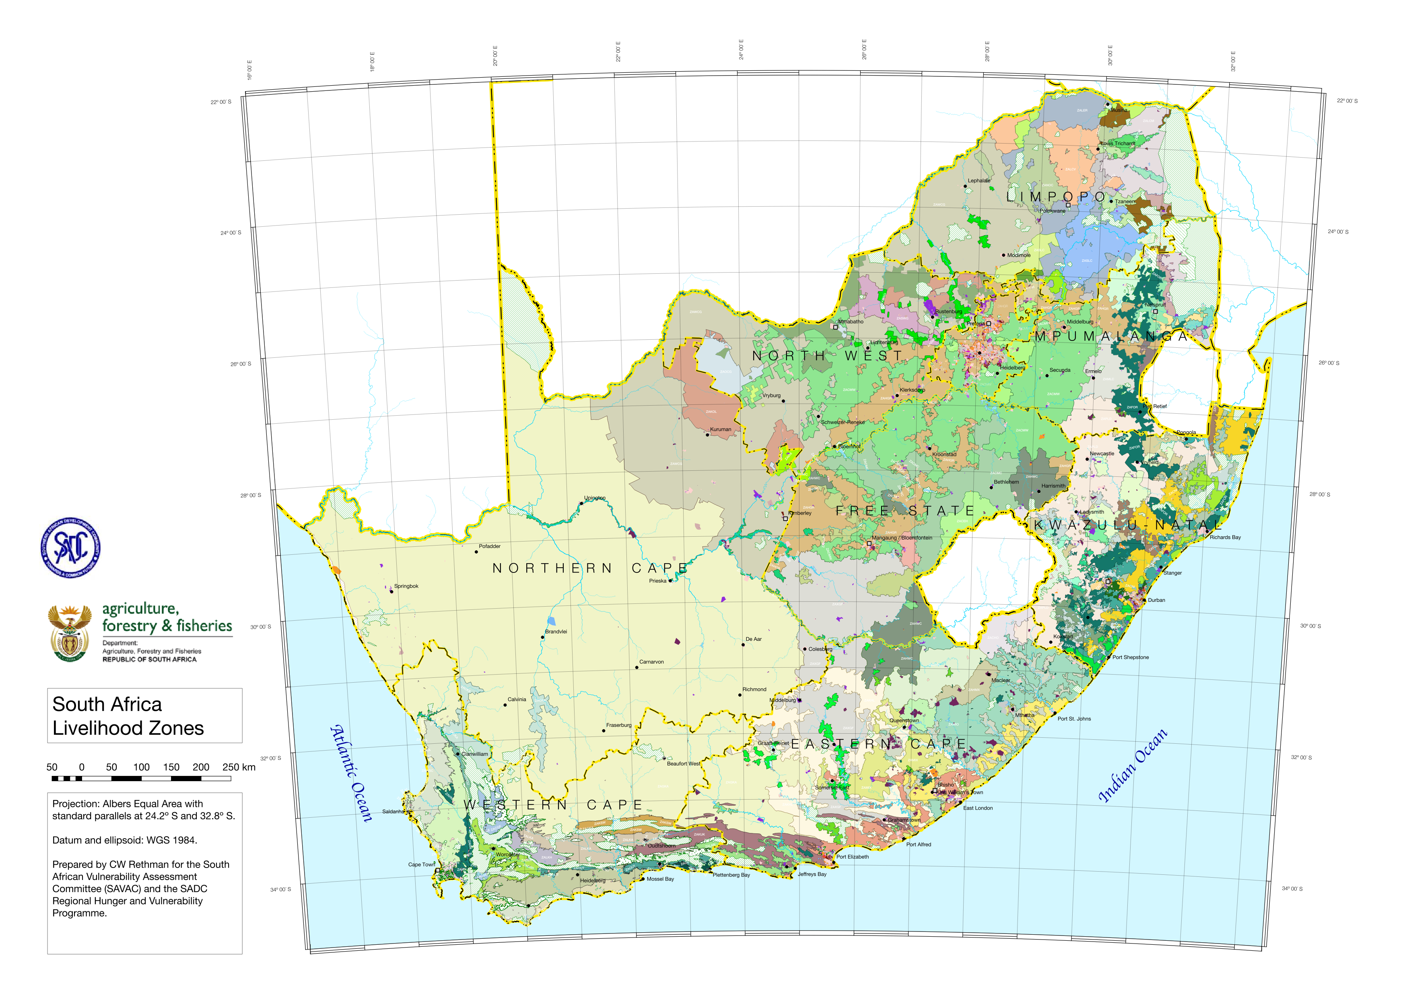1: Map of the livelihood zones of South Africa

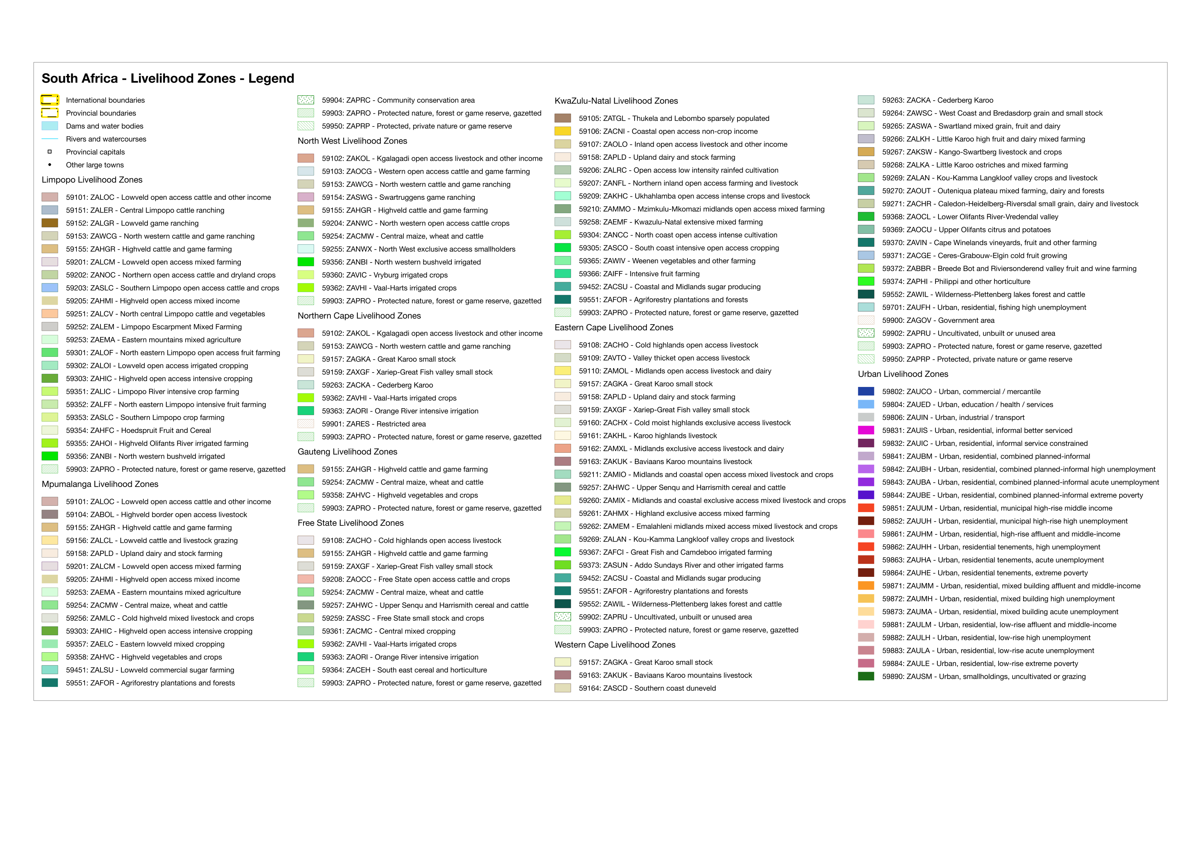

## Executive Summary

Southern African Development Community member states have been carrying out assessments annually (or sometimes more frequently) since 2002 under the coordination of the Regional Vulnerability Assessment and Analysis Programme (RVAA Programme), itself reporting to the Regional Vulnerability Assessment Committee. These assessments have been joint undertakings between governments, local and international non-government organisations, academia and international multi-lateral agencies (such as the UN agencies). Within this system, National Vulnerability Assessment Committees (NVACs) have been formed and in South Africa, the South African Vulnerability Assessment Committee, chaired by the Department of Agriculture, Forestry and Fisheries, has been established, along with a secretariat in the Subsistence Farming and Food Security Directorate. The SAVAC is mandated with undertaking food security, risk and vulnerability assessments and the author was requested to carry out this study with a view to understanding the impact of the current drought in the country, as well as other factors such as poor economic performance.

During 2014 and 2015 the value of the Rand slipped from around to R8.00 to the United States Dollar down to less than R15.00. This has its origins in many issues, such as declining global commodity prices, but it it is also subject to influence from good or bad governance, the former able to halt or minimise fall out from external factors, the latter a cause of accelerated damage. The drought caused the late onset of the 2015/2016 summer agricultural season and the resultant extremely poor production has forced the country to import a massive proportion of basic foods, especially cereals. Having been purchased on the world market in Dollars and then transported to Randfontein, the cost of these imports is high. South Africa is not alone in this predicament; neighbouring countries are experiencing even worse failures and critical shortages.

The SAVAC uses a combination of two approaches for assessing risk and vulnerability. The first is longitudinal in nature as it studies the impacts of events over a specific time frames (usually a year), while concerning itself less with the details of variations between individuals and households. The other approach is a cross-sectional ‘snapshot’ of conditions at a point in time, which provides details of the variations across a population. The former approach is called the Household Economy Approach (HEA) and is the section to which this report is dedicated.

HEA uses a framework of collecting detailed ‘baselines’ on households’ livelihoods for a period, usually a year, so that a coherent, logical picture of how a group of households obtain their cash income, their food income and what they expend money on is understood in depth. The information is aggregated geographically by livelihood zones and locally by wealth groups. Armed with these baselines, an analyst can investigate the prevailing or forecast conditions to understand their effect on the lives of the poor. During this study, the author made use of existing baselines, but was also forced to synthesise baseline livelihoods pictures using data from other sources, so that good national coverage could be achieved. These ‘synthesis’ baselines include the remaining open access livelihood zones (livestock, mixed and cropping), farm workers and the urban poor.

In order to determine the extent and degree of impact of the drought, different sources were used. The average of the Vegetation Condition Index (VCI) for January 2016 was chosen for the extent and this image was digitised and applied to crop data for crop problem specification. Other problem specifications, e.g. for livestock, self-employment activities, small business or petty trading, casual labour (agricultural, construction and domestic), formal labour, wild foods, fishing, social grants and loans access were also studied. Some of these problem specifications could not be determined as they still had to occur in the future.

Prices were analysed and from the data it would appear that staple prices are likely to be around 35% higher this year than last year. This is 65% higher than in the baseline year and the problem specification is thus 165% (problem specification = this year / last year).

The analysis aimed at understanding how households would meet their basic needs. These needs are defined according to four thresholds: food energy, the food poverty line (FPL), the lower bound poverty line (LBPL) and the upper bound poverty line (UBPL). The food energy threshold is about households reaching their minimum average food energy requirement through basic starches and cereals only. The FPL includes other food commodities for a more varied (though not necessarily healthy) diet. The LBPL and UBPL include a further basket of commodities, the difference between the two being quantities.

**Table** 1: Populations at risk and food deficits by province

|  |  |  |
| --- | --- | --- |
| Province | Pop at risk of food deficit | Food deficits maize eq (MT) |
| Eastern Cape | 588,606 | 61,104 |
| Free State | 102,946 | 8,962 |
| KwaZulu-Natal | 1,766,923 | 129,689 |
| North West | 336,226 | 34,668 |
| Northern Cape | 177,314 | 12,778 |
| Western Cape | 709,691 | 52,600 |
| Gauteng | 352,955 | 26,087 |
| Mpumalanga | 357,777 | 37,900 |
| Limpopo | 490,543 | 57,060 |
| Grand Total | 4,882,981 | 420,848 |

**Table** 2: Populations at risk and food poverty line deficits by province

|  |  |  |
| --- | --- | --- |
| Province | Pop at risk of FPL deficit | FPL deficit total ZAR |
| Eastern Cape | 588,606 | 1,074,977,708 |
| Free State | 102,946 | 150,563,075 |
| KwaZulu-Natal | 1,799,426 | 2,979,042,673 |
| North West | 336,226 | 652,102,973 |
| Northern Cape | 177,314 | 234,940,381 |
| Western Cape | 709,691 | 864,660,857 |
| Gauteng | 352,955 | 436,536,551 |
| Mpumalanga | 357,777 | 671,195,776 |
| Limpopo | 490,543 | 1,066,014,623 |
| Grand Total | 4,915,484 | 8,130,034,617 |

**Table** 3: Populations at risk and lower bound poverty line deficits by province

|  |  |  |
| --- | --- | --- |
| Province | Pop at risk of LBPL deficit | LBPL deficit total ZAR |
| Eastern Cape | 2,311,857 | 4,771,695,802 |
| Free State | 264,120 | 667,988,403 |
| KwaZulu-Natal | 4,513,510 | 10,683,152,361 |
| North West | 1,249,674 | 2,851,366,812 |
| Northern Cape | 399,567 | 1,015,768,406 |
| Western Cape | 2,135,754 | 4,910,843,053 |
| Gauteng | 1,004,648 | 2,376,515,067 |
| Mpumalanga | 1,255,144 | 2,936,190,483 |
| Limpopo | 2,065,161 | 4,320,963,534 |
| Grand Total | 15,199,435 | 34,534,483,922 |

**Table** 4: Populations at risk and upper bound poverty line deficits by province

|  |  |  |
| --- | --- | --- |
| Province | Pop at risk of UBPL deficit | UBPL deficit total ZAR |
| Eastern Cape | 3,403,718 | 17,130,019,769 |
| Free State | 506,271 | 2,366,277,220 |
| KwaZulu-Natal | 6,029,906 | 34,011,923,331 |
| North West | 1,801,186 | 9,365,714,569 |
| Northern Cape | 534,993 | 3,046,323,683 |
| Western Cape | 5,146,630 | 21,527,836,623 |
| Gauteng | 2,348,543 | 9,988,422,398 |
| Mpumalanga | 2,045,696 | 10,076,232,825 |
| Limpopo | 3,488,656 | 16,873,295,770 |
| Grand Total | 25,305,599 | 124,386,046,186 |

The problem specifications divided the geography into drought hazard affected areas and non-hazard areas. Furthermore, households within these areas and within the wealth groups can be divided into those who receive social grants and those who do not.

Social grants play such a crucial role in livelihoods that their presence or absence is decisive in risk and vulnerability; generally, the effect of social grants is much greater than the effect of the drought.

The results of the analysis were scraped off the analysis spreadsheets and placed into a PostgreSQL database for spatial and relational querying. The PostgreSQL queries combine the livelihood zones and their temporary ‘synthesis’ zones, the drought hazard area, the enumeration small areas and their associated census populations, the population projections to 2016, the social grants access, the wealth groups, the single zone analysis spreadsheets and the four different thresholds into a series of tables for calculating summaries and for outputting maps.

The provincial summarised results are show in **Tables Table** to  **Table**. Detailed maps can be found on pages Figure to Figure, in **Figures Figure** to  **Figure**.

There are approximately **4,883,000 people who will have a food energy deficit**—which amounts to **420,900 MT** of cereal equivalent over the whole consumption year. These people have a critical food shortage and are likely to hungry or engage in damaging livelihood strategies to stay alive. These are the poorest people who do *not* receive social grants. There are approximately **4,915,500 people who are below the FPL**, the sum of their deficit is **ZAR 8,130,035,000**, or about ZAR 8.13 billion. These people are *in addition* to the 20.2% of the population reported by Statistics SA as below the FPL. Approximately **25,305,600 people (45.3% of the population of the country) are below the upper bound poverty line**; their deficit amounts to approximately **ZAR 124,386,000,000** or ZAR 124.386 billion.

It is recommended that an immediate response be made for poor or indigent households that do not receive social grants (or have a family member who receives social grants). This is a matter of urgency. Furthermore, it is critical that exchange rates remain stable until sufficient stocks of food are purchased until the next harvest. This will keep food prices stable or perhaps even drop.

In the medium and long term interventions that strengthen agriculture, promote job creation and provide skills will contribute to a decrease in households below the UBPL.

## Introduction

The Department of Agriculture, Forestry and Fisheries (DAFF), in collaboration with the Southern African Development Community (SADC) Regional Vulnerability Assessment and Analysis (RVAA) Programme, is working towards strengthening food insecurity and vulnerability assessment in South Africa. Through this partnership, a number of activities have been conducted towards institutionalisation of the South African Vulnerability Assessment Committee (SAVAC). The activities include:

* A scoping study, a strategic plan and the formation of Provincial VACs in three provinces;
* Baselines assessments in Limpopo province;
* An outcome forecast analysis (OFA) in Limpopo;
* Baselines assessments in Free State and KwaZulu-Natal provinces, and;
* This exercise, a national outcome forecast analysis (NOFA).

However, during 2015 and 2016 two events have had enormous impact on the lives of the country’s poorest people: the occurrence of a severe drought resulting from an extreme El Niño event and the progressive devaluation of the Rand, the country’s local currency. The former has impacted on farmers’ ability to produce food locally, and the latter has substantially pushed up the price of imports.

In order to understand how these factors impact downstream on households access to quality food, we need to first understand how those households make a living. This necessitates understanding *the sum[1]* of the different strategies they use to obtain enough food, to acquire the services and other goods they need to achieve the acceptable standard of living.

The size and complexity of South Africa as a country requires the vulnerability assessment system to be decentralised to provincial level or through the establishment of Provincial Vulnerability Assessment Committees (PVACs). The first provincial vulnerability assessment committee (PVAC) formed was the Limpopo VAC (LimVAC) and further PVACs have been formed in KwaZulu-Natal and Free State. As result of these efforts, full baselines with livelihoods and food security indicators’ assessments have been carried out in *fourteen livelihood zones* by 29 April 2016.

The SAVAC uses a system that combines the Household Economy Approach (HEA), which provides a longitudinal or temporal picture of the *depth* of changing household food access and living standards, with the Food Security Continuum (the ‘Continuum’), which provides a detailed cross-sectional ‘snapshot’ description of people and household under different food security indicators. The basic principle underlying the Household Economy Approach is that the understanding of local livelihoods is essential for analysing the impact (at household level), of shocks such as drought, conflict or market changes. The household economy approach analysis establishes a picture of typical, normal livelihood patterns for households in different geographical areas, in order to understand a range of conditions that local communities must cope with in a normal year as its baseline assessment.

The HEA methodology has been widely adopted in most Member States in the SADC Region. The methodology saves on resources and time, making it affordable and sustainable under small budgets. The methodology also attempts to maximise the use of existing information and survey data. Besides data generated using HEA, SAVAC also uses a range of secondary sources of data such as the crop estimates from the Department of Agriculture, population projections from Statistics South Africa (Stats SA), price time series from Stats SA and NAMC and consumer price index (CPI) and inflation rates from Stats SA. Ordinarily, a field exercise is also conducted that provides an opportunity to verify secondary data with that obtained from the province, district and municipalities as well as the villagers.

The baseline information is then used as a reference point for modelling the likely effects of shocks such as drought, floods and market failure. These shocks may affect people’s ability to maintain their livelihoods or in extreme cases, they could be life-threatening. Any external response to these shocks needs to be based on the provision information and analysis, which gives solid guidance for short, medium and long term relief, recovery and development initiatives.

The purpose of the forecast scenario analysis exercise was to establish whether livelihoods of the household in the area covered by the zones have been affected, compared with the baseline outcomes. This will be used to demonstrate the approach and provide recommendations for appropriate policy action.

This exercise was carried out by one consultant, who used secondary sources entirely to define problem specifications and modelling the possible effects on households. Crop failure may, for example, leave one group of households without anything to eat if crop production is their main source of food but another group may be able to cope because they have alternative sources of food and income that can make up for lost crop production.

Baseline data was used to determine the key parameters that needed to be analysed and these included crop and livestock production, prices, and government assistance programmes among others. The SAVAC also consulted Department of Agriculture Officers in the municipalities within the livelihood zones and villages to seek their technical input and participation in the forecast analysis data collection.

This report focuses on the current agricultural season in terms of general rainfall and weather conditions, crop and Livestock production and household sources of food and cash income.

The analysis combines current year monitoring data with baseline data to project the most likely scenario in the quarter of the 2015/16 consumption year.

## A Summary of the Assessment Process

The process of baseline livelihood profiling started in 2014 with a livelihood zoning exercise, given the significance of geography as a determinant of livelihood patterns. A livelihood zone was visited and the next step was to define the wealth groups in the livelihood zone as wealth determines options available to the household for access to food and income.

Having patterned households according to where they live and their wealth[2], the next step was to generate baseline livelihood profiles for typical households in each wealth group for a defined baseline or reference consumption year. An understanding of food access is gained by investigating the sum of ways households obtain food; that is, how much food they get from their own direct food crop production, their livestock, gifts from others, exchanges or barters and from purchases. To understand the latter, information is also collected on how much cash income is earned in a year and what essential needs are met with the earned income.

Obviously, it is not practical to analyse in detail the various components of each and every household’s livelihood in the country, so a level of aggregation needs to be applied.

The first level of aggregation is geographic and although administration areas are the logical basis for reporting, very often an administration area might contain a many different groups of people, whose livelihoods will be vulnerable to different shocks or hazards, for example, farmers are vulnerable to drought, miners are vulnerable to mine closures which might result from collapsing commodity prices and business people are vulnerable to exchange rate shocks. Obviously, it makes sense to segment these different groups off as much as possible before doing the analysis and geographically, this is done by defining **livelihood zones**.

Within the livelihood zones, livelihoods depend on the resources that households have at their disposal. From an analytical point of view (but hardly from a privacy perspective), it would be ideal to have a complete inventory of all assets of all households in the country. However, this is not realistic and a practical approach involves grouping households who have approximately similar assets. It is important to note that ‘assets’ are not just the tangible assets we normally think of like cattle, vehicles, land or money, they also include intangible ‘human assets’ like education or health, ‘social assets’ like people’s networks and connections, ‘political assets’ like access to leaders, an ID book, etc. and ‘environmental assets’ like water, soil quality, forests or infrastructure. These groups of households are called **wealth groups** and in all livelihood zones there are three or four wealth groups (usually described as ‘Very Poor’, ‘Poor’, ‘Middle’ and ‘Better Off’). These wealth groups are defined by the communities during the **wealth breakdown**, when the baseline assessment teams explore issues related to household vulnerability as well as the coping strategies and options they undertake during bad years.

Once the baseline is established, analysis can be made on the likely impact of a shock or hazard in the current year. This process involves assessing how food access will be affected by the hazard and, given households’ asset holdings and capacity to earn more, what other food sources can be added or expanded to make up for the initial shortfall. After all these factors are considered, final deficits emerge once households have exhausting all their coping strategies. The SAVAC used the period April 2013 to March 2014 as the baseline or reference consumption year and therefore the current analysis reflects the impact of current problems for the forecast period of 2013 to 2014.

### The key parameters evaluated in April 2016

Using the baseline profiles, key parameters of change in each livelihood were identified. Each parameter affects a particular source of food, source of income or expenditure by changing either the access to the quantity of that source or the price for which it is either bought or sold. Examples of key parameters are the crops grown by households, their livestock, their labour, the social grants they receive from government and the food and non-food items that they purchase. With consumption, foodstuffs are grouped into staple and non-staple, and are combined with non-food expenditure to be compared with accepted standards, called thresholds, which are: the food energy requirement, the Food Poverty Line (FPL), the Lower Bound Poverty line (LBPL) and the Upper Bound Poverty Lines (UBPL).

Key parameters *always* compare the consumption year under review (in this case the period from April 2016 to March 2017) with the baseline consumption years (in all livelihoods it is the period from April 2013 to March 2014). An important characteristic of key parameters is whether they are *known* or *unknown*: known parameters are those which impact on livelihoods early in the consumption year and thus have already occurred, allowing their measurement, while unknown parameters have yet to occur during the consumption year and so cannot be measured. Of course, with the consumption year under review only just having started, there remain a lot of unknown parameters, which can only be included by constructing *scenarios*.

The key parameters assessed included:

* Household own-production and how this year it compares with that in the baseline year March 2013;
* Household access to food from agricultural labour exchange and how this compares with the baseline year;
* Access to food from livestock products and how this compares with the baseline year;
* Quantities of income-activities in the current year from crop sales, livestock sales, agricultural labour, other casual labour, petty trading, access to social grants and other income activities that vary across wealth groups, compared with the baseline;
* The prices of maize and livestock in the current year compared with baseline year prices;
* The price of items in the minimum non staple basket (soap, paraffin, matches, sugar, Tea and salt), and the essential expenditure basket (education, medical, ploughing, seed, livestock treatment, cooking oil, clothing and grinding costs).

The key parameters for 2016/2017 were compared with the baseline, 2013/2014, and the findings from this analysis formed the current year problem specification for scenario modelling.

### Methodology

#### The six stages of the ousehold Economy Approach

The South Africa Vulnerability Assessment Committee (SAVAC), conducts assessments and analysis using a livelihoods based analytical framework, called the Household Economy Approach (HEA), for modelling its forecasts. There are six stages in a household or food economy analysis:

1. **Livelihood zoning** – the area under consideration is divided into geographical areas where people broadly share similar patterns of livelihood;
2. **Wealth breakdowns** – the population in each livelihood zone is then further subdivided into wealth groups consisting of people with similar resource or asset bases;

These first two stages are concerned with dividing the population into groups of households that share similar characteristics in terms of their access to food and income. The assumption underlying these two stages is that access to food and income is determined by two factors; geography and economic status (i.e. relative wealth). While geography (where a household lives) determines the options for obtaining food and income, wealth generally determines a household’s ability to exploit those options.

1. The third stage involves developing a detailed picture of food access, income and expenditure for each wealth group in ‘typical’ or ‘normal’ year. This picture describes household **livelihood strategies***.*

The resulting product from these first three stages is called the **baseline***[3]*. The data from these stages are stored in maps (the livelihood zones, as in **Figure Figure** on page Figure) and in the **baseline storage spreadsheets (BSSs)**, an example of the summary of which is presented in the first four columns of **Table Table**. These BSSs are an inefficient and cumbersome store for this type of information but they nevertheless provide a summary outcome that can be used in an outcome forecast analysis (OFA).

1. The fourth stage is to define the **hazard** or change for the current year in reference to the baseline year. As we are ‘peeking’ into the future we do not know all the potential hazards that await households, so we build **scenarios** based on reasoned and stated **assumptions**. This process is called defining the **problem specification**.
2. The fifth stage is the **response analysis**; where **response strategies** that households may employ to ensure their minimum needs are met are included together with the hazard and baseline livelihood strategies.
3. The sixth and final stage is to combine all the above information (baseline access, hazard and response strategies) to generate projections of future food and income access. The results from the analysis can then be collated into totals by administrative area (such as provinces and districts) for informing decision making at the appropriate levels.

These last three steps constitute the **outcome forecast analysis (OFA)** and since, this is an OFA for the entire country, it is referred to as a **national outcome forecast analysis (NOFA)**. The process can be summarised in an *approximate* mathematical form thus[4]:

This formula is applied in a more complex way in the **single zone analysis spreadsheets (SZASs)**, into which the problem specifications are entered with the details of the analysis of the households’ responses. These spreadsheets are essentially complex calculators; they take the sources of food (in food energy terms), the sources of income and the expenditures of each wealth group from the baselines and process them through the problem specification, factoring in the response analysis and presenting the outcome, in either food energy terms or cash terms.

The resultant total (cash and non-cash) income from the analysis outcomes are compared with four thresholds: the food energy requirement, the Food Poverty Line (FPL), the Lower Bound Poverty Line (LBPL) and the Upper Bound Poverty Line (UBPL). If incomes or food sources fall below any of these thresholds a deficit is recorded. The food energy deficit is expressed in food energy terms, while the FPL, LBPL and UBPL are expressed in cash terms; this gives four output parameters to be recorded for compilation. This processes is done with a view to estimating individuals who are below the thresholds and require policy intervention.

Using 2011 census data for the **enumeration small areas** (ESAs), population growth projections and the hazard extent defined earlier during the problem specification, outcomes were converted from livelihood zones to administrative areas, so that appropriate policy interventions can be designed and implemented.

#### The Entire Process

In order to achieve the objectives laid out, this exercise was broken down into 36 steps:

##### Preparation of the Baselines

1. Prepare a synthesis-baseline for farm workers;
2. Prepare a synthesis baseline for the urban poor.

##### Preparation of the analysis spreadsheets;

1. Prepare analysis spreadsheets for all assessed and completed livelihood zones;
2. Prepare synthesis analysis spreadsheets for the remaining open access livelihood zones in the country;
3. Prepare analysis spreadsheets for farm workers and for the urban poor.

##### Collecting data from secondary sources

1. Collect secondary source data for crop production, largely from the Crop Estimates Committee (CEC) for each harvest from 2013 onwards;
2. Collect secondary source satellite imagery and climatic spatial data (for example, the Standard Precipitation index);
3. Collect secondary source data for price problem specifications;
4. Collect secondary economic forecasts such as inflation, gross domestic product (GDP) and gross national product (GNP) growth rates.

##### Defining the hazard area and getting crop production problem specifications

1. To define the “hazard-affected” spatial area in the country, review and choose from the various rainfall and vegetation maps and remote sensing raster images;
2. Use a desktop Geographic Information System (GIS) to geo-reference the raster image or convert the origin rainfall vector feature set to the map coordinate reference system (CRS);
3. For raster images, in the desktop GIS, convert the colour remote sensing images to greyscale if the image contains more then one colour (for example, from red to yellow to green) by applying different weightings on each primary colour (red, blue and green) to ensure that each colours does not overlap with another colour’s grey shade value (e.g. dark green must be a different grey value from dark red);
4. Remove the any lines or borders within the image by filtering out all-black or dark grey pixels (which should be beyond the darkest colour shade);
5. Convert the raster image to vector polygons (‘polygonise’ or ‘vectorise’), with an attribute in the polygon table holding the greyscale value.
6. Import the vector feature set into a geo-spatially enabled database (such as PostGIS) for further operations;
7. Switch the greyscale values to text values representing the range of covered by each colour in the original raster image. This should result in an ordinal text value that traverses the remote sensing image from its lowest value range to its highest range;
8. Filter out all polygons smaller than nine pixels;
9. Buffer the resultant polygons to make sure that they overlap one another that polygons separated by only one pixel will be combined;
10. Remove any edge boundaries or other image paraphernalia by cropping the image to a polygon that defines the area of interest.
11. Select an appropriate cut-off for the vector layer on the new ordinal value column, so only the “hazard-affected” (in the current case, “drought-affected”) areas are shown;
12. Union (“dissolve” in ESRI parlance) the resultant filtered polygons in single multi-polygon for the remaining “hazard-affected” areas (which can be dumped to obtain separate single-polygon features, if needed);
13. Compile the crop estimate data to obtain provincial commercial crop problem specifications and national ‘subsistence’ crop problem specifications;
14. Overlay (“intersect” and “union”, in ESRI parlance) the “hazard-affected” area polygons onto the crop national crop areas;
15. Choose appropriate values for normal or non-hazard crop problem specifications in the open-access (or ‘subsistence agriculture’) and commercial areas in each province, then calculate the problem specification for the drought hazard areas using the crop estimates problem specs from step 22 (above);
16. Obtain, derive or choose scenarios for problem specifications of other agricultural production (crops, livestock, game, aquaculture, fishing);
17. Obtain, derive or choose scenarios for employment opportunities, self-employment opportunities and small business problem specifications;
18. Obtain, derive or choose scenarios for problem specifications on prices;
19. Decide on the ratios of grant and non-grant recipients; the analysis should be split into two cases: those that receive grants and those that do not.

##### Run the outcome analysis on the spreadsheets

1. Enter all the problem specifications in all the outcome analysis spreadsheets to run the analysis (to save time, a strategic approach can be made by entering common problem specifications, copying the spreadsheets and then entering the variants for each scenario);
2. View and study each livelihood zone/hazard grouping to understand and account for the analysis;
3. Collect all the outcomes (food deficit, food poverty line deficit, lower bound poverty line deficit and upper bound poverty line deficit) for each wealth group in each scenario in each livelihood zone into a single large table.

##### Attribute the analysis to populations and calculate the totals

1. Overlay (“intersect” and “union”, in ESRI parlance) the “hazard-affected” area polygons onto the enumeration small areas (SAs), and assign an attribute “hazard affected” as well as the month and date to a new table of small areas;
2. Calculate the affected populations in each enumeration small area (ESA) and their deficits for each threshold.
3. Create pivot tables for each outcome;
4. Map the numbers of people (or percentages of people) affected for each outcome;
5. Map the amounts of deficit for each outcome.

This involved a considerable amount of processing. To get the job done quicker, scripts were written and applied to many of the processes. Fortunately, this can be done given modern software and database tools such as Postgres, PostGIS, NodeJS and the QGIS desktop mapping application (with its many plugins).

The outcomes are presented as graphs, tables and maps from **Figure Figure** on page Figure, **Table Table** on page Table, to **Figure Figure** on page Figure and **Tables Table** on page Table and  **Table** on page Table.

## Findings

The findings follow the 37 steps outlined above and are explained in sequence.

### The Baselines

##### Farm Workers (Step 1)

Data for the farm workers was obtained from the two main surveys, the Western Cape Provincial Agriculture’s ‘Farm Worker Household Survey Reports 2014/15’[5], the ‘Farm Sectoral Determination: An Analysis Of Agricultural Wages In South Africa’ by the Bureau for Food and Agricultural Policy.

Farm workers are divided here into three categories that are used in place of wealth groups: full-time employed, seasonal or temporarily employed and casual workers. Full time employees by and large enjoy all the benefits befitting employees under the Basic Conditions of Employment Act; although there may be exceptions to this the general pattern is compliance. However, not all farm workers are full-time employed and the nature of farming is such that at certain times of the year demand for labour increases. Conversely, mechanisation provides an alternative, though capital-intensive route for employers. There is also a gradual process acquisition of commercial farms by corporate entities—family farms are decreasing in number.

The main difference between temporary/seasonal workers and casuals is that casuals will do piecework for many different employers, getting hired for particular jobs that need doing, whilst temporary or seasonal workers will be hired for somewhat longer periods (months instead of weeks or days) and are more likely to be hired repeatedly. Casual workers generally have the most menial work, and the lowest incomes.

The studies above gave the sources of income for casual workers as casual labour, self-employment and social grants, with a little bit of public works employment and food aid (usually through school feeding programmes) included as well. The pattern is very similar for seasonal workers, although they are often able to engage in small business activities such as selling airtime, hawking goods or running a small stall. This is because their slightly higher incomes allow them the possibility of saving for the minimal capital for these very small enterprises.

**Figure 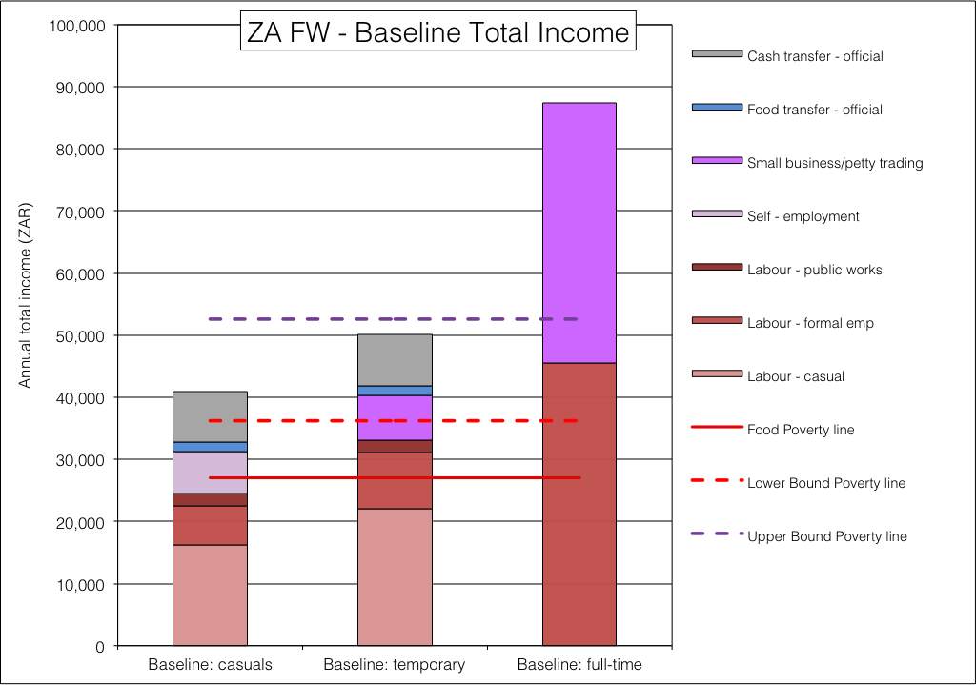**2: Commercial farm workers’ livelihoods

It was found that full-time employees often have small businesses as well, perhaps being run by another member of the family. These small businesses bolster household incomes to almost double the wages of the worker.

The studies found that very few farm workers, regardless of their employment status, do their own farming on any significant scale. Consequently nearly all food consumed is from purchases. **Figure Figure** shows the baseline total incomes.

##### Urban Poor (Step 2)

Urban areas are geographically delineated by wealth, wealthier people tend to live in plush suburbs that exclude poorer households. Therefore, to exclude the wealthiest urban households from this analysis, only the urban livelihood zones with poor households were included. Thus, the urban livelihoods zones included for this analysis are:

* The informal settlements: LZ codes 59830, 59831 and 59832;
* The combined formal and informal settlements: LZ codes 59840, 59841, 59842, 59843 and 59844;
* Municipal high rise areas with extreme poverty: LZ codes 59852
* Residential tenements with high unemployment or poverty: LZ codes 59862, 59863 and 59864;
* Mixed residential areas with high unemployment or poverty: LZ codes 59872 and 59873;
* Low rise residential areas with high unemployment or poverty: LZ codes 59882, 59883 and 59884;

In the analysis, these livelihood zone codes are all mapped to a temporary ‘analysis code’: 59899 representing the ‘Urban Poor’.

The Information for the baselines data for the Urban Poor was obtained from the National Income Dynamics Surveys (**NIDS**) Wave 4[6] and its associated papers[7]. The NIDS data has variables that link numbers of households with amounts of income for each source. This has to be converted to amounts of income per group; in this case we are looking at the urban and the poorest half of the population. This half was divided into four (quartiles), for which livelihoods with cash income and expenditure were constructed.

The poorest two quartiles depend most on social grants, although cash gifts, casual work and self-employment also contribute—some income for the second quartile comes from a small business or petty trading activity. The first quartile are also below the upper bound poverty line (UBPL), although they are above the lower bound and food poverty lines.

Figure 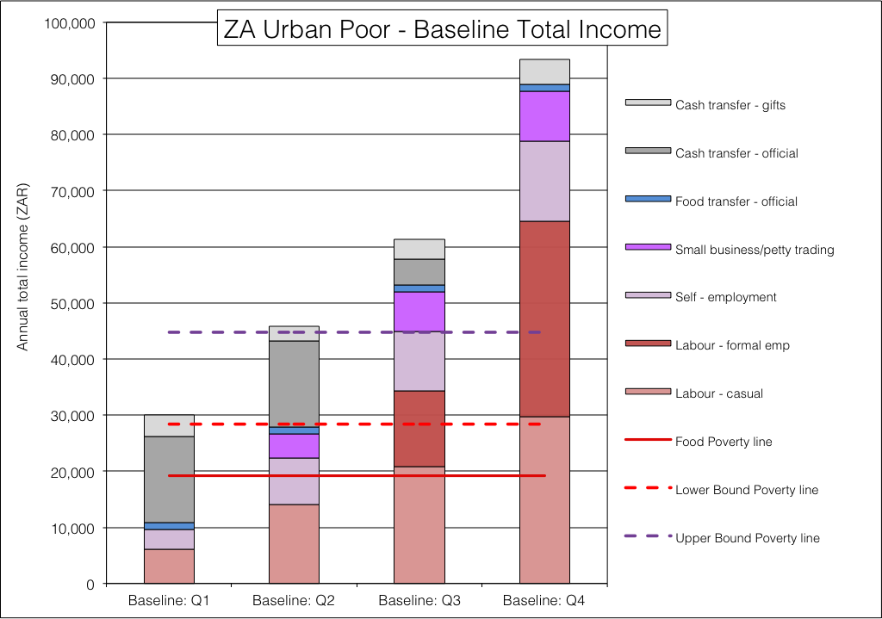3: Urban poor households’ livelihoods

It is only in the third quartile that employment becomes a significant part of income. Nevertheless, casual work still plays an important role.

An issue with poor urban households is that they often have relatives in rural areas as well; these relatives may expect remittances and support from their urban counterparts. However, for this analysis, the rural and urban households are treated as distinct from one another. Even though there may be money transfers and other links between, they remain two independent economic units.

### The Analysis Spreadsheets

##### Existing baselines (Step 3)

Single zone analysis spreadsheets (SZASs) were prepared from the existing baselines. These spreadsheets contain an income equivalent of both food sources and cash sources (the ‘total income’) so that food produced and consumed directly is included in the analysis and access calculations. The food purchased is based on the commodities in the food poverty line (FPL), so all income calculations reference to this and the other two poverty lines, the lower bound poverty line (LBPL) and the upper bound poverty line (UBPL). An example of this spreadsheet is given below in **Table Table** (the red-bordered cell is where the deficit will appear if there is one), while **Table Table** show the total income summary section of the spreadsheet (the deficits are highlighted with boundaries and coloured text if they are present: khaki for the UPBL deficit—as in **Table**  **Table**, orange for a LBPL deficit and red for an FPL deficit).

**Table** 5 - Example of an analysis spreadsheet

|  |  |  |  |  |  |  |  |  |  |  |  |  |
| --- | --- | --- | --- | --- | --- | --- | --- | --- | --- | --- | --- | --- |
| **ZAKHC: 59208** | Okhahlamba open access intense crops and livestock | | | | | |  | | | | | |
| BASELINE ACCESS |  | | | PROBLEM SPECIFICATION | | | | RESPONSE | | SUMMARY | | |
| **Sources of Food : Poor HHs** |  | | |  | | | |  | |  | | |
|  | Baseline | Expand | Max. | Problem | Food Intake | | Con.prob | Max.curr | Curr. | Baseline | Initial | Curr. |
|  | Access | -ability | Access | %norm | kJ/day |  | %norm | Access | Access | Access | Deficit | Access |
| Cows' milk - season 1 | 2% | 0% | 2% | 20% | baseline: |  | 20% | 0% | 0% | 2% | 0% | 1% |
| Own meat | 2% | 0% | 2% | 20% | 8800 |  | 20% | 0% | 0% | 2% | 0% | 1% |
| Maize: kg produced | 19% | 0% | 19% | 30% | for analysis: |  | 30% | 6% | 6% | 19% | 6% | 6% |
| Beans: kg produced | 3% | 0% | 3% | 20% | 8800 |  | 20% | 1% | 1% | 3% | 1% | 1% |
| potatoes: kg produced | 1% | 2% | 3% | 20% |  |  | 20% | 1% | 0% | 1% | 0% | 0% |
| Food aid | 12% | 0% | 12% | 100% |  |  | 100% | 12% | 12% | 12% | 12% | 12% |
| Purchase - other | 1% | -1% | 0% | 100% |  |  | 100% | 0% | 1% | 1% | 1% | 1% |
| Purchase - desirable | 0% | 0% | 0% | 100% |  |  | 100% | 0% | 0% | 0% | 0% | 0% |
| Purchase - fpl non staple | 20% | 3% | 22% | 100% |  |  | 100% | 22% | 21% | 20% | 20% | 21% |
| Purchase - staple | 59% |  | 303% | 100% |  |  | 100% | 155% | 59% | 59% | 29% | 59% |
| food deficit |  |  |  |  |  |  |  |  | 0% |  | 30% | 0% |
| total | 120% | 4% | 368% |  |  |  |  | 197% |  |  | 70% |  |
|  |  | | |  | | | | adj.fact = | 0.46 |  | | |
| **Income : Poor HHs** |  | | |  | | | |  | | % of baseline income | | |
|  | Baseline | Expand | Max. | Problem | Comm. | Staple | Con.prob | Max.curr | Curr. | Baseline | Initial | Curr. |
| Cash | Access | -ability | Access | %norm | Price | Price | %norm | Access | Access | Access | Deficit | Access |
| Cattle sales - local: no. sold | 6,750 | 0 | 6,750 | 50% | 118% | 165% | 59% | 3,983 | 3,983 | 13% | 7% | 7% |
| Goat sales - local: no. sold | 3,000 | -2,500 | 500 | 50% | 118% | 165% | 59% | 295 | 1,093 | 6% | 3% | 2% |
| Sheep sales - local: no. sold | 0 | 0 | 0 | 50% | 118% | 165% | 59% | 0 | 0 | 0% | 0% | 0% |
| Chicken sales: no. sold | 0 | 0 | 0 | 100% | 118% | 165% | 118% | 0 | 0 | 0% | 0% | 0% |
| Maize: kg produced | 0 | 0 | 0 | 30% | 140% | 165% | 42% | 0 | 0 | 0% | 0% | 0% |
| Beans: kg produced | 1,500 | 0 | 1,500 | 20% | 140% | 165% | 28% | 420 | 420 | 3% | 1% | 1% |
| potatoes: kg produced | 160 | -160 | 0 | 20% | 140% | 165% | 28% | 0 | 24 | 0% | 0% | 0% |
| Agricultural cash income -- see Data2 | 2,760 | 0 | 2,760 | 50% | 111% | 165% | 56% | 1,532 | 1,532 | 5% | 3% | 3% |
| Construction cash income -- see Data2 | 0 | 0 | 0 | 50% | 111% | 165% | 56% | 0 | 0 | 0% | 0% | 0% |
| Domestic work cash income | 2,200 | 0 | 2,200 | 50% | 111% | 165% | 56% | 1,221 | 1,221 | 4% | 2% | 2% |
| Labour migration(formal employment) | 0 | 0 | 0 | 40% | 118% | 165% | 47% | 0 | 0 | 0% | 0% | 0% |
| Small business -- see Data2 | 0 | 0 | 0 | 80% | 118% | 165% | 94% | 0 | 0 | 0% | 0% | 0% |
| Social development -- see Data2 | 22,020 | 0 | 22,020 | 100% | 118% | 165% | 118% | 25,984 | 25,984 | 41% | 49% | 49% |
| Public works -- see Data2 | 14,916 | 0 | 14,916 | 100% | 118% | 165% | 118% | 17,601 | 17,601 | 28% | 33% | 33% |
| Gifts/social support: type (Child support, Pension and Foster Care) | 0 | 0 | 0 | 100% | 100% | 165% | 100% | 0 | 0 | 0% | 0% | 0% |
| Remittances | 0 | 0 | 0 | 100% | 111% | 165% | 111% | 0 | 0 | 0% | 0% | 0% |
| total: | 53,306 | -2,660 | 50,646 |  |  |  |  | 51,035 | 51,857 | 100% | 99% | 97% |
|  |  |  |  |  |  |  |  |  |  |  | | |
| **Expenditure : Poor HHs** |  |  |  |  |  |  |  |  |  | % of baseline expenditure | | |
|  | Baseline |  |  | Problem | Comm. |  | Con.prob | Max.curr | Curr. | Baseline | Initial | Curr. |
| Cash | Expend |  |  | %norm | Price |  | %norm | Expend | Expend | Expend | Deficit | Expend |
| fpl non-staple food | 14,936 |  |  | 100% | 140% |  | 140% | 20,910 | 20,910 | 28% | 39% | 39% |
| lbpl | 15,579 |  |  | 100% | 118% |  | 118% | 18,383 | 18,383 | 29% | 34% | 34% |
| ubpl | 27,744 |  |  | 100% | 118% |  | 118% | 0 | 1,141 | 52% | 14% | 2% |
| resilience | 4,656 |  |  | 100% | 118% |  | 118% | 0 | 0 | 9% | 0% | 0% |
| staple food | 6,940 |  |  |  |  |  |  | 30,125 | 11,423 | 13% | 11% | 21% |
| other | 0 |  |  |  |  |  |  |  | 0 | 0% | 0% | 0% |
| total: | 53,306 |  |  |  |  |  |  | 51,035 | 51,857 | 131% | 99% | 97% |
| exp. deficit |  |  |  |  |  |  |  | 18,383 | 0 |  | -20% | 0% |
| Cost of staple |  |  |  |  |  |  |  |  |  |  |  |  |
| name of staple | mix |  |  |  |  |  |  |  |  |  |  |  |
| kg pppd | 0.65 |  |  |  |  |  |  |  |  |  |  |  |
| HH size | 8 |  |  |  |  |  |  |  |  |  |  |  |
| cost per kg | 6.24 |  |  |  |  |  |  |  |  |  |  |  |
| cost of staple | 11,771 |  |  |  |  |  | 165% | 19,422 |  |  |  |  |
| cost of FPL (100% staple & non-staple) | 24,063 |  |  |  |  |  | 149% | 35,969 |  |  |  |  |
|  |  |  |  |  |  |  |  |  |  |  |  |  |

It will noticed that although food sources like own crops consumed or wild foods consumed are treated as an income, food purchases are not. Food purchases, although a source of food, are an item of expenditure rather than an income. It must be emphasised that for income, household sizes of all the wealth groups are normalised to that of the ‘poor’ wealth group (in the case in **Table Table** and  **Table** above, it is eight people), while baseline incomes are adjusted to what the FPL would have cost in today’s Rands. The

**Table** 6 - Example of the analysis spreadsheet total income and

deficits summary

|  |  |  |  |
| --- | --- | --- | --- |
| Indicates there is a UBPL deficit present  Text will change to **orange**  if there is an LBPL deficit  Text will change to **red**  if there is an FPL deficit | **Baseline** | **Init Def** | **Response** |
| Own crops consumed | 4,042 | 1,267 | 1,306 |
| Own crops sold | 2,481 | 465 | 444 |
| Animal products consumed | 853 | 188 | 188 |
| Animal products sold | 0 | 0 | 0 |
| Animals sold | 14,575 | 5,753 | 5,076 |
| Wild foods consumed and sold | 0 | 0 | 0 |
| Labour - casual | 7,414 | 2,753 | 2,753 |
| Labour - formal emp | 0 | 0 | 0 |
| Labour - public works | 22,297 | 17,601 | 17,601 |
| Self - employment | 0 | 0 | 0 |
| Small business/petty trading | 0 | 0 | 0 |
| Food transfer - official | 2,095 | 2,312 | 2,312 |
| Food transfer - gifts | 0 | 0 | 0 |
| Cash transfer - official | 32,916 | 25,984 | 25,984 |
| Cash transfer - gifts | 0 | 0 | 0 |
| Other | 0 | 0 | 0 |
| **TOTAL** | **86,673** | **56,322** | **55,664** |
| Food Poverty line | 35,969 | 35,969 | 35,969 |
| Lower Bound Poverty line | 54,352 | 54,352 | 54,352 |
| Upper Bound Poverty line | 87,090 | 87,090 | 87,090 |
| Resilience line |  |  |  |
|  |  |  |  |
|  |  |  |  |
| FPL Deficit | 0 | 0 | 0 |
| LBPL Deficit | 0 | 0 | 0 |
| UBPL Deficit | ***417*** | ***30,768*** | ***31,426*** |

##### Other Open Access Livelihood Zones, Farm Workers and the Urban Poor (Step 3 to 5)

No baselines exist for the remainder of the open access tenure livelihood zones and it is not possible to synthesise them each in any way without fresh and adequate field data. But to do the analysis, some sort of ‘baseline’ was needed and these were made for the three main types of open access livelihood zone: livestock-dominated based zones, mixed crops and livestock based zones and more crop-dominated livelihood zones. The baseline livelihood source summaries for these zones were derived from averages of the existing zones of the same type, as it is likely that the actual patterns on the ground of the unknown livelihood zones will be similar to the ‘known’ and completed livelihood zones. These were entered directly into the single zone analysis spreadsheets (SZASs) so that the problem specifications could be prepared.

#### Secondary Source Data (Step 6 to 9)

This analysis was completed entirely with data from secondary sources. Normally, when an assessment of this nature is undertaken, some primary data will still be captured and used alongside that from the secondary indicators. This helps to ‘ground truth’ the analysis, as well as filling in the indicator gaps that monitoring systems often leave out in livelihoods, such as: casual labour opportunities, informal or petty trading, crafts and self-employment.

#### Hazard Definition and Problem Specification (Steps 10 to 28)

The hazards people face can be broken into two types: spatial and non-spatial. Spatial hazards are those that are confined to particular geographical areas (such as crop failures resulting from drought or floods), whereas non-spatial hazards are those that afflict people (but not necessarily all people) in all areas (such as a general rise in prices or changes to social development policies).

With both hazard types, a determination needs to be made for those that experience the hazard versus those that do not.

Usually, a combination of approaches are applied to arrive at a spatial definition of the hazard. The first approach is to use some sort of spatial hazard data, such as remote sensing images, while the second approach is to look at the production factors of interest (for example, crops or livestock).

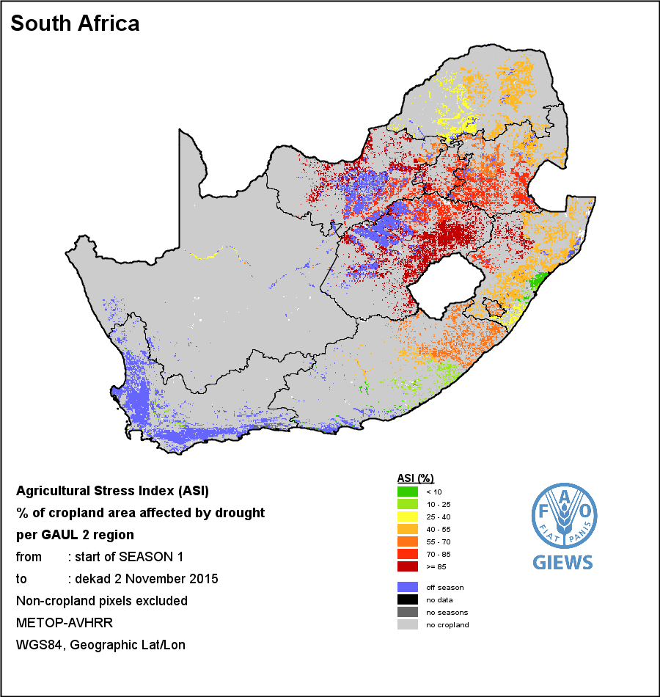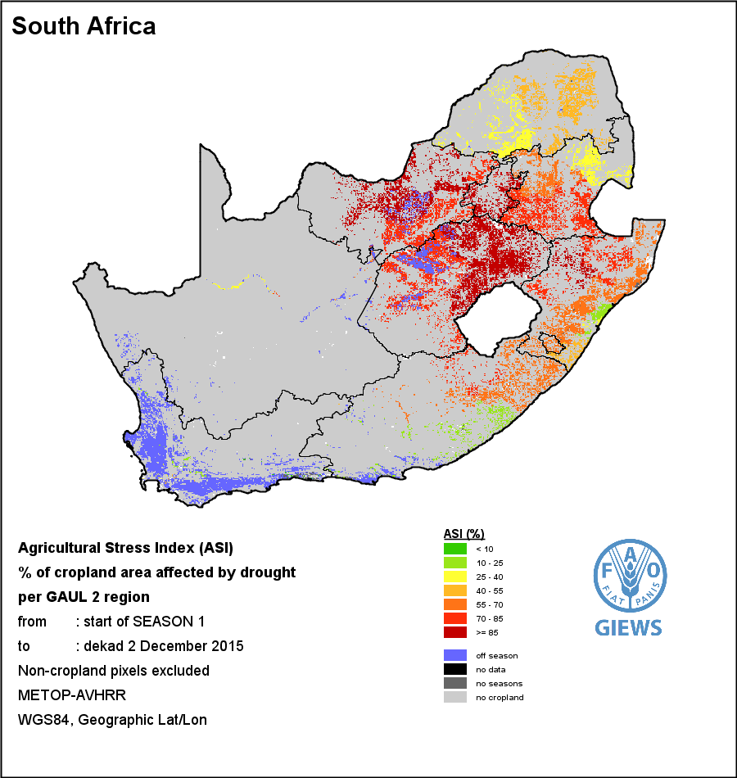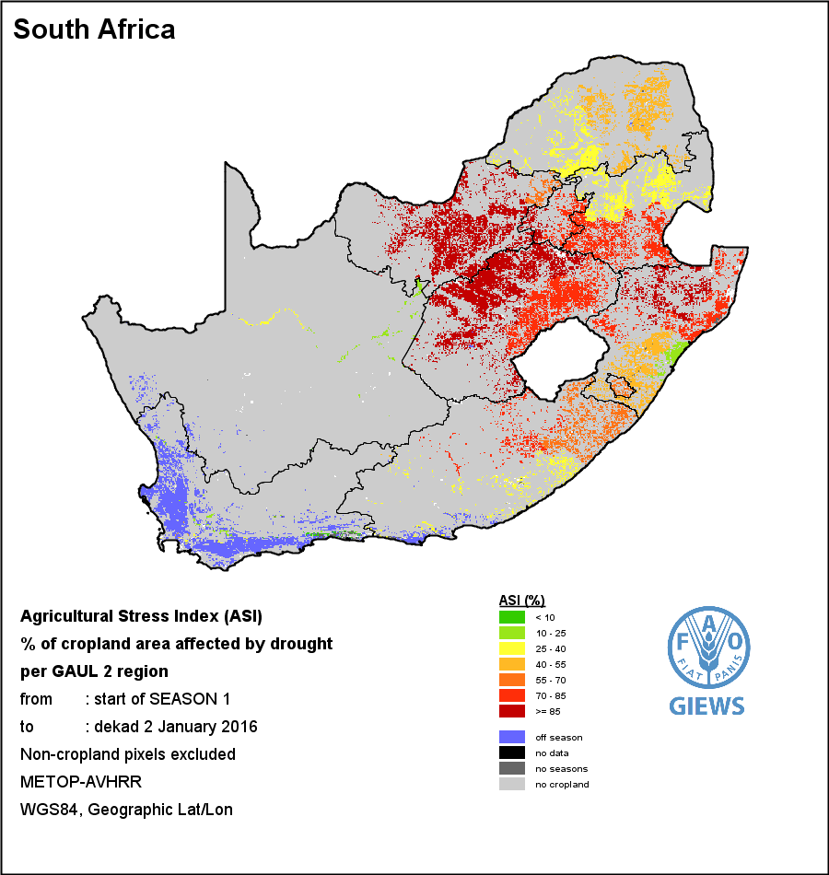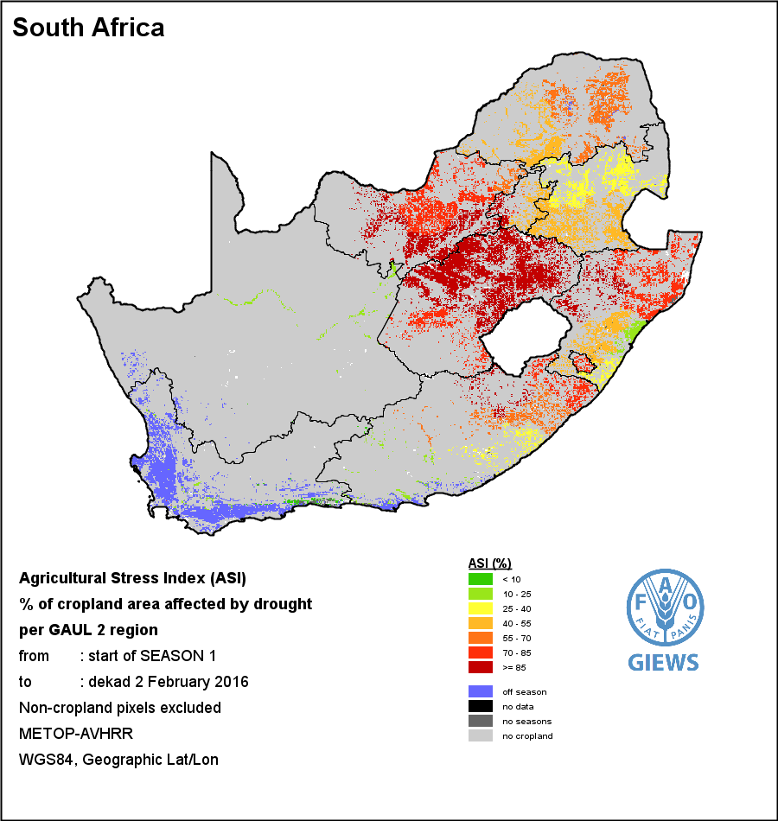  
**Figure** 4: Agricultural stress index (ASI) remote sensing maps for the second dekad of November 2015, December 2015, January 2016 and February 2016 (source: GIEWS, FAO <http://www.fao.org/giews/earthobservation/country/index.jsp?lang=en&code=ZAF>#). The images are reproduced as provided by the source, with longitudes and latitudes mapped to a cartesian plane, based on the World Geodetic Survey 1984 origin and ellipsoid.

##### Climatic Spatial Data and Remote Sensing (Step 10)

The author looked at several types of remote sensing data sets and these include:

* Rainfall deviation from satellite images (source: FAO);
* Rainfall deviation from local sources (source: ARC-ISCW);
* Standard precipitation index (SPI) (source: ARC-ISCW);
* Normalised differential vegetation index (NDVI) (source: FAO-GIEWS);
* Vegetation condition index (VCI) (source: FAO-GIEWS);
* Vegetation health index (VHI) (source: FAO-GIEWS); and
* Agriculture stress index (ASI) (source: FAO-GIEWS).

At first glance, the agricultural stress index (ASI) appeared to be the simplest and most attractive set to use to determine hazard areas, with a historical set of images for each dekad that shows how, where and when the drought developed to it most devastating. **Figure Figure** the development of the drought over the months from November 2015 to February 2016. The ASI has the advantage that it is a combination of a range of factors that affect crop performance, so in many ways it is good for establishing a problem specification. However, it also suffers some disadvantages:

* The ASI focusses only on crops, while in many affected parts of the country livestock are the key productive components; and
* The ASI only shows results for the current cropping season, so areas with different seasonal priorities (such as winter rainfall) have to come from a different set of images.

Nevertheless, the images in **Figure Figure** do show the extent of crop failure: the dark red areas of North West, Free State and northern KwaZulu-Natal, as well as the red or orange parts of KwaZulu-Natal, Eastern Cape and Limpopo. Note, the winter rainfall Western Cape and the vast area under livestock grazing in North West, Northern Cape and Free State do not show up.

Therefore, the analyst considered precipitation and vegetation maps for more information.

Precipitation, when compared with the long term average as in the rainfall anomaly (RFA), is an important determinant, although crop and grazing conditions depend as much on the *distribution* of rainfall as they do on the total amount that fell. The standard precipitation index (SPI) takes these factors into account (SPI - McKee et al., 1993) and was formulated to display drought events from rainfall data by quantifying precipitation deficits on different time scales. Spatially, the data are grouped per quaternary catchment for each time period and are based on the historical distribution of rainfall. The time period chosen here is the three-month average, so each image (for each month) represents a moving average over 24 months, twelve months, six months, three months and a single month for that particular month. These are published by the Agricultural Research Council’s Institute For Soil, Climate And Water (ARC-ISCW) in their monthly publication “*Umlindi* – the Watchman”.

The development of the drought is clear from the images. It began in the north of KwaZulu-Natal in December 2014, spread up to southern Mpumalanga in February 2015 and on to North West in March 2015, afflicting Free State in October 2015. The drought reached its worst in December 2015, with the rains finally arriving in the summer rainfall regions in January 2016. A month after the onset of these rains, the natural vegetation was showing recovery, although the cropping season was lost for much of North West, Free State, Northern Cape, northern KwaZulu-Natal, northern Eastern Cape, the lowveld of Mpumalanga and Limpopo and the Swartland area of Western Cape.

Lastly, the condition of the vegetation shows the impact of rainfall (or the lack of it) on the actual crops and grazing. The vegetation condition index (VCI) has been chosen here.

**Figures Figure**,  **Figure** and  **Figure** contain a time series of SPI, RFA and VCI, starting in December 2014 (in 2014 there was a localised drought in North West Province) and running up until February 2016. The SPI images are for three-month categories, which means they are like a three-month moving average ending at the particular month (e.g. the three-month SPI for November 2015 is the SPI for September, October and November 2015).

The vegetation condition image for January 2016 was chosen because it captures the after-effects of the previous months’ low rainfall, as well as the relief that some parts of the country received that month for the limited rains.

##### Georeferencing, conversion of colour raster images to single-value vector format (Steps 11 to 16)

Much of the analysis depends on land area measurements: for example, the overlapping or common area between map features representing different variables. Considering that the analysis takes place at a national (small) scale, the maps need to be reprojected to a suitable coordinate reference system (CRS) for measuring area reasonably quickly.

The South African Albers Equal Area Conical CRS does this well and so the images are georeferenced and reprojected to it[8]; the result is shown below in **Figure Figure**.

Rainfall Anomaly (RFA)

Vegetation Condition Index (VCI)

3-Month Standard Precipitation Index (SPI)

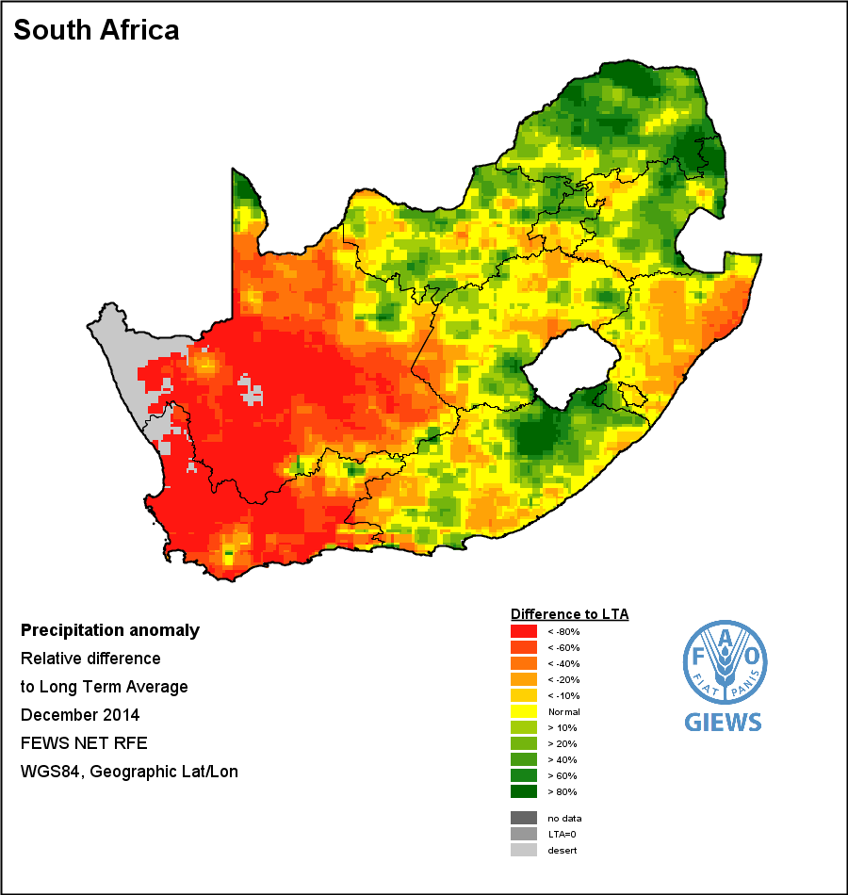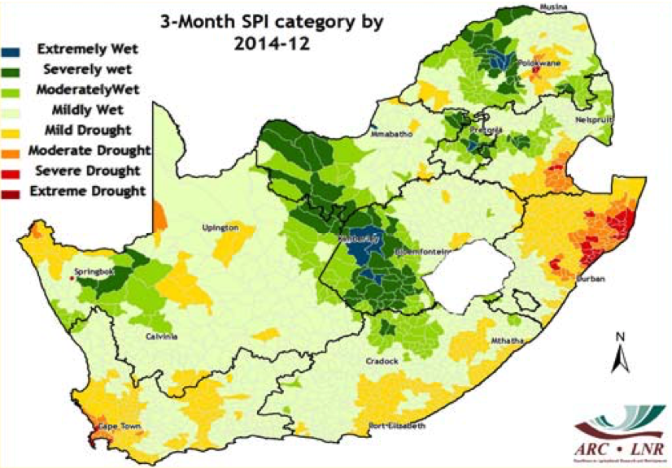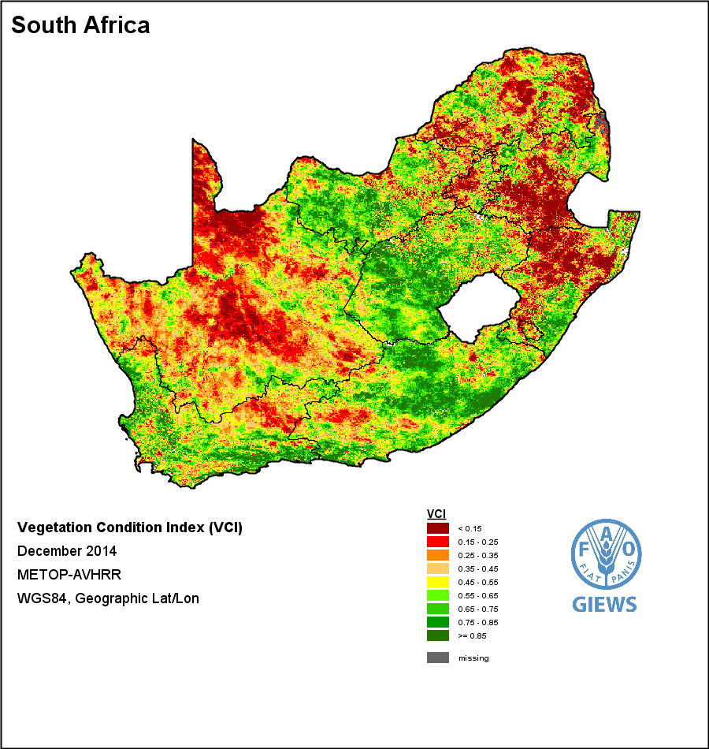

Jan 2015

Feb 2015

Apr 2015

Dec 2014

Mar 2015

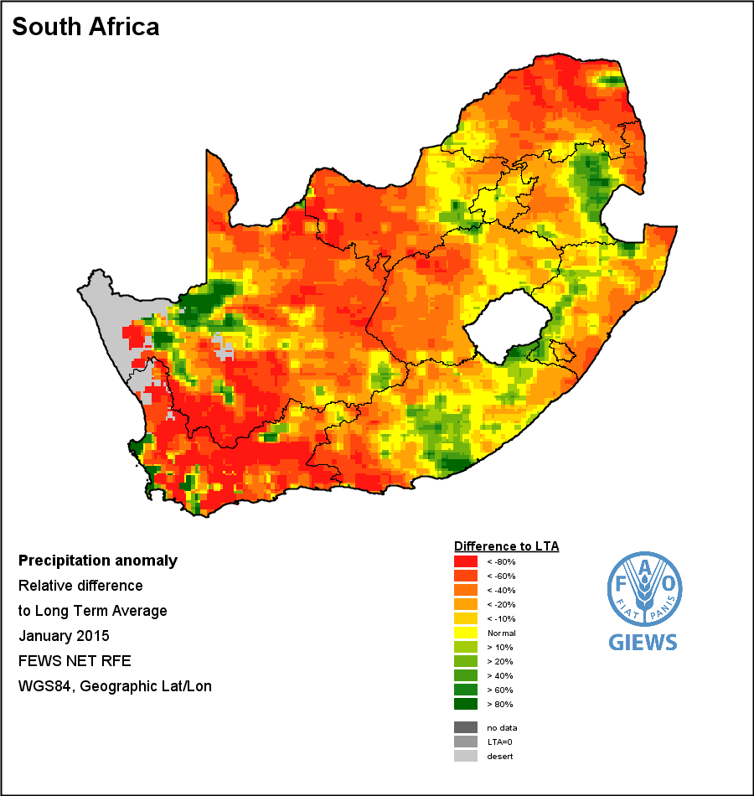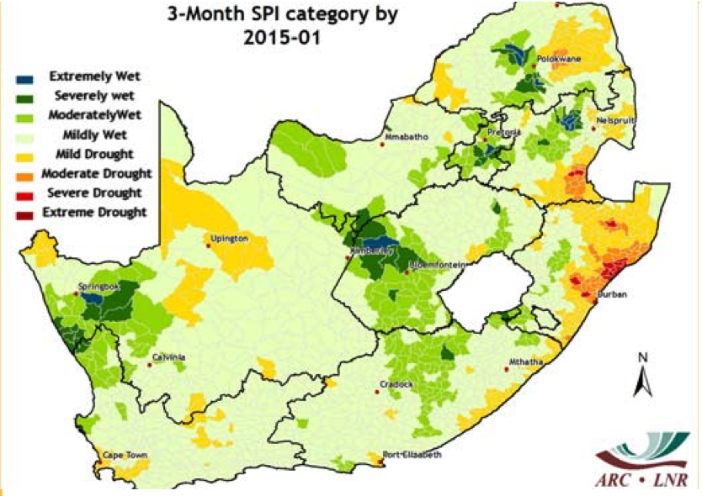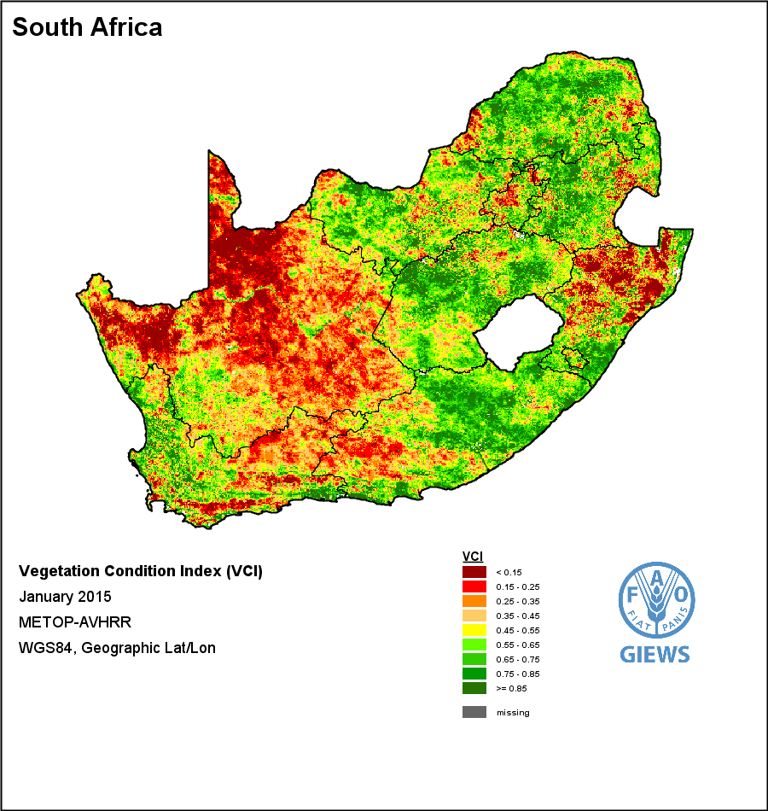

Jan 2015

Feb 2015

Apr 2015

Dec 2014

Mar 2015

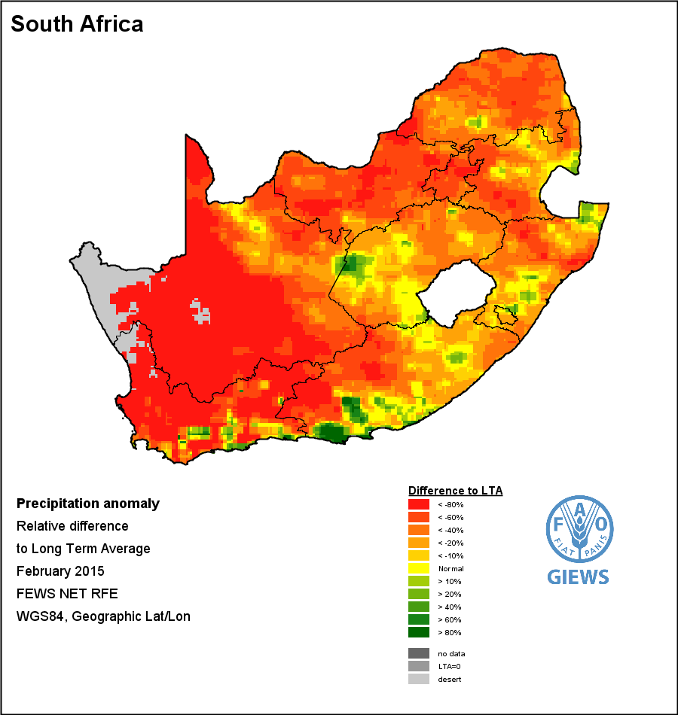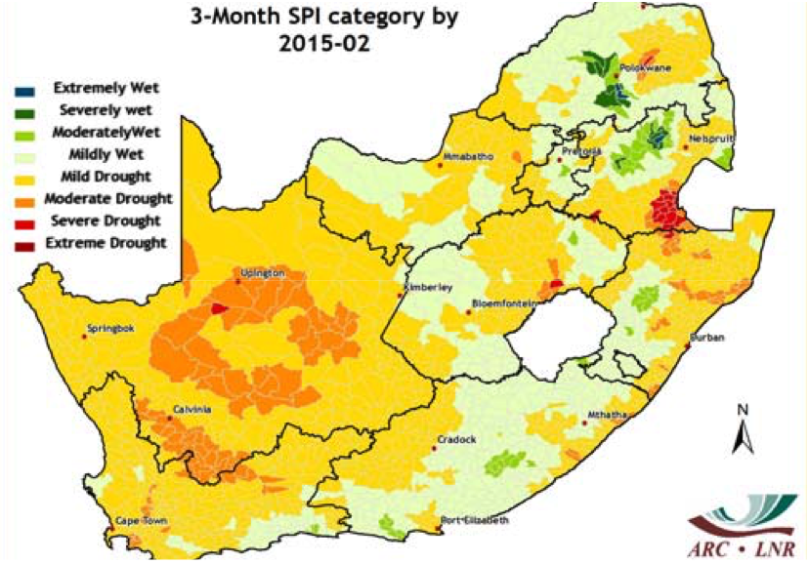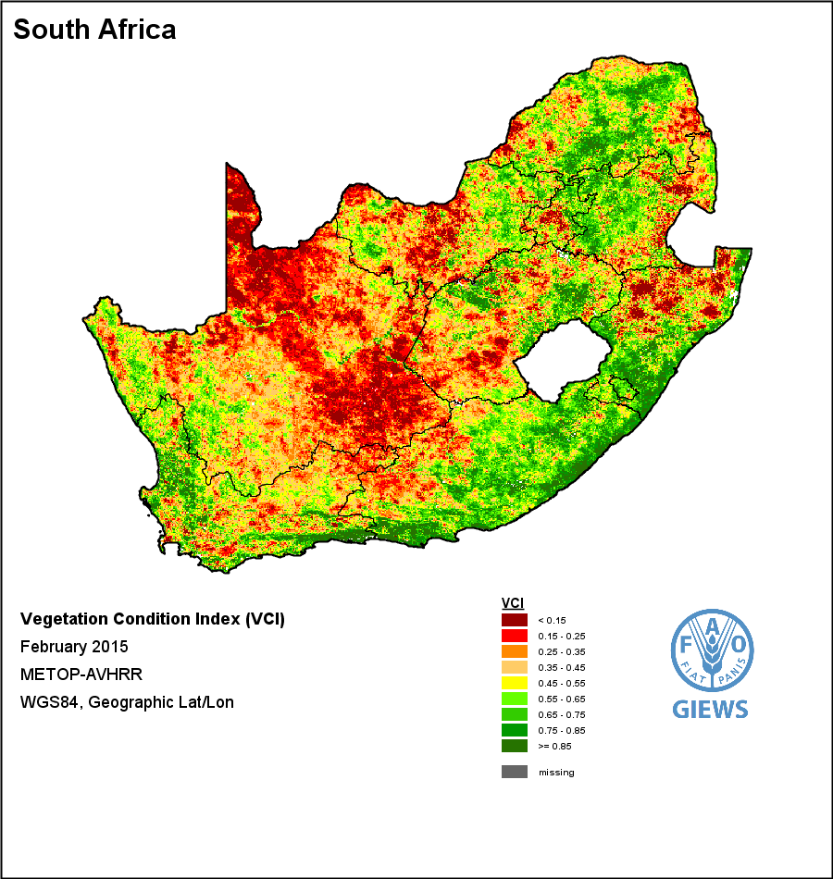

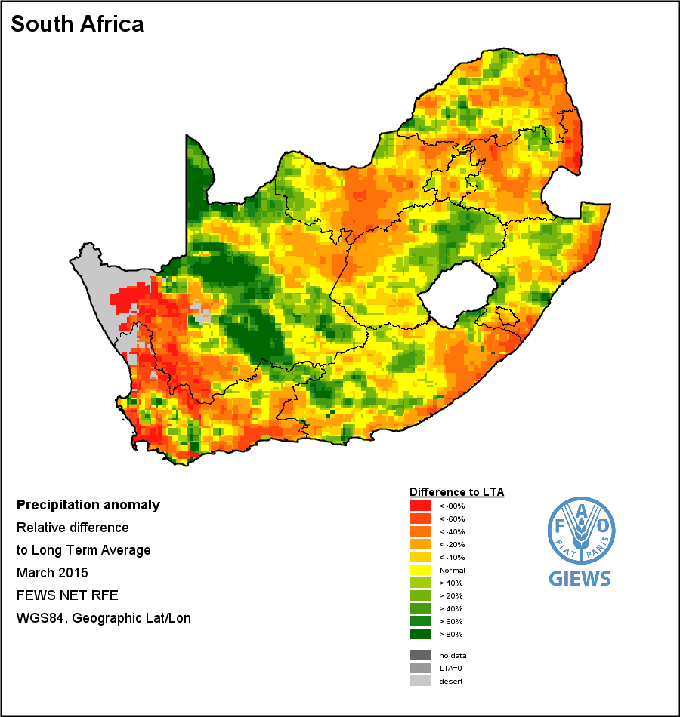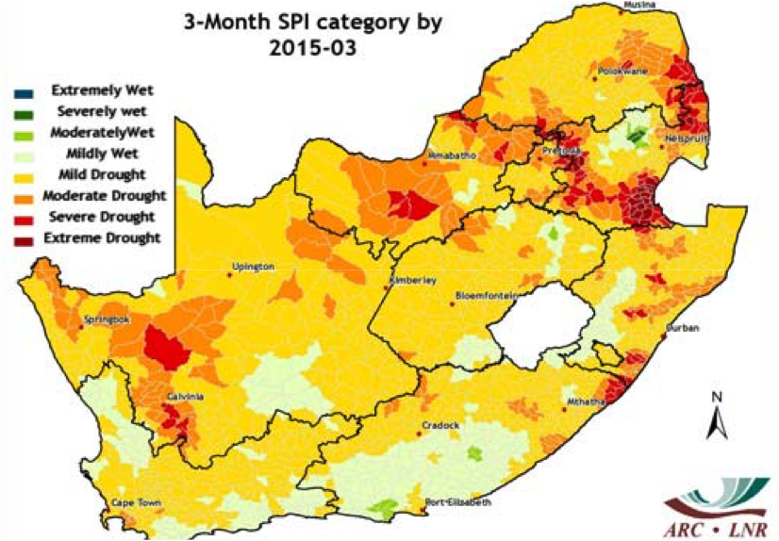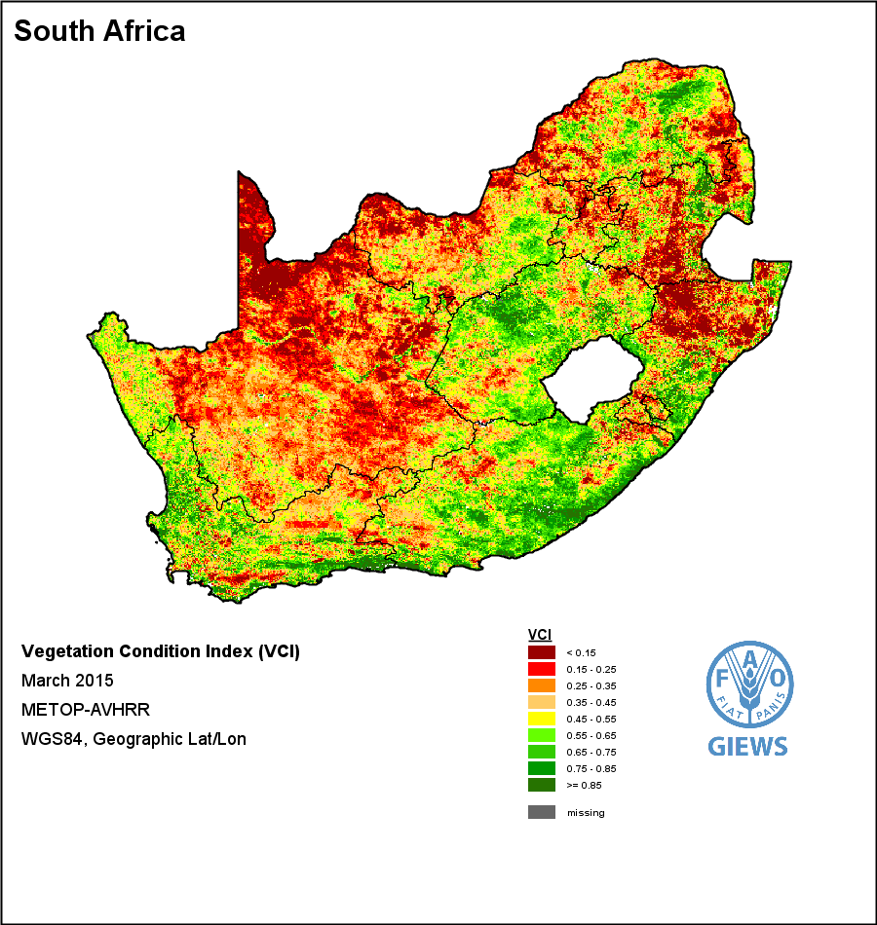

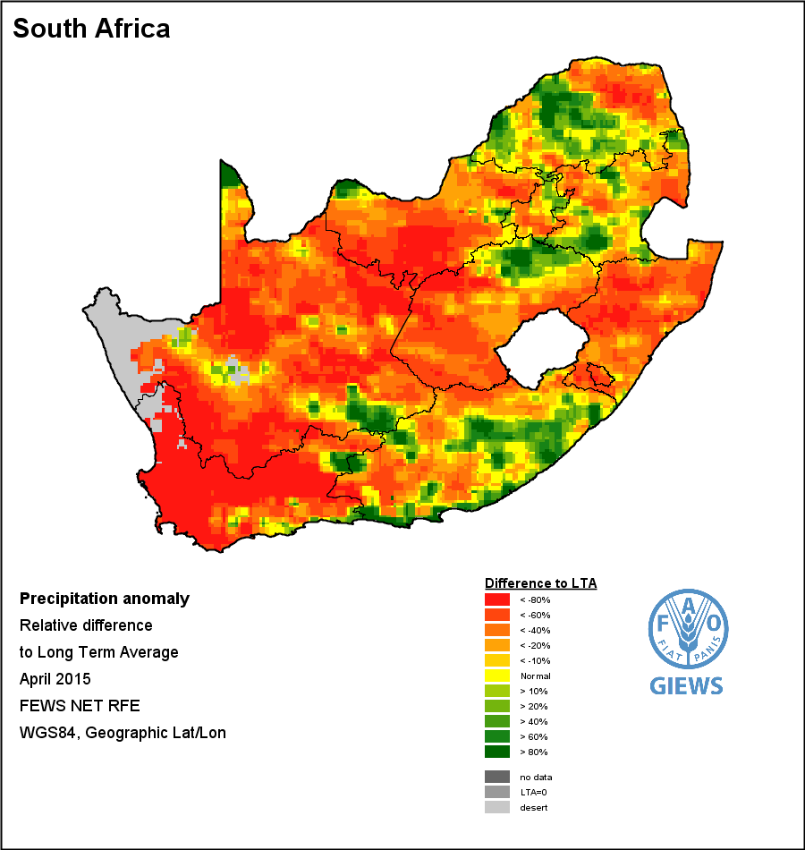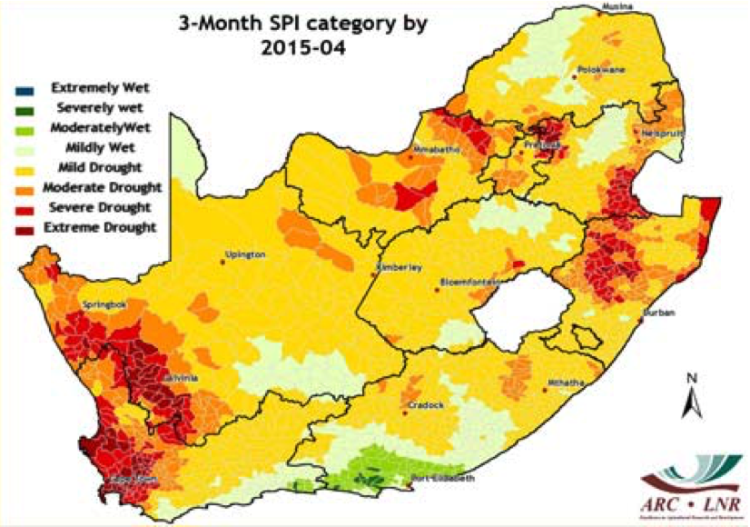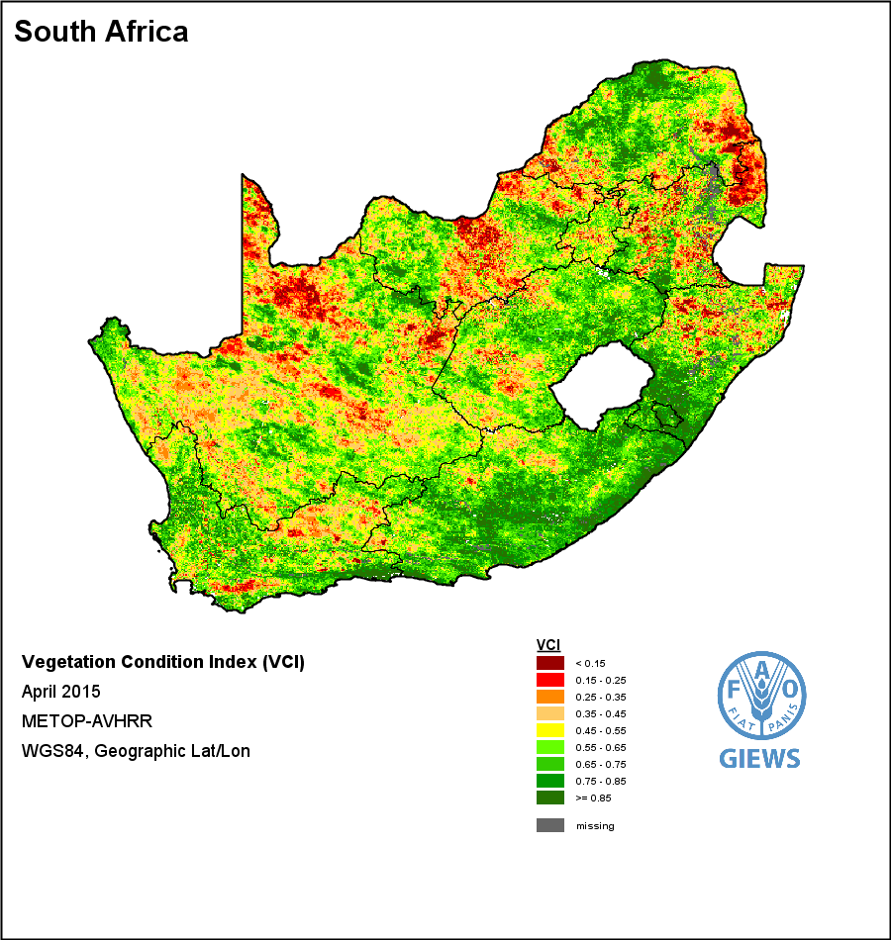 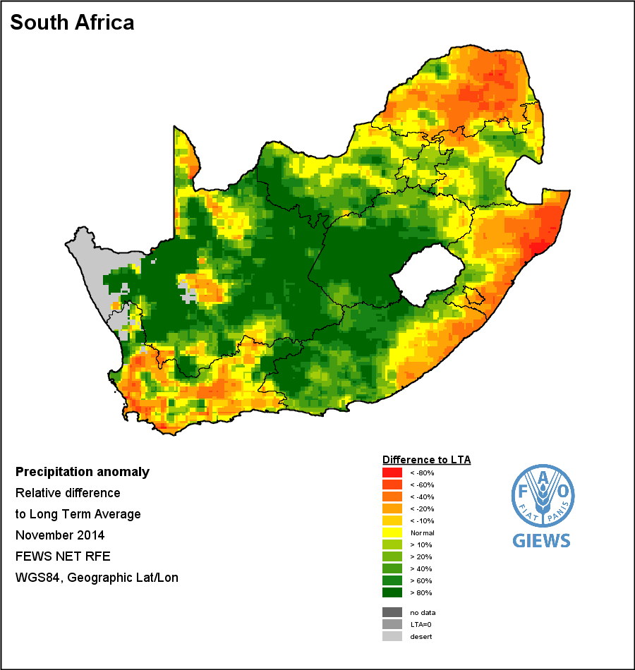   
**Figure** 5: Monthly rainfall anomaly (source: FAO-GIEWS [http://www.fao.org/giews/earthobservation/country/index.jsp?lang=en&code=ZAF#](http://www.fao.org/giews/earthobservation/country/index.jsp?lang=en&code=ZAF)), vegetation condition index (Source: FAO-GIEWS) and standard precipitation index (Source: ARC-ISCW [http://www.arc.agric.za/Pages/Newsletters.aspx#k=UMLINDI](http://www.arc.agric.za/Pages/Newsletters.aspx" \l "k=UMLINDI)) from December 2014 to April 2015. The images are reproduced as provided by the source, with longitudes and latitudes mapped to a cartesian plane, based on the World Geodetic Survey 1984 origin and ellipsoid.

Rainfall Anomaly (RFA)

Vegetation Condition Index (VCI)

3-Month Standard Precipitation Index (SPI)

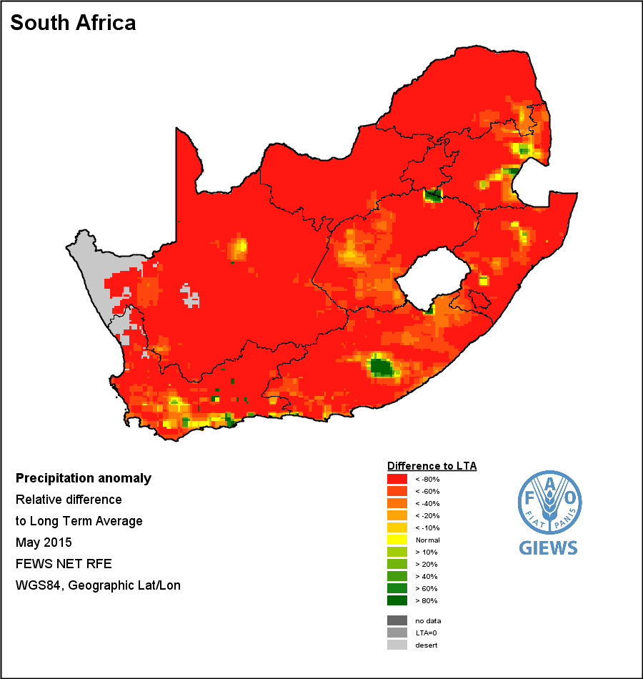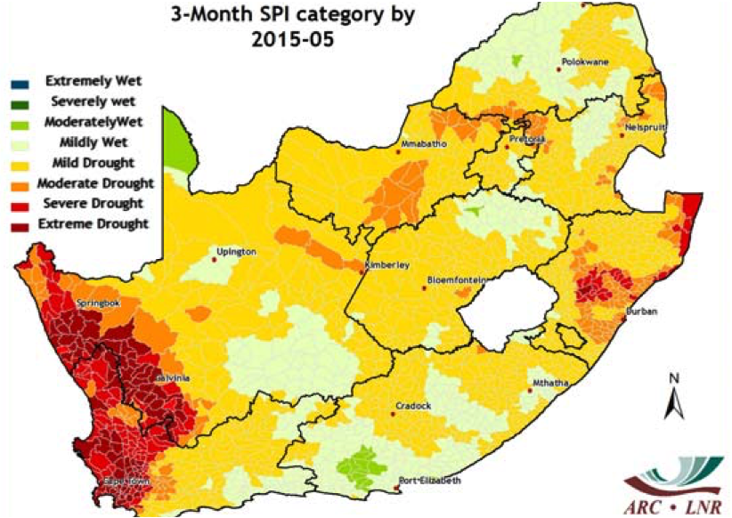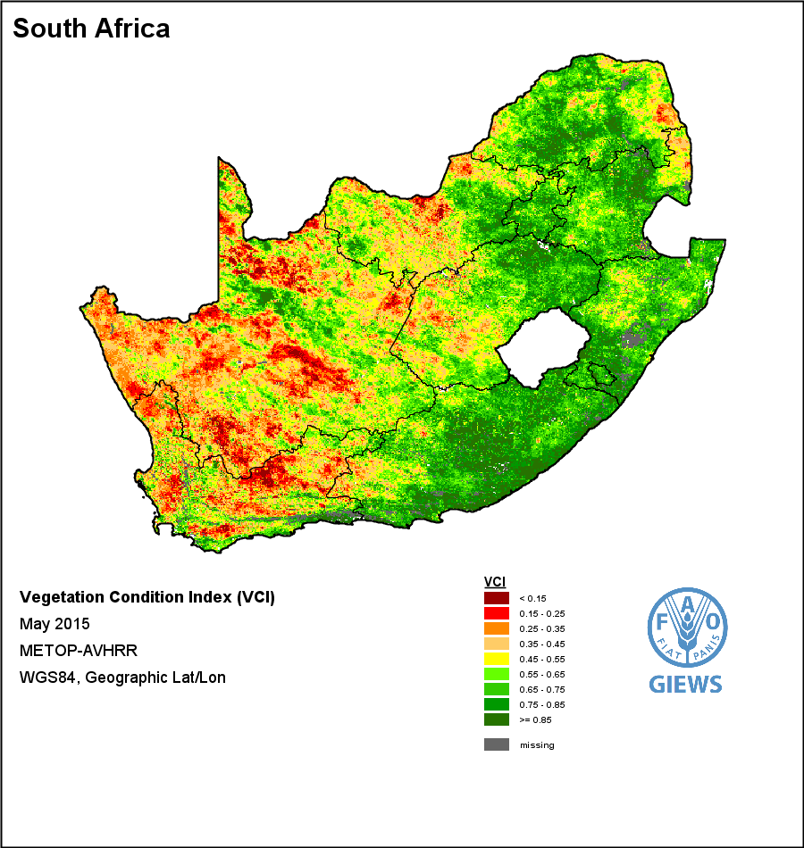

May 2015

Jun 2015

Jul 2015

Aug 2015

Sep 2015

May 2015

Jun 2015

Jul 2015

Aug 2015

Sep 2015

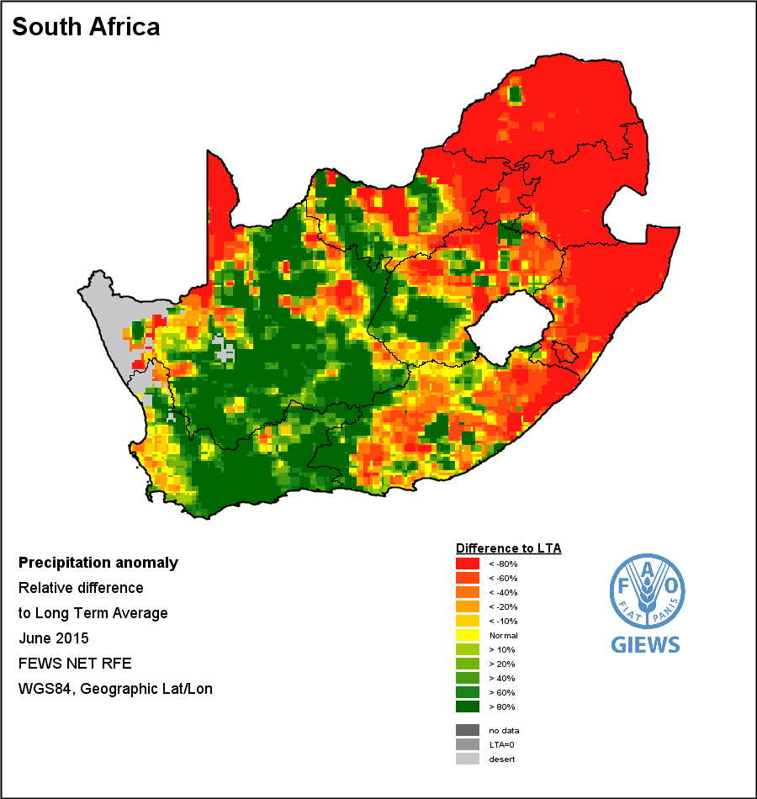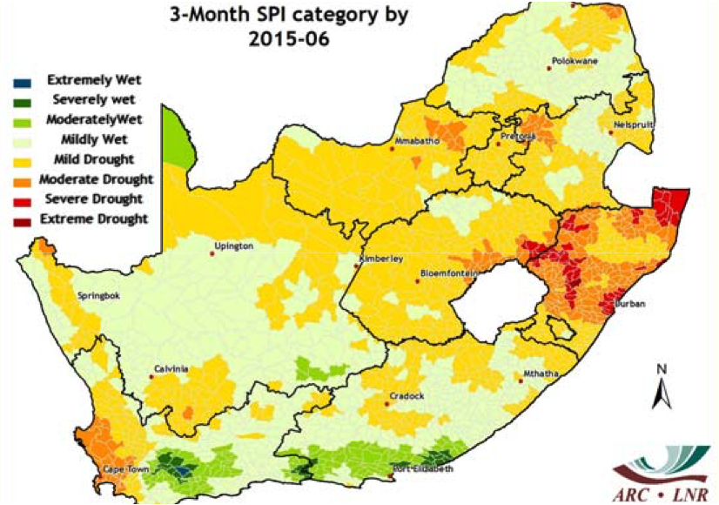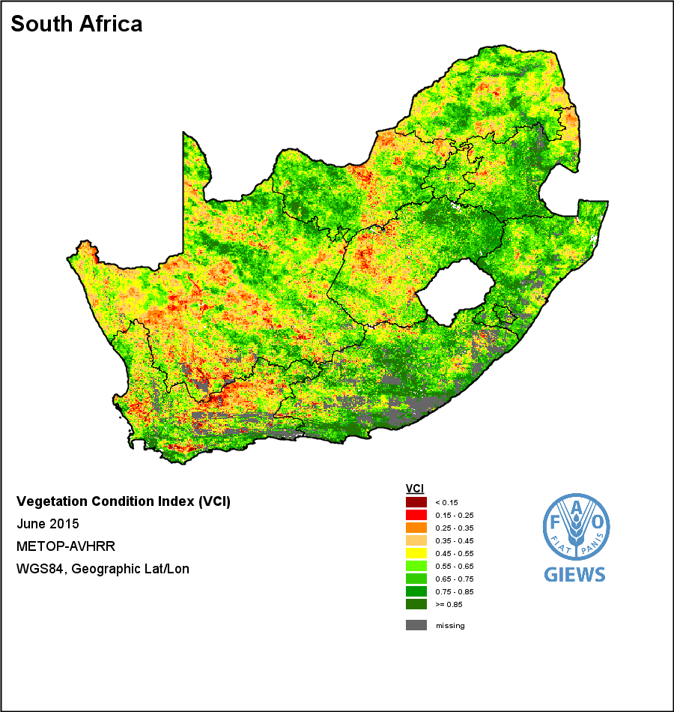

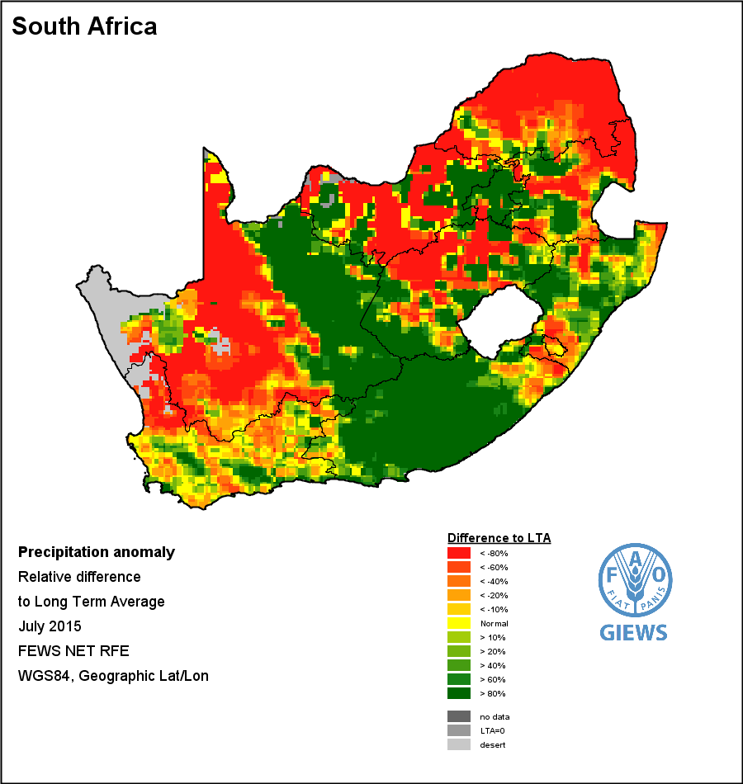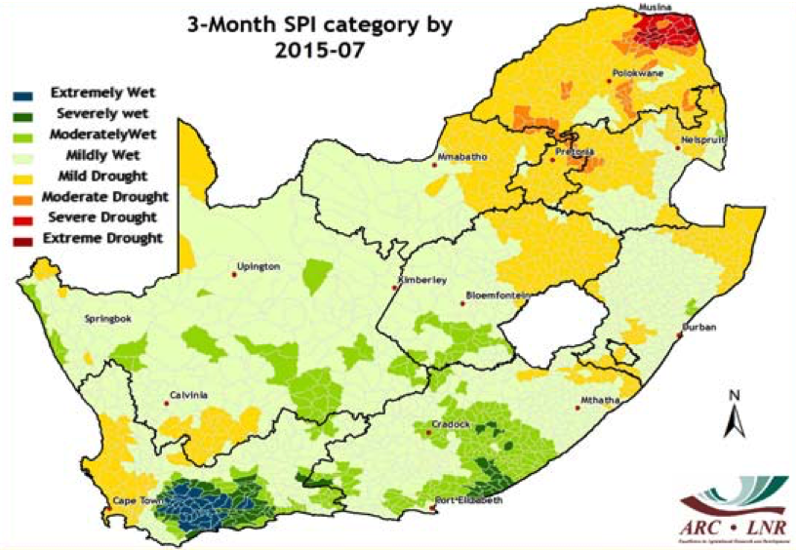

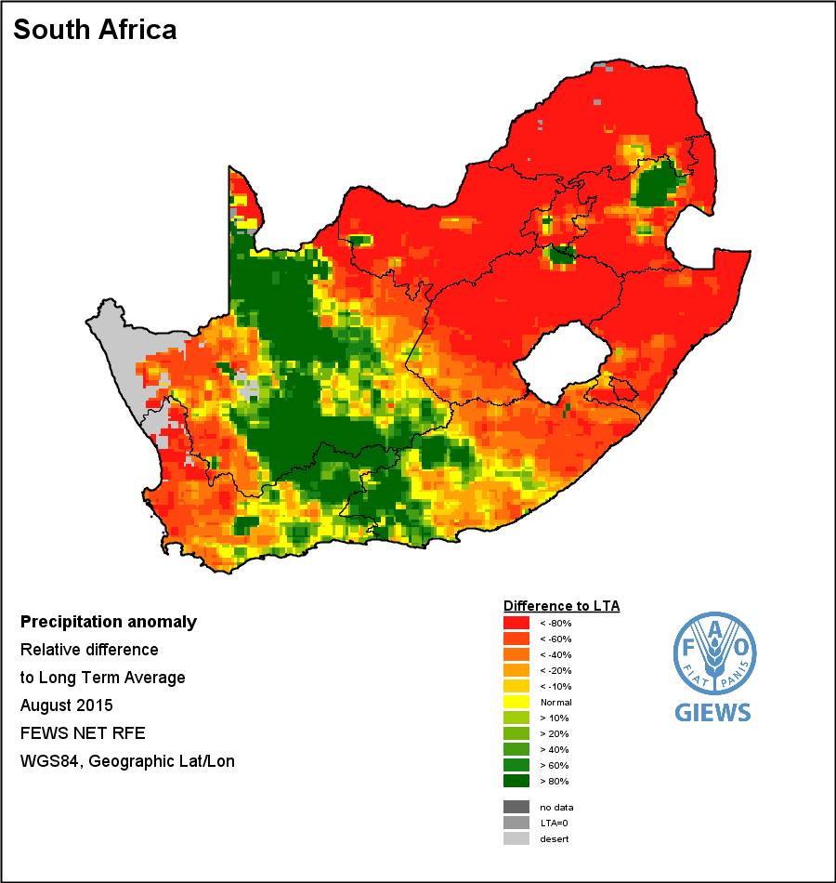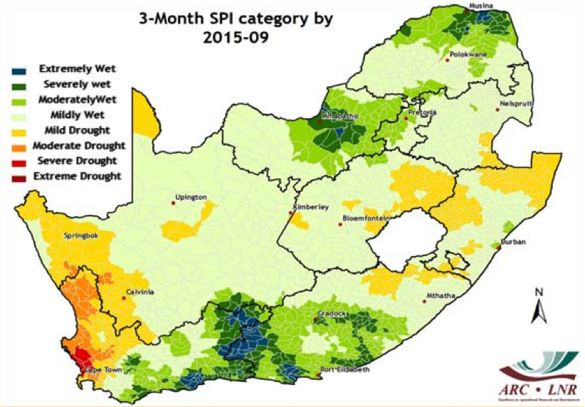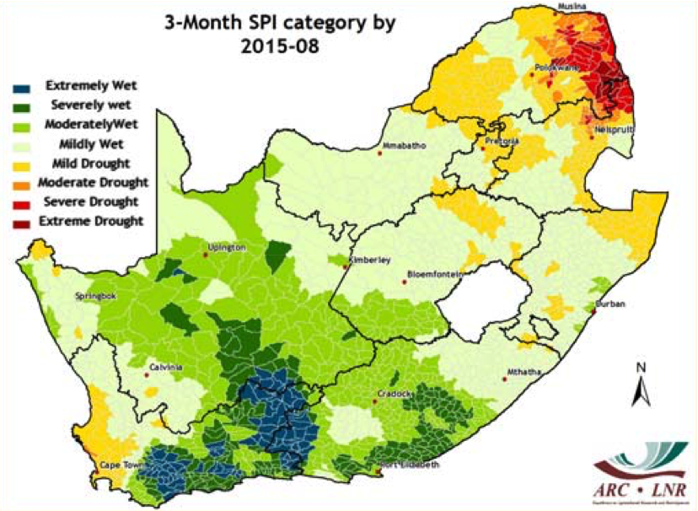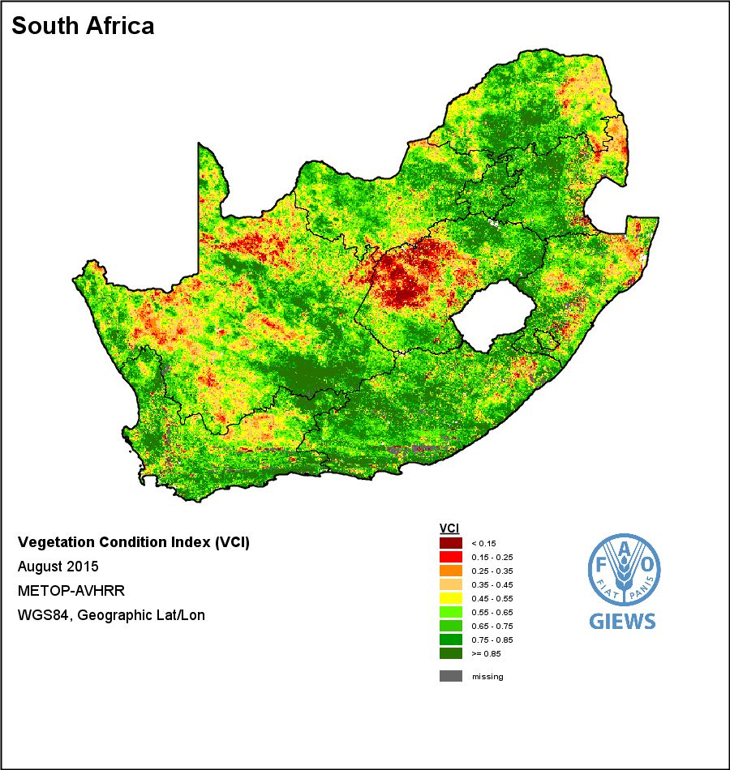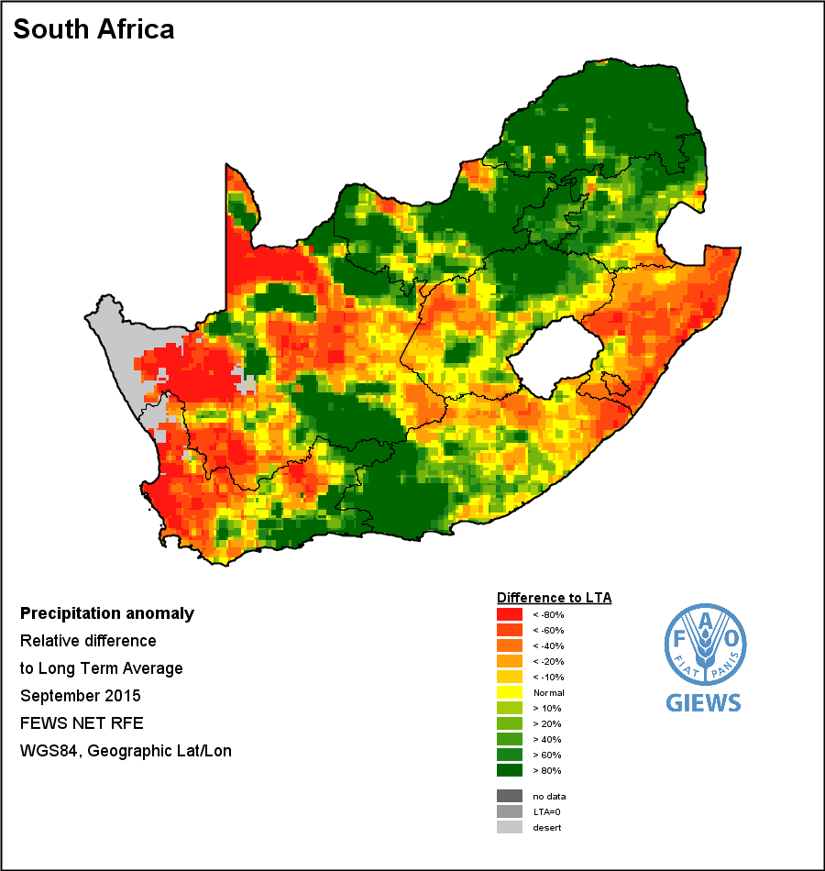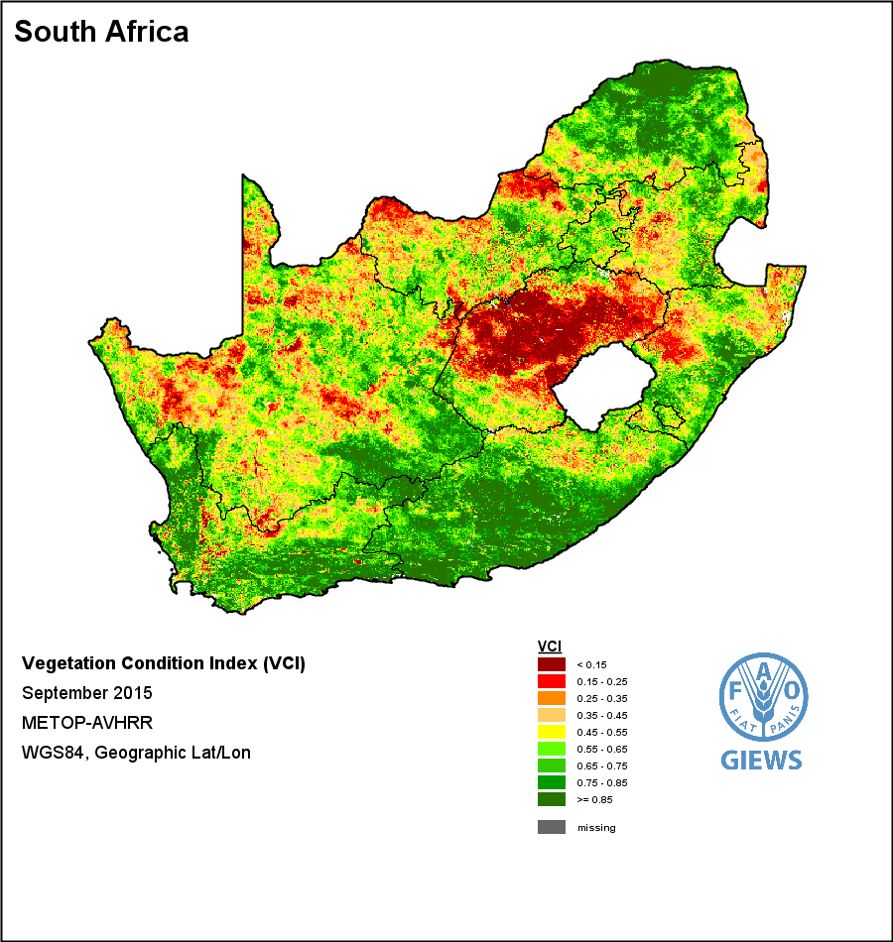

   
**Figure** 6: Monthly rainfall anomaly (source: GAO-GIEWS [http://www.fao.org/giews/earthobservation/country/index.jsp?lang=en&code=ZAF#](http://www.fao.org/giews/earthobservation/country/index.jsp?lang=en&code=ZAF)), vegetation condition index (Source: FAO-GIEWS) and standard precipitation index (Source: ARC-ISCW [http://www.arc.agric.za/Pages/Newsletters.aspx#k=UMLINDI](http://www.arc.agric.za/Pages/Newsletters.aspx" \l "k=UMLINDI)) from May to September 2015. The images are reproduced as provided by the source, with longitudes and latitudes mapped to a cartesian plane, based on the World Geodetic Survey 1984 origin and ellipsoid.

Rainfall Anomaly (RFA)

Vegetation Condition Index (VCI)

3-Month Standard Precipitation Index (SPI)

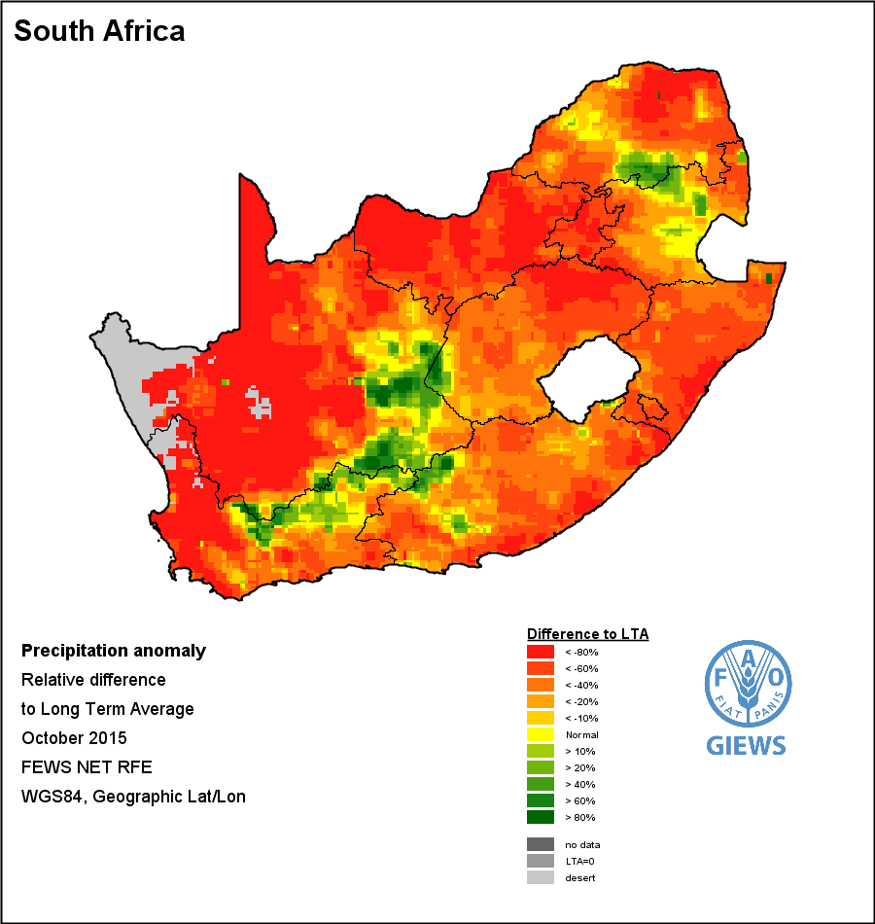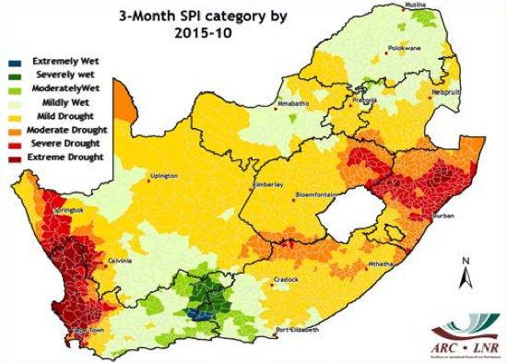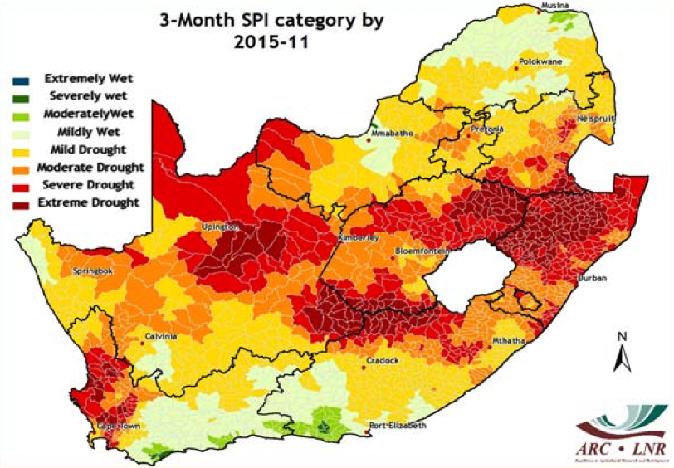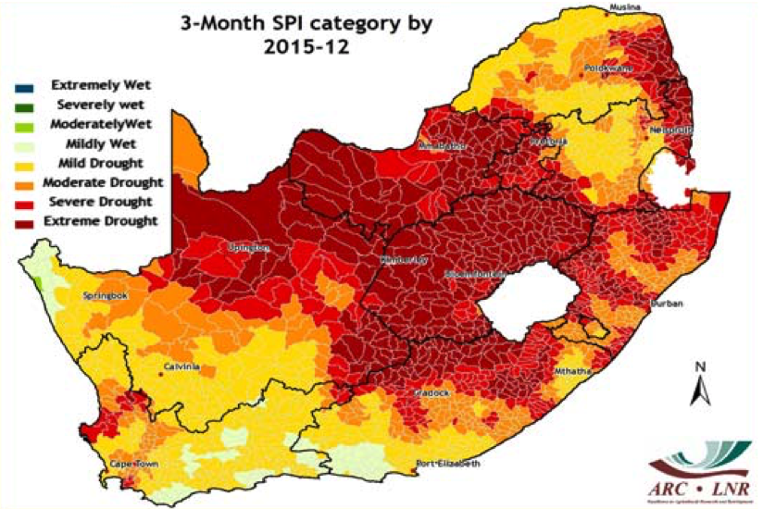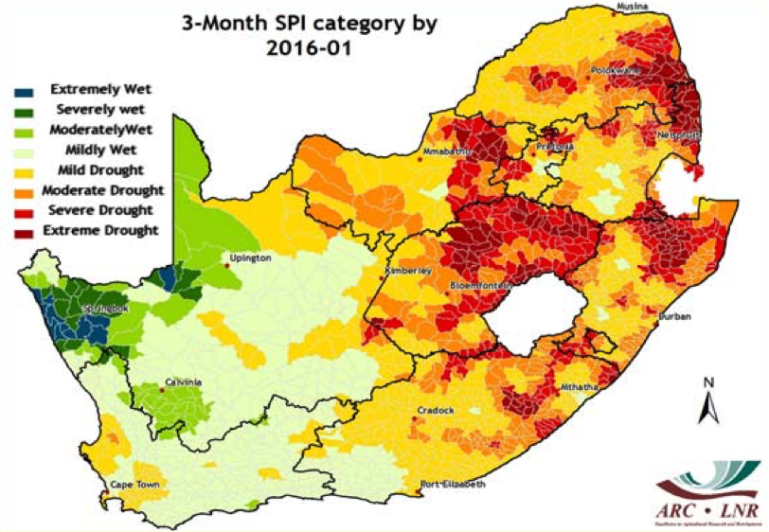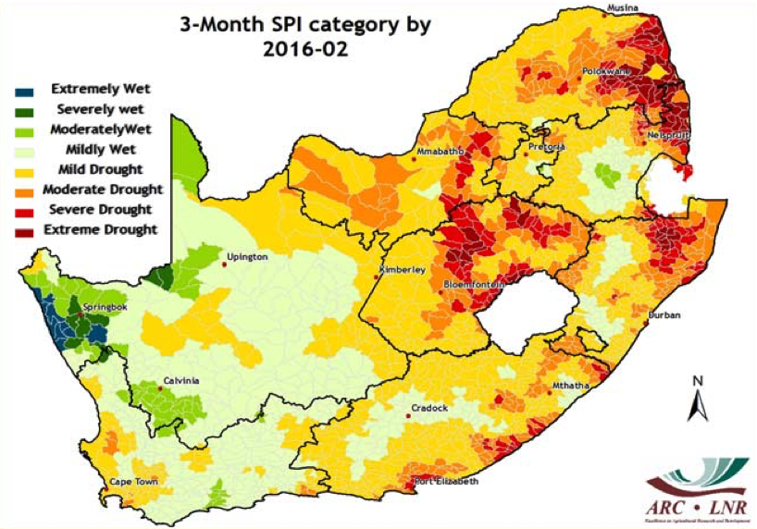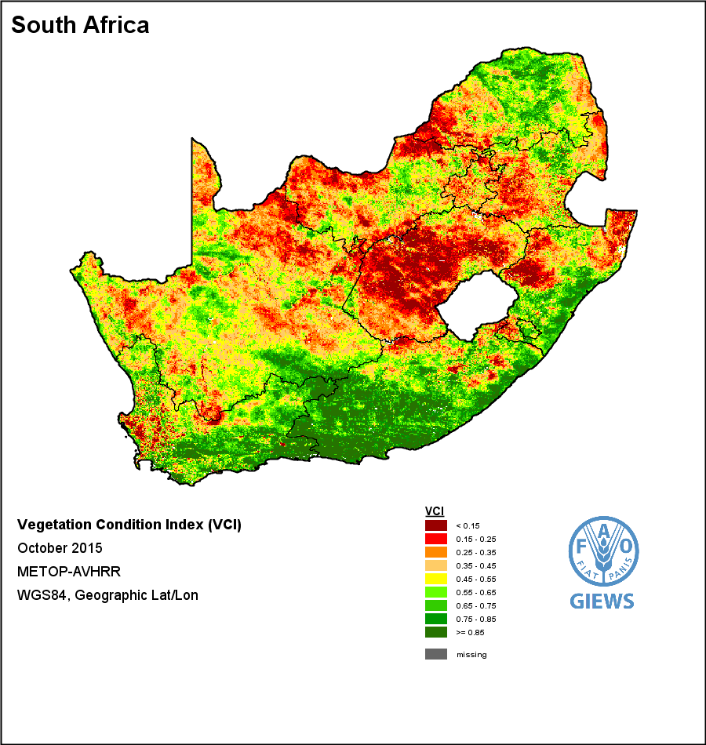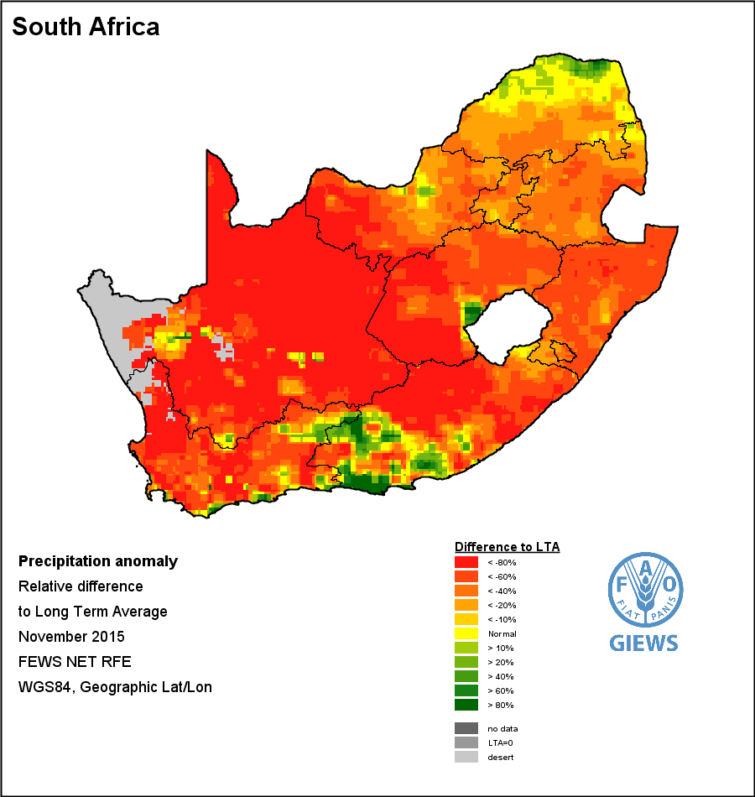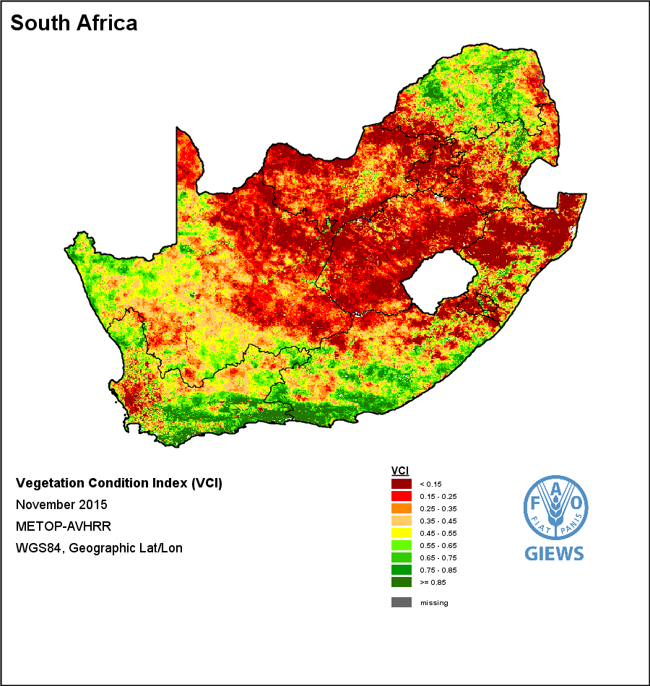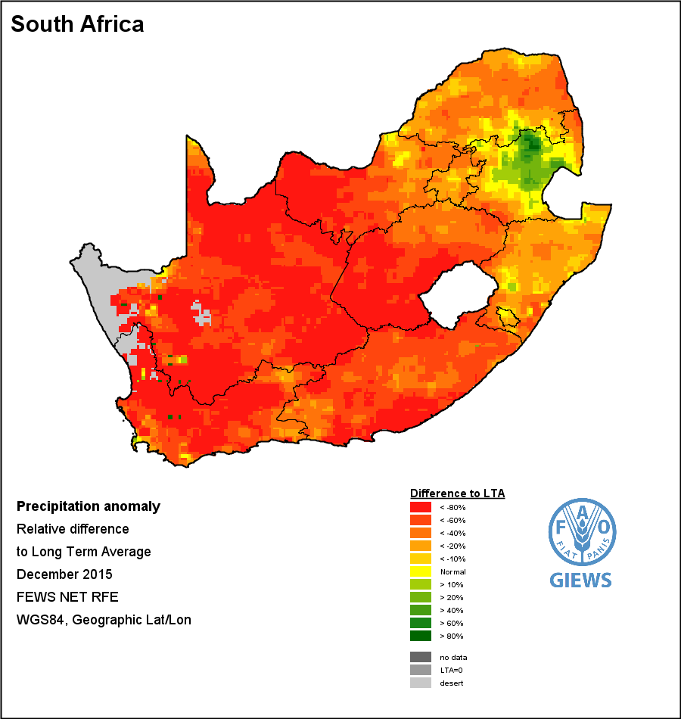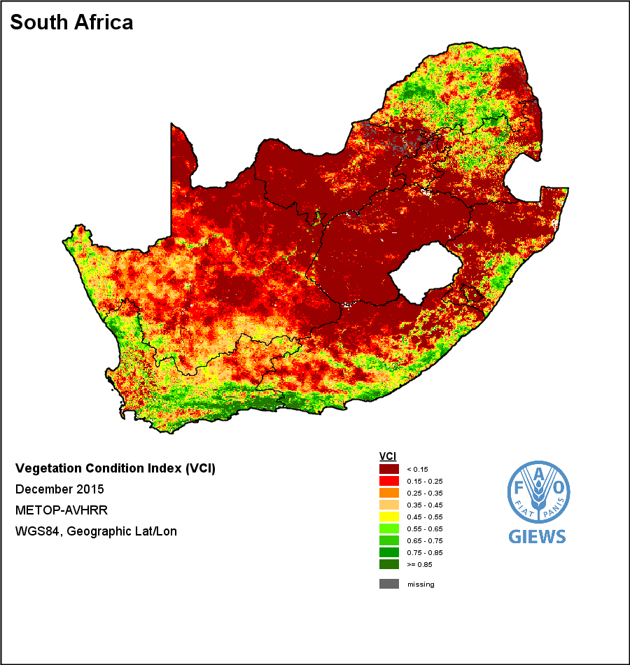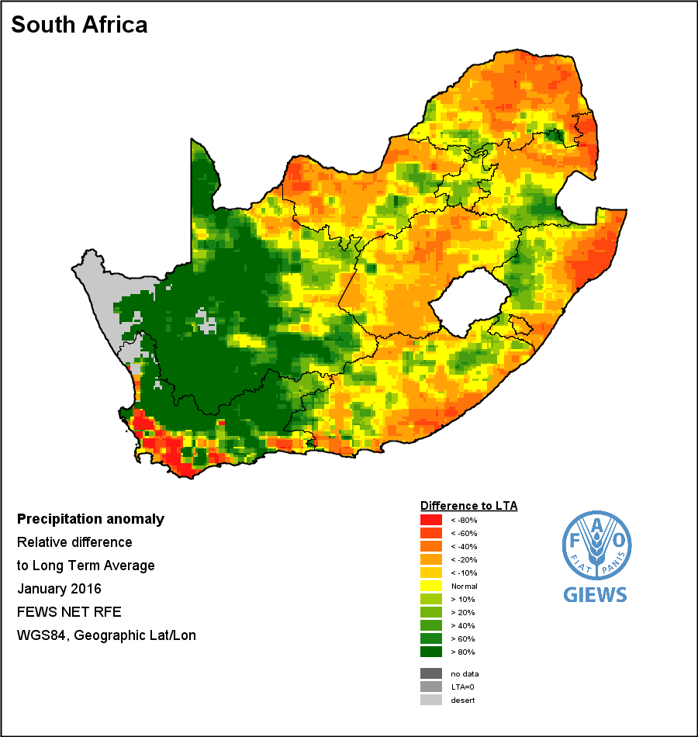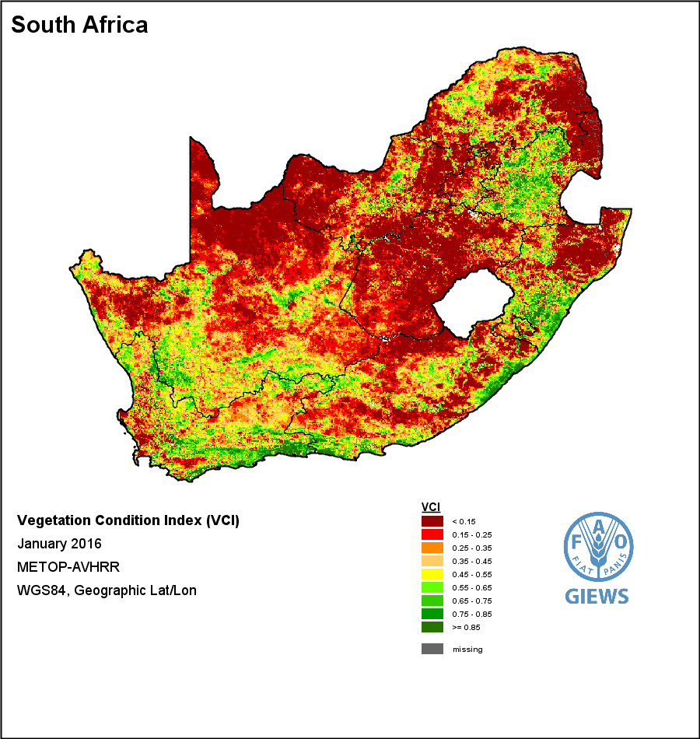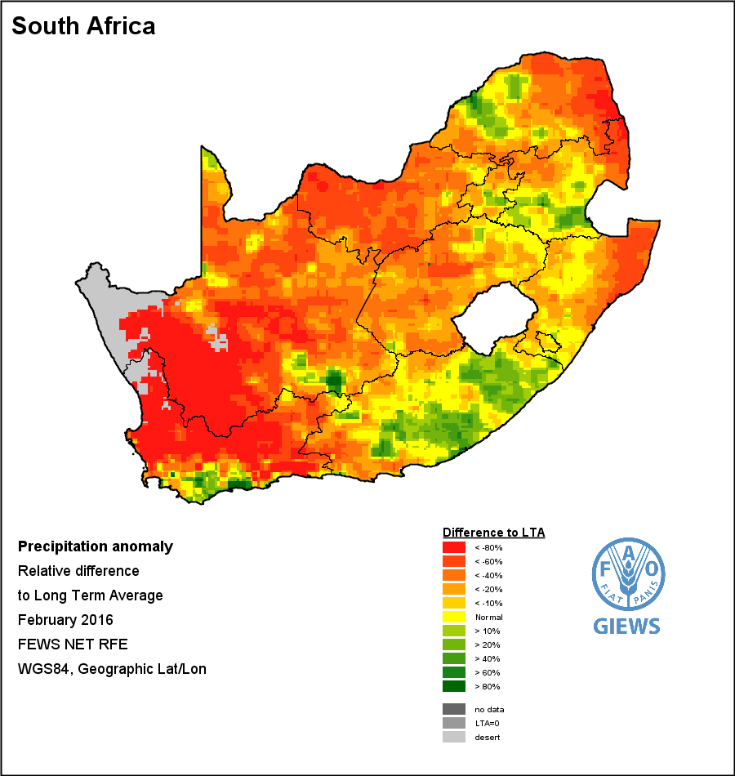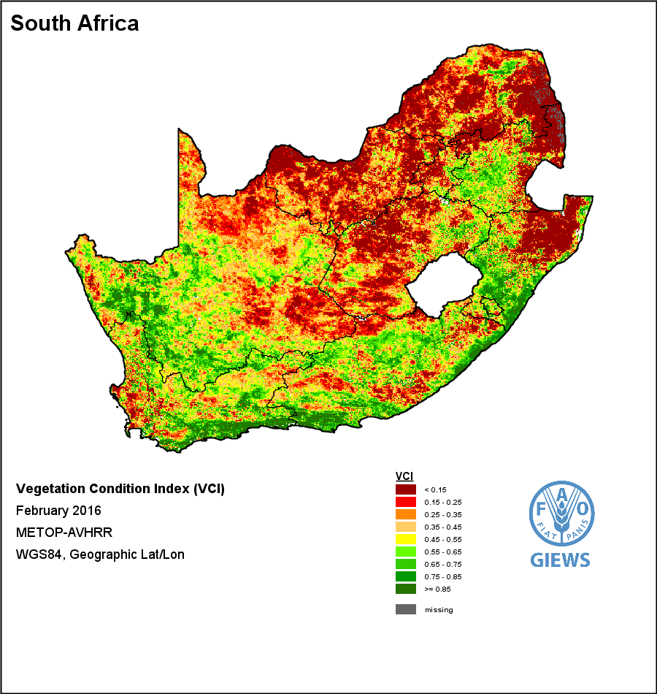

Nov 2015

Dec 2015

Jan 2016

Feb 2016

Oct 2015

Nov 2015

Dec 2015

Jan 2016

Feb 2016

Oct 2015

   
**Figure** 7: Monthly rainfall anomaly (source: FAO-GIEWS [http://www.fao.org/giews/earthobservation/country/index.jsp?lang=en&code=ZAF#](http://www.fao.org/giews/earthobservation/country/index.jsp?lang=en&code=ZAF)), vegetation condition index (Source: FAO-GIEWS) and standard precipitation index (Source: ARC-ISCW [http://www.arc.agric.za/Pages/Newsletters.aspx#k=UMLINDI](http://www.arc.agric.za/Pages/Newsletters.aspx" \l "k=UMLINDI)) from October 2015 to February 2016. The images are reproduced as provided by the source, with longitudes and latitudes mapped to a cartesian plane, based on the World Geodetic Survey 1984 origin and ellipsoid.

**Figure** 8: VCI image reprojected to the South African Albers Equal Area (please note the provincial boundaries are those of the image and are incorrect)

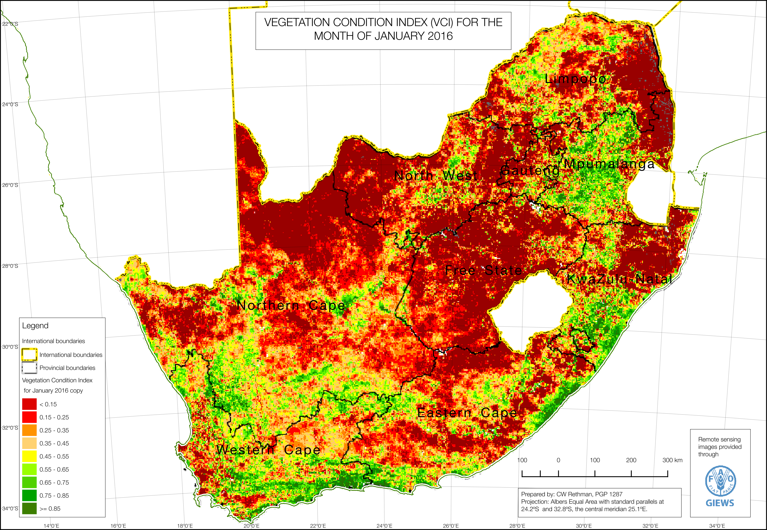

Rainfall Anomaly (RFA)

Vegetation Condition Index (VCI)

3-Month Standard Precipitation Index (SPI)

Rainfall Anomaly (RFA)

Vegetation Condition Index (VCI)

3-Month Standard Precipitation Index (SPI)

Rainfall Anomaly (RFA)

Vegetation Condition Index (VCI)

3-Month Standard Precipitation Index (SPI)

The colours in the image where the drought was worst are those with a value less than 0.35, that is: dark red, red and dark orange. The analyst was unable to obtain the original images with pixel values representing the VCI value, so the colour spectrum from this image was converted to suitable values.

This was done by converting the pixel colours to greyscale, adjusting the red and green shades so that they do not have the same grey values (dark red and dark green can convert to the same grey shade, but obviously they represent opposite values on the image). This way, the green and red coloured pixels are staggered from one another in terms of grey shading. The result is shown below in **Figure Figure**, note the greyscale colour value in square brackets after the VCI value on the legend (e.g. “[RGB=151,151,151]”).

The country and level 1 boundaries in the raster images needed removal. Fortunately, this was easily done by filtering the greyscale image on black and very dark values. It did, unfortunately, also leave ‘holes’, ‘gashes’ or blank values where the lines used to be.

This raster image could then be converted to a vector format. The conversion process applies a union (a ‘merge’ or ‘dissolve’) to adjacent pixels having the same shade, so that the resultant vector feature has polygons that comprise one or more pixels, depending on the shade values. The grey-shade values appeared as an attribute column on the vector table and were mapped to the VCI ranges by adding a column with the ranges values as text. The result was imported into PostGIS/Postgres and is shown in **Figure Figure**. Note that although this graphic appears to be similar in its presentation as the greyscale image in **Figure Figure**, it is in fact fundamentally different because the previously green areas of the map are now lighter than any of the red of orange areas. For example, compare the coastal belt just south of Durban, which was to be green in the original VCI image in **Figure Figure**, then became a darker grey in **Figure Figure** and a lighter orange in **Figure Figure**.

**Figure** 10: VCI raster image converted to polygon vector format with the VCI value range restored

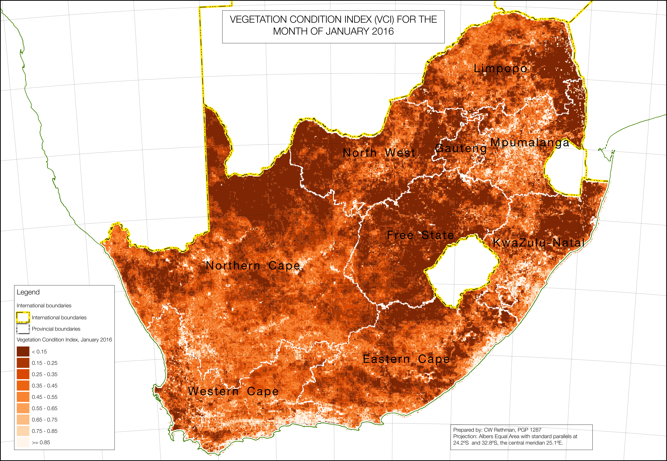

**Figure** 9: VCI image converted to greyscale, with reds offset from greens to ensure separation of shades (please note the provincial boundaries are those of the image and are incorrect)

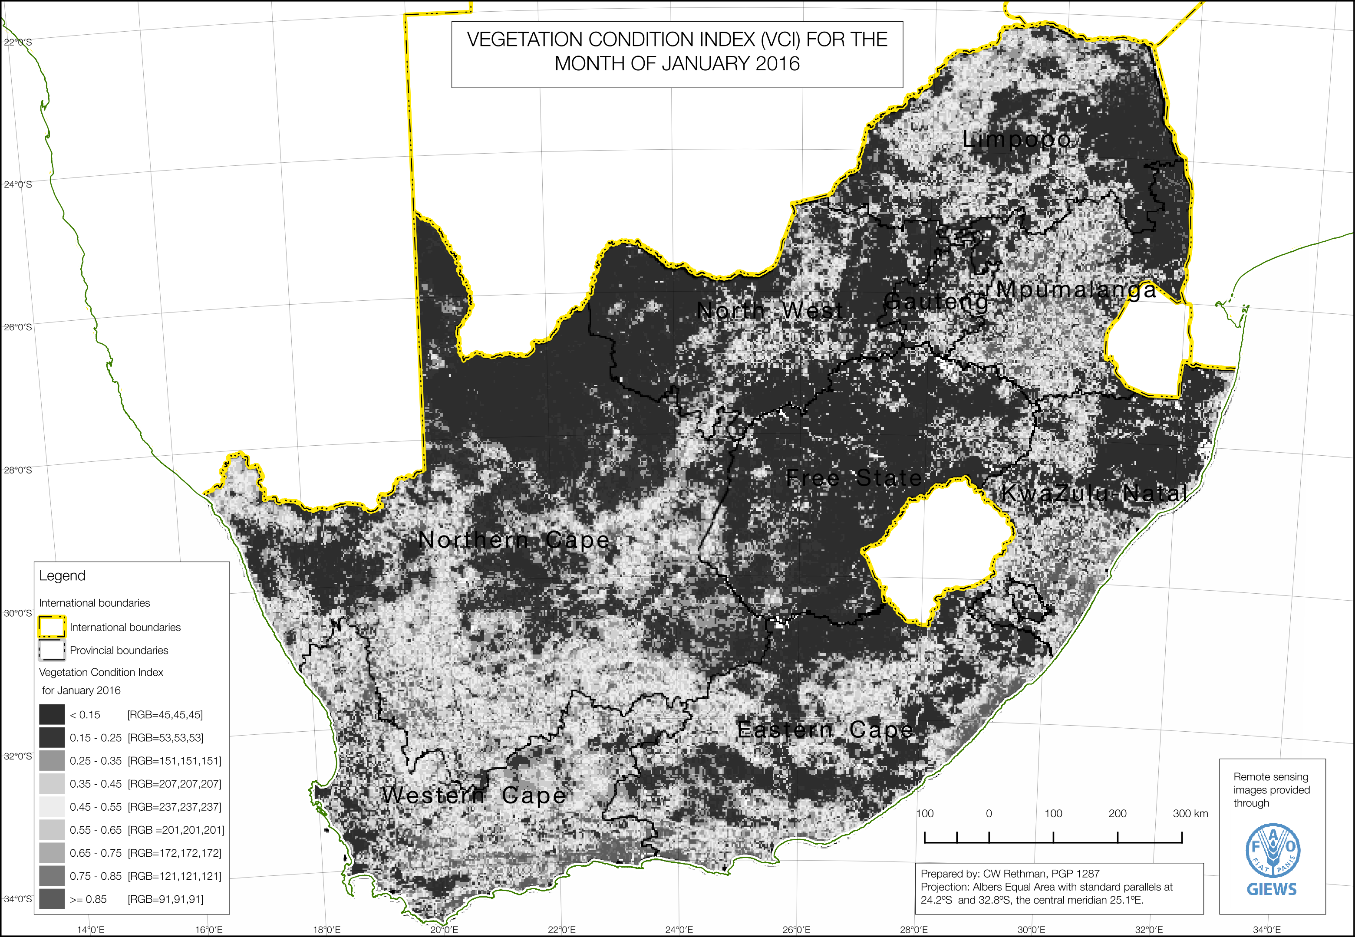

**Figure** 12: The ‘drought hazard area’ defined from the VCI remote sensing image for January 2016

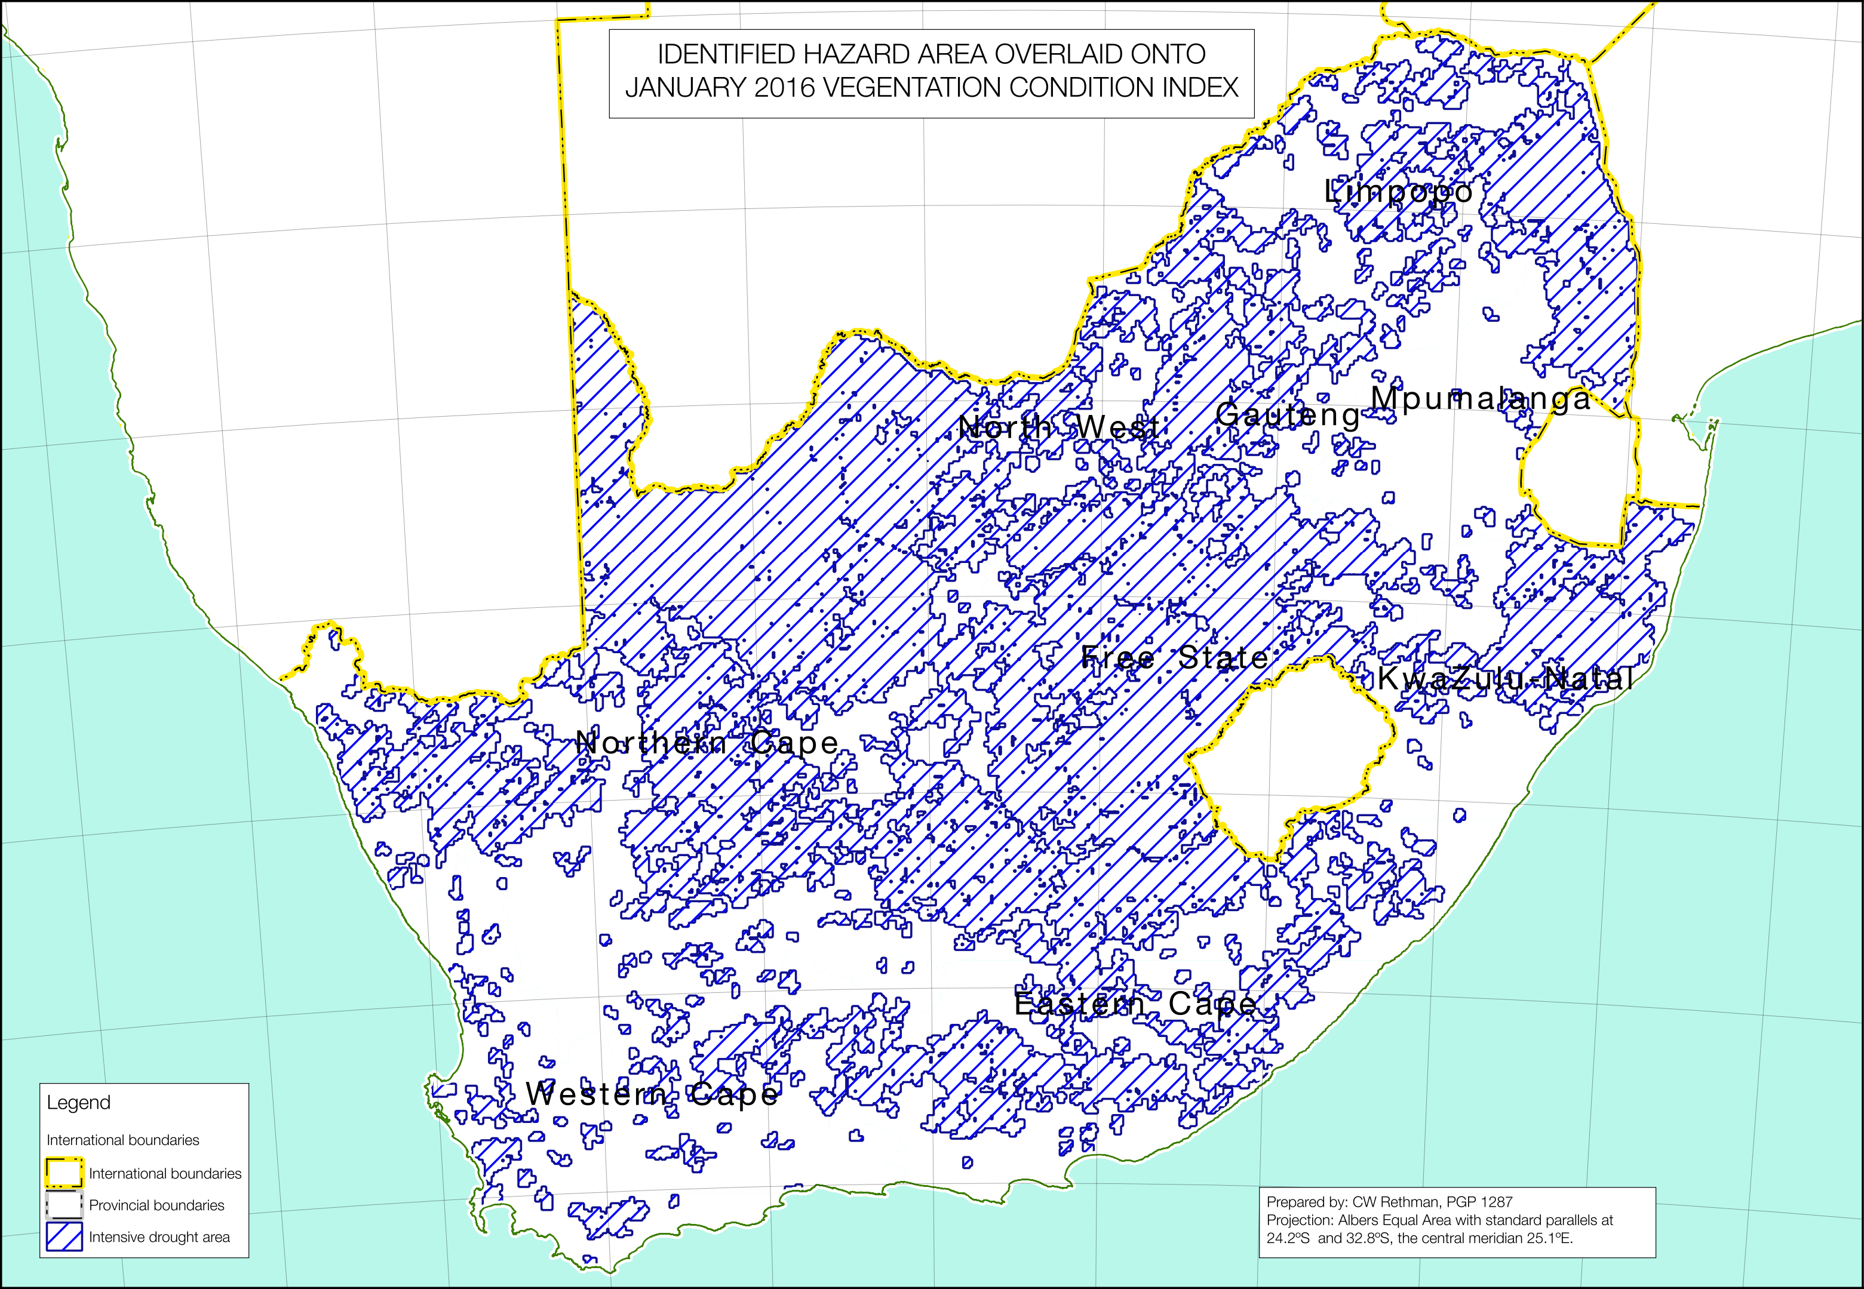

**Figure** 11: The process of selecting only larger groups of pixels and buffering them, shown for VCI values of 0.25 to 0.3

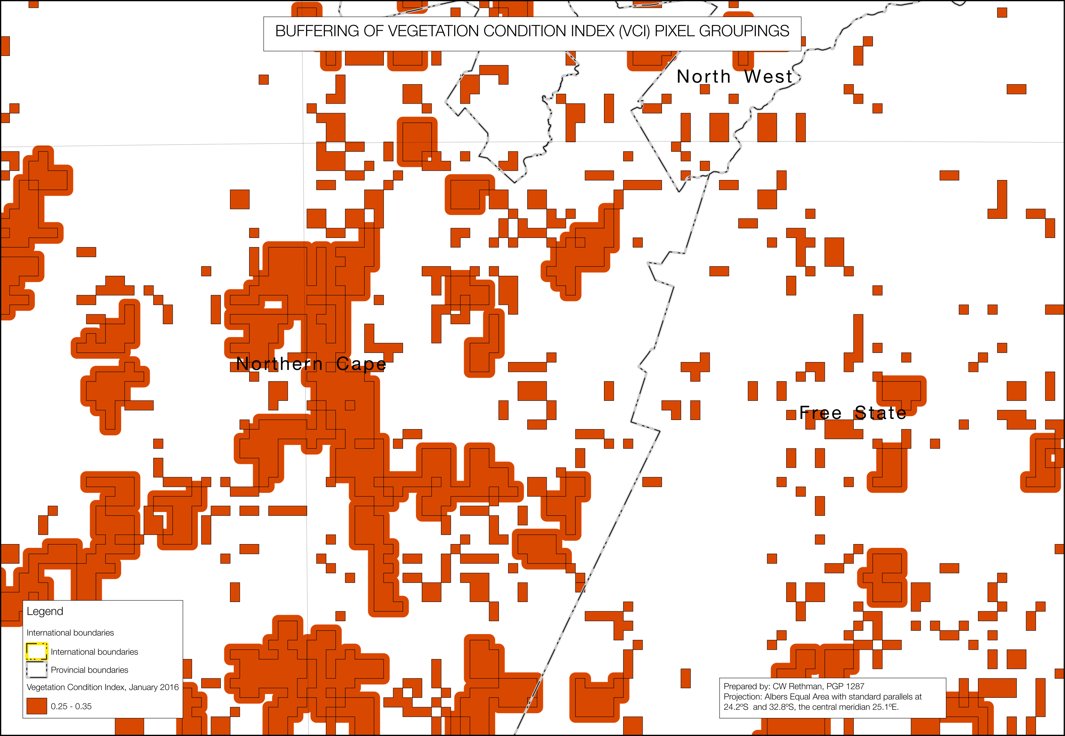

##### Buffering, cleaning and filtering out the small groups of pixels (Steps 17 to 19)

Very small areas of low vegetation condition could be considered outliers or anomalies that do not need to be included in the general hazard area. All features smaller than nine pixels were thus filtered out and the remaining features buffered by 1500 metres to ensure that when they are combined by a union into larger polygon features set out as the drought-affected area, they are closer to one another than one pixel width (which is approximately 2500 metres).

At this point all the extra graphics and paraphernalia from the remote-sensing images can be removed as well; they are easily filtered out with simple spatial query parameters.

##### Obtaining the hazard area; filtering the worst affected pixels and then combining them together with a union (Step 20 and 21)

**Figure** 13: The drought hazard area (affected area) superimposed onto the original VCI image for January 2016 (please note the provincial boundaries are those of the image and are incorrect)

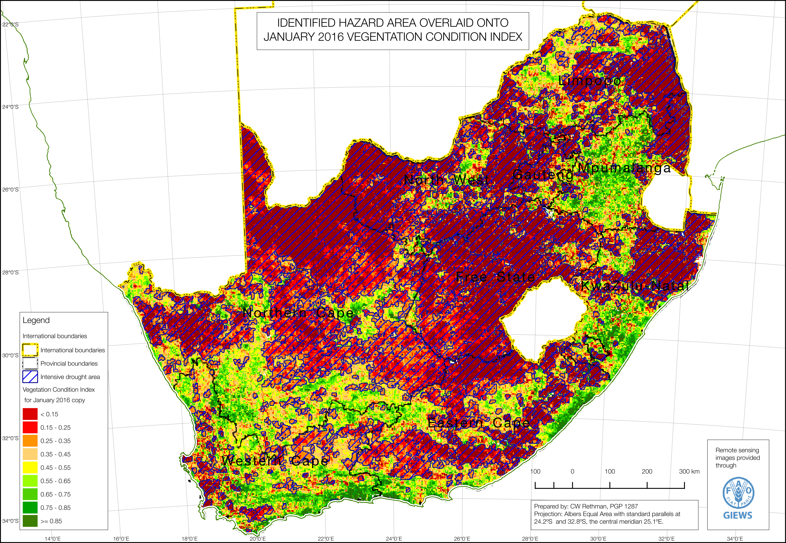

The threshold for ‘drought’ conditions was set at all VCI values below 0.35 and the buffered polygons were then combined to form a single ‘drought hazard area’ feature set. This drought hazard area is shown below in **Figure Figure**. The feature set polygons were initially combined into a single large multi-polygon, which was dumped into its many constituent pieces, so that the feature set table now has many rows, which are spatially indexed.

**Figure Figure** shows the drought hazard area superimposed onto the original VCI remote sensing image. The result is a satisfactory coverage of the worst drought areas in the country.

##### Crop Production

##### Analysing the crop estimates and obtaining worst and best areas (Step 22)

Crop estimates from the Crop Estimates Committee (CEC). These are published four times for each summer and winter season. However, the estimates available from the CEC on their website are totals for the provinces only, with the addition of a national figure for ‘subsistence’ agriculture. Going forward, it will be extremely useful if these provincial crop estimate numbers could be further broken, perhaps into district-level numbers or even better, municipality-level. This data will contain a lot more local resolution.

Crop problem specifications are arrived at by dividing this year’s production by the baseline year’s production over the same area. In all livelihood zones the baseline consumption year was 2013-2014, so the harvests achieved in 2013 served as the comparative production data, i.e., the problem specification is derived by dividing 2016 production data by 2013 production data.

**Table Table** below shows the production data for the 2013 baseline year, the current year (where available) and the problem spec for non-commercially grown and commercially grown major crops—with the commercially grown major crops subdivided by province.

##### Obtaining agricultural problem specifications for hazard and non-hazard sections (Steps 23 to 25)

**Figure** 14: Drought hazard area overlaid onto the major agricultural regions

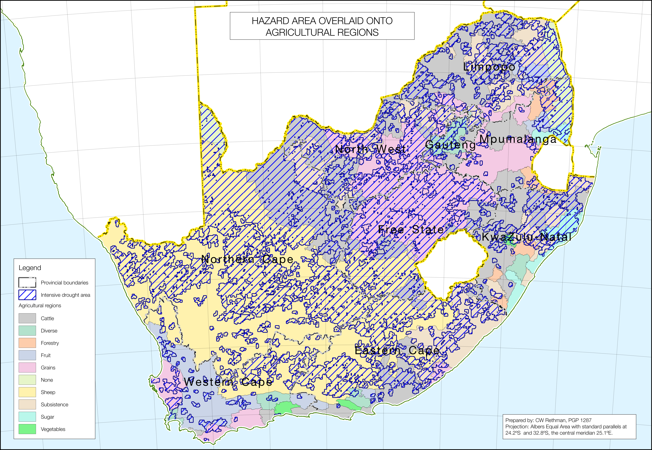

The difficulty is that CEC crop estimates and problem specifications apply to the whole of each province; they do not discriminate between drought-affected and non-drought affected areas in each province. To discriminate between these two cases, the breakdown between ‘normal’ and ‘drought-affected’ areas was achieved by overlaying the drought hazard area from **Figure Figure** onto the major agricultural regions, as shown in **Figure Figure**, and then comparing the area of land under the hazard with that which is not for the agricultural region.

Areas under the hazard sections and non-hazard sections were derived through a spatial union of the hazard area, the agricultural regions and the provinces.

In terms of grain crops—primarily maize in the summer rainfall parts of the country—the approach was to decide on a reasonable crop problem specification for the *non-hazard* (or ‘normal’) *sections* of each agricultural region in each province and then calculate the *hazard section* problem specification from the CEC data for the province, the non-hazard problem specification and the comparative land areas for the hazard and non-hazard sections. Consideration was made on the degree of coverage of the hazard section on the agricultural regions in the province as well as the CEC crop estimates for that province when deciding on an appropriate non-hazard problem specification.

In badly affected provinces (Free State, KwaZulu-Natal, Eastern Cape and North West) the non-hazard problem specification was 77%. In Limpopo, the drought varied in its intensity across the province, and the *non-hazard section* problem specification was 140%, while in Mpumalanga the *non-hazard section*, which in the end was larger than in Free State or KwaZulu-Natal due to the January rains, nevertheless suffered reduced production, so problem specification was set at 70%. The ‘subsistence’ (or open-access tenure) agricultural region also has maize production and also has hazard and non-hazard sections, although there are significant variations in the degree of affectedness from the hazard. A problem specification of 109% (i.e., 9% more than 2013 production) was used for the *non-hazard section* in these subsistence regions. In Northern Cape and Western Cape, the tiny areas under maize were generally quite good in the *non-hazard sections*, being irrigated, and achieved a high problem specification of 200% (or double the 2013 value) [9]. At the time of analysis, winter crop production data for 2016 in were not available.

**Table** 7 - Crop production and problem specification values

|  |  |  |  |  |  |  |  |  |  |
| --- | --- | --- | --- | --- | --- | --- | --- | --- | --- |
| Province | Datum | Maize, white | Maize, yellow | Sorghum | Beans | Soya | Sunflower | Groundnuts | Wheat |
| Non-commercial | BL Prod | 459,995 | 215,095 |  |  |  |  |  |  |
| CY Prod | 286,175 | 149,565 |  |  |  |  |  |  |
| P. Spec | 62% | 70% |  |  |  |  |  |  |
| Limpopo, commercial | BL Prod | 153,000 | 136,300 | 21,000 | 10,800 | 55,000 | 79,200 | 1,200 | 142,800 |
| CY Prod | 173,250 | 127,600 | 9,800 | 4,500 | 38,400 | 48,750 | 2,000 | N/A |
| P. Spec | 113% | 94% | 47% | 42% | 70% | 62% | 167% | N/A |
| Mpumalanga, commercial | BL Prod | 1,020,000 | 1,980,000 | 44,850 | 11,900 | 369,000 | 10,230 | 750 | 27,900 |
| CY Prod | 672,000 | 1,452,000 | 35,000 | 6,000 | 360,000 | 4,400 | - | N/A |
| P. Spec | 66% | 73% | 78% | 50% | 98% | 43% | 0% | N/A |
| North West, commercial | BL Prod | 1,158,250 | 437,500 | 11,970 | 4,800 | 17,600 | 175,000 | 10,000 | 105,450 |
| CY Prod | 680,000 | 200,000 | 3,900 | 3,300 | 13,950 | 232,750 | 8,550 | N/A |
| P. Spec | 59% | 46% | 33% | 69% | 79% | 133% | 86% | N/A |
| Northern Cape, commercial | BL Prod | 25,300 | 647,700 | - | 1,700 | 7,000 | 100 | 14,000 | 298,200 |
| CY Prod | 35,625 | 665,000 | - | 630 | 12,400 | 600 | 15,500 | N/A |
| P.Spec | 141% | 103% | - | 37% | 177% | 600% | 111% | N/A |
| Gauteng, commercial | BL Prod | 370,000 | 239,250 | 1,500 | 3,400 | 32,000 | 5,070 | - | 6,000 |
| CY Prod | 205,800 | 218,400 | - | 3,500 | 48,300 | - | - | N/A |
| P. Spec | 56% | 91% | 0% | 103% | 151% | 0% | - | N/A |
| Free State | BL Prod | 2,573,750 | 2,272,500 | 7,400 | 19,200 | 225,750 | 297,000 | 16,200 | 252,000 |
| CY Prod | 1,092,000 | 37,800 | 37,800 | 17,000 | 156,600 | 440,000 | 6,500 | N/A |
| P.Spec | 42% | 42% | 511% | 89% | 69% | 148% | 40% | N/A |
| KwaZulu-Natal | BL Prod | 258,500 | 312,000 | 1,344 | 7,800 | 80,000 | - | 150 | 37,800 |
| CY Prod | 193,800 | 278,400 | 2,000 | 2,640 | 61,600 | - | - | N/A |
| P.Spec | 75% | 89% | 149% | 34% | 77% | - | - | N/A |
| Eastern Cape | BL Prod | 18,500 | 87,000 | - | 200 | 750 | - | - | 19,800 |
| Prod | 10,000 | 60,000 | - | 375 | 2,100 | - | - | N/A |
| P.Spec | 54% | 69% | - | 188% | 280% | - | - | N/A |
| Western Cape | BL Prod | 3,000 | 30,000 | - | 400 | - | - | - | 914,500 |
| CY Prod | 5,000 | 40,000 | - | 150 | 1,200 | - | - | N/A |
| P.Spec | 167% | 133% | - | 38% | - | - | - | N/A |
| Total Commercial | BL Prod | 5,580,300 | 6,142,250 | 88,064 | 60,200 | 787,100 | 566,600 | 42,300 | 1,804,450 |
| CY Prod | 3,067,475 | 3,986,900 | 88,500 | 38,095 | 694,550 | 730,500 | 32,550 | N/A |
| P. Spec | 55% | 65% | 60% | 63% | 88% | 129% | 77% | N/A |

This resulted in problem specifications of 27% to 49% in all the provinces with large portions of the hazard section within them (highly-affected provinces).

**Table** 8 - Crop production disaggregation for all provinces

|  |  |  |  |  |  |  |  |
| --- | --- | --- | --- | --- | --- | --- | --- |
| Province | Agriculture Type | Area Agric. Type (Ha) | CEC Pr. Spec | Hazard | Hazard Area (Ha) | % Hazard Area | Hazard Prob. Spec |
| All provinces | Subsistence grains | 13,198,889 | 62% | drought | 7,884,053 | 60% | 30% |
| normal | 5,314,836 | 40% | 109% |
| Eastern Cape | Commercial grains | 288,584 | 54% | drought | 139,844 | 48% | 30% |
| normal | 148,740 | 52% | 77% |
| Free State | Commercial grains | 7,987,746 | 42% | drought | 6,804,745 | 85% | 36% |
| normal | 1,183,001 | 15% | 77% |
| Gauteng | Commercial grains | 271,004 | 56% | drought | 137,155 | 51% | 36% |
| normal | 133,849 | 49% | 77% |
| KwaZulu-Natal | Commercial grains | 492 | 75% | drought | 20 | 4% | 27% |
| normal | 472 | 96% | 77% |
| Limpopo | Commercial grains | 1,023,062 | 113% | drought | 285,091 | 28% | 43% |
| normal | 737,971 | 72% | 140% |
| Mpumalanga | Commercial grains | 2,974,656 | 66% | drought | 287,721 | 10% | 29% |
| normal | 2,686,935 | 90% | 70% |
| North West | Commercial grains | 4,640,096 | 59% | drought | 3,004,416 | 65% | 49% |
| normal | 1,635,680 | 35% | 77% |
| Northern Cape | Commercial grains | 97 | 141% | drought | 88 | 91% | 135% |
| normal | 9 | 9% | 200% |
| Western Cape | Commercial grains | 2,097,713 | 167% | drought | 508,228 | 24% | 64% |
| normal | 1,589,485 | 76% | 200% |

The results are presented in **Table Table** above. These are very approximate calculations and are intended to illustrate a principle for estimating local problem specifications, not provide the most accurate answer. More accurate problem specifications can be obtained by viewing production data at a lower geographical level, such as municipality or lower. Detailed estimates have been produced at provincial and local levels both commercial and non-commercial growers using aerial and ground surveys, such as the *Producer Independent Crop Estimate System* by SiQ[10]. These kinds of surveys are recommended for improving accuracy in future analyses.

The key crop problem specifications use in this analysis is that for ‘subsistence’ agricultural region grains, which were set at 30% in the hazard areas and 109% in the non-hazard (normal) areas. Problem specifications for other crops were set at 20% in the hazard areas and 100% in the non-hazard areas. Similarly, livestock production (milk and meat) problem specifications were set at 20% in hazard areas and 50% in non-hazard areas.

##### Obtaining problem specifications for employment, self-employment, small business and prices (Step 26)

It is well-known that most South Africans purchase their food and this implies that an understanding of cash income sources are critical for any food security analysis in the country. Cash income sources consist of employment, grants[11], self-employment, small businesses, gifts and remittances. It is important to differentiate between an income source quantity and the income itself: income source quantity refers to the amount of the thing people can use to get income, whereas income itself also takes into account the effect of *prices*, which will be dealt with in the next section. The problem specifications for the income source quantity and its price may be independent of one another, which is why they are analysed separately. Examples of income source quantities are ‘days of work’ for casual labour, ‘bundles of firewood’ for self-employment or ‘sales volume’ for small business. **Table Table** lists a summary of the most important income source quantity problem specifications for hazard and non-hazard section.

**Table** 9 - Income source quantity problem specifications for types of livelihood zones (where data are not shown it is because the income source is not in the baseline).

|  |  |  |  |  |  |  |  |  |  |  |
| --- | --- | --- | --- | --- | --- | --- | --- | --- | --- | --- |
| Livelihood zone types (abbreviation, code) | Hazard section | Agricultural casual labour | Construction casual labour | Domestic casual labour | Formal employment | Labour migration | Self-employment | Small business | Gifts | Remittances |
| Urban poor (ZAUP, 59800) | Hazard | 50% | 50% | 50% | 100% |  | 100% | 100% | 100% | 100% |
| Non-hazard | 100% | 100% | 100% | 100% |  | 100% | 100% | 100% | 100% |
| Commercial farm workers (ZAFW, 59050) | Hazard | 50% | 50% | 50% | 60% |  | 80% | 100% |  |  |
| Non-hazard | 100% | 100% | 100% | 100% |  | 100% | 100% | 100% | 100% |
| Rural open-access LZs | Hazard | 50% | 50% | 50% | 60% | 40% | 80% | 80% | 100% | 100% |
| Non-hazard | 100% | 100% | 100% | 100% | 80% | 80% | 80% | 100% | 100% |

Without any field surveys to draw upon, it was not possible to obtain problem specification data for each zone. Rather, single national problem specifications were applied, with some changes between rural open access livelihood zones, the commercial farm workers and the urban poor being apparent in formal employment (prospects in urban areas, whether hazard-affected or not, are the same as before), self-employment and small business.

##### Obtaining problem specifications on prices (Step 27)

The first and foremost price to watch is staple; staple is not important in the diet of many South Africans; it is a key input or influence for other necessary food commodities.

Obtaining price problem specifications is about looking into the future—what will the price likely be over the period from the current year’s harvest (from April 2016) to the next year’s harvest (from April 2017)? As it is impossible to know this forecast, a *scenario* has to be constructed that will form the basis of the analysis. The scenario does not dictate that this will *become the future*; it merely says that “given some presently unknown conditions, this is the *likely* consequence at household level”.

Using data from the National Agricultural Marketing Council (NAMC) and the CPI baskets from Statistics SA, a trend graph of *average* prices for a 5 kg packet of maize meal was constructed. The graph was arranged into a series of lines, each line representing the prices for the *consumption year*, a period that starts from the harvest and runs through to just before the next harvest. By looking at the average shape of the line over the year and then projecting ahead from the last known data point (in this case it was April 2016) using this average shape, a curve ‘forecast’ or scenario curve can be generated. This scenario follows the average annual trend—in the case of maize meal the prices usually rise up towards the end of the consumption year. The problem specification is derived by taking the average price for the forecast year and dividing by the average of the baseline year (the assumption being here that most households purchase food all year round).

**Figure** 15: Maize meal prices from April 2013 to April 2017 (projected)

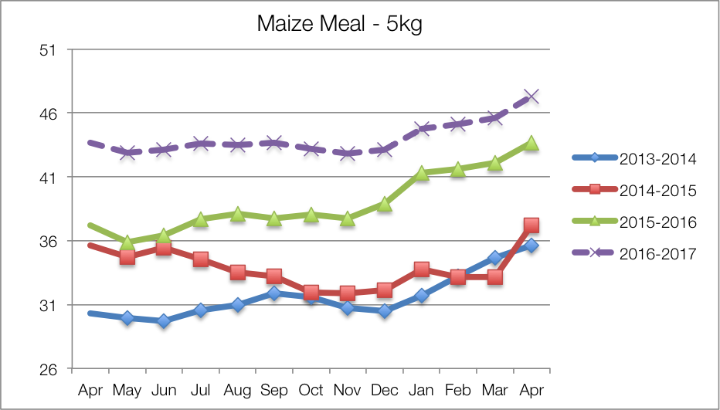

Using this analysis, the purchase prices of staple food commodities (maize meal, samp, bread and rice) are projected (by March 2017) to increase **by around 65%** *more than the baseline year* (April 2013 to March 2014). This massive increase and represents a jump of 35% from last year alone. The staple price problem specification is thus 165% (current year average price/baseline year average price) and it is applied to all livelihood zones. This projection is based on the previous price changes and on forecasts for inflation generally. This may or may not change in reality—a lot will depend on the domestic supply situation, the country's import requirements and the position with the Rand weakening further against the major currencies.

In rural areas in all livelihood zones there are fewer outlets and distribution costs mean that staple prices in the villages are higher than in towns or cities. Traders who increase their prices of food commodities beyond that of increases elsewhere are seen as exploiting vulnerable rural communities. This is because ‘very poor’ and ‘poor’ households in these zones purchase 50–70% of their annual food requirements, increases in staple prices seriously affects their access to food. This is a key parameter for the SAVAC to monitor.

##### Other Food Items' Purchase Price Changes

A diet that is confined to staples is not healthy and diversity is essential for people to obtain all the nutrients they require, providing them with the capacity for a productive and dignified life. In order to account this required diversity, the SAVAC were required to refer to standard food baskets used in other surveys, such as the Living Standards Surveys and General Household Surveys. The latter compares levels of consumption with poverty levels, the lowest of which is the Food Poverty Line (FPL). The FPL is composed of a list of varied commodities, the sum of the energy content of which still equals 8800 kJ per person per day (2100 kcal per person per day).

The SAVAC has used the same list of commodities for its FPL as those in the income-expenditure surveys, which, taken together with staple, represents the minimum threshold for household incomes in the villages. SAVAC Rand values for this threshold are similar to the provincial threshold used by Statistics South Africa, the differences reflect the purely rural local variations in prices and availability of commodities.

The non-staple FPL items are projected to increase at the provincial non-cereal food inflation rates, with the projection for the coming months based on the overall food inflation projections. The resultant problem specification for the 2016-2017 consumption year for non-staple foods is 140%, or an increase in prices of 40% since the baseline year (April 2013 to March 2014). This was applied to all livelihood zones.

##### Prices of non-food basket items (for the LBPL and UBPL)

In addition to non-staple food products, households need to purchase other goods and services that meet their basic needs. These goods and services include items such as soap, paraffin, electricity, matches, salt (zero food energy), tea or coffee (zero food energy), services, schooling, health, veterinary, taxes, community contributions, clothing, communications, transport and so on.

When the cost of the smallest quantity of these commodities is added to that of staple and non-staple food, this becomes the Lower Bound Poverty Line (LBPL). When a larger quantity of each of these commodities is used, it defines the Upper Bound Poverty Line (UBPL).

Lastly, there are important investments that households must make each year if they are to have sustainable livelihoods. This means that they must spend on maintenance of all their capital (human, social, physical, environmental and financial) if they are to be able to develop themselves further and withstand or recover from future livelihood hazards. This expenditure therefore includes livelihood-specific investments in inputs for agriculture or business activities (including labour), educational investments, health and nutrition investments. Critically, these investments usually have a knock-on impacts from one wealth group to another; for example, money spent on labour hire by the better-off adds significantly to poorer households' incomes.

The sum of the expenditure on all of these investments with the other preceding expenditures in the UBPL, LBPL, FPL and staple purchase, make up the Resilience Line. Unlike the FPL, LBPL and UBPL, the Resilience Line varies across wealth groups, as households with more productive assets must spend more to maintain and use those assets.

The team used the general prevailing inflation rate with a forecast for the coming months to obtain the change in price from the baseline year (April 2013 to March 2014) to the current forecast year (April 2016 to March 2017) for the LBPL, UBPL and the resilience line. The resultant problem specification for these thresholds is 118%, or an 18% increase in prices. This was applied to all livelihood zones.

##### Food purchase availability

Generally, food is available in all retail outlets, such as the big grocery chain stores such as Pick’n Pay, Spar, and Shoprite, as well as the smaller local stores. There are some areas within the rural livelihood zones that may need monitoring to confirm food availability.

##### Grants and non-grants recipients (Step 28)

Social grants are, for many families, a life-saving necessity. Furthermore, they are often the largest single source of income for many households and therefore are pivotal in this analysis. The two grants that have the largest impact are Old Age Grants and Child Support Grants. Although other grants such as War Veterans Grants are of substantial value for poor people, they provided to very small proportions of the population. However, the odds of a poor household having at least one child or one elderly person (male over 65 years or female over 60 years) and qualifying for social grants are reasonable and this is why social grants are factored into the livelihoods baselines. Nevertheless, there are *still* some households that do not qualify for some technical reason or are unable to benefit—what of them?

In order to capture them on our model, we consider two possible scenarios: one with social grants and one without. This means that the income source quantity problem specification for social grants is either 100% (representing those with grants) or 0% (representing those without grants).

This means that in each livelihood zone or analysis group there are four possible ‘partition scenarios’—scenarios partitioning people into one of four possible groups: **hazard section with grants**, **hazard section without grants**, **non-hazard section with grants** and **non-hazard section without grants**.

This analysis does not include possible emergency or short term interventions or grants; this is because the analysis *seeks to inform* the design of such responses by stating the forecast should these responses not be present.

#### The Analysis (Steps 29 to 31)

##### Running the analysis (Step 29)

Each scenario in each livelihood zone was completed on a single-zone analysis spreadsheet (SZAS), the SZAS file containing individual sheets for each wealth group, with the livelihoods outcomes compared with the three different thresholds (food poverty line (FPL, in cash and food terms), the lower bound poverty line (LBPL) and the upper bound poverty line (UBPL). This means that in a livelihood zone there is one SZAS file for each partition scenario, or four SZAS files per zone, leading to a total of 76 SZASs over 19 livelihood zones. Usually, there are four wealth groups in a livelihood zone, although some have only three and this means that, in effect, this NOFA covered a total of 292 different analyses.

The calculated problem specification percentages from steps 23 to 28 above, which are the changes in the current year compared to baseline year, were entered into the analysis spreadsheet to calculate the food and expenditure deficit. These problem specs are only entered into a set of columns in the sheet for the ‘poor’ wealth group; the SZAS copies them to the other wealth groups itself. Based on expandability factors already entered into the SZAS, it automatically computes the outcomes.

##### The livelihoods analysis (Step 30)

It must be emphasised that the drought this year was only one hazard; the other powerful hazard is economic: the price changes. Hence, even people living in non-drought areas may still be at the same risk of food insecurity because of this. Similarly, people that are exposed to a certain kind of hazard may not be vulnerable to it (for example, people earning a salary will likely not be as vulnerable to drought as people who farm). This will be explored below as we studying the livelihood systems and explore the impacts of the various changes in environmental and the economic situations for different wealth groups.

Analysis was done for both the drought-affected and unaffected areas of each livelihood zone. Both unaffected and affected areas had the same or very similar price problem specifications; the differences being in crop and livestock production.

Affected areas fared slightly worse than unaffected areas but the difference was not substantial, highlighting the relative unimportance of agriculture as a source of food and income, compared with social grants, paid employment and small businesses. The hazards that are more likely to have an impact on livelihoods and consumption levels are therefore those that affect these incomes and expenditure, such as high borrowing rates (affecting the government's ability to deliver on social grants, as well as loans for starting businesses), high food purchase prices and the lack of opportunities for work (agricultural, domestic and short-term contracts, such as construction).

The poorest households invest the least in agriculture; they depend on social grants and casual work as their main source of income. The casual work may be domestic, construction or agricultural—in the case of the latter it may be local (within the village or on commercial farms). The direct impact of the drought on them has therefore been the least—indirectly, they may suffer from reduced work opportunities. This may seem counter-intuitive to readers schooled in regarding village economies as “subsistence agriculture”. Similarly, the better-off have either full-time employment or a small business that cushions their livelihood from losses due to drought or weather hazards. Hence, in rural open-access livelihood zones, it is often the 'middle' households who are more dependent on agriculture but lack the cushions of full-time employment, a small business or social grants and who are *directly* most vulnerable to drought.

The very poor and poor households do depend heavily on the market for their food and, with the kind of income activities in which they engage in such as weeding work, harvesting work, low-level petty trading, craft selling and domestic work already stretched to the limit, opportunities for them to expand their income are minimal. Hence, their vulnerability is to *price changes and shocks*.

Wealthier households may dispose of assets or switch non-essential expenditure to food purchases and essential expenditure.

In an analysis of this kind in South Africa, while starvation or life-threatening mass hunger are important issues to be aware of, our focus is generally more on poverty, living standards and the opportunities people have for escaping the worst conditions. This means that over time, the analysis factors in impoverishment brought on by external events to households' livelihoods. The comprehensive safety net and social grant system ought to cover the bare minimum needs for all citizens, automatically preventing famine or extreme deprivation for the great majority of people. However, the grant system is designed around needs for an average year, while this assessment studies the impact of ephemeral change, from one year to the next. Therefore it is not surprising, given the leap upwards in food prices, that there are food poverty line deficits in many livelihood zones, especially among the unfortunate few households that lack access to any substantial social grants.

**Figure 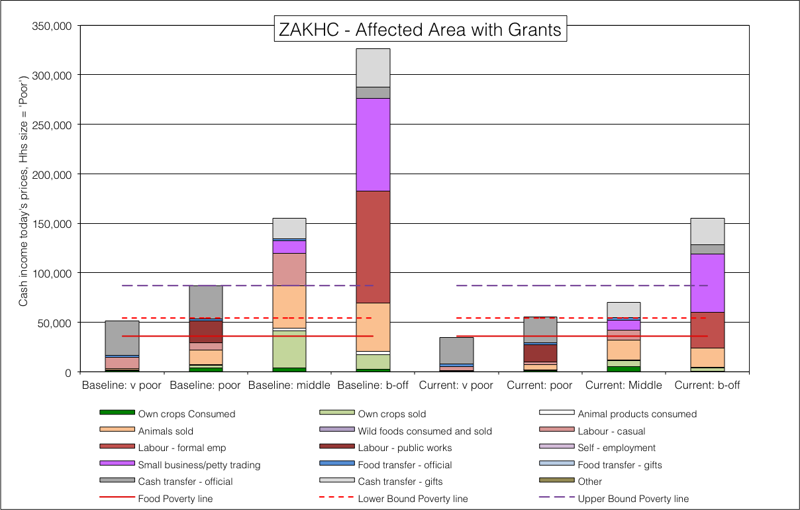**16: Livelihood strategies for the **drought hazard-affected** Okhahlamba open-access intense crops and livestock livelihood zone (ZAKHC, 59208), **with** social grants

**Figure 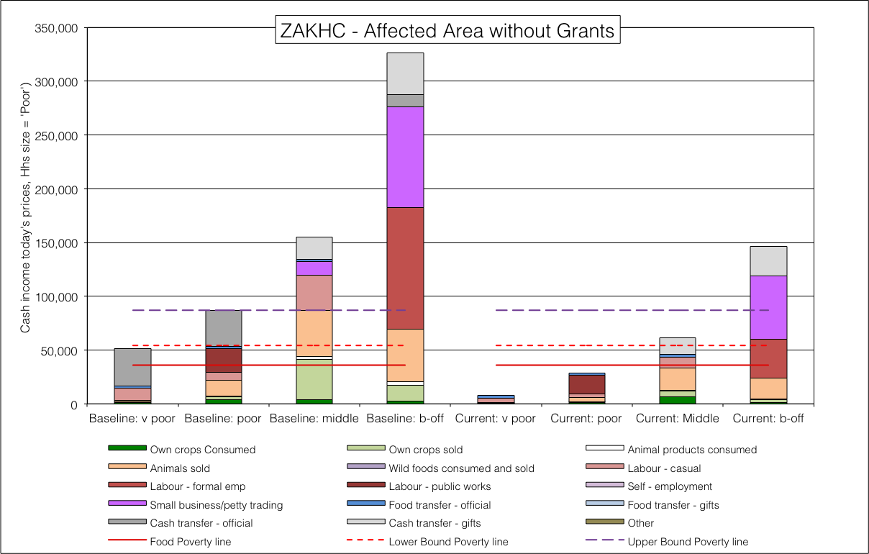**17: Livelihood strategies for the **drought hazard-affected** Okhahlamba open-access intense crops and livestock livelihood zone (ZAKHC, 59208), **without** social grants

The analysis converts all production (including that which is consumed directly) into a cash equivalent, based on what it would cost to have purchased the items that are produced and consumed directly, and then adding the cash values together over a whole year to obtain and annual total income.

##### Example 1: Okhahlamba Open-Access Intense Crops and Livestock

**Figures Figure** and  **Figure** show the annual total incomes for Okhahlamba open-access intense crops and livestock livelihood zone (ZAKHC, 59208) *in the drought hazard-affected areas* where households do and do not receive social grants, respectively. All four wealth groups are shown in the graphs, which include the baseline and the forecast year; the four bars on the left representing each wealth group in the baseline situation and the four bars on the right representing the same for the forecast situation. It is important to note three features with these graphs:

**Figure 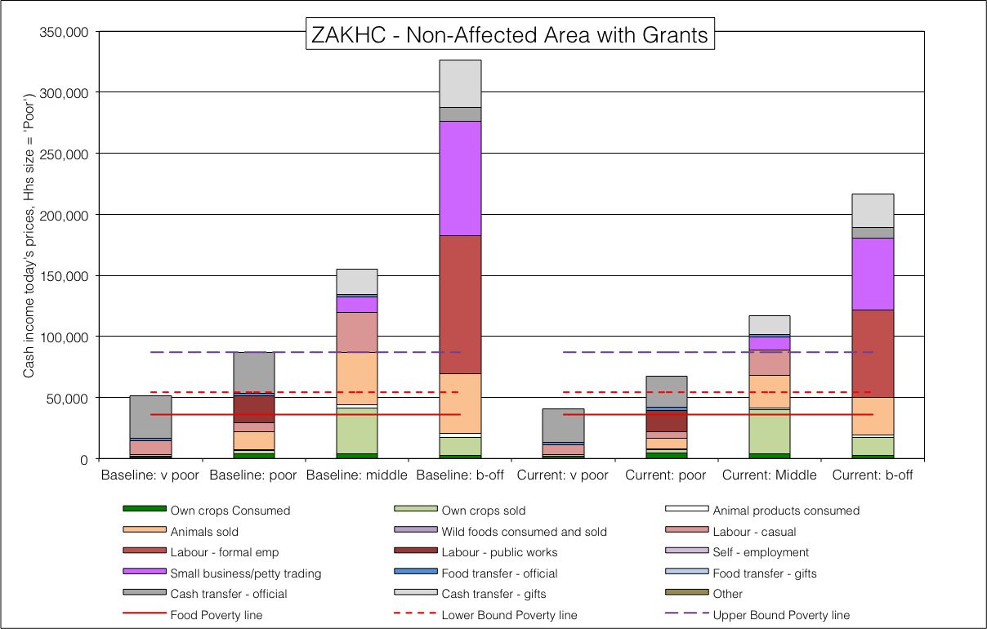**18: Livelihood strategies for the **non-affected** Okhahlamba open-access intense crops and livestock livelihood zone (ZAKHC, 59208), **with** social grants

**Figure 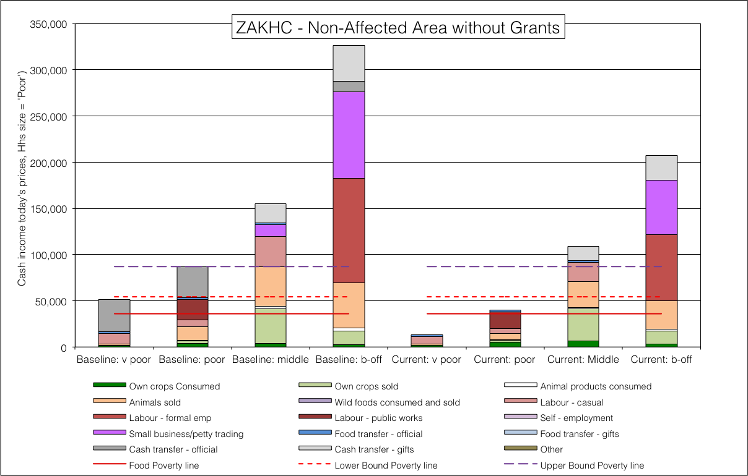**19: Livelihood strategies for the **non-affected** Okhahlamba open-access intense crops and livestock livelihood zone (ZAKHC, 59208), **without** social grants

* The wealth groups are broken down by different percentages (the better-off are fewest in number)—the bars do ***not*** represent quartiles;
* Income values and expenditure thresholds have been normalised to a common household size;
* Income values and expenditure thresholds have been normalised to today's Food Poverty Line cost. This means that the FPL in the baseline is set the same as that of the current forecast year and thus stable incomes, such as from full-time employment, will appear diminished because of reduced purchasing power. Based on their relative cost, the LBPL and UBPL lines may be higher or lower than in the baseline.

**Figure 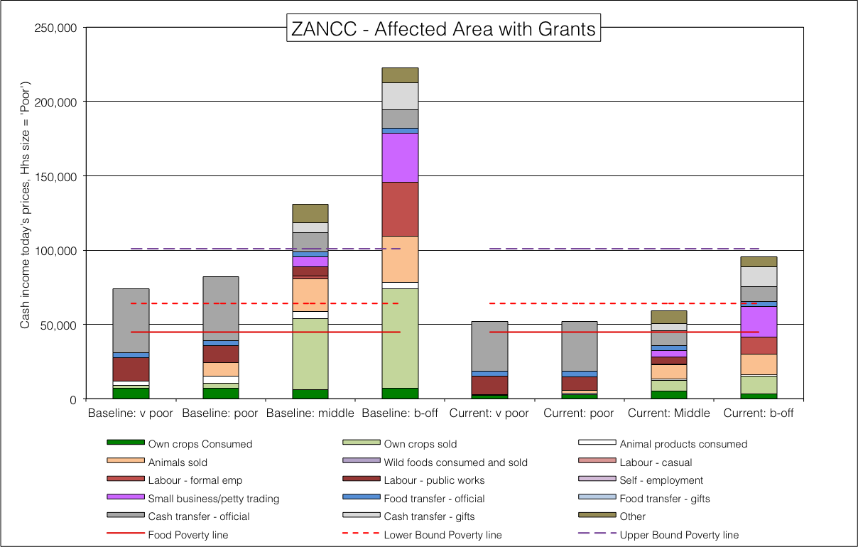**20: *Livelihood strategies for the* **drought hazard-affected** north coast open-access intense cultivation livelihood zone (ZANCC, 59304), **with** social grants

Contrast the drought situation with the non-drought affected analyses for the two grant and non-grant groups: the substantial difference is with the ‘middle’ wealth group, who lost their production the drought hazard-affected area: their total incomes thus fall below the UBPL. **Table Table** summarise these deficits and the patterns can be seen there.

**Table** 10 - Summary of annual deficits in Rands for Okhahlamba open-access intense crops and livestock LZ (ZAKHC, 59208)

|  |  |  |  |  |  |  |  |  |  |
| --- | --- | --- | --- | --- | --- | --- | --- | --- | --- |
|  | | Very Poor | | Poor | | Middle | | Better-off | |
| Poverty line | Hazard | Grants | No Grants | Grants | No Grants | Grants | No Grants | Grants | No Grants |
| UBPL | No Drought | **46,248** | **73,516** | **19,320** | **47,033** | No deficit | No deficit | No deficit | No deficit |
| Drought | **52,175** | **79,443** | **31,426** | **58,187** | **17,218** | **25,852** | No deficit | No deficit |
| LBPL | No Drought | **13,510** | **40,778** | No deficit | **14,295** | No deficit | No deficit | No deficit | No deficit |
| Drought | **19,437** | **46,705** | No deficit | **25,449** | No deficit | No deficit | No deficit | No deficit |
| FPL | No Drought | No deficit | **22,395** | No deficit | No deficit | No deficit | No deficit | No deficit | No deficit |
| Drought | **1,054** | **28,322** | No deficit | **7,066** | No deficit | No deficit | No deficit | No deficit |

##### Example 2: North Coast Open-Access Intense Cultivation

The north coast of KwaZulu-Natal was badly affected by the drought. The plains north of Empangeni up to Mkuze contain good agricultural land that is extensively cropped and constitute the North coast open access intense cultivation livelihood zone (ZANCC, 50304). The situation for drought hazard-affected areas with and without grants are given in **Figures Figure** and  **Figure** below.

Notice how the poorest households can nevertheless reach the food poverty line, even with the impact of the drought, which is important in this crop-growing livelihood, provided they are receiving at least some social grants. However, for the unlucky few households that do not receive grants, their effective income falls to critically low levels and their situation is dire. Also, the ‘middle’ and ‘better-off’ households are farmers in this zone; this makes them vulnerable to the drought, which has pulled them both down below the UBPL. Essentially, in this zone, communities are impoverished by the drought and hungry if they do not receive social grants.

**Figure Figure** and  **Figure** show the same graphs for households in the non-drought affected part of the livelihood zone. Income from crops remains good, although declining purchasing power due to high food prices reduces incomes across the board somewhat.

Once again, the poorest households without grants are the ones in a critical state, well below the food poverty line, regardless of whether they are in the drought-affected area or not. **Table Table** lists the deficits for this livelihood zone.

**Figure 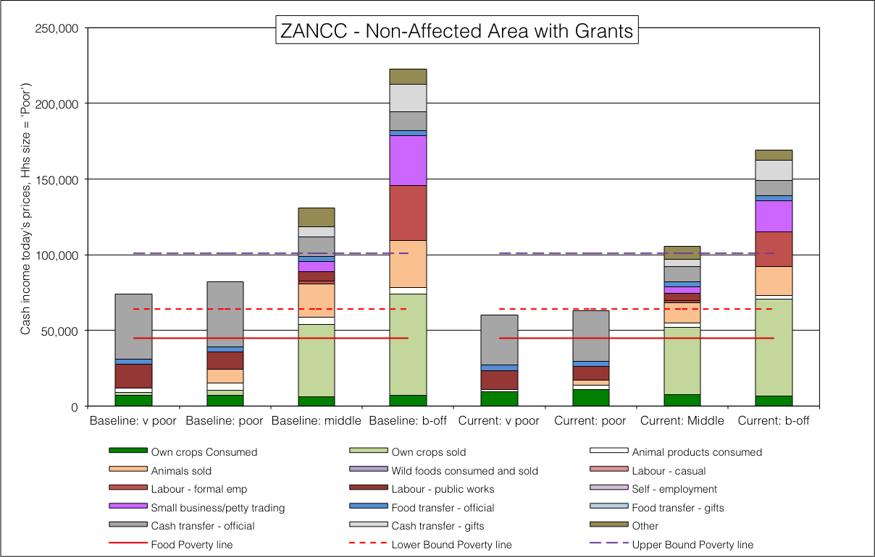**22: *Livelihood strategies for the* ***non*-affected** north coast open access intense cultivation livelihood zone (ZANCC, 59304), **with** social grants

**Figure 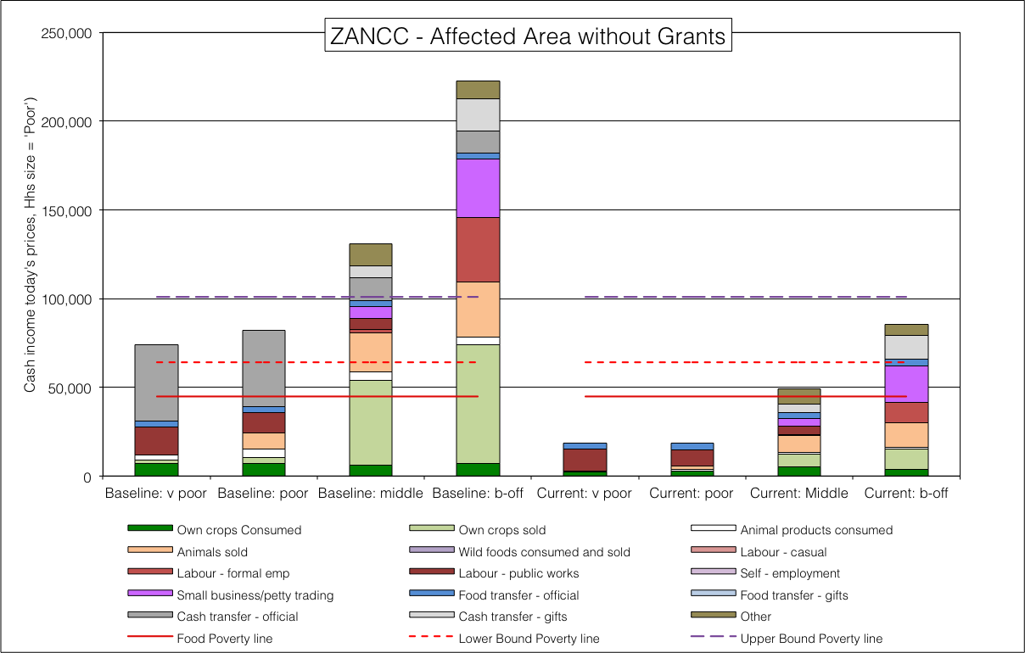**21: *Livelihood strategies for the* **drought hazard-affected** north coast open access intense cultivation livelihood zone (ZANCC, 59304), **without** social grants

**Table** 11 - Summary of annual deficits in Rands for north coast open access intense cultivation LZ (ZANCC, 59304)

**Figure 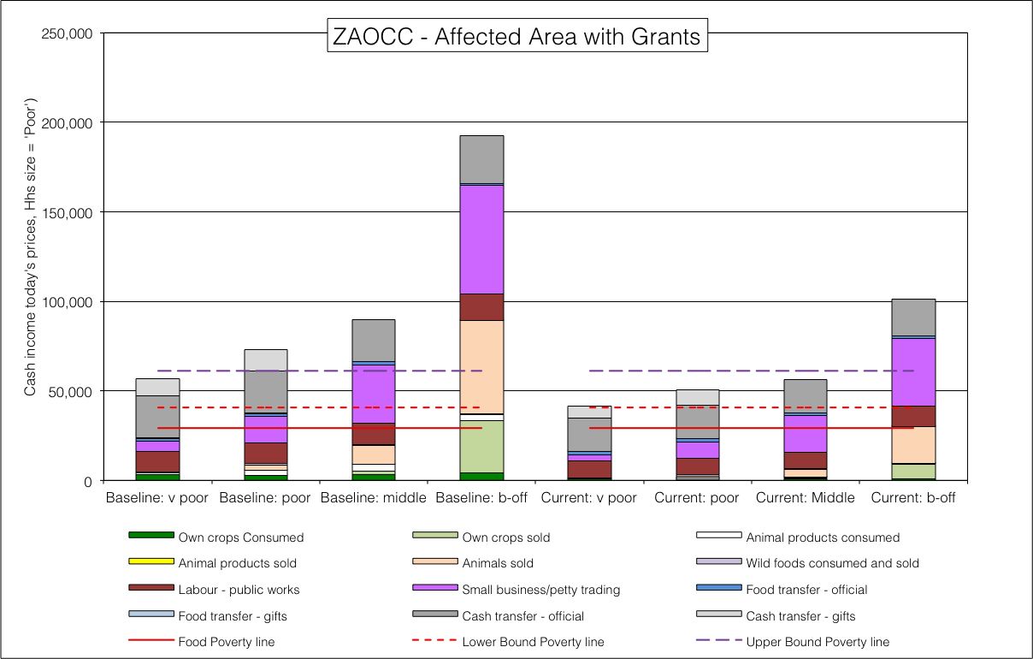**24: *Livelihood strategies for the* **drought hazard-affected** *Free State open access cattle and crops* livelihood zone (ZAOCC, 59209), **with** social grants

**Figure 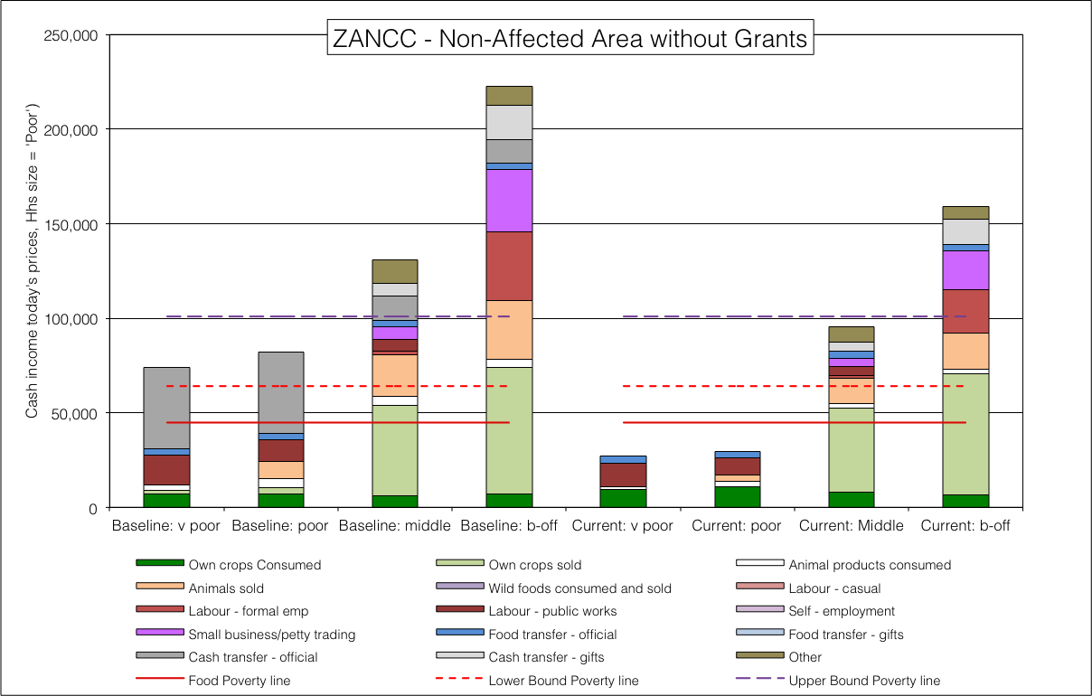**23: *Livelihood strategies for the* ***non*-affected** north coast open access intense cultivation livelihood zone (ZANCC, 59304), **without** social grants

|  |  |  |  |  |  |  |  |  |  |
| --- | --- | --- | --- | --- | --- | --- | --- | --- | --- |
|  | | Very Poor | | Poor | | Middle | | Better-off | |
| Poverty line | Hazard | Grants | No Grants | Grants | No Grants | Grants | No Grants | Grants | No Grants |
| UBPL | No Drought | **40,573** | **73,990** | **37,867** | **71,284** | No deficit | **5,257** | No deficit | No deficit |
| Drought | **48,754** | **82,172** | **49,019** | **82,436** | **41,740** | **51,793** | **5,578** | **15,445** |
| LBPL | No Drought | **3,743** | **37,160** | **1,036** | **34,454** | No deficit | No deficit | No deficit | No deficit |
| Drought | **11,924** | **45,341** | **12,188** | **45,606** | **4,910** | **14,963** | No deficit | No deficit |
| FPL | No Drought | No deficit | **17,895** | No deficit | **15,189** | No deficit | No deficit | No deficit | No deficit |
| Drought | No deficit | **26,077** | No deficit | **26,341** | No deficit | No deficit | No deficit | No deficit |

##### Example 3: Free State Open Access Cattle and Crops

The Free State open access cattle and crops endured the drought’s worst: ‘middle’ and ‘better-off’ households’ income will reduce by a third and social grants will be vital for the ‘poor’ and ‘very poor’.

**Figure 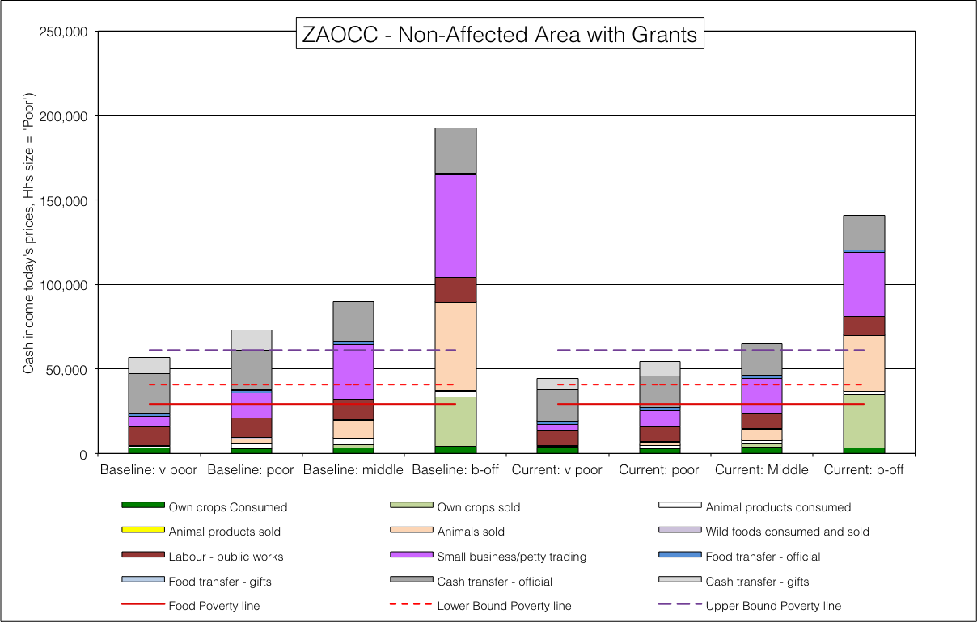**26: *Livelihood strategies for the* ***non*-affected** *Free State open-access cattle and crops* livelihood zone (ZAOCC, 59209), **with** social grants

**Figure 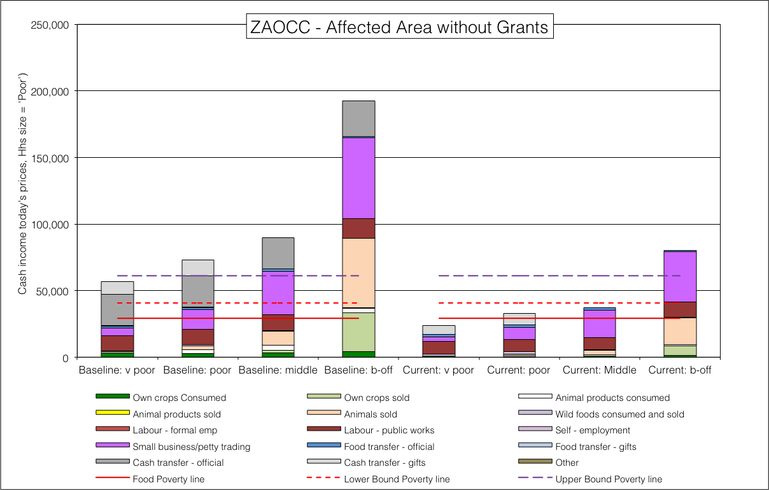**25: *Livelihood strategies for the* ***drought hazard*-affected** *Free State open access cattle and crops* livelihood zone (ZAOCC, 59209), **without** social grants

**Table** 12 - Summary of annual deficits in Rands for the Free State open access cattle and crops LZ (ZAOCC, 59304)

**Figure 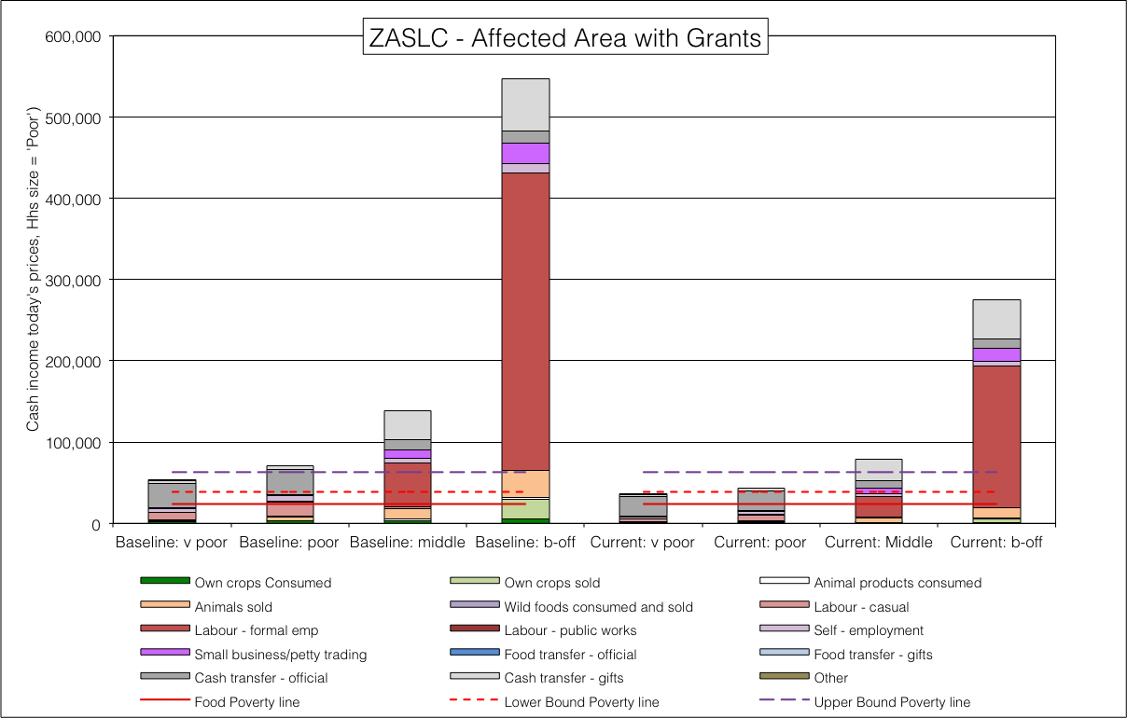**28: *Livelihood strategies for the* ***drought hazard*-affected** s*outhern Limpopo open access livestock and crops* livelihood zone (ZASLC, 59203), **with** social grants

**Figure 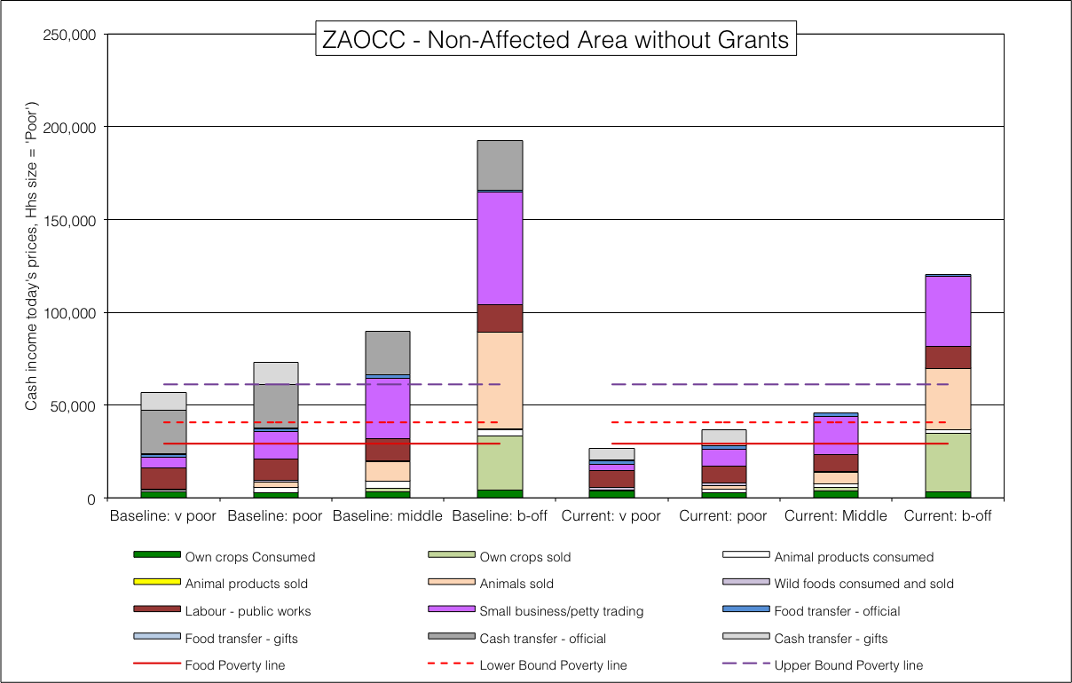**27: Livelihood strategies for the **non-affected** Free State open-access cattle and crops livelihood zone (ZAOCC, 59209), **without** social grants

|  |  |  |  |  |  |  |  |  |  |
| --- | --- | --- | --- | --- | --- | --- | --- | --- | --- |
|  | | Very Poor | | Poor | | Middle | | Better-off | |
| Poverty line | Hazard | Grants | No Grants | Grants | No Grants | Grants | No Grants | Grants | No Grants |
| UBPL | No Drought | **16,887** | **34,279** | **6,656** | **24,273** | No deficit | **15,444** | No deficit | No deficit |
| Drought | **19,879** | **37,515** | **10,475** | **28,107** | **4,762** | **24,205** | No deficit | No deficit |
| LBPL | No Drought | No deficit | **13,818** | No deficit | **3,812** | No deficit | No deficit | No deficit | No deficit |
| Drought | No deficit | **17,054** | No deficit | **7,646** | No deficit | **3,744** | No deficit | No deficit |
| FPL | No Drought | No deficit | **2,329** | No deficit | No deficit | No deficit | No deficit | No deficit | No deficit |
| Drought | No deficit | **5,565** | No deficit | No deficit | No deficit | No deficit | No deficit | No deficit |

##### Example 4: Southern Limpopo open-access livestock and crops

Livelihoods in this zone, which is mostly in Sekhukhune District, rely mostly on social grants (for the ‘very poor’, ‘poor’ and ‘middle’ and formal employment (for the better-off and middle). There is some contribution from remittances and a little from livestock. Cropping is minimal. Consequently, the *direct* impacts of the drought are small but in the case of the ‘very poor’, it makes the difference between being above or below the LBPL. The *indirect* impact from high food purchase prices is drastic, virtually cutting purchasing power in half. Not having access to grants has the most impact, and ‘poor’ and ‘very poor’ households in this situation are below the food poverty line as well as the having a food energy deficit.

**Figure 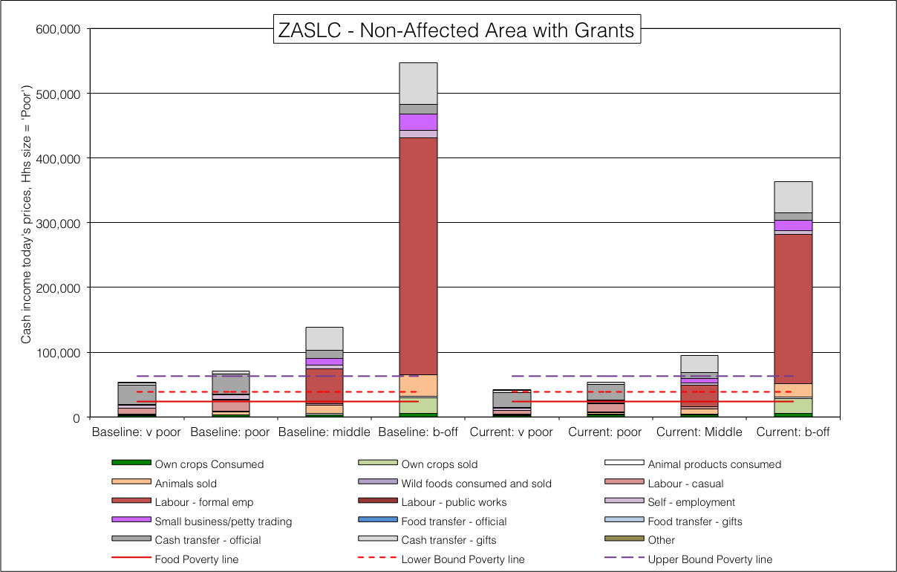**30: *Livelihood strategies for the* ***non*-affected** *southern Limpopo open access livestock and crops* livelihood zone (ZASLC, 59203), **with** social grants

**Figure 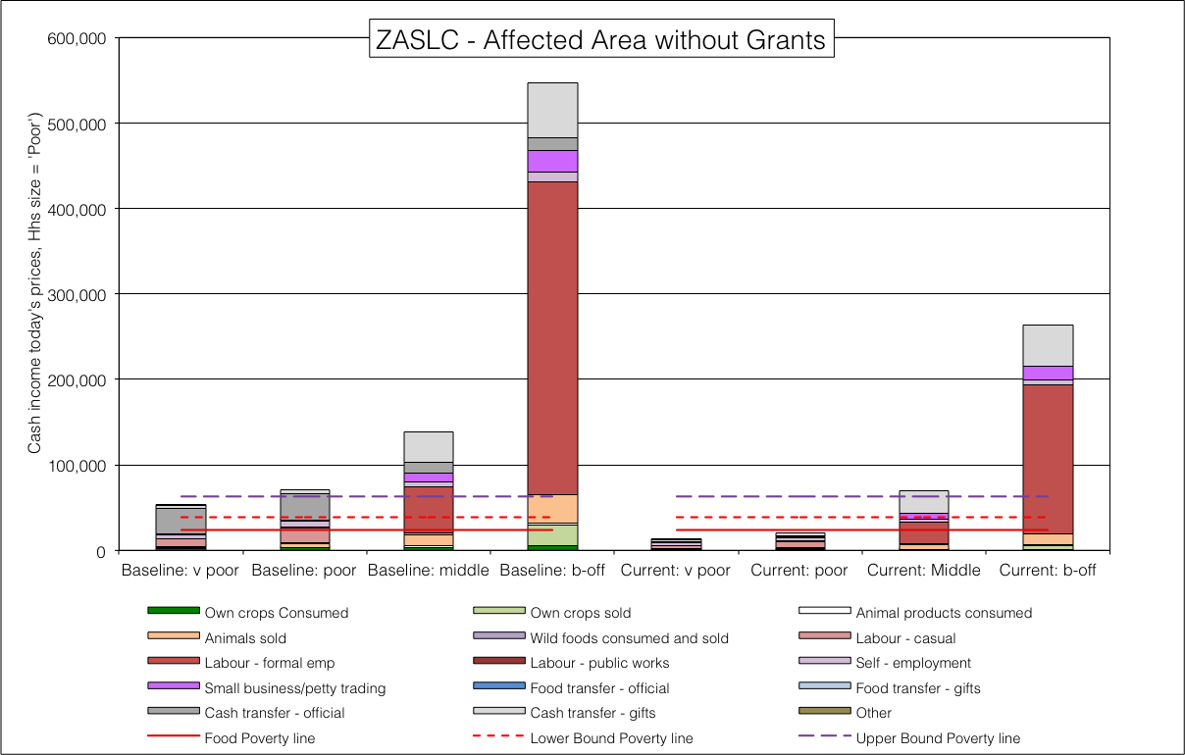**29: *Livelihood strategies for the* ***drought hazard*-affected** s*outhern Limpopo open access livestock and crops* livelihood zone (ZASLC, 59203), **without** social grants

**Figures Figure** to  **Figure** and **Table Table** show the analysis and summarise its results.

**Table** 13 - Summary of annual deficits in Rands for the southern Limpopo open access livestock and crops LZ (ZASLC, 59203)

**Figure 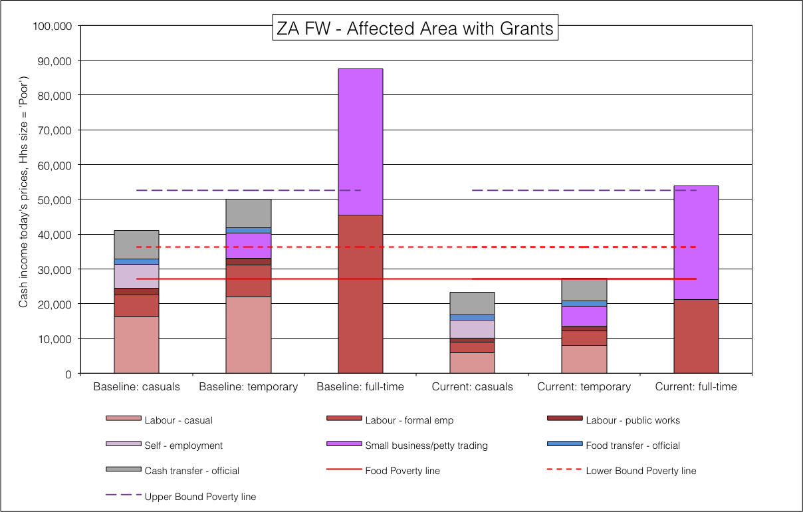**32: *Livelihood strategies for the* ***drought hazard*-affected** *farm workers* (ZA FW, 59050), **with** social grants

**Figure 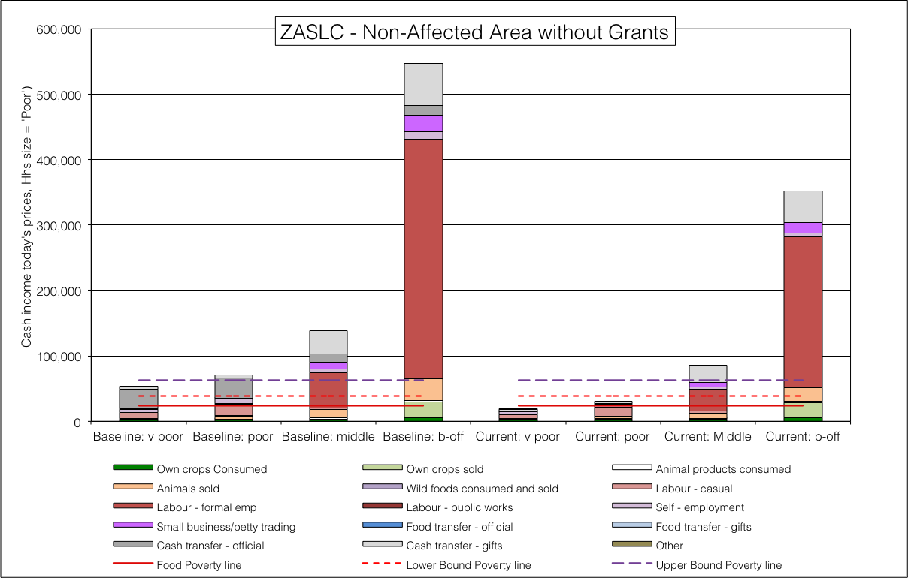**31: *Livelihood strategies for the* ***non*-affected** *southern Limpopo open access livestock and crops* livelihood zone (ZASLC, 59203), **without** social grants

|  |  |  |  |  |  |  |  |  |  |
| --- | --- | --- | --- | --- | --- | --- | --- | --- | --- |
|  | | Very Poor | | Poor | | Middle | | Better-off | |
| Poverty line | Hazard | Grants | No Grants | Grants | No Grants | Grants | No Grants | Grants | No Grants |
| UBPL | No Drought | **21,851** | **44,747** | **8,939** | **31,755** | No deficit | No deficit | No deficit | No deficit |
| Drought | **27,010** | **50,178** | **19,409** | **42,386** | No deficit | No deficit | No deficit | No deficit |
| LBPL | No Drought | No deficit | **20,194** | No deficit | **7,201** | No deficit | No deficit | No deficit | No deficit |
| Drought | **2,546** | **25,625** | No deficit | **17,833** | No deficit | No deficit | No deficit | No deficit |
| FPL | No Drought | No deficit | **4,991** | No deficit | No deficit | No deficit | No deficit | No deficit | No deficit |
| Drought | No deficit | **10,421** | No deficit | **2,630** | No deficit | No deficit | No deficit | No deficit |

##### Example 5: Farm workers on commercial farms

Farm workers with social grants have similar livelihoods and deficits in both the hazard-affected areas (see **Figure Figure**) and in the in non-affected areas (see **Figure Figure**), since their incomes are actually derived from cash sources and grants—although casual labour opportunities are somewhat affected by the drought.

**Figure 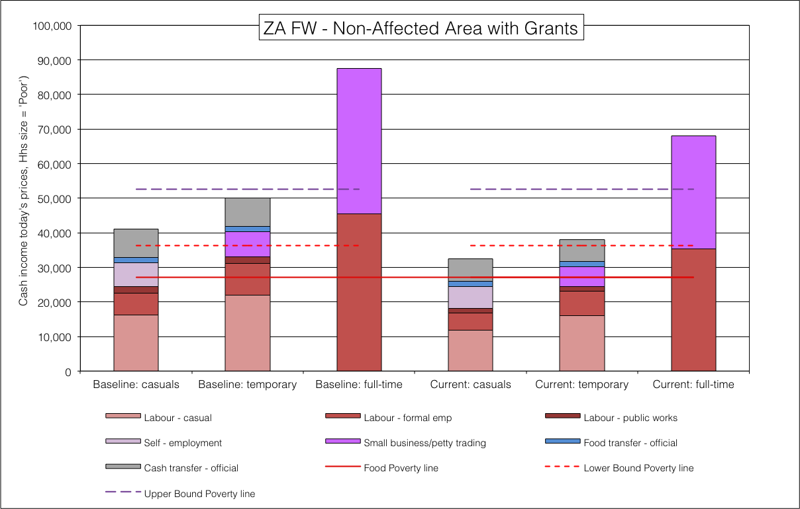**34: *Livelihood strategies for the* ***non*-affected** *farm workers* (ZA FW, 59050), **with** social grants

Figure 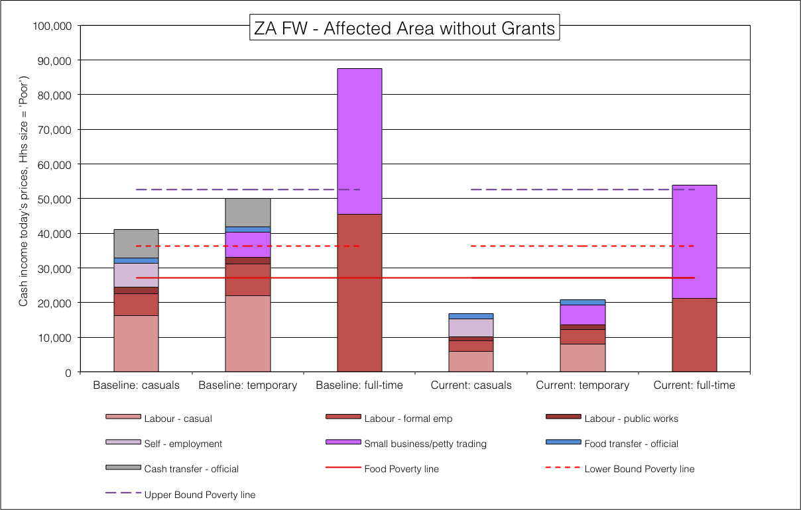33: *Livelihood strategies for the* ***drought hazard*-affected** *farm workers* (ZA FW, 59050), **without** social grants

**Table** 14 - Summary of annual deficits in Rands for farm workers (ZA FW, 59050)

**Figure 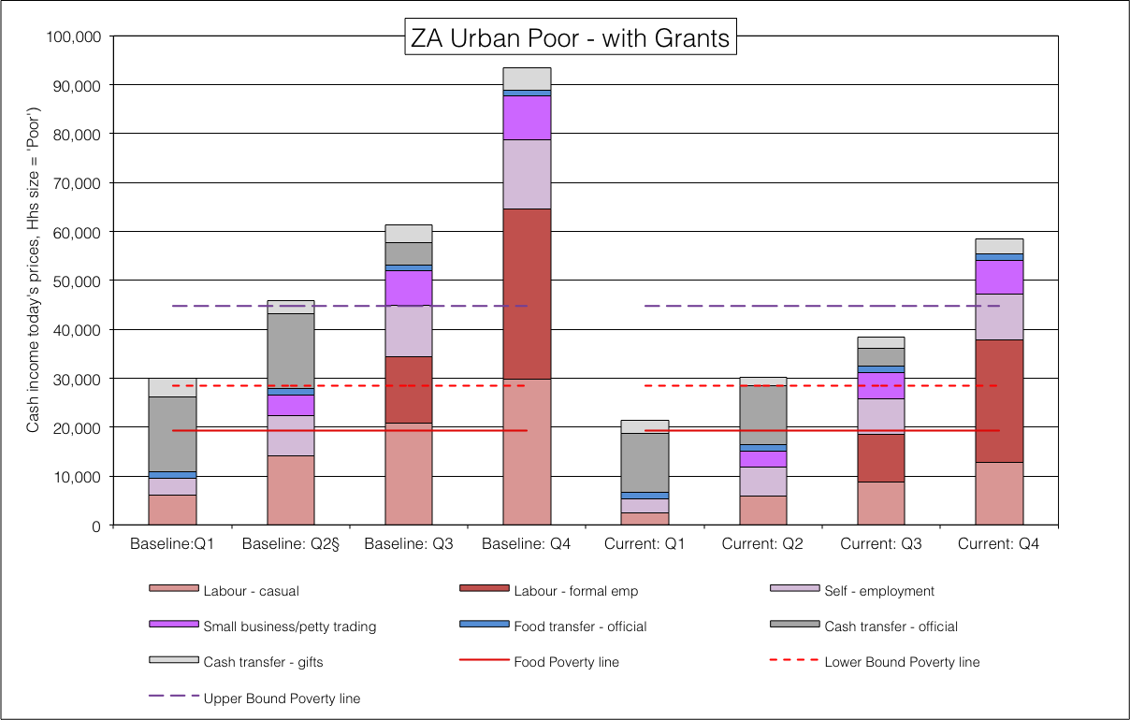**36: *Livelihood strategies for the* *urban poor* (ZA FW, 59050), **with** social grants

**Figure 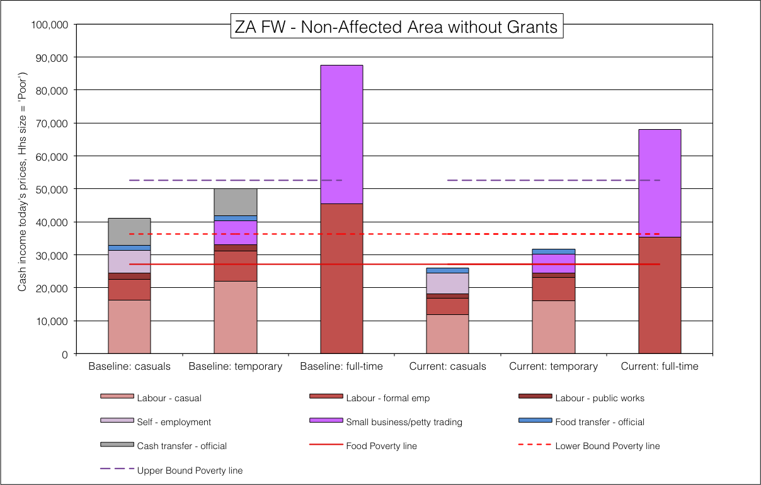**35: *Livelihood strategies for the* ***non*-affected** *farm workers* (ZA FW, 59050), **without** social grants

|  |  |  |  |  |  |  |
| --- | --- | --- | --- | --- | --- | --- |
|  | | Casuals | | Temporary/Seasonal | | Full-time |
| Poverty line | Hazard | Grants | No Grants | Grants | No Grants | No Grants |
| UBPL | No Drought | **20,202** | **26,574** | **14,491** | **20,863** | No deficit |
| Drought | **29,359** | **35,731** | **25,370** | **31,742** | No deficit |
| LBPL | No Drought | **3,833** | **10,205** | No deficit | **4,494** | No deficit |
| Drought | **12,990** | **19,362** | **9,001** | **15,373** | No deficit |
| FPL | No Drought | No deficit | **1,014** | No deficit | No deficit | No deficit |
| Drought | **3,798** | **10,170** | No deficit | **6,182** | No deficit |

##### Example 6: The Urban Poor

**Figure 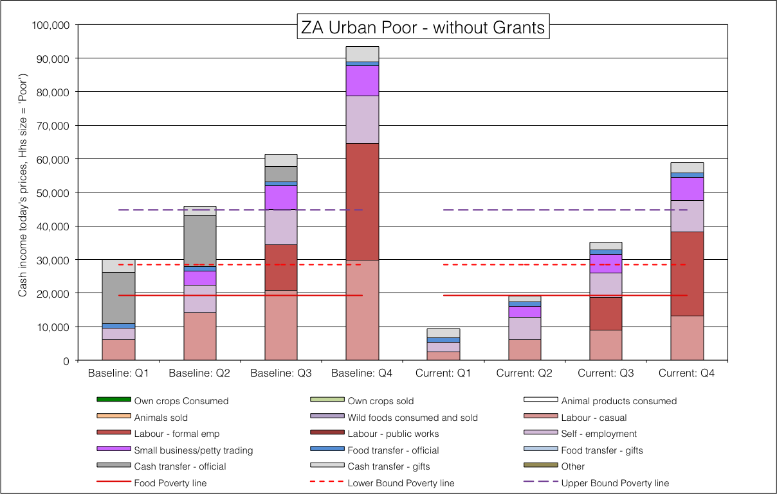**37: *Livelihood strategies for the* *urban poor* (ZA FW, 59050), **without** social grants

Because agricultural activities amount to almost nothing towards households’ livelihoods in urban areas, the impact of the drought *directly* on the total incomes of urban households because of the drought is negligible. The *indirect* impact through high purchase prices for food stuffs is significant and damaging—but this is not determined by whether the households live in an urban area that is in the drought-affected part of the country or not. The outcomes for households remain the same both inside and out of the drought area.

Casual and formal work opportunities have been affected by the drought; these is a consequence of individuals protecting their essential expenditure to be able to manage the increased prices, and businesses spending less on labour due to high borrowing costs and tighter budgets.

Social grants, however, do make a difference. Poorer quartile 1 and quartile 2 households without access to social grants have far disastrously high deficits *for all poverty lines*. These are reported in **Table Table** below.

**Table** 15 - Summary of annual deficits in Rands for the urban poor (ZAUP, 59800)

|  |  |  |  |  |  |  |  |  |  |
| --- | --- | --- | --- | --- | --- | --- | --- | --- | --- |
|  | | Quartile 1 | | Quartile 2 | | Quartile 3 | | Quartile 4 | |
| Poverty line | Hazard | Grants | No Grants | Grants | No Grants | Grants | No Grants | Grants | No Grants |
| UBPL | No Drought | **23,308** | **35,341** | **14,583** | **25,712** | **6,320** | **9,590** | No deficit | No deficit |
| LBPL | No Drought | **6,939** | **18,972** | No deficit | **9,343** | No deficit | No deficit | No deficit | No deficit |
| FPL | No Drought | No deficit | **9,781** | No deficit | **151** | No deficit | No deficit | No deficit | No deficit |

##### Collecting all the outcomes together (Step 31)

A command line interface (CLI) program called collect_analysis.js[12] was written in JavaScript that ‘scrapes’ the single zone analysis spreadsheets of all their relevant outcomes and enters the data into a PostgreSQL database table, zaf.tbl_ofa_analysis. This PostgreSQL table can then be joined to hazard and spatial tables in a query for computing the affected populations, total numbers and administrative area breakdowns. ‘Spreadsheet scraping’ saves time, automating the otherwise laborious process of copying and pasting data from 76 analysis spreadsheets (1,168 data transfers), which would be daunting, to say the least.

#### Finalising the totals (Steps 32 to 36)

**Figure** 38: Map of the enumeration small areas (ESAs), segmented into ‘drought’ and ‘less drought’ or ‘normal’.

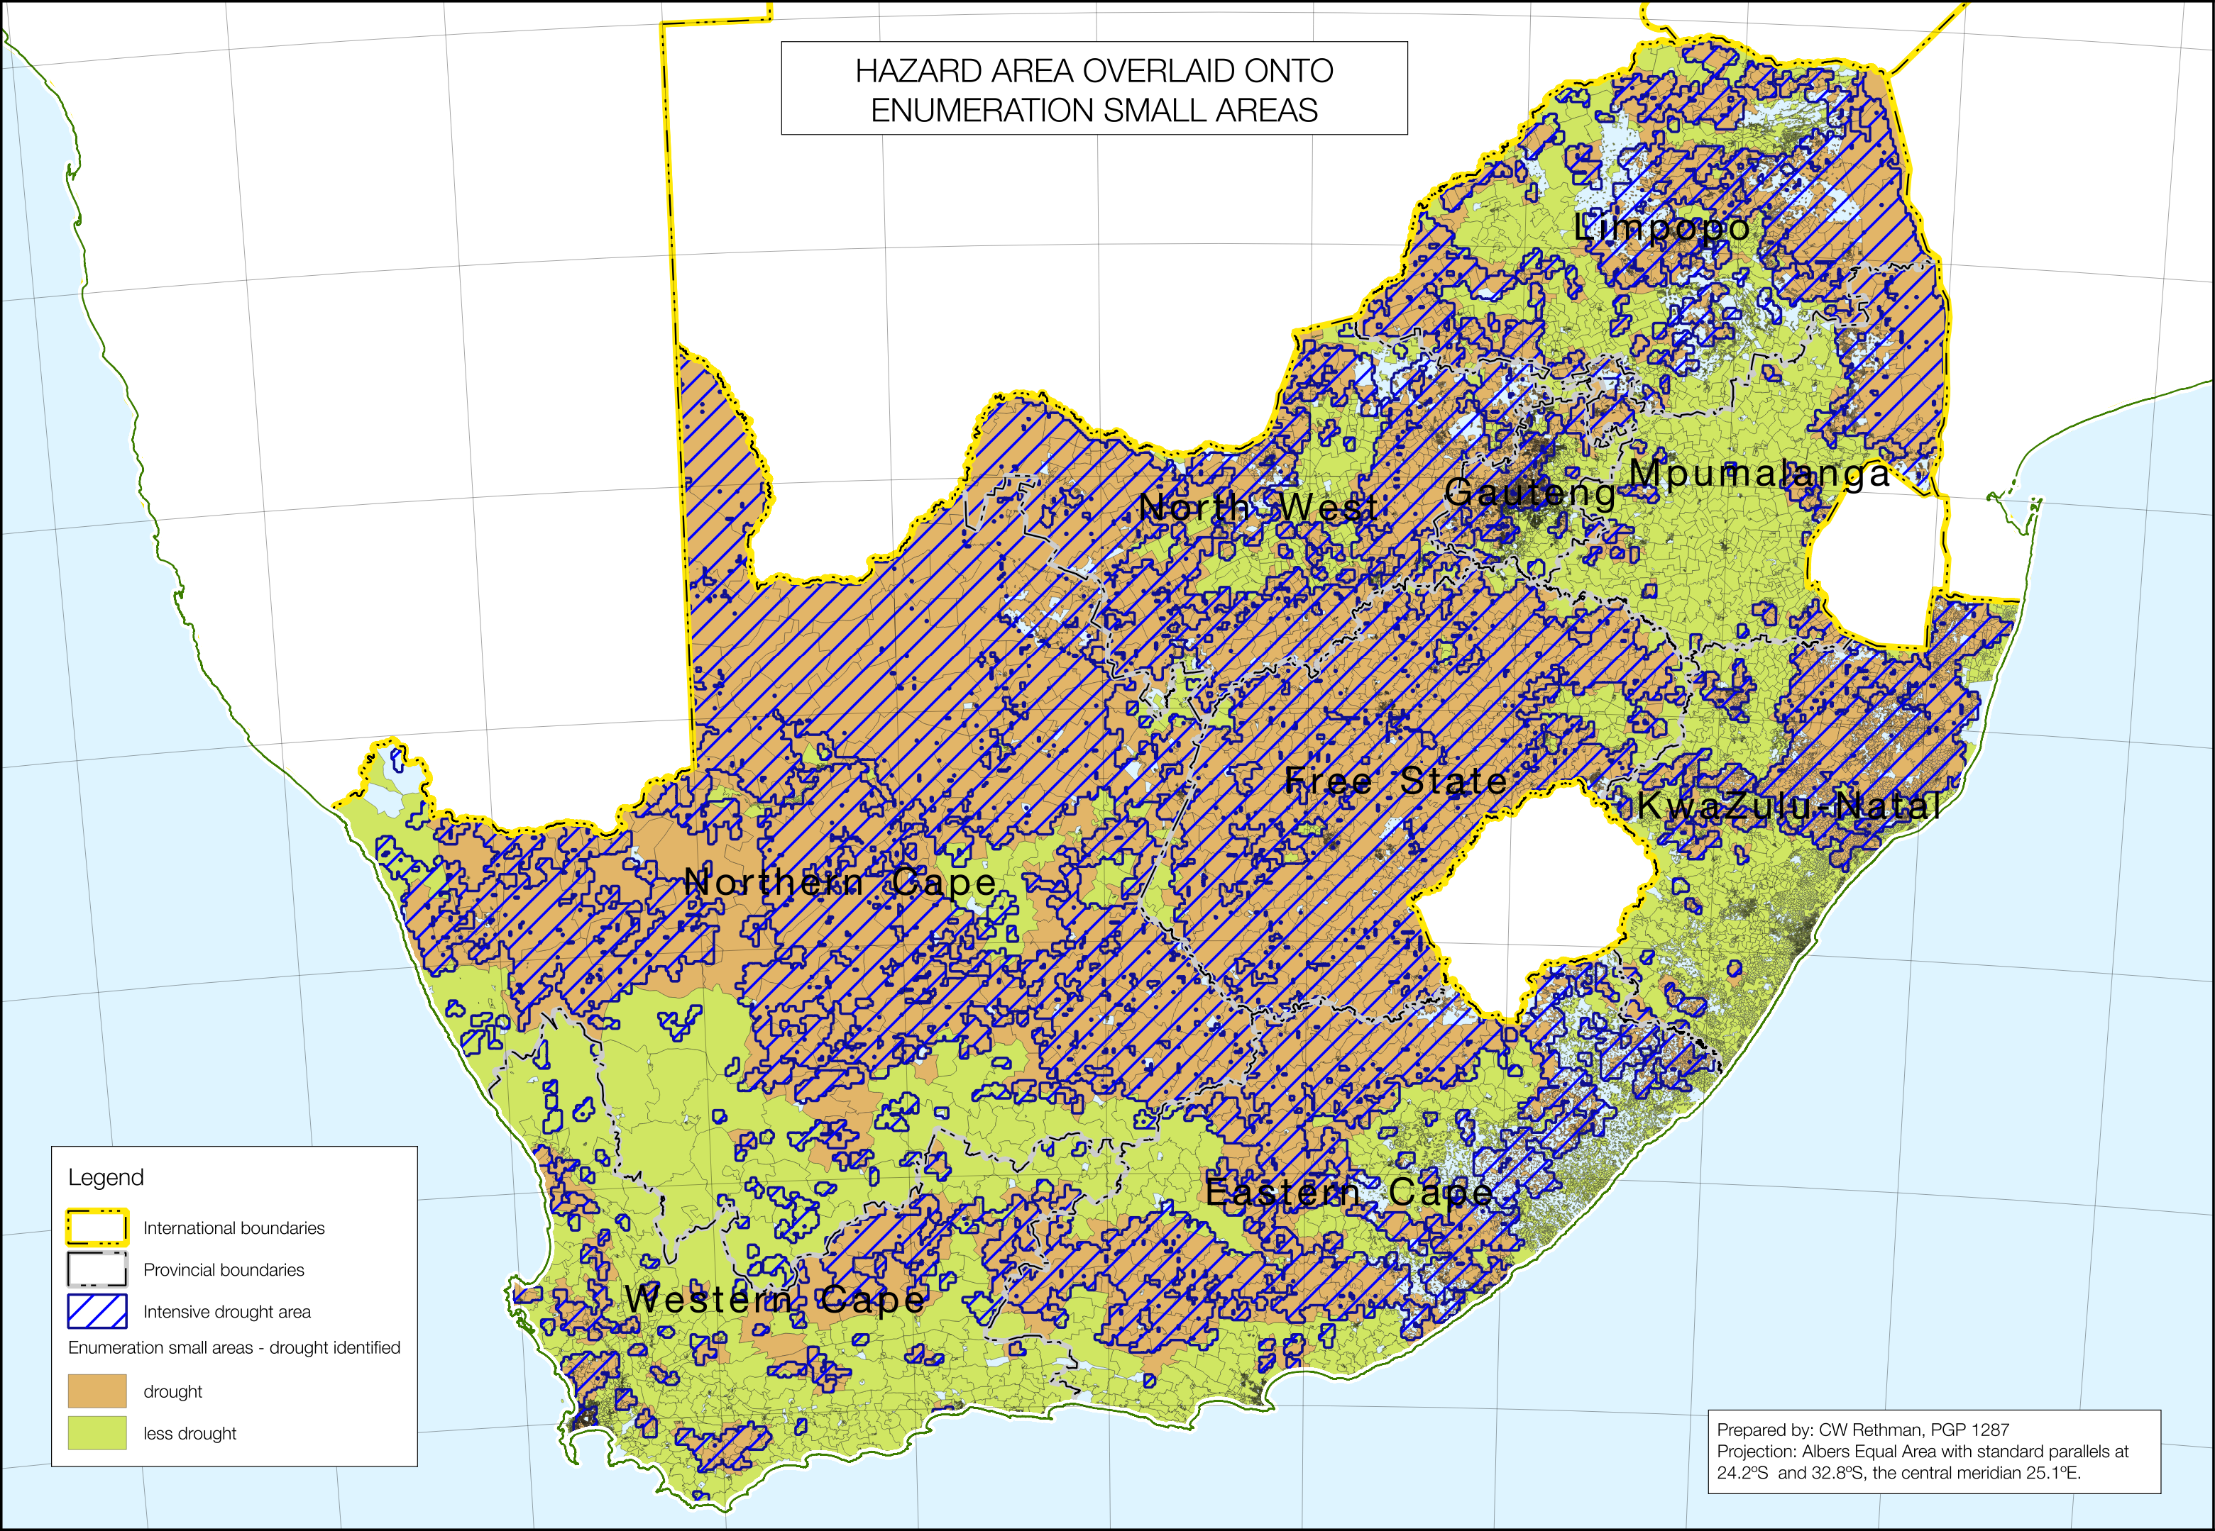

##### Assigning hazard status to the smallest population units (Step 32)

The number of affected people is calculated using the enumeration small areas (ESAs) and their associated data from the 2011 Statistics South Africa Population and Household Census. To make this work, the hazard area needs to be defined in terms of these ESAs.

The division between affected and unaffected populations under study are calculated by overlaying the drought hazard affected areas from **Figure Figure** onto the ESAs and then to assign an attribute, for the current assessment, of either ‘drought’ or ‘normal’ to the whole ESA (ESAs are not split up). This decision on whether to assign a value of ‘drought’ or ‘normal’ to an ESA was based thus:

1. ESAs that are entirely within the drought hazard affected area are classified affected and are assigned a value of ‘drought’.
2. ESAs that straddle a drought hazard affected area boundary and but have more than 33% of their area overlapping it are classified affected and assigned a value of ‘drought’.
3. ESAs that straddle a drought hazard affected area boundary but have less than 33% of their area overlapping it are classified unaffected and assigned a value of ‘normal’.
4. Small Areas that lie entirely outside the drought hazard affected area are classified unaffected and are assigned a value of ‘normal’.

This process was carried out automatically in PostgreSQL/PostGIS by a query called hazard_analysis.sql. The segmented ESA results from this query can then be mapped and are presented in **Figure Figure**. Since the ESAs already have a livelihood zone attribute attached to them, it is possible to distinguish ESAs and their associated populations of which livelihood analysis to apply and for which drought/normal problem specification.

##### Calculate the affected populations in each enumeration small area (ESA) and their deficits for each threshold (Step 33)

The baselines and analysis presented in the previous section and in **Appendix B** do not correspond exactly to the livelihood zones list. Therefore a table was constructed that maps livelihood zones to the analyses, for example, “North western cattle and game ranching (ZAWCG, 59153)” is mapped to “Commercial farm workers (ZA_FW, 59050)”. The complete list of zone mapping is provided in **Appendix A**.

The hazard-segmented ESAs, the table with ESA populations, the district population growth rates from 2011 (the year of the census) to 2016 (this year), the table that maps livelihood zones to currently available baselines and the table of outcomes by livelihood zone, drought hazard, wealth group, access to grants and threshold are all combined in a single query, hazard_outcomes.sql, that computes the resultant populations at risk and their combined deficits. The query generates four files in comma-separated value (CSV) format, which can readily be imported into Microsoft Excel for pivoting. This is presented below in the next section.

##### Summary of deficits by administrative areas (Step 34)

The following tables, **Table Table** and **Table Table**, contain a breakdown by district (or metropolitan area) of each deficit threshold, with groupings by province. Further breakdowns, by municipality, are available in **Appendix F**. These data are obtained from pivot tables that summarise the outputs from the query, hazard_outcomes.sql.

The most extreme deficit is food energy. These arise if households are unable to purchase a basket of cereals that will provide them with 8,800 kJ per person per day or 100% of the average daily food energy requirement. The basket of cereals comprises maize meal, rice, wheat flour, potatoes and sweet potatoes. Households with a food energy deficit are going to be hungry and they will compromise their assets, their health and do what they can to get food. Their situation goes beyond impoverishment and inequality; it is more about survival itself. This analysis suggests that, under the given scenario and with 20% of households or families not having someone with access to social grants, **approximately 4.88 million people will face this deficit**, which amounts to approximately **421,000 metric tons of grain equivalent** over the whole year**.**

The food poverty line is an expenditure level that provides for a more comprehensive basket of commodities than the commodities used to calculate the food energy deficit. The list of commodities is set by Statistics SA and is provided in **Appendix E**. As the cost of the food poverty line is higher than that of the simple starch diet for the food energy threshold, the number of people below this line is also somewhat higher. The analysis suggests that, under the given scenario and with 20% of households or families not having someone with access to social grants, **approximately 4.19 million people will face this deficit**. The total cost of filling the income gap is approximately **ZAR 8.13 billion** over the whole year. This amounts to an *average* of ZAR 1,654 per person over the whole consumption year—or R147 per month. **Note**: the actual amounts per person will differ across livelihood zones, wealth groups and affected areas and groupings.

Statistics South Africa report that 20,2% of South Africans already live below the FPL; this equates to approximately 11.295 million people over the 2016 projected population. The 4.19 million people reported (above) in this analysis are *over and above the already existing numbers*, which means a **37% increase** **in food poverty** this consumption year. As has been explained in the problem specification and analysis sections, this risk of increase in food poverty is largely because of food price increases, brought on by the weak Rand and low grain production (forcing more expensive imports) which resulted from the drought.

Without external action, it is likely that nutritional status, especially that of children, will decline and more people will require treatment for disorders that nutritionally-related. In addition, the South African Social Security Agency (SASSA) should see an increase in applicants for indigent or other grants.

Although the integers presented in **Table Table** and  **Table** are exact, the actual numbers can vary by ±15%, so they must not be used too literally. Tthe population for the Eastern Cape with a food energy deficit could be rounded off to 588,600 people. Rounded figures are not presented because this is the way that the database calculates these outcomes and rounding errors were being minimised.

**Table** 16 - Food energy deficits (in metric tons), Food Poverty line deficits (in ZAR) and their associated populations at risk, per district and province

|  |  |  |  |  |
| --- | --- | --- | --- | --- |
| Province/District | Sum of population with a food deficit | Sum of deficit maize eq (MT) | Sum of population with an FPL deficit | Sum of FPL deficit in ZAR |
| Eastern Cape | 588,606 | 61,104 | 588,606 | 1,074,977,708 |
| Alfred Nzo | 115,699 | 13,515 | 115,699 | 240,473,916 |
| Amathole | 108,662 | 11,033 | 108,662 | 184,112,926 |
| Buffalo City | 44,806 | 4,090 | 44,806 | 67,889,480 |
| Cacadu | 11,372 | 686 | 11,372 | 12,197,122 |
| Chris Hani | 69,384 | 6,888 | 69,384 | 129,335,329 |
| Joe Gqabi | 35,525 | 4,222 | 35,525 | 79,775,975 |
| Nelson Mandela Bay | 21,457 | 1,567 | 21,457 | 25,522,737 |
| O.R. Tambo | 181,701 | 19,103 | 181,701 | 335,670,223 |
| Free State | 102,946 | 8,962 | 102,946 | 150,563,075 |
| Fezile Dabi | 11,793 | 808 | 11,793 | 15,138,015 |
| Lejweleputswa | 17,139 | 1,224 | 17,139 | 21,856,180 |
| Mangaung | 21,551 | 1,584 | 21,551 | 26,787,913 |
| Thabo Mofutsanyane | 47,004 | 4,983 | 47,004 | 79,702,251 |
| Xhariep | 5,459 | 363 | 5,459 | 7,078,715 |
| Gauteng | 352,955 | 26,087 | 352,955 | 436,536,551 |
| City of Johannesburg | 97,988 | 7,379 | 97,988 | 122,130,613 |
| City of Tshwane | 98,774 | 7,238 | 98,774 | 121,766,334 |
| Ekurhuleni | 84,428 | 6,333 | 84,428 | 103,888,837 |
| Sedibeng | 27,577 | 1,941 | 27,577 | 32,651,046 |
| West Rand | 44,188 | 3,195 | 44,188 | 56,099,722 |
| KwaZulu-Natal | 1,766,923 | 129,689 | 1,799,426 | 2,979,042,673 |
| Amajuba | 33,940 | 3,600 | 33,940 | 74,353,661 |
| Ethekwini | 209,945 | 13,867 | 222,100 | 379,511,159 |
| Harry Gwala | 298,734 | 25,654 | 299,040 | 494,234,930 |
| iLembe | 83,234 | 5,076 | 90,126 | 177,158,099 |
| Ugu | 278,926 | 18,613 | 281,060 | 437,685,464 |
| Umgungundlovu | 132,045 | 9,188 | 137,298 | 233,306,220 |
| Umkhanyakude | 149,738 | 11,184 | 152,789 | 259,202,160 |
| Umzinyathi | 72,778 | 6,693 | 73,962 | 144,751,544 |
| Uthukela | 114,607 | 8,915 | 114,607 | 196,443,775 |
| Uthungulu | 218,966 | 13,271 | 220,454 | 305,141,747 |
| Zululand | 174,010 | 13,629 | 174,050 | 277,253,914 |
| Limpopo | 490,543 | 57,060 | 490,543 | 1,066,014,623 |
| Capricorn | 141,562 | 16,953 | 109,627 | 259,355,526 |
| Greater Sekhukhune | 126,742 | 14,282 | 59,869 | 87,474,643 |
| Mopani | 109,627 | 13,681 | 141,562 | 286,498,969 |
| Vhembe | 52,743 | 6,036 | 126,742 | 306,730,495 |
| Waterberg | 59,869 | 6,109 | 52,743 | 125,954,989 |
| Mpumalanga | 357,777 | 37,900 | 357,777 | 671,195,776 |
| Ehlanzeni | 205,183 | 23,788 | 205,183 | 406,715,450 |
| Gert Sibande | 51,831 | 4,286 | 51,831 | 72,695,682 |
| Nkangala | 100,763 | 9,826 | 100,763 | 191,784,644 |
| North West | 336,226 | 34,668 | 336,226 | 652,102,973 |
| Bojanala | 170,198 | 18,731 | 170,198 | 356,409,447 |
| Dr Kenneth Kaunda | 24,761 | 1,666 | 24,761 | 31,604,793 |
| Dr Ruth Segomotsi Mompati | 50,346 | 5,255 | 50,346 | 83,623,676 |
| Ngaka Modiri Molema | 90,921 | 9,015 | 90,921 | 180,465,058 |
| Northern Cape | 177,314 | 12,778 | 177,314 | 234,940,381 |
| Frances Baard | 68,922 | 4,563 | 68,922 | 87,872,052 |
| John Taolo Gaetsewe | 41,358 | 4,309 | 41,358 | 70,138,653 |
| Namakwa | 14,238 | 852 | 14,238 | 16,782,052 |
| Pixley ka Seme | 26,230 | 1,577 | 26,230 | 31,047,884 |
| Z.F Mgcawu | 26,566 | 1,478 | 26,566 | 29,099,740 |
| Western Cape | 709,691 | 52,600 | 709,691 | 864,660,857 |
| Cape Winelands | 88,909 | 6,226 | 88,909 | 103,858,865 |
| Central Karoo | 11,555 | 842 | 11,555 | 14,035,297 |
| City of Cape Town | 479,152 | 36,370 | 479,152 | 593,484,341 |
| Eden | 68,210 | 4,941 | 68,210 | 80,949,693 |
| Overberg | 25,722 | 1,846 | 25,722 | 30,618,729 |
| West Coast | 36,143 | 2,376 | 36,143 | 41,713,932 |
| Grand Total | 4,882,981 | 420,848 | 4,915,484 | 8,130,034,617 |

The Lower Bound Poverty Line (LBPL) and the Upper Bound Poverty Line (UBPL) are two poverty lines used to describe absolute poverty in South Africa. Both consist of the same as the FPL basket, with the addition of non-food goods and services considered essential for survival and growth. The difference between the LBPL and the UBPL is only in the *amount* of non-food goods and services in the basket; the UBPL does not include any goods or services not in the LBPL.

It is important to stress that populations with Food Energy deficits are a subset of those with FPL deficits, who are in turn themselves a subset of those with LBPL deficits, then those with UBPL Deficits.

**Table** 17 - Lower bound poverty line (LBPL) deficit and population at risk per district

|  |  |  |  |  |
| --- | --- | --- | --- | --- |
| Row Labels | Sum of population with an LBPL deficit | Sum of LBPL deficit in ZAR | Sum of population with an UBPL deficit | Sum of population with an UBPL deficit |
| Eastern Cape | 2,311,857 | 4,771,695,802 | 3,398,280 | 17,100,231,645 |
| Alfred Nzo | 482,624 | 1,023,151,082 | 688,861 | 3,527,722,176 |
| Amathole | 391,589 | 802,977,864 | 578,593 | 2,896,011,745 |
| Buffalo City | 135,403 | 322,571,332 | 276,747 | 1,235,456,736 |
| Cacadu | 35,643 | 73,454,129 | 66,642 | 306,466,986 |
| Chris Hani | 294,752 | 585,108,401 | 399,381 | 2,094,079,750 |
| Joe Gqabi | 147,675 | 343,229,492 | 212,550 | 1,102,020,447 |
| Nelson Mandela Bay | 67,685 | 150,825,388 | 161,764 | 672,389,052 |
| O.R. Tambo | 756,486 | 1,470,378,115 | 1,013,742 | 5,266,084,752 |
| Free State | 264,120 | 667,988,403 | 498,573 | 2,317,183,450 |
| Fezile Dabi | 24,522 | 66,865,251 | 36,688 | 192,425,256 |
| Lejweleputswa | 40,348 | 104,397,560 | 78,755 | 368,258,176 |
| Mangaung | 58,957 | 141,332,475 | 136,023 | 564,942,587 |
| Thabo Mofutsanyane | 130,323 | 326,426,954 | 236,278 | 1,120,956,687 |
| Xhariep | 9,970 | 28,966,162 | 10,829 | 70,600,744 |
| Gauteng | 1,004,648 | 2,376,515,067 | 2,249,959 | 9,371,459,629 |
| City of Johannesburg | 281,617 | 668,611,599 | 664,503 | 2,747,824,029 |
| City of Tshwane | 279,742 | 660,851,757 | 615,744 | 2,584,433,217 |
| Ekurhuleni | 251,510 | 584,639,117 | 598,721 | 2,471,909,781 |
| Sedibeng | 82,773 | 186,136,408 | 165,589 | 689,564,170 |
| West Rand | 109,006 | 276,276,186 | 205,402 | 877,728,432 |
| KwaZulu-Natal | 4,513,510 | 10,683,152,361 | 5,995,523 | 33,847,824,161 |
| Amajuba | 183,097 | 328,477,213 | 201,845 | 1,129,385,418 |
| Ethekwini | 746,497 | 1,727,229,365 | 1,300,268 | 6,321,050,780 |
| Harry Gwala | 325,947 | 1,219,385,762 | 363,465 | 2,690,446,284 |
| iLembe | 342,807 | 736,587,263 | 455,053 | 2,520,849,159 |
| Ugu | 469,126 | 1,219,595,723 | 507,781 | 3,286,998,634 |
| Umgungundlovu | 345,221 | 885,095,515 | 534,358 | 2,889,334,296 |
| Umkhanyakude | 459,438 | 1,019,477,067 | 576,141 | 3,342,761,410 |
| Umzinyathi | 340,383 | 609,968,840 | 384,937 | 2,136,901,449 |
| Uthukela | 307,545 | 748,363,632 | 422,559 | 2,314,064,906 |
| Uthungulu | 526,467 | 1,131,654,850 | 650,574 | 3,811,896,197 |
| Zululand | 466,982 | 1,057,317,131 | 598,542 | 3,404,135,628 |
| Limpopo | 2,065,161 | 4,320,963,534 | 3,477,314 | 16,798,821,238 |
| Capricorn | 466,992 | 960,970,521 | 720,176 | 3,739,203,914 |
| Greater Sekhukhune | 232,245 | 366,492,090 | 770,513 | 2,920,600,369 |
| Mopani | 561,520 | 1,195,071,311 | 803,990 | 4,128,611,714 |
| Vhembe | 585,218 | 1,307,471,793 | 900,797 | 4,371,092,121 |
| Waterberg | 219,186 | 490,957,819 | 281,838 | 1,639,313,120 |
| Mpumalanga | 1,255,144 | 2,936,190,483 | 2,034,511 | 10,015,884,123 |
| Ehlanzeni | 698,458 | 1,694,281,069 | 1,144,305 | 5,618,522,797 |
| Gert Sibande | 167,759 | 366,239,603 | 309,633 | 1,444,220,180 |
| Nkangala | 388,927 | 875,669,811 | 580,573 | 2,953,141,145 |
| North West | 1,249,674 | 2,851,366,812 | 1,784,885 | 9,255,277,595 |
| Bojanala | 670,572 | 1,559,514,264 | 975,275 | 4,997,657,485 |
| Dr Kenneth Kaunda | 50,655 | 138,173,428 | 69,719 | 383,055,969 |
| Dr Ruth Segomotsi Mompati | 155,283 | 359,659,182 | 266,535 | 1,266,544,732 |
| Ngaka Modiri Molema | 373,164 | 794,019,937 | 473,356 | 2,608,019,409 |
| Northern Cape | 399,567 | 1,015,768,406 | 534,993 | 3,046,323,683 |
| Frances Baard | 133,018 | 365,873,430 | 149,951 | 964,102,504 |
| John Taolo Gaetsewe | 106,371 | 277,051,611 | 179,914 | 891,178,642 |
| Namakwa | 32,214 | 78,209,746 | 40,011 | 238,277,590 |
| Pixley ka Seme | 58,808 | 143,773,269 | 72,647 | 434,487,585 |
| Z.F Mgcawu | 69,156 | 150,860,350 | 92,470 | 518,277,363 |
| Western Cape | 2,135,754 | 4,910,843,053 | 5,169,517 | 21,600,443,386 |
| Cape Winelands | 276,036 | 608,733,051 | 628,038 | 2,682,084,342 |
| Central Karoo | 33,979 | 78,450,449 | 79,215 | 336,341,120 |
| City of Cape Town | 1,429,017 | 3,338,613,834 | 3,560,694 | 14,726,071,084 |
| Eden | 213,616 | 475,999,117 | 509,503 | 2,132,177,068 |
| Overberg | 78,581 | 176,652,917 | 183,125 | 775,340,821 |
| West Coast | 104,525 | 232,393,686 | 208,942 | 948,428,952 |
| Grand Total | 15,199,435 | 34,534,483,922 | 25,143,555 | 123,353,448,910 |

The households with LBPL and UBPL deficits consist of those already reported to be below these lines (45,5% of the population, or 25.442 million people), as well others who are newly added to the list as a consequence of the drought and market conditions (it is not possible to separate the two). The total UBPL deficit of approximately ZAR 123 billion amounts to and average of ZAR 4,906 per at risk person per year, or R409 per at risk person per month.

**Figure** 39: Choropleth map of the percentage of the population with a food energy deficit, by enumeration small areas, municipalities, districts and provinces.

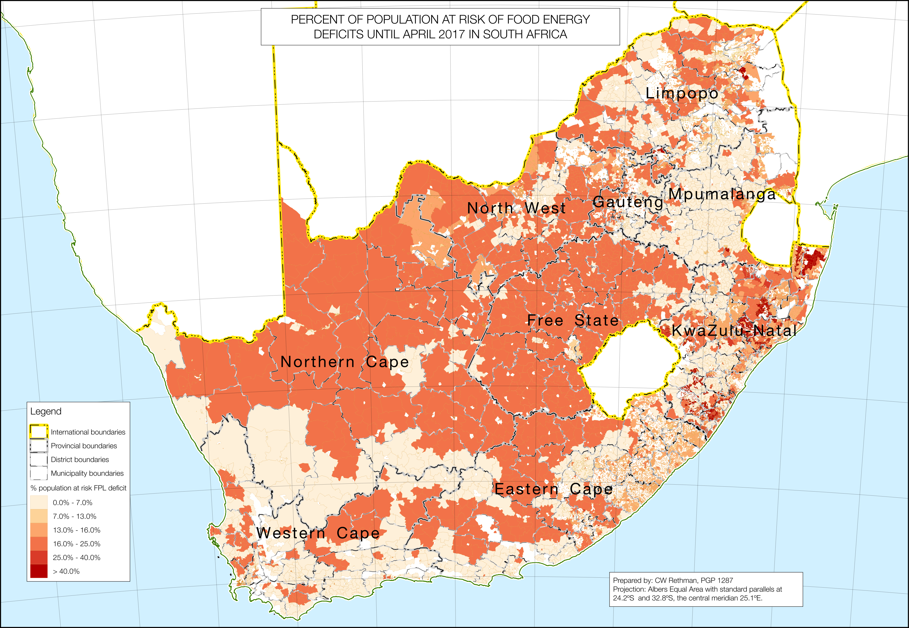

##### The percentages of people affected for the food energy deficit and the UBPL deficit (Step 35)

The map in **Figure Figure** shows the percentage of people at risk of a food energy deficit in each enumeration small area (ESA) as well as the outlines of municipalities, districts and provinces, so the distribution of populations at risk within these administrative units can be observed. It must be noted that a characteristic of ESAs is that in some rural parts of the country (notably in Limpopo, North West, Eastern Cape and KwaZulu-Natal), there are ‘islands’ of population with ESAs surrounded by a ‘sea’ of empty space where there is no ESA. This is because the ‘empty’ space is largely uninhabited grazing land and the small population data from that space is added to the ESAs in the concentrated areas, to ensure that laws on privacy of data are upheld. This creates a misleading impression that an area has a low percentage of people at risk, when in fact it is just the lack of ESAs in the area.

The map in **Figure Figure** is very similar to **Figure Figure**, the map showing the percentages of people below the Food Poverty Line (FPL), which also shows how higher percentage ESAs follow the hazard area.

##### Map the amounts of deficit for each outcome (Step 36)

The deficits outcomes are mapped in two different ways:

1. The deficit per capita total of all people living in the enumeration small area (ESA); and
2. The deficit per capita of people at risk living in the ESA.

These two outcomes are presented for the food energy deficits, the food poverty line (FPL) deficits and the upper bound poverty line (UBPL) deficits in **Figures Figure** to  **Figure** from page Figure to page Figure.

**Figure** 40: Choropleth map of the percentage of the population with a food poverty line deficit, by enumeration small areas, municipalities, districts and provinces, overlaid with the drought hazard-area.

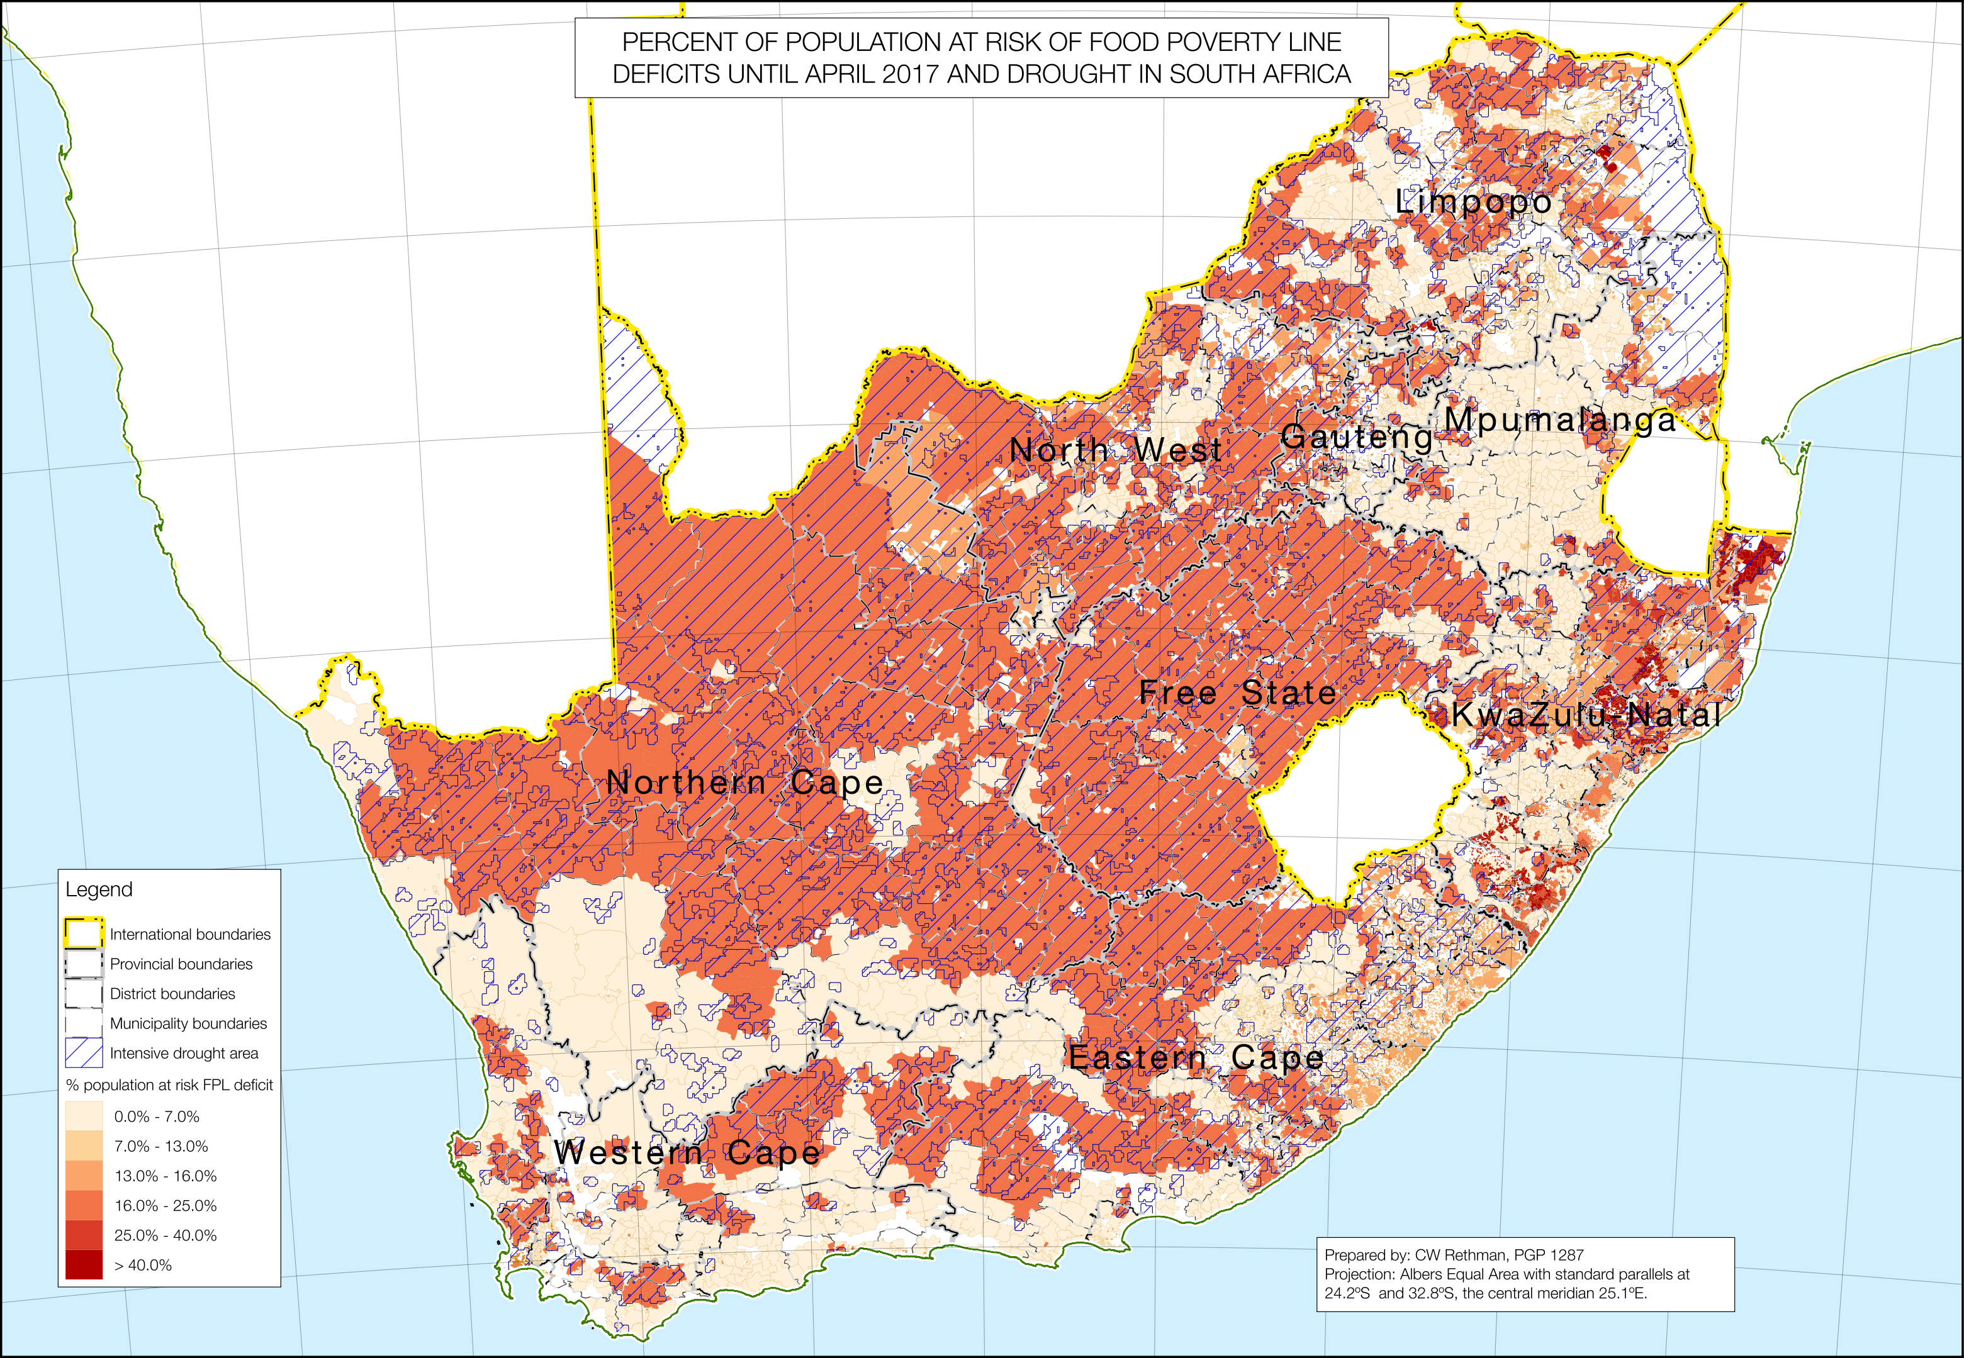

**Figure** 41: Choropleth map of the food energy deficit in maize equivalent per capita total population, by enumeration small areas, municipalities, districts and provinces.

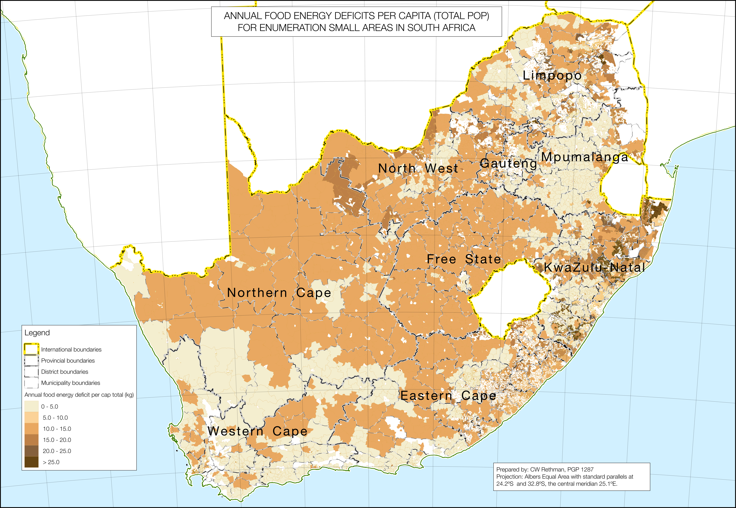

**Figure** 42: Choropleth map of the food energy deficit in maize equivalent per person at risk, by enumeration small areas, municipalities, districts and provinces.

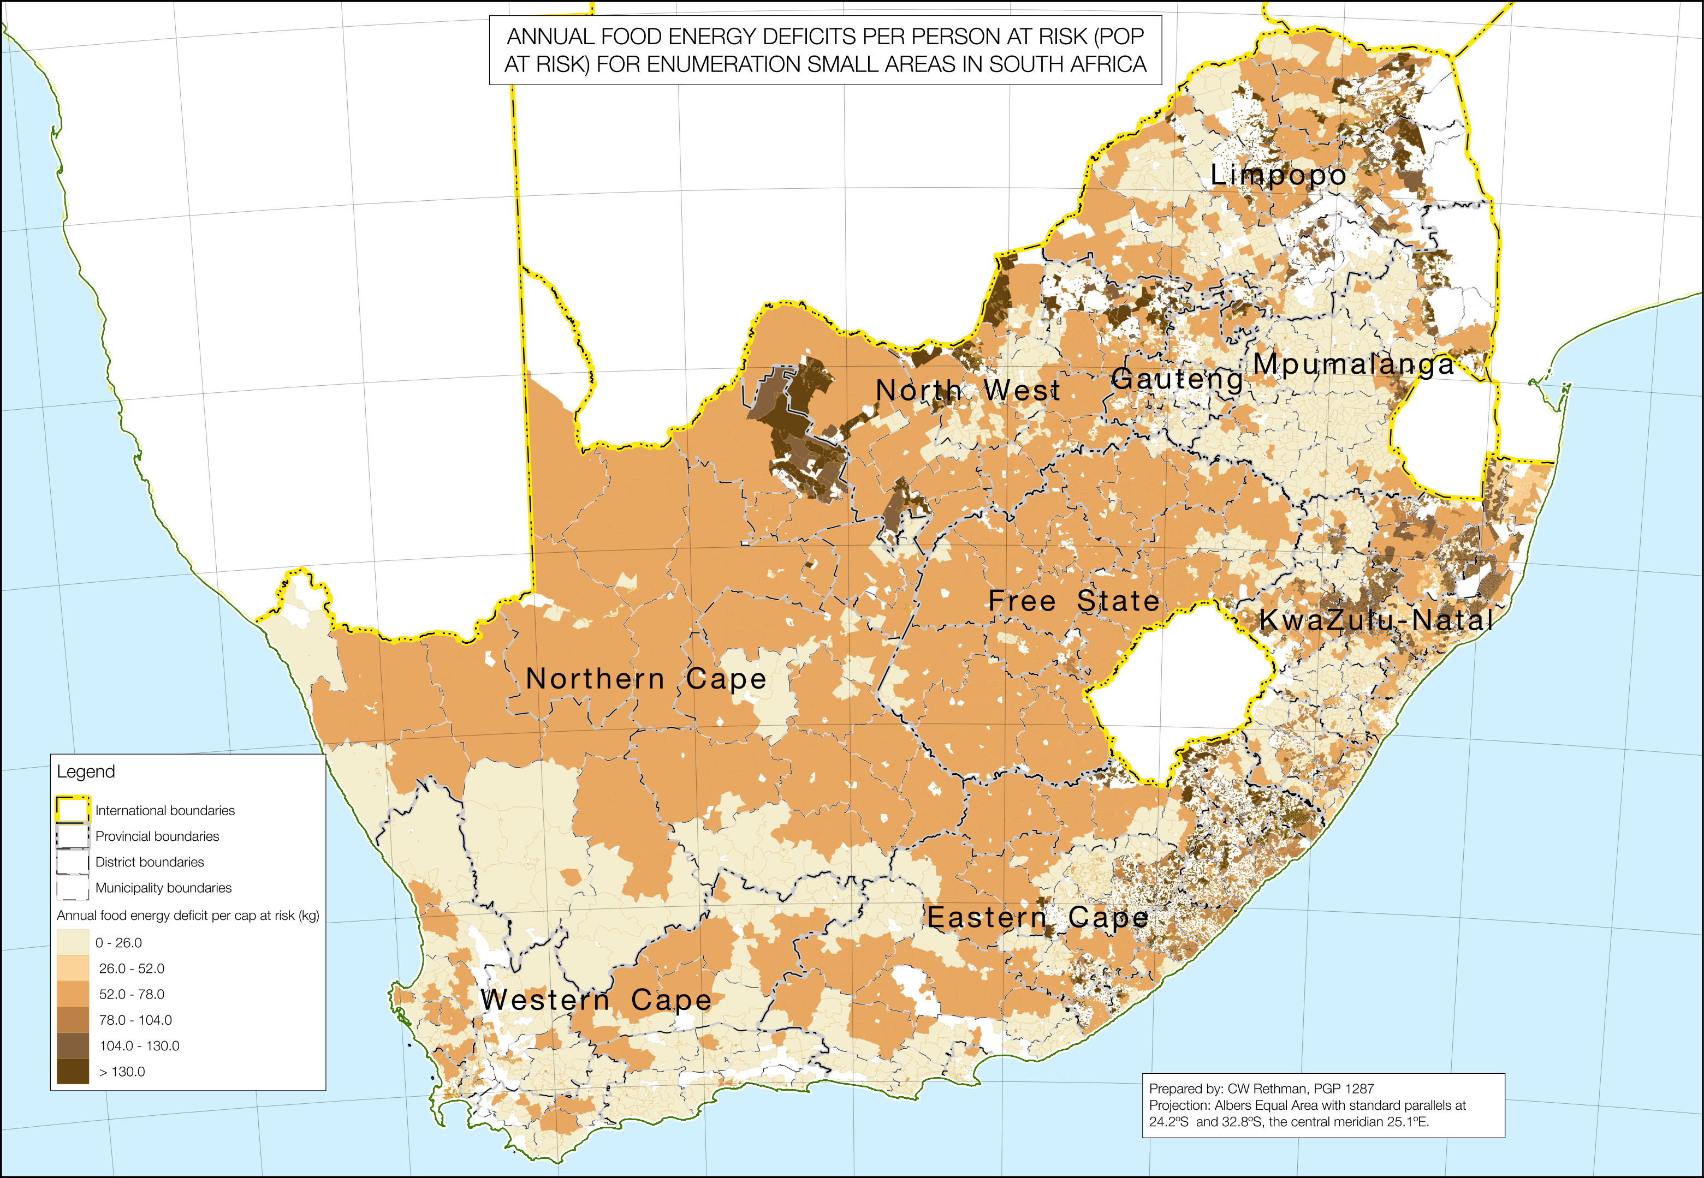

**Figure** 43: Choropleth map of the food poverty line (FPL) deficit in Rands per capita total population, by enumeration small areas, municipalities, districts and provinces.

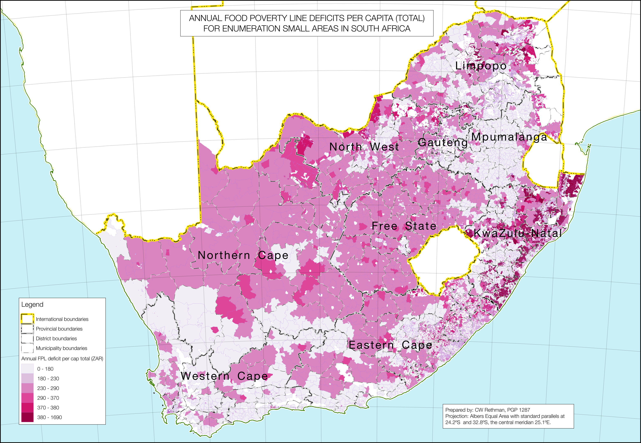

### Conclusion

**Figure** 44: Choropleth map of the food poverty line (FPL) deficit in Rands per person at risk, by enumeration small areas, municipalities, districts and provinces.

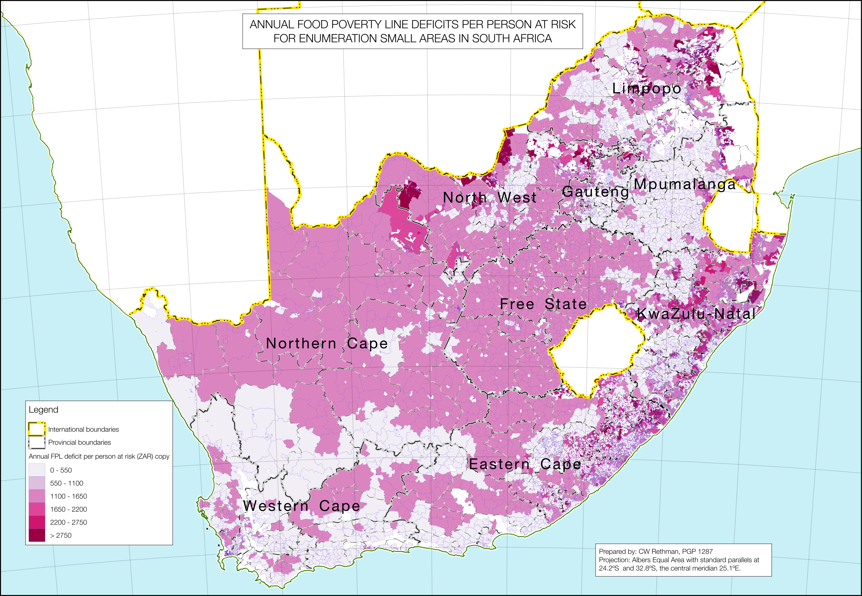

**Figure** 45: Choropleth map of the upper bound poverty line (UBPL) deficit in Rands per capita total population, by enumeration small areas, municipalities, districts and provinces.

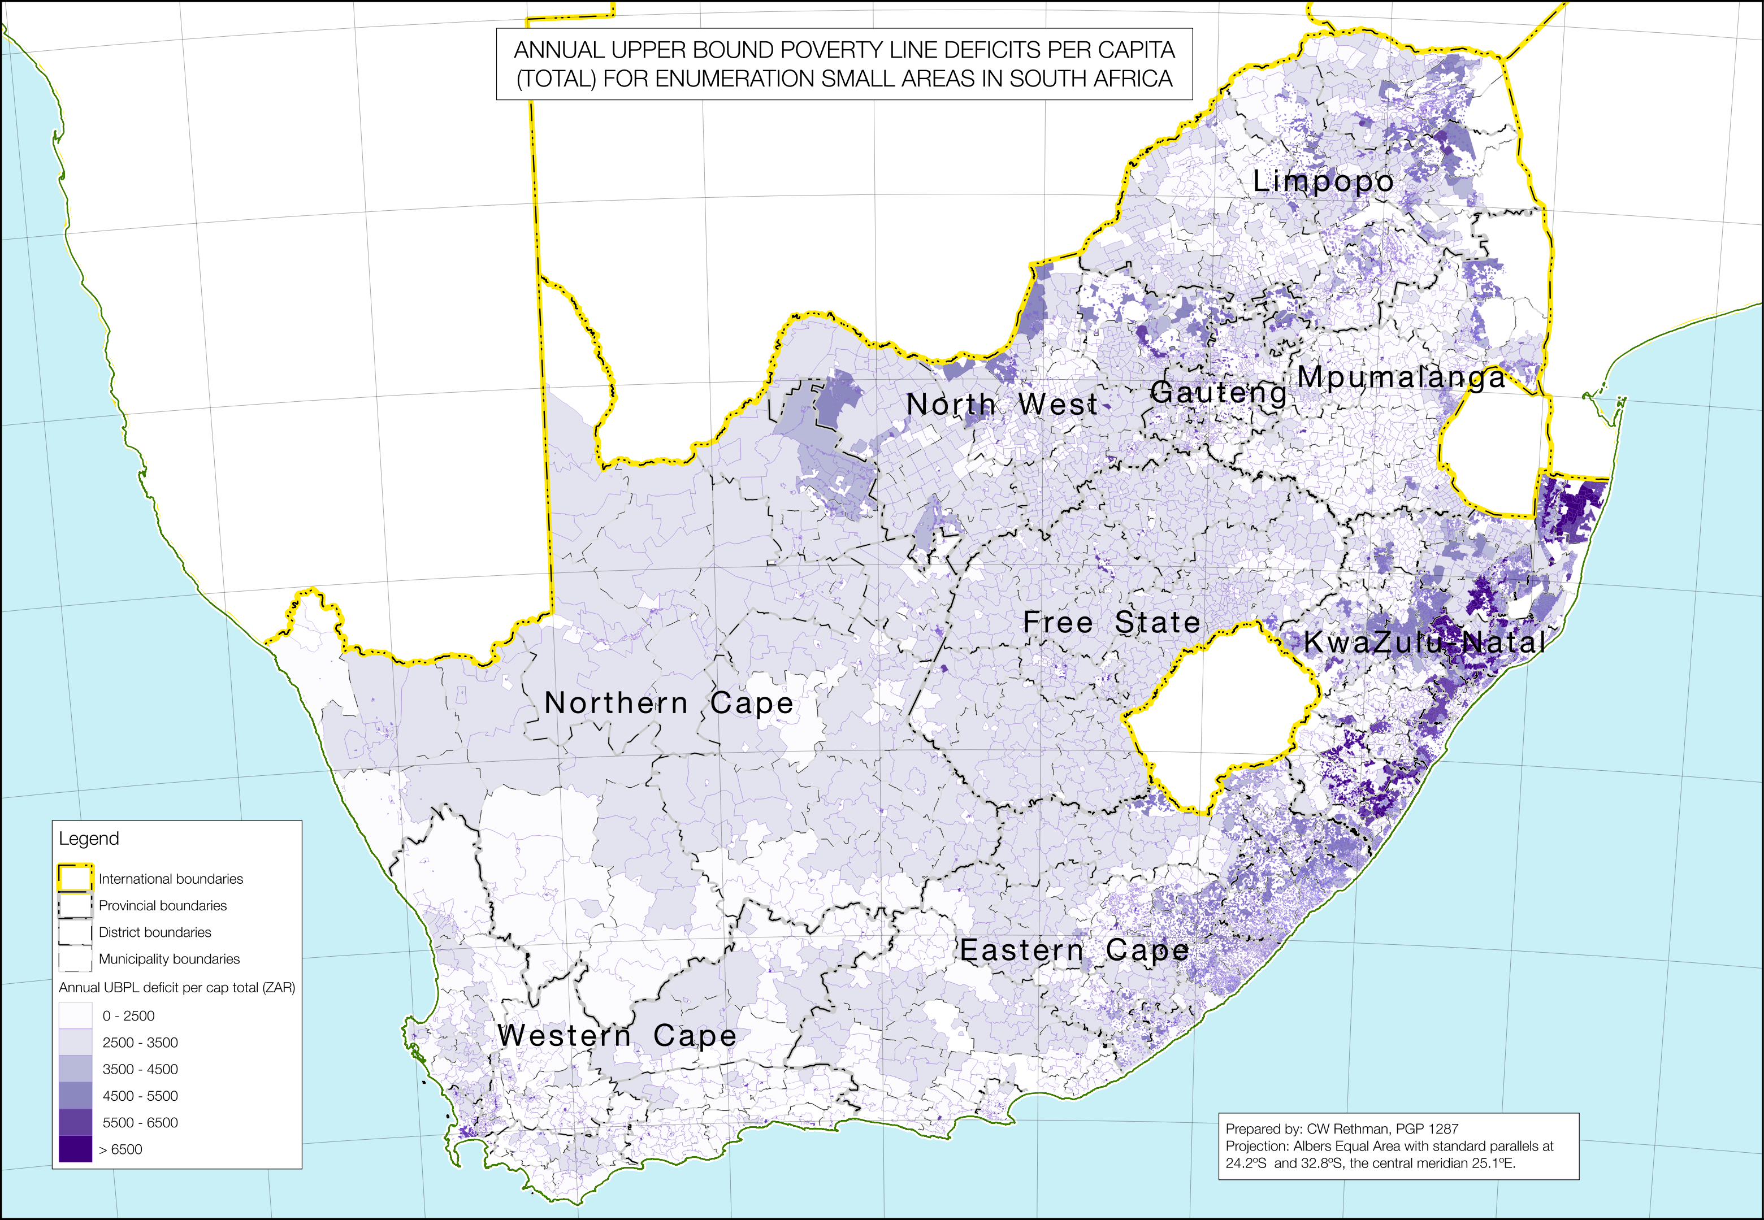

**Figure** 46: Choropleth map of the upper bound poverty line (UBPL) deficit in Rands per person at risk, by enumeration small areas, municipalities, districts and provinces.

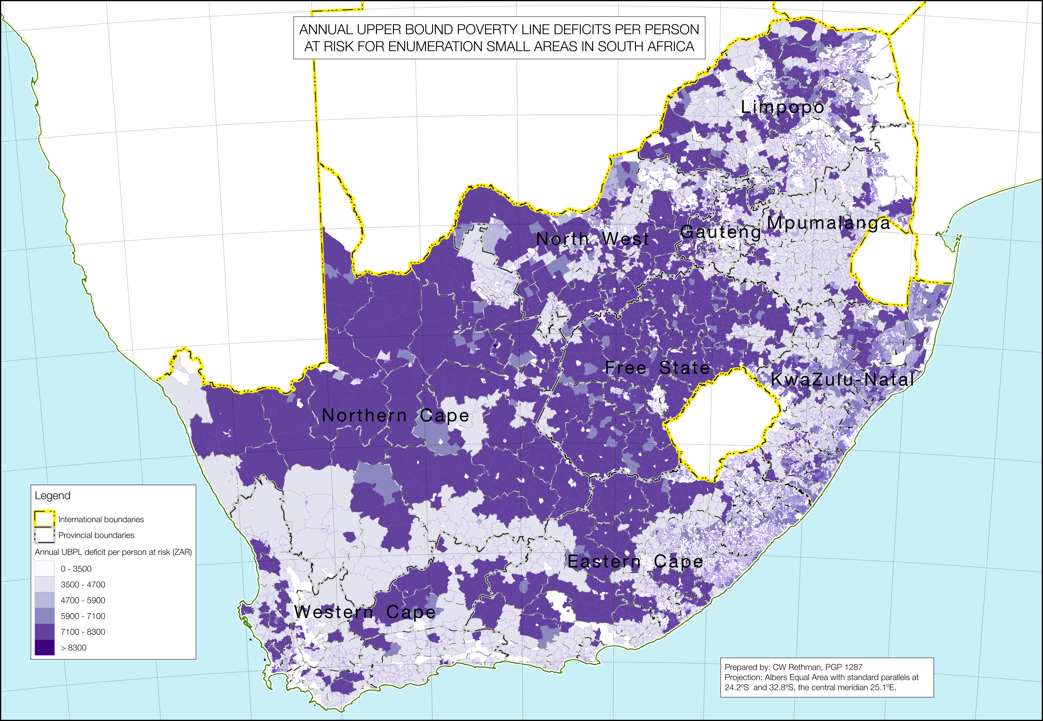

In the current consumption year, April 2016 to March 2017, households will face difficulties with the hike in basic food prices, brought on by the weak Rand and the current drought, which has forced the country into importing a greater percentage of food stuffs, especially cereals, than is usual. On top of this, households that support themselves, albeit to a limited extent, with their own crops and agriculture, have experienced severe failures in the areas exposed to the drought. Other knock-on effects are reduced opportunities for labour-based employment, both full-time and casual. This impacts on the poorest households in both rural and urban areas the most. *Households, in both rural (traditional tenure and commercial farm areas) and urban settings, drought-affected and not-affected areas, that are unable to have at least one member access social grants are at extreme risk—they are facing critical food shortages and hunger that needs to be addressed immediately and adequately*.

The ‘poor’ and ‘very poor’ households in all livelihood zones rely mostly on purchases (an average of 80% of their total annual food energy intake) and this makes them highly vulnerable to fluctuating food prices. The combination of high food and other commodity prices, constrained work opportunities (especially through reduced availability of both agricultural labour and domestic labour opportunities), augmented somewhat by poor crop production from April 2016 onwards, will reduce household capacity across the board in livelihood zones to access quality food and a decent standard of living, defined by the Upper Bound Poverty Line.

Approximately 4,883,000 people are below the average food energy requirement of 8,800 kJ per person per day. The total food energy deficit be 420,850 metric tons for the whole year. There will be approximately 4,915,500 people below the Food Poverty Line (FPL) this consumption year, totalling up to a deficit of approximately ZAR 8,130,035,000. These people are *in addition to* previous numbers from income-expenditure surveys. The Upper Bound Poverty Line (UBPL), considered a measure of general poverty, will have 25,143,600 people with a deficit, that accumulates to ZAR 123,353,449,000 or ZAR 123 billion.

### Recommendations

#### IMMEDIATE

1. Consider ramping up social grants temporarily for all indigent households. This should be aimed at the those households facing food energy deficits (this generally excludes all households already on some sort of grant). It should be scaled back once food prices stabilise or, hopefully, come down from their current levels. This could be considered an emergency response;
2. Maintain financial discipline and fiscal prudence to protect the Rand from any further devaluation. This will help stabilise prices.

#### FURTHER ALONG

1. The Extended Public Works Programme (EPWP) can provide assets to communities and may be self-selecting to targeted the ‘very poor’ and ‘poor’ households, at the same time increasing available employment slots;
2. The SAVAC needs to continue with its high level of commitment and energy in completing the baselines. At present, funding is a constraint and the committee needs to actively seek more sustainable funding. Once this is in place, tools can be developed and systems improved to streamline and make data collection and analysis more cost-effective;
3. Crop assessments need to be extended to traditional or open access areas and made available easily to the public. The data should be available to the lowest possible level; at the very least at the municipality level. This will increase awareness of and contributions to agriculture, as well as improving this kind of analysis;
4. Pressure to deliver services must be maintained and waste minimised. Opportunities for job creation, especially in urban areas but also in the rural hinterland, need to be maximised.

#### LONGER TERM

1. There are opportunities to develop high potential land for increasing household incomes through irrigation of vegetables and other high value crops;
2. In many areas, food, crop and livestock production is plentiful, especially during the peak season but incomes are weak or non-existent due to the lack of markets or adequate marketing facilities. This is a priority area for investment;
3. Government agricultural inputs need to be managed efficiently and delivered on time to ensure timely operation of agricultural activities;
4. The is considerable potential for developing both individual and community micro-financing for job creating opportunities;
5. Continue with improvements in the quality and quantity of education, including adult education and training to enable opportunities in new sectors. New possibilities with e-learning arising from the spread of high bandwidth Internet, open source software and hardware, and mobile technologies should be considered.

## Appendix A

### List of all livelihood zones and codes included in the study, with the baselines used

Many baselines in the country have not yet been completed, so temporary ‘alternative baselines’ were synthesised in this study to permit approximate analysis. The following table lists the livelihood zones and their corresponding ‘alternative’ livelihood zones used for this analysis.

LZ Code | Alt Code | Abbrev | Alt Abbrev | Name | Alt Name

---------+----------+--------+------------+------------------------------------------------------------------+-----------------------------------------------------

59101 | 59100 | ZALOC | ZA1XX | Lowveld open access cattle and other income | Open access livestock husbandry

59102 | 59100 | ZAKOL | ZA1XX | Kgalagadi open access livestock and other income | Open access livestock husbandry

59103 | 59100 | ZAOCG | ZA1XX | Western open access cattle and game farming | Open access livestock husbandry

59104 | 59100 | ZABOL | ZA1XX | Highveld border open access livestock | Open access livestock husbandry

59105 | 59105 | ZATGL | ZATGL | Thukela and Lebombo sparsely populated | Thukela and Lebombo sparsely populated

59106 | 59106 | ZACNI | ZACNI | Coastal open access non-crop income | Coastal open access non-crop income

59107 | 59107 | ZAOLO | ZAOLO | Inland open access livestock and other income | Inland open access livestock and other income

59108 | 59100 | ZACHO | ZA1XX | Cold highlands open access livestock | Open access livestock husbandry

59109 | 59100 | ZAVTO | ZA1XX | Valley thicket open access livestock | Open access livestock husbandry

59110 | 59100 | ZAMOL | ZA1XX | Midlands open access livestock and dairy | Open access livestock husbandry

59151 | 59050 | ZALER | ZA_FW | Central Limpopo cattle ranching | Commercial farm workers

59152 | 59050 | ZALGR | ZA_FW | Lowveld game ranching | Commercial farm workers

59153 | 59050 | ZAWCG | ZA_FW | North western cattle and game ranching | Commercial farm workers

59154 | 59050 | ZASWG | ZA_FW | Swartruggens game ranching | Commercial farm workers

59155 | 59050 | ZAHGR | ZA_FW | Highveld cattle and game farming | Commercial farm workers

59156 | 59050 | ZALCL | ZA_FW | Lowveld cattle and livestock grazing | Commercial farm workers

59157 | 59050 | ZAGKA | ZA_FW | Great Karoo small stock | Commercial farm workers

59158 | 59050 | ZAPLD | ZA_FW | Upland dairy and stock farming | Commercial farm workers

59159 | 59050 | ZAXGF | ZA_FW | Xariep-Great Fish valley small stock | Commercial farm workers

59160 | 59050 | ZACHX | ZA_FW | Cold moist highlands exclusive access livestock | Commercial farm workers

59161 | 59050 | ZAKHL | ZA_FW | Karoo highlands livestock | Commercial farm workers

59162 | 59050 | ZAMXL | ZA_FW | Midlands exclusive access livestock and dairy | Commercial farm workers

59163 | 59050 | ZAKUK | ZA_FW | Baviaans Karoo mountains livestock | Commercial farm workers

59164 | 59050 | ZASCD | ZA_FW | Southern coast duneveld | Commercial farm workers

59201 | 59200 | ZALCM | ZA2XX | Lowveld open access mixed farming | Open access mixed livestock and crops

59202 | 59202 | ZANOC | ZANOC | Northern open access cattle and dryland crops | Northern open access cattle and dryland crops

59203 | 59203 | ZASLC | ZASLC | Southern Limpopo open access cattle and crops | Southern Limpopo open access cattle and crops

59204 | 59200 | ZANWC | ZA2XX | North western open access cattle crops | Open access mixed livestock and crops

59205 | 59200 | ZAHMI | ZA2XX | Highveld open access mixed income | Open access mixed livestock and crops

59206 | 59206 | ZALRC | ZALRC | Open access low intensity rainfed cultivation | Open access low intensity rainfed cultivation

59207 | 59207 | ZANFL | ZANFL | Northern inland open access farming and livestock | Northern inland open access farming and livestock

59208 | 59208 | ZAKHC | ZAKHC | Ukhahlamba open access intense crops and livestock | Ukhahlamba open access intense crops and livestock

59209 | 59209 | ZAOCC | ZAOCC | Free State open access cattle and crops | Free State open access cattle and crops

59210 | 59210 | ZAMMO | ZAMMO | Mzimkulu-Mkomazi midlands open access mixed farming | Mzimkulu-Mkomazi midlands open access mixed farming

59211 | 59200 | ZAMIO | ZA2XX | Midlands and coastal open access mixed livestock and crops | Open access mixed livestock and crops

59251 | 59050 | ZALCV | ZA_FW | North central Limpopo cattle and vegetables | Commercial farm workers

59252 | 59050 | ZALEM | ZA_FW | Limpopo Escarpment Mixed Farming | Commercial farm workers

59253 | 59050 | ZAEMA | ZA_FW | Eastern mountains mixed agriculture | Commercial farm workers

59254 | 59050 | ZACMW | ZA_FW | Central maize, wheat and cattle | Commercial farm workers

59255 | 59050 | ZANWX | ZA_FW | North West exclusive access smallholders | Commercial farm workers

59256 | 59050 | ZAMLC | ZA_FW | Cold highveld mixed livestock and crops | Commercial farm workers

59257 | 59050 | ZAHWC | ZA_FW | Upper Senqu and Harrismith cereal and cattle | Commercial farm workers

59258 | 59050 | ZAEMF | ZA_FW | Kwazulu-Natal extensive mixed farming | Commercial farm workers

59259 | 59050 | ZASSC | ZA_FW | Free State small stock and crops | Commercial farm workers

59260 | 59050 | ZAMIX | ZA_FW | Midlands and coastal exclusive access mixed livestock and crops | Commercial farm workers

59261 | 59050 | ZAHMX | ZA_FW | Highland exclusive access mixed farming | Commercial farm workers

59262 | 59050 | ZAMEM | ZA_FW | Emalahleni midlands mixed access mixed livestock and crops | Commercial farm workers

59263 | 59050 | ZACKA | ZA_FW | Cederberg Karoo | Commercial farm workers

59264 | 59050 | ZAWSC | ZA_FW | West Coast and Bredasdorp grain and small stock | Commercial farm workers

59265 | 59050 | ZASWA | ZA_FW | Swartland mixed grain, fruit and dairy | Commercial farm workers

59266 | 59050 | ZALKH | ZA_FW | Little Karoo high fruit and dairy mixed farming | Commercial farm workers

59267 | 59050 | ZAKSW | ZA_FW | Kango-Swartberg livestock and crops | Commercial farm workers

59268 | 59050 | ZALKA | ZA_FW | Little Karoo ostriches and mixed farming | Commercial farm workers

59269 | 59050 | ZALAN | ZA_FW | Kou-Kamma Langkloof valley crops and livestock | Commercial farm workers

59270 | 59050 | ZAOUT | ZA_FW | Outeniqua plateau mixed farming, dairy and forests | Commercial farm workers

59271 | 59050 | ZACHR | ZA_FW | Caledon-Heidelberg-Riversdal small grain, dairy and livestock | Commercial farm workers

59301 | 59301 | ZALOF | ZALOF | North eastern Limpopo open access farming | North eastern Limpopo open access farming

59302 | 59302 | ZALOI | ZALOI | Lowveld open access irrigated cropping | Lowveld open access irrigated cropping

59303 | 59300 | ZAHIC | ZA3XX | Highveld open access intensive cropping | Open access cropping

59304 | 59304 | ZANCC | ZANCC | North coast open access intense cultivation | North coast open access intense cultivation

59305 | 59305 | ZASCO | ZASCO | South coast intensive open access cropping | South coast intensive open access cropping

59351 | 59050 | ZALIC | ZA_FW | Limpopo River intensive crop farming | Commercial farm workers

59352 | 59050 | ZALFF | ZA_FW | North eastern Limpopo intensive fruit farming | Commercial farm workers

59353 | 59050 | ZASLC | ZA_FW | Southern Limpopo crop farming | Commercial farm workers

59354 | 59050 | ZAHFC | ZA_FW | Hoedspruit Fruit and Cereal | Commercial farm workers

59355 | 59050 | ZAHOI | ZA_FW | Highveld Olifants River irrigated farming | Commercial farm workers

59356 | 59050 | ZANBI | ZA_FW | North western bushveld irrigated | Commercial farm workers

59357 | 59050 | ZAELC | ZA_FW | Eastern lowveld mixed cropping | Commercial farm workers

59358 | 59050 | ZAHVC | ZA_FW | Highveld vegetables and crops | Commercial farm workers

59360 | 59050 | ZAVIC | ZA_FW | Vryburg irrigated crops | Commercial farm workers

59361 | 59050 | ZACMC | ZA_FW | Central mixed cropping | Commercial farm workers

59362 | 59050 | ZAVHI | ZA_FW | Vaal-Harts irrigated crops | Commercial farm workers

59363 | 59050 | ZAORI | ZA_FW | Orange River intensive irrigation | Commercial farm workers

59364 | 59050 | ZACEH | ZA_FW | South east cereal and horticulture | Commercial farm workers

59365 | 59050 | ZAWIV | ZA_FW | Weenen vegetables and other farming | Commercial farm workers

59366 | 59050 | ZAIFF | ZA_FW | Intensive fruit farming | Commercial farm workers

59367 | 59050 | ZAFCI | ZA_FW | Great Fish and Camdeboo irrigated farming | Commercial farm workers

59368 | 59050 | ZAOCL | ZA_FW | Lower Olifants River-Vredendal valley | Commercial farm workers

59369 | 59050 | ZAOCU | ZA_FW | Upper Olifants citrus and potatoes | Commercial farm workers

59370 | 59050 | ZAVIN | ZA_FW | Cape Winelands vineyards, fruit and other farming | Commercial farm workers

59371 | 59050 | ZACGE | ZA_FW | Ceres-Grabouw-Elgin cold fruit growing | Commercial farm workers

59372 | 59050 | ZABBR | ZA_FW | Breede Bot and Riviersonderend valley fruit and wine farming | Commercial farm workers

59373 | 59050 | ZASUN | ZA_FW | Addo Sundays River and other irrigated farms | Commercial farm workers

59374 | 59050 | ZAPHI | ZA_FW | Philippi and other horticulture | Commercial farm workers

59451 | 59050 | ZALSU | ZA_FW | Lowveld commercial sugar farming | Commercial farm workers

59452 | 59050 | ZACSU | ZA_FW | Coastal and Midlands sugar producing | Commercial farm workers

59551 | 59050 | ZAFOR | ZA_FW | Agriforestry plantations and forests | Commercial farm workers

59552 | 59050 | ZAWIL | ZA_FW | Wilderness-Plettenberg lakes forest and cattle | Commercial farm workers

59701 | 59899 | ZAUFH | ZA_UP | Urban, residential, fishing high unemployment | Urban poor

59830 | 59899 | ZAUIT | ZA_UP | Traditional tenure informal settlement | Urban poor

59831 | 59899 | ZAUIS | ZA_UP | Urban, residential, informal better serviced | Urban poor

59832 | 59899 | ZAUIC | ZA_UP | Urban, residential, informal service constrained | Urban poor

59841 | 59899 | ZAUBM | ZA_UP | Urban, residential, combined planned-informal | Urban poor

59842 | 59899 | ZAUBH | ZA_UP | Urban, residential, combined planned-informal high unemployment | Urban poor

59843 | 59899 | ZAUBA | ZA_UP | Urban, residential, combined planned-informal acute unemployment | Urban poor

59844 | 59899 | ZAUBE | ZA_UP | Urban, residential, combined planned-informal extreme poverty | Urban poor

59852 | 59899 | ZAUUH | ZA_UP | Urban, residential, municipal high-rise high unemployment | Urban poor

59862 | 59899 | ZAUHH | ZA_UP | Urban, residential tenements, high unemployment | Urban poor

59863 | 59899 | ZAUHA | ZA_UP | Urban, residential tenements, acute unemployment | Urban poor

59864 | 59899 | ZAUHE | ZA_UP | Urban, residential tenements, extreme poverty | Urban poor

59872 | 59899 | ZAUMH | ZA_UP | Urban, residential, mixed building high unemployment | Urban poor

59873 | 59899 | ZAUMA | ZA_UP | Urban, residential, mixed building acute unemployment | Urban poor

59882 | 59899 | ZAULH | ZA_UP | Urban, residential, low-rise high unemployment | Urban poor

59883 | 59899 | ZAULA | ZA_UP | Urban, residential, low-rise acute unemployment | Urban poor

59884 | 59899 | ZAULE | ZA_UP | Urban, residential, low-rise extreme poverty | Urban poor

59890 | 59050 | ZAUSM | ZA_FW | Urban, smallholdings, uncultivated or grazing | Commercial farm workers

(106 rows)

## Appendix B

### Graphs of the livelihood zones not reported in the text

Coastal open-access non-crop income (ZACNI, 59106)

North eastern Limpopo open access farming (ZALOF, 59301)

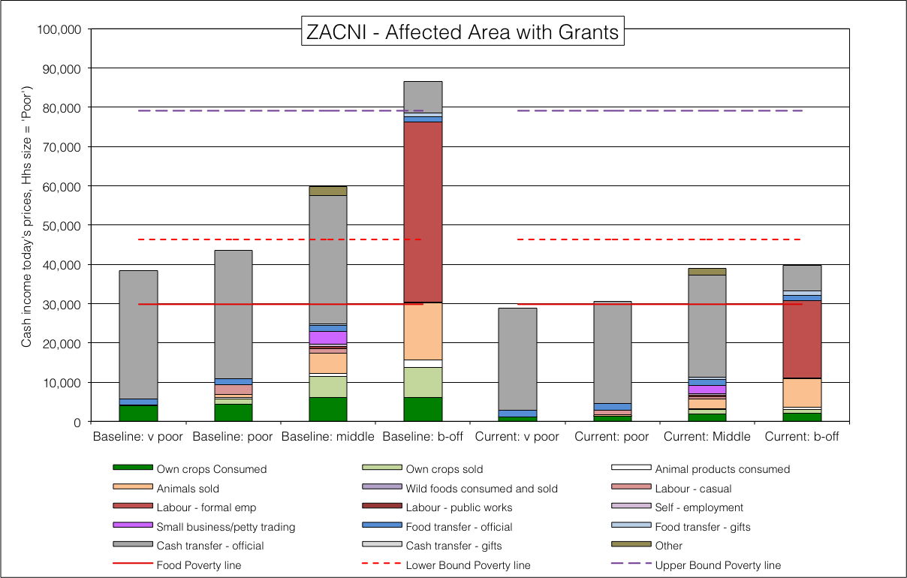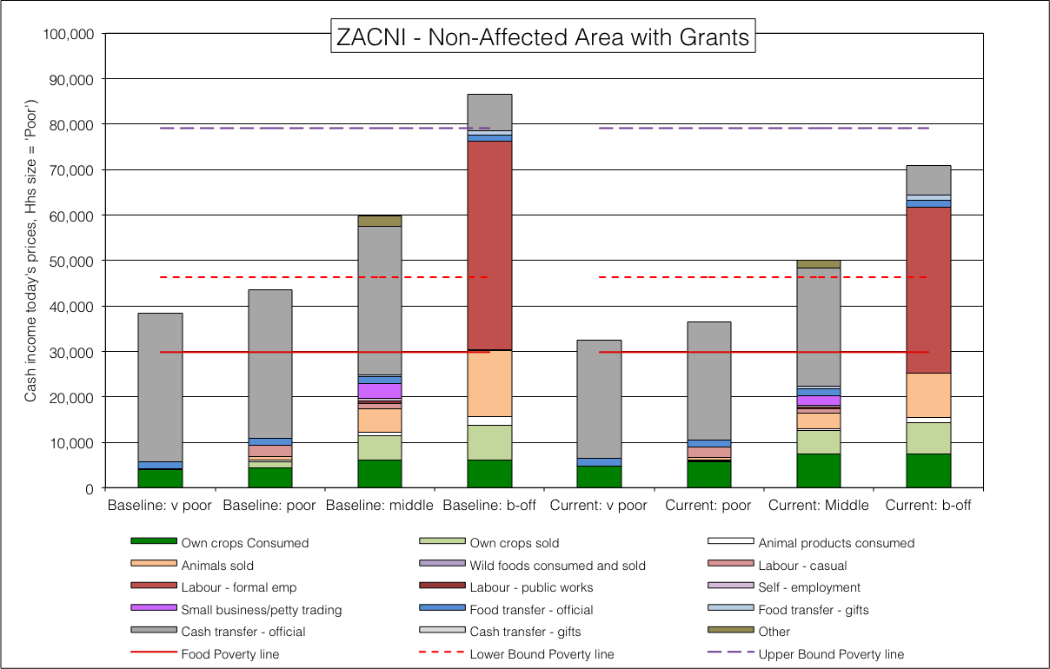

**Figure 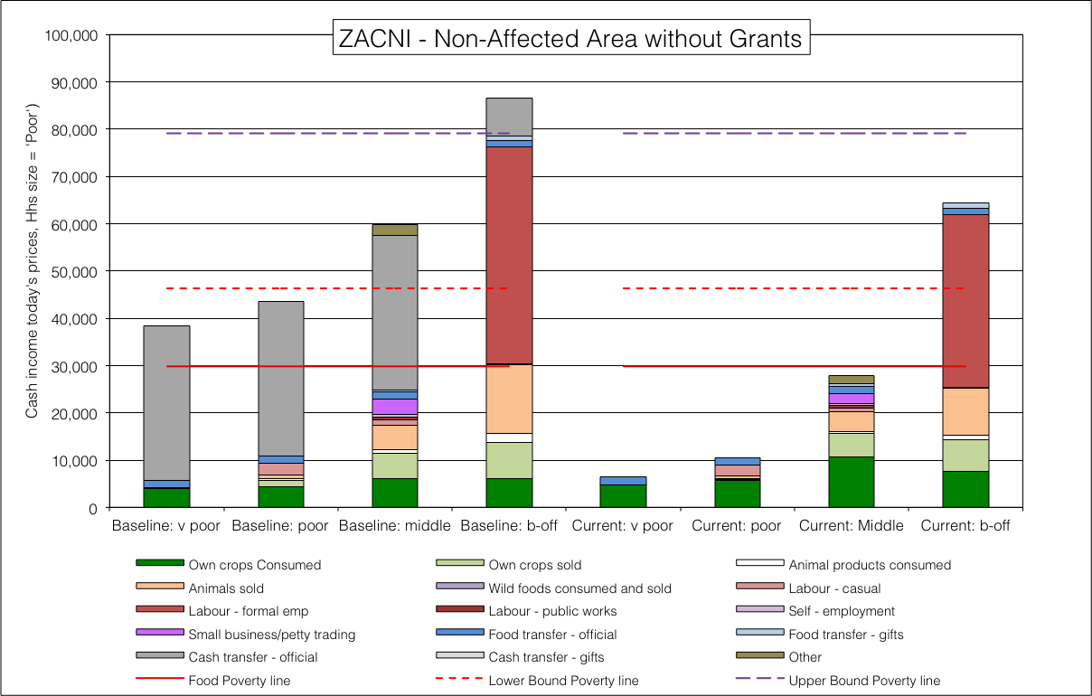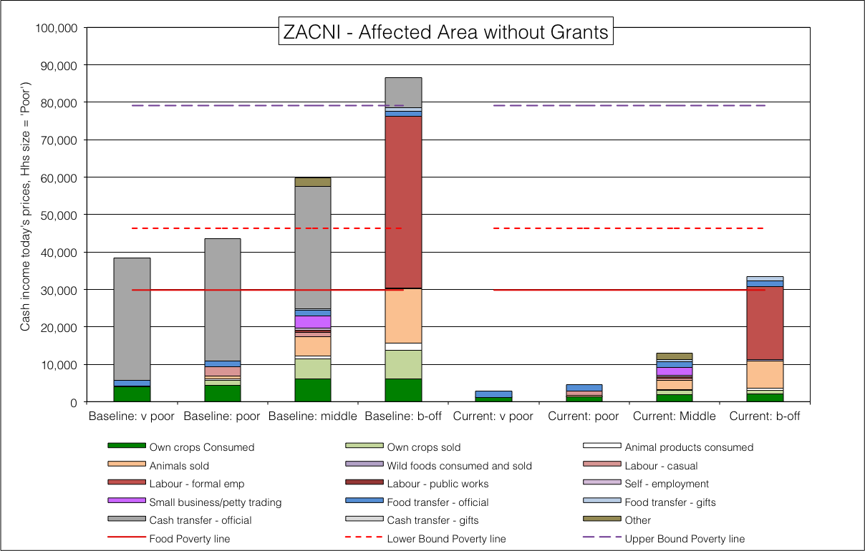**47: ZACNI livelihoods for each of the four scenarios

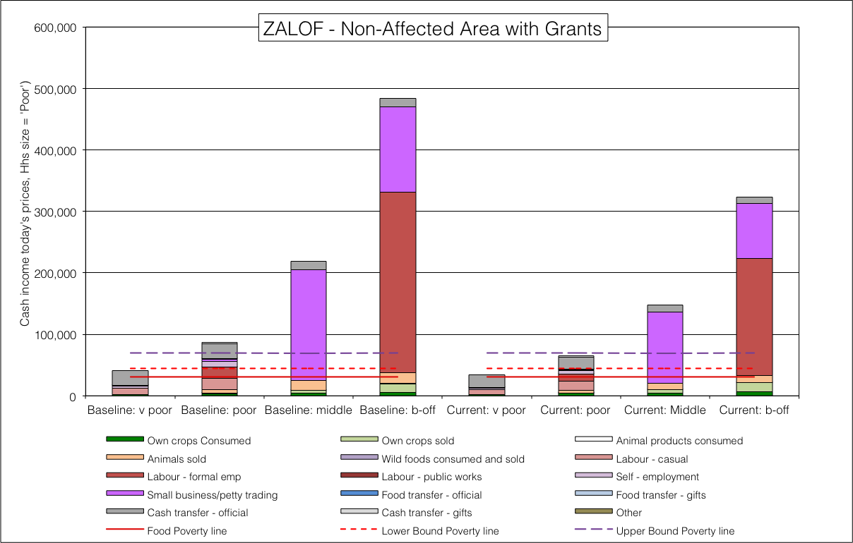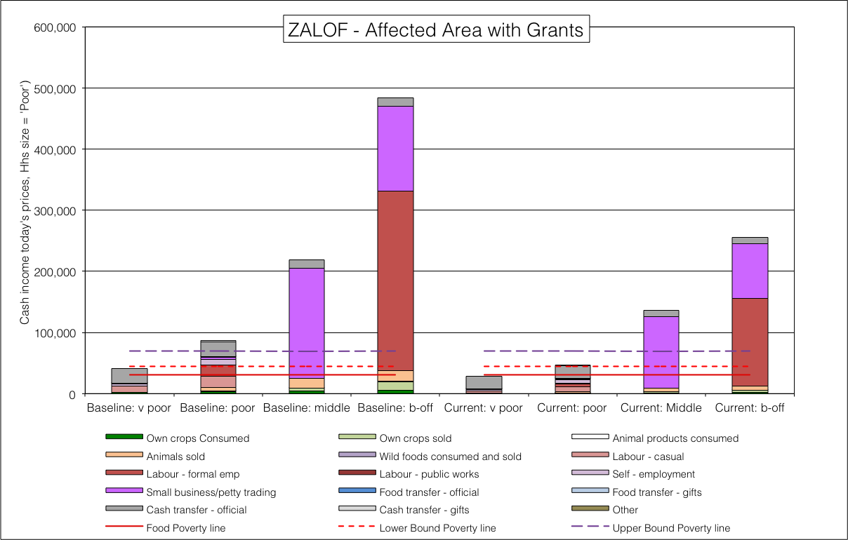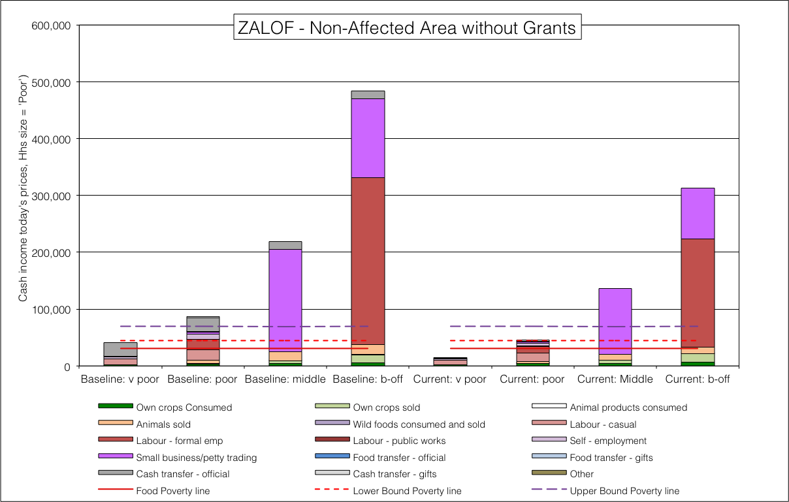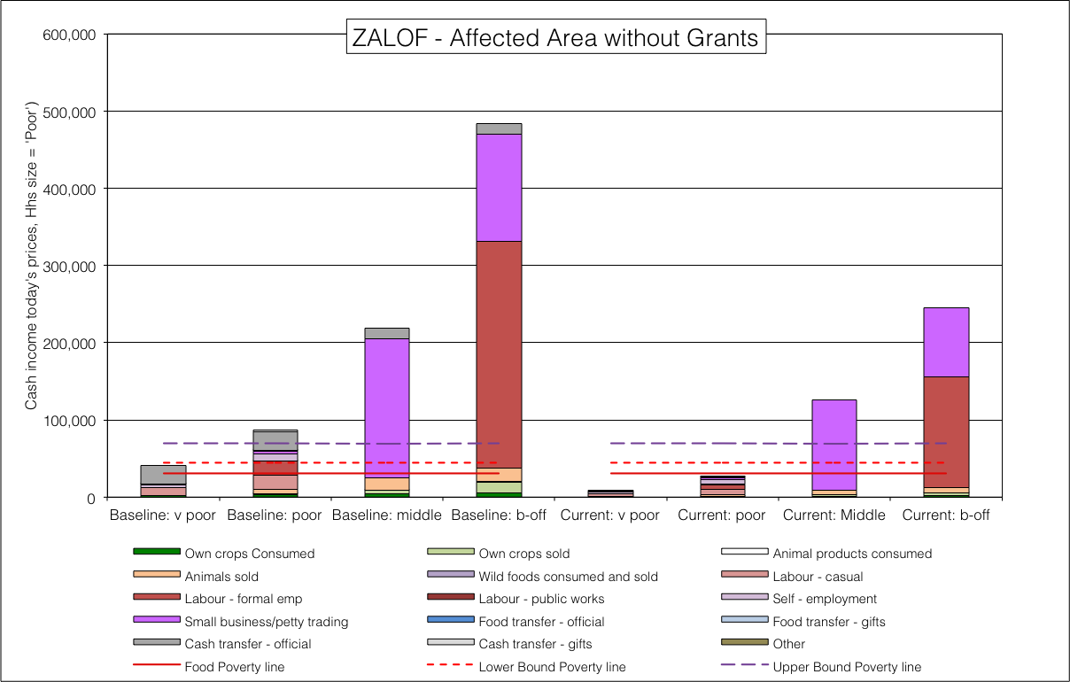

**Figure** 48: ZALOF livelihoods for each of the four scenarios

Lowveld Open Access Irrigated Cropping Livelihood Zone (ZALOI, 59302)

Open access low intensity rain fed cultivation (ZALRC, 59206)

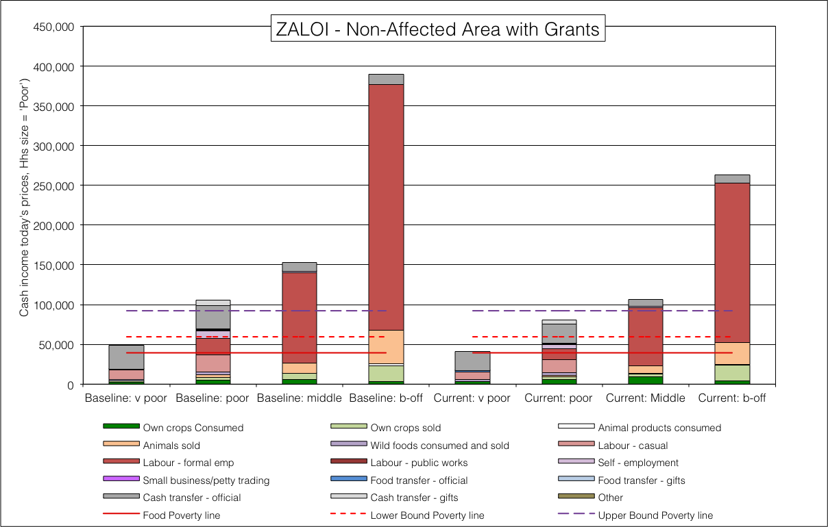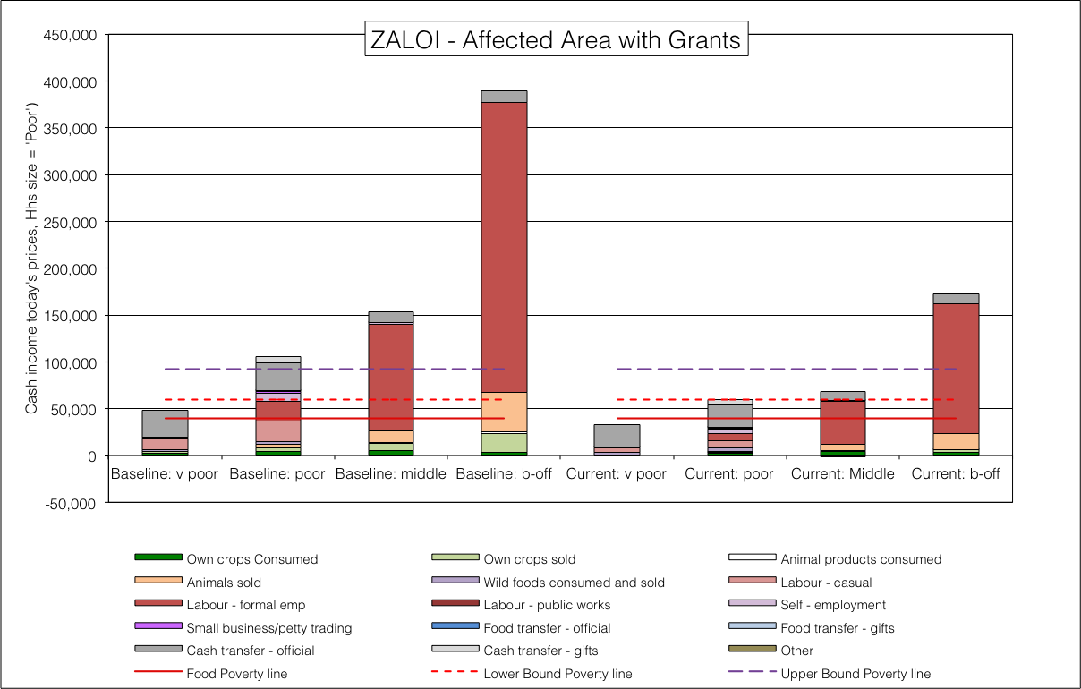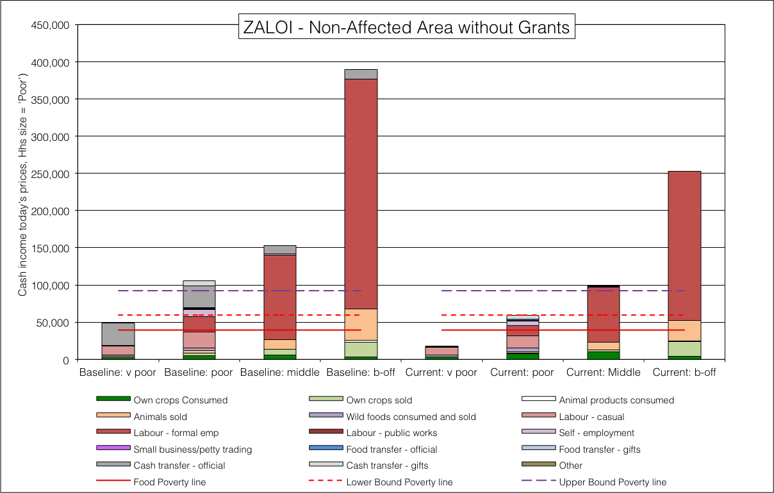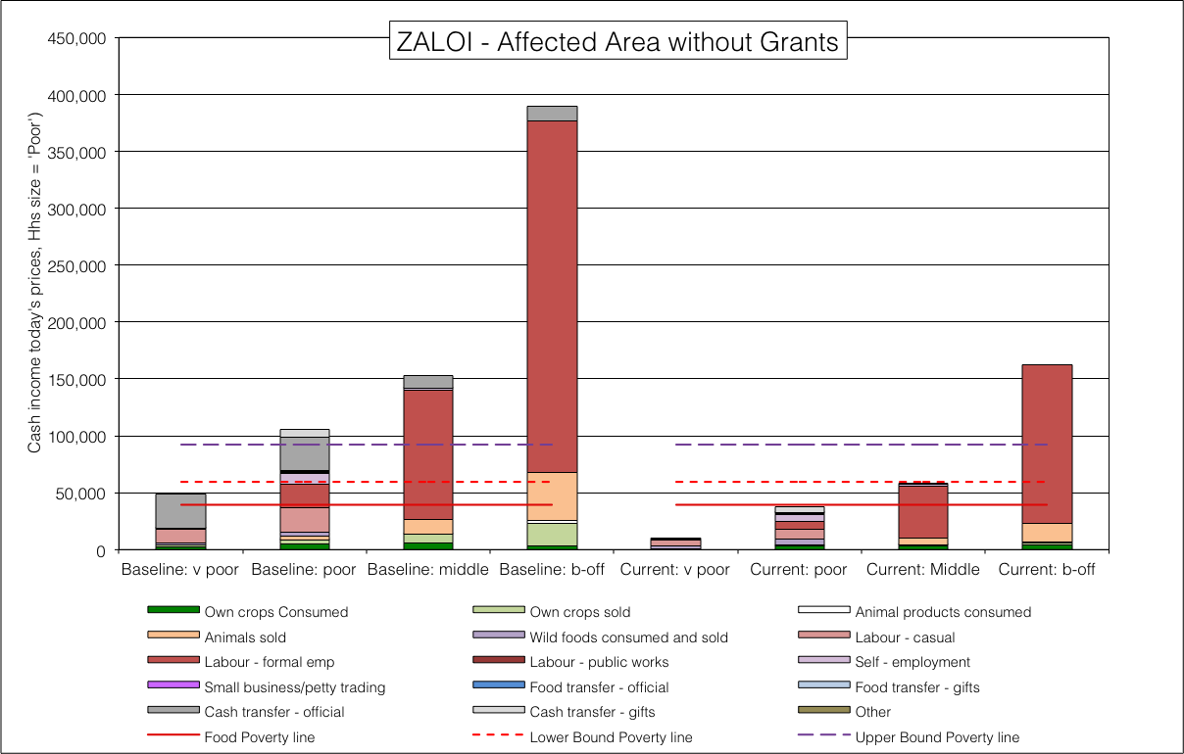**Figure** 49: ZALOI livelihoods for each of the four scenarios

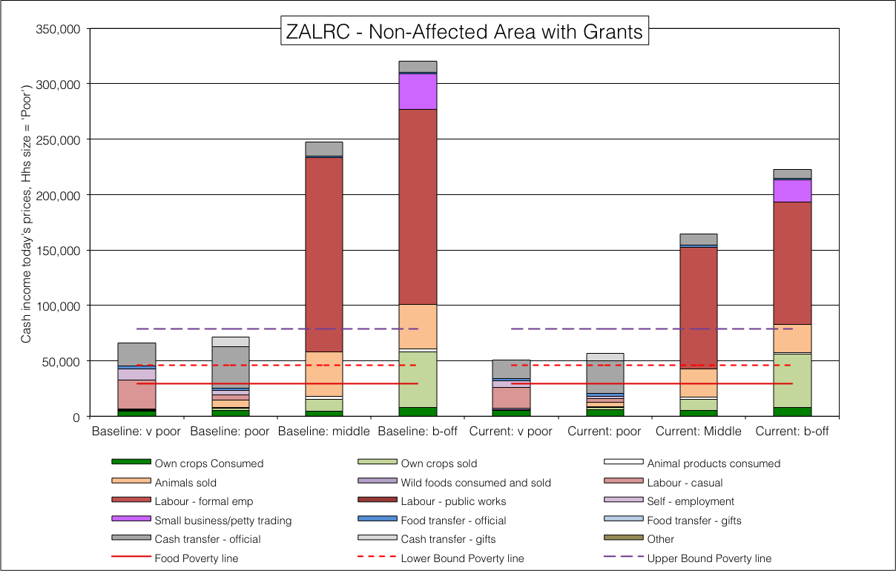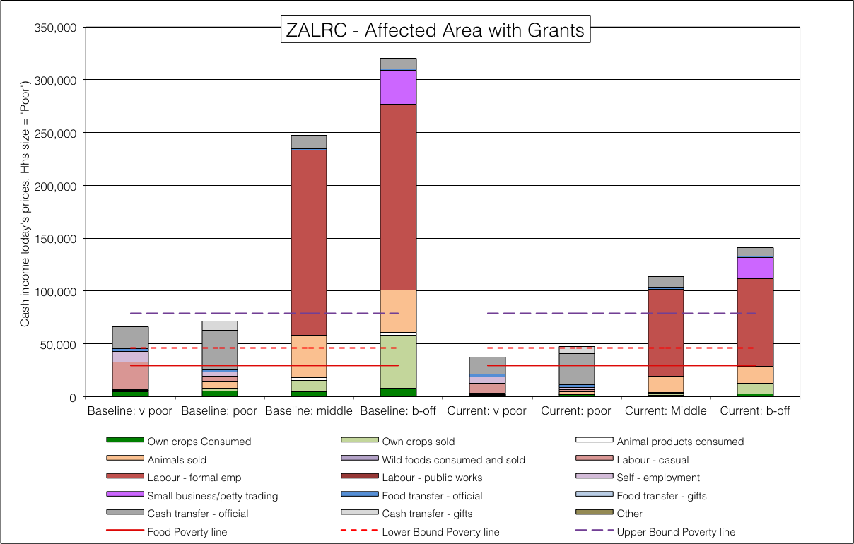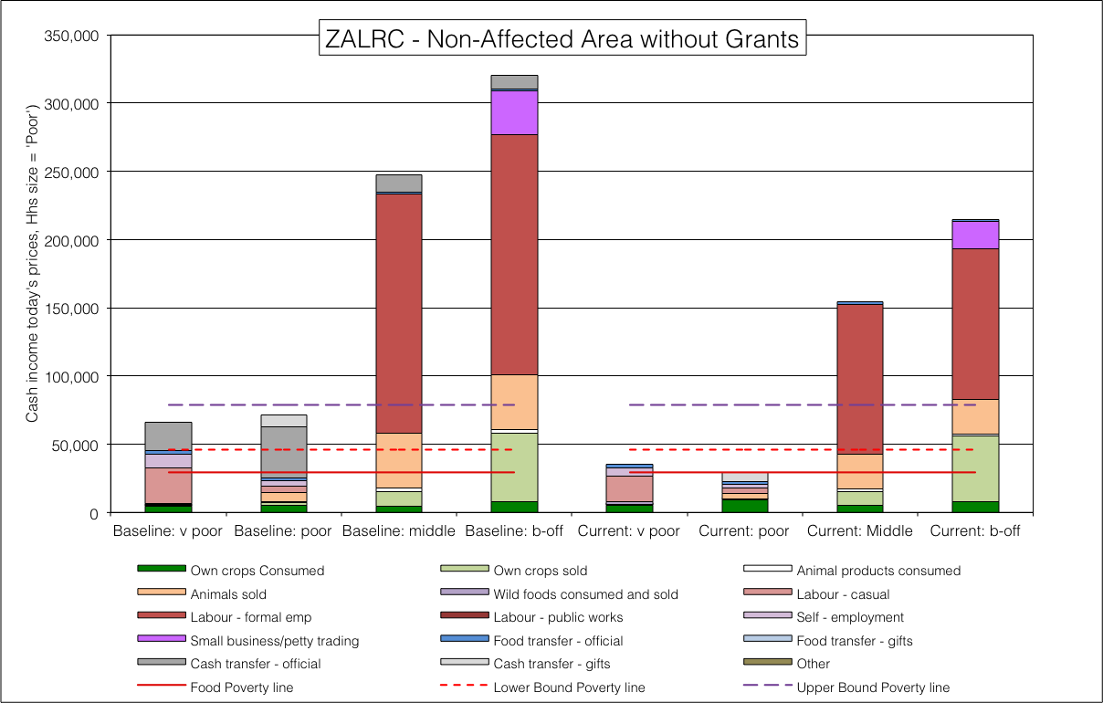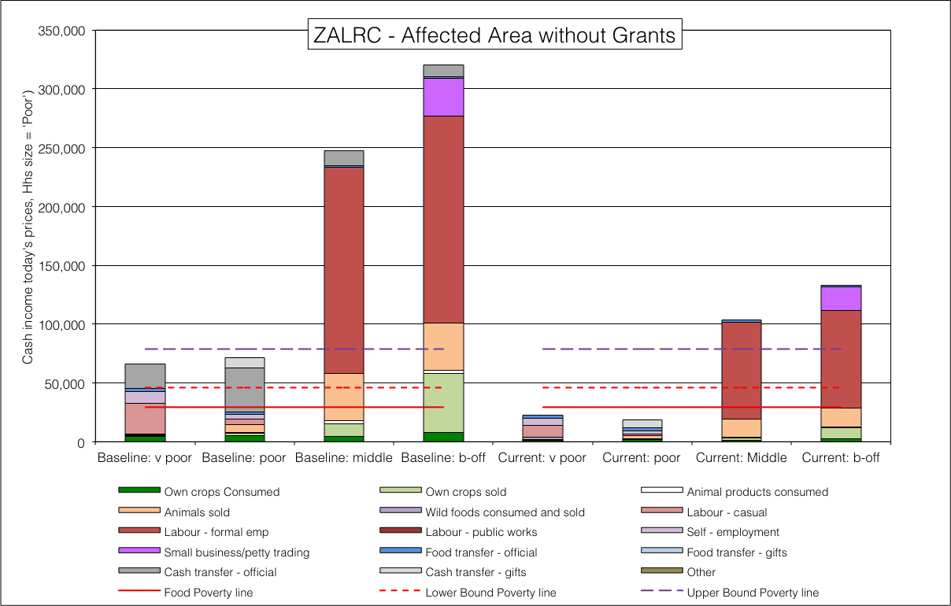**Figure** 50: ZALRC livelihoods for each of the four scenarios

Mzimkulu-Mkomazi midlands open access mixed farming (ZAMMO, 59210)

Northern inland open access farming and livestock (ZANFL, 59207)

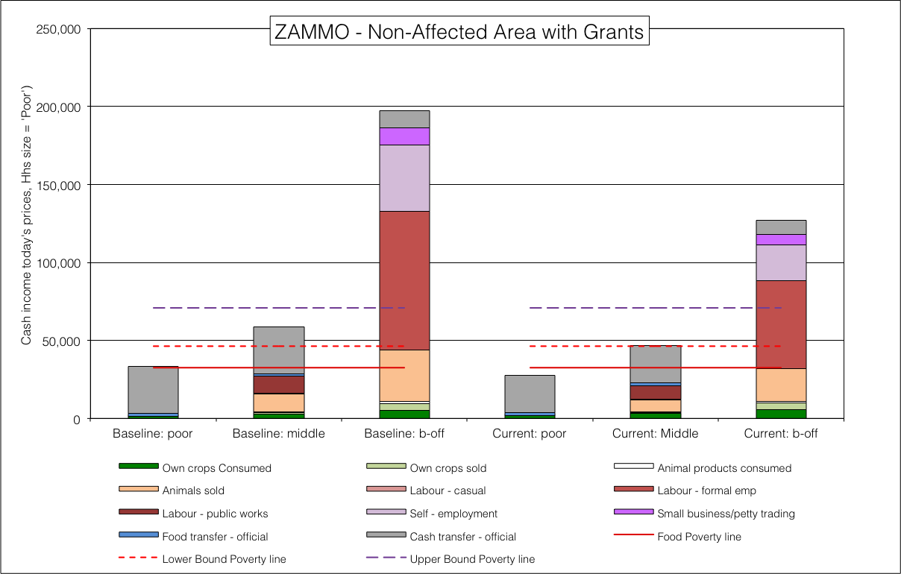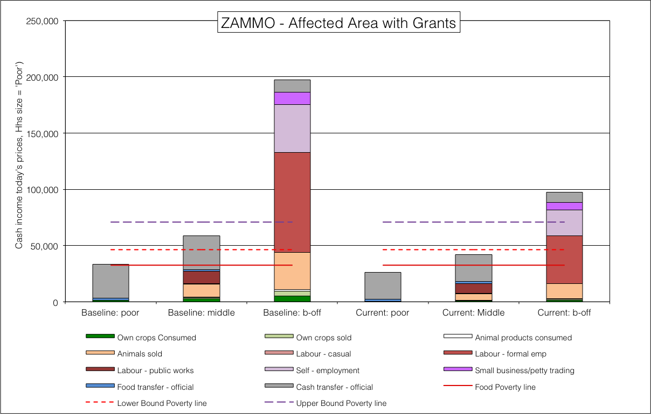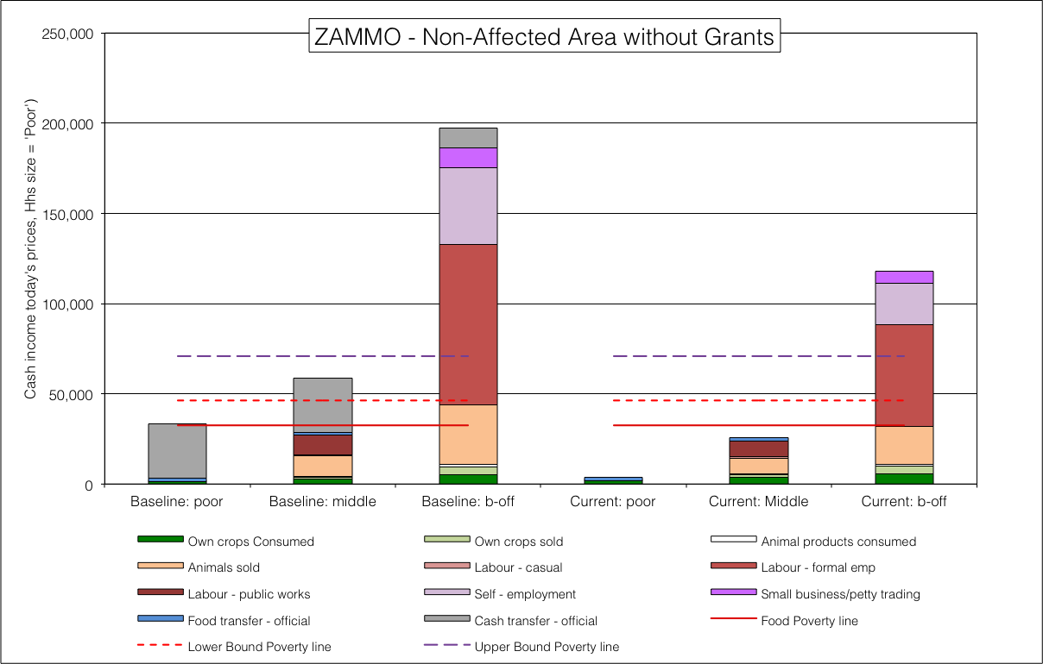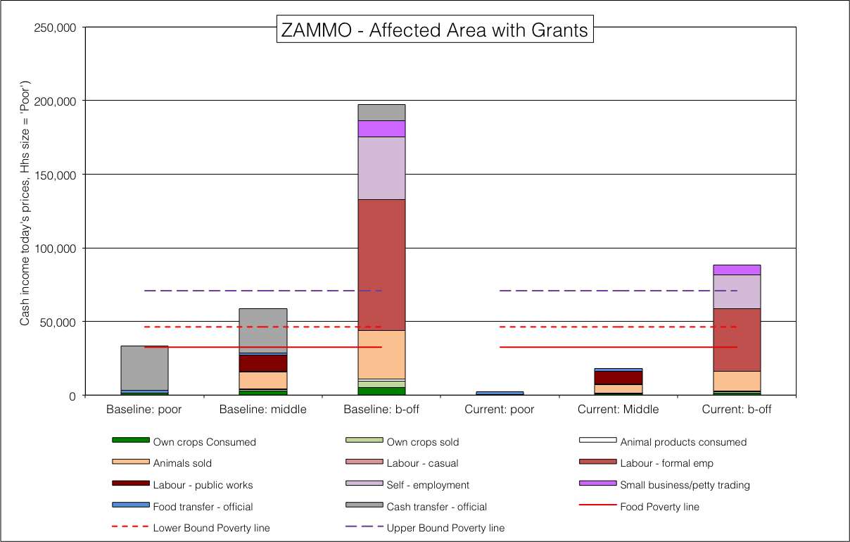**Figure** 51: ZAMMO livelihoods for each of the four scenarios

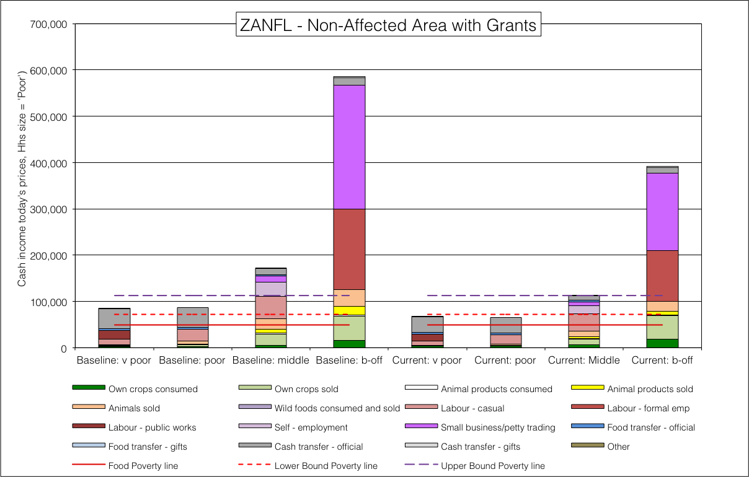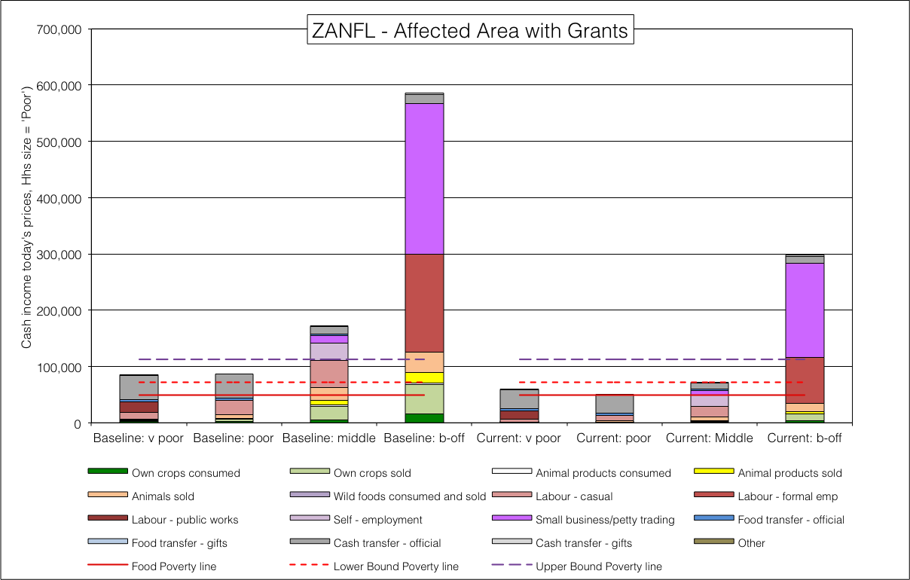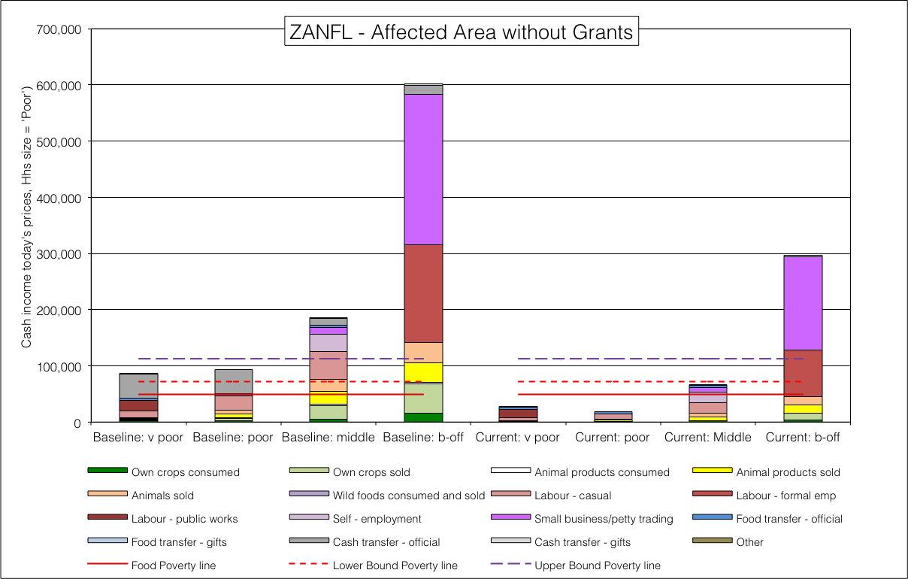**Figure** 52: ZANFL livelihoods for each of the four scenarios

Northern open access cattle and dry land crops livelihood zone (ZANOC, 59202)

Inland open access livestock and other income livelihood zone (ZAOLO, 59107)

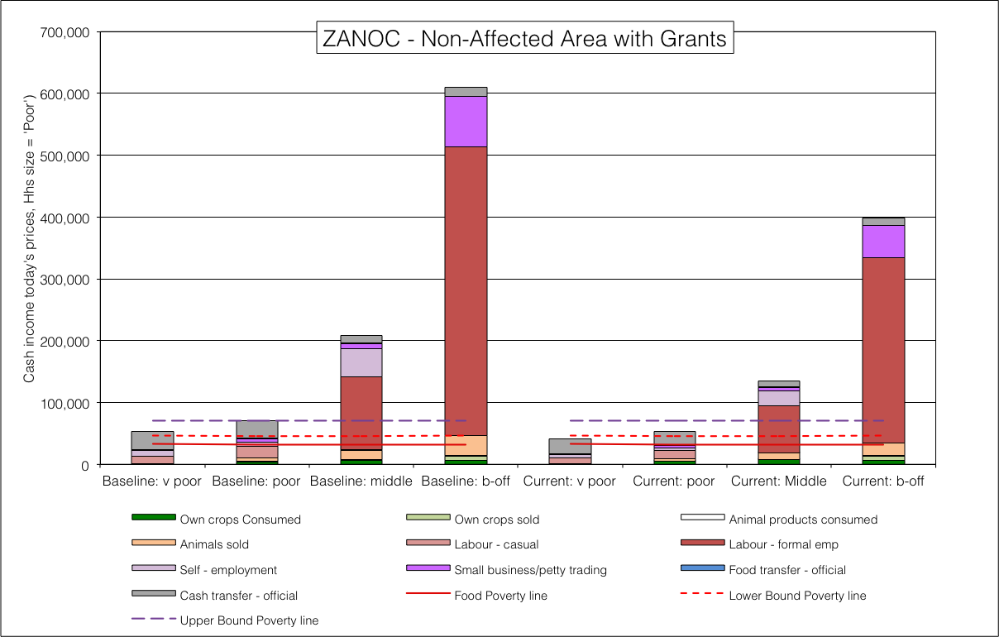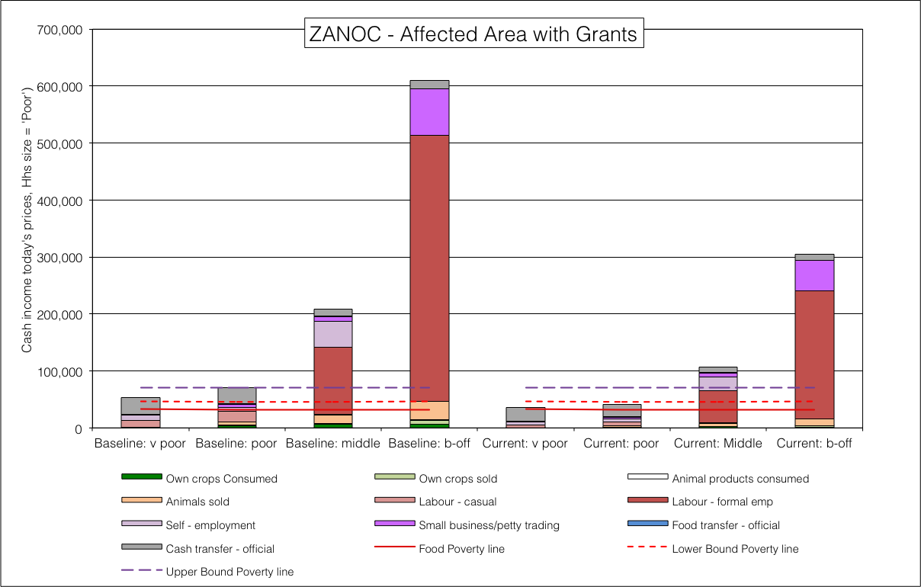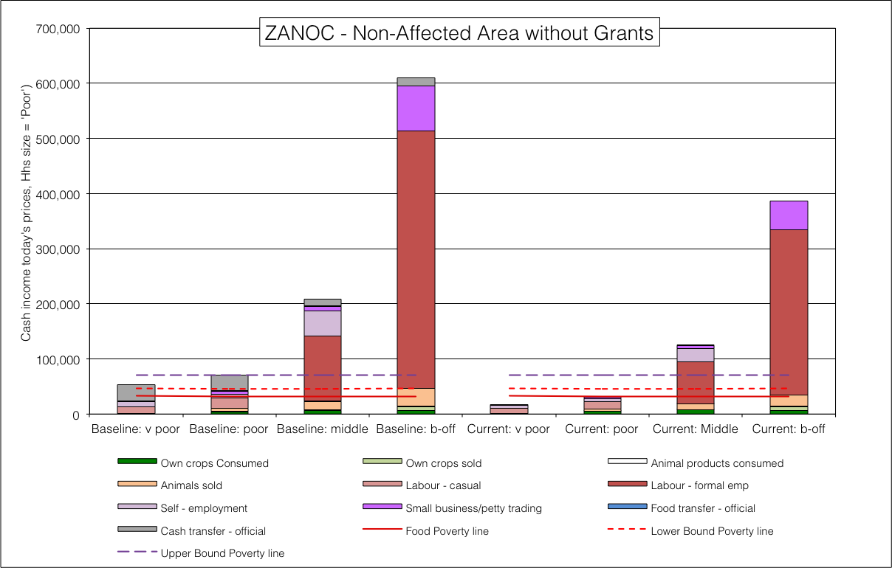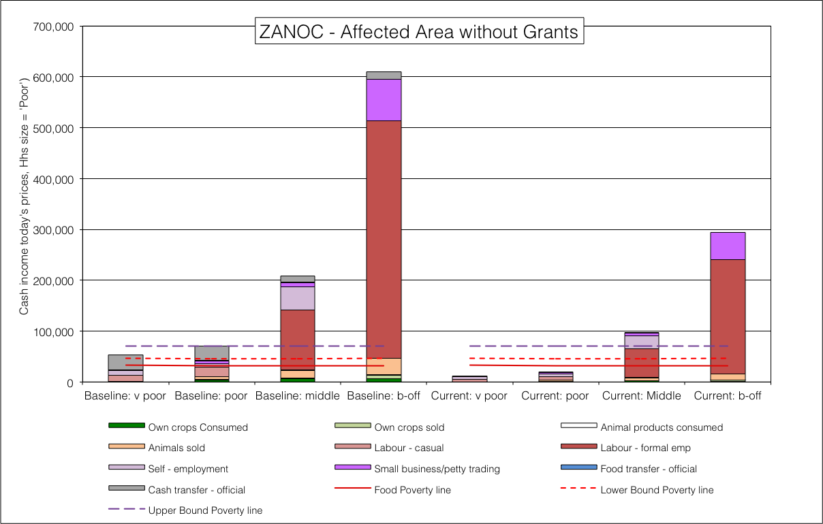**Figure** 53: ZANOC livelihoods for each of the four scenarios

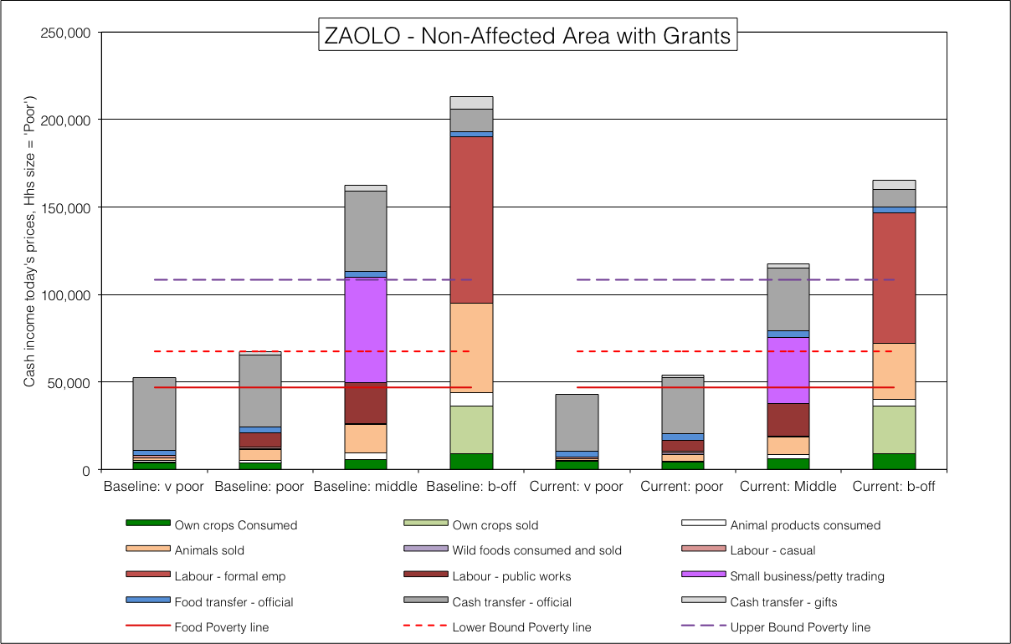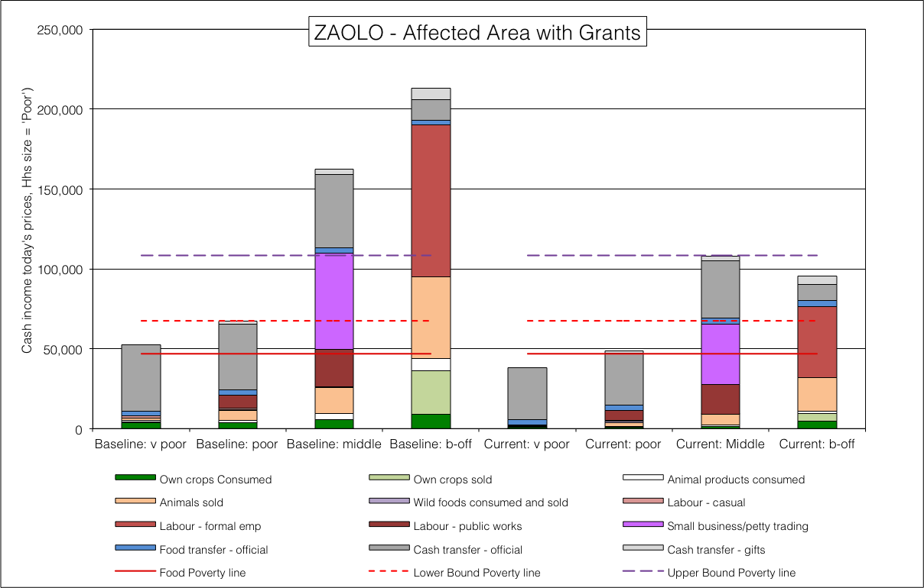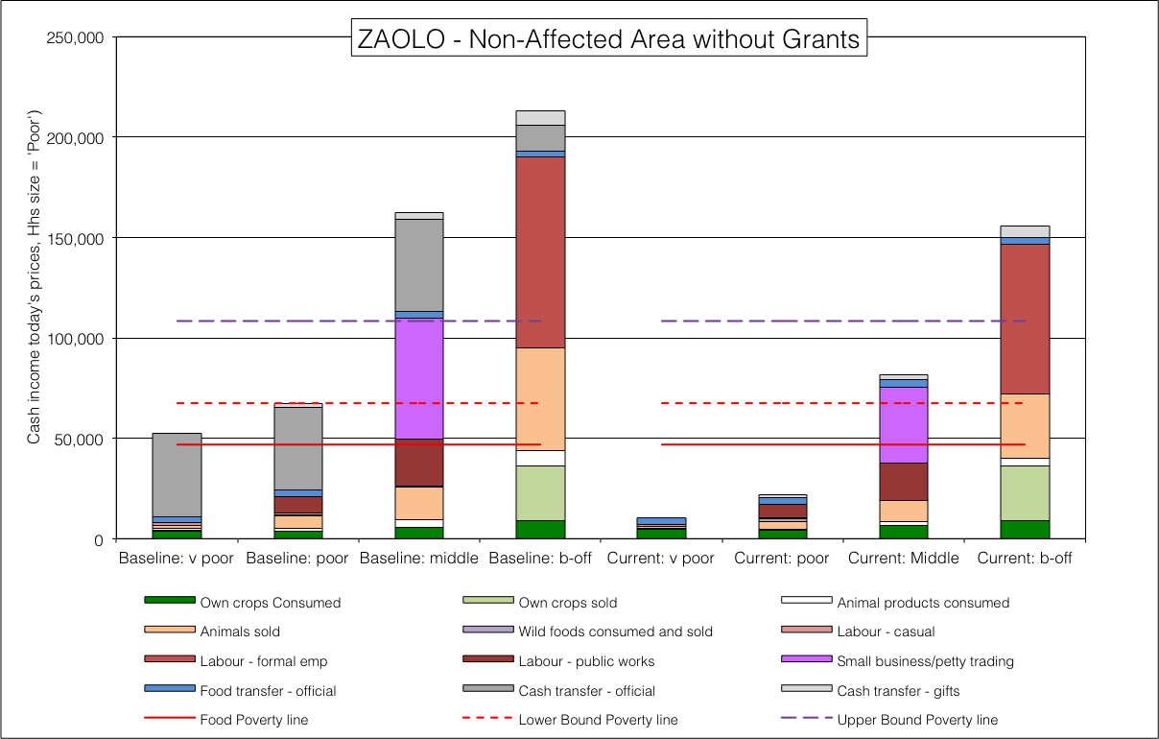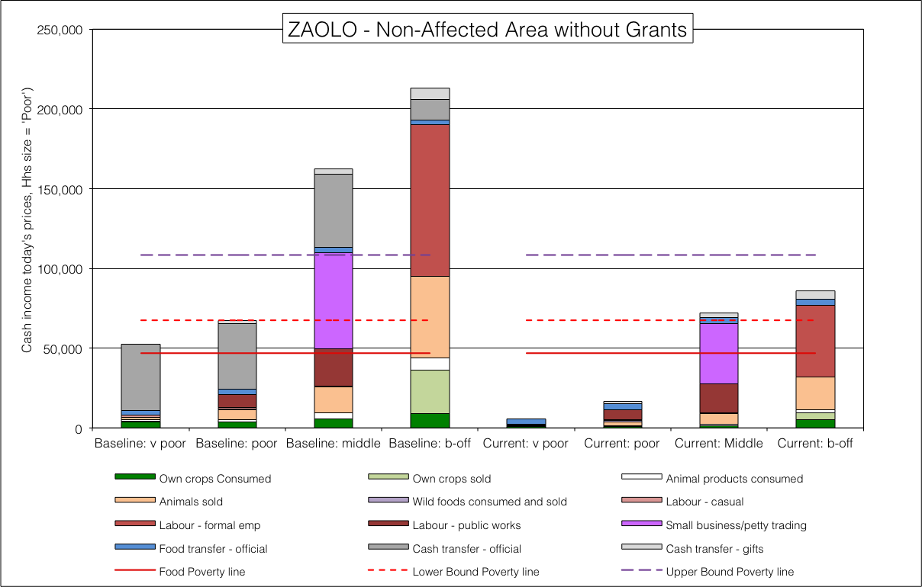**Figure** 54: ZAOLO livelihoods for each of the four scenarios

South coast intensive open access cropping (ZASCO, 59305)

Thukela and Lebombo sparsely populated (ZATGL, 59105)

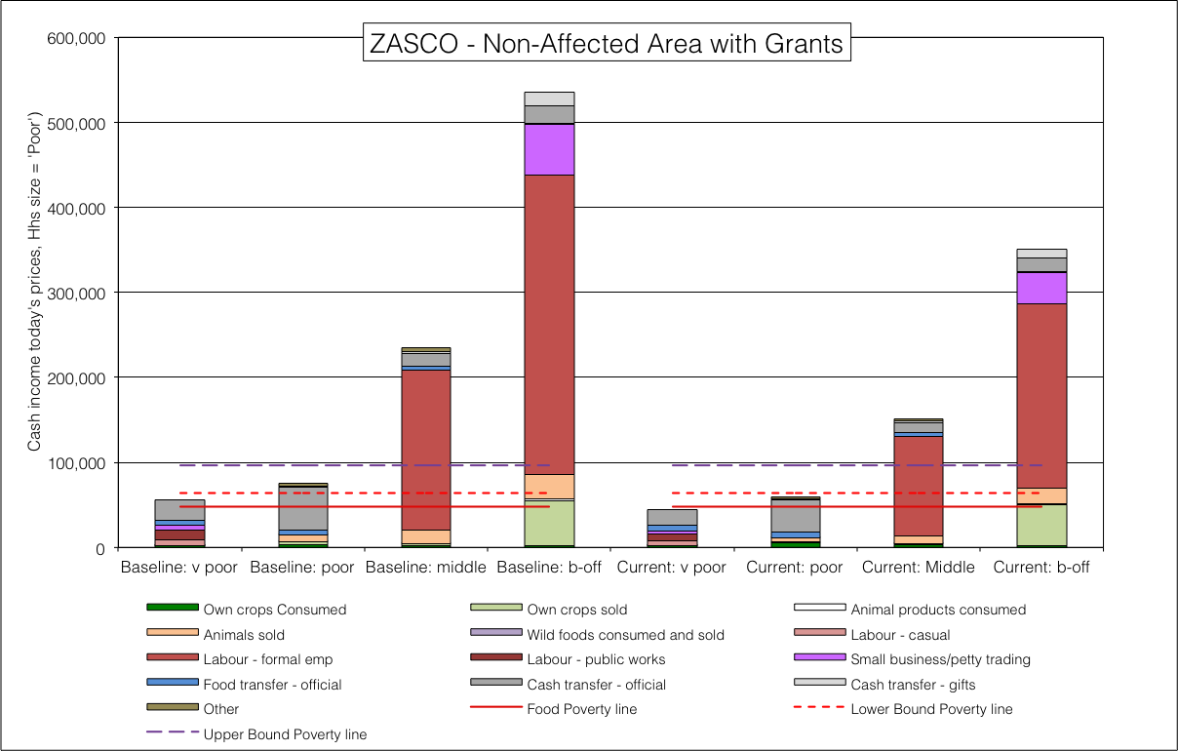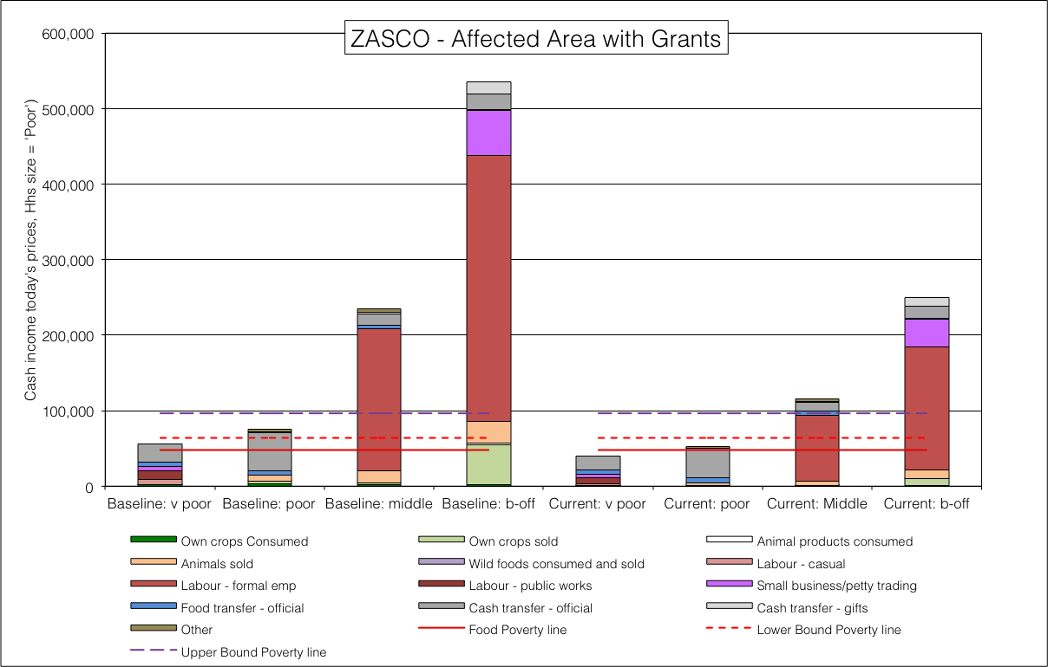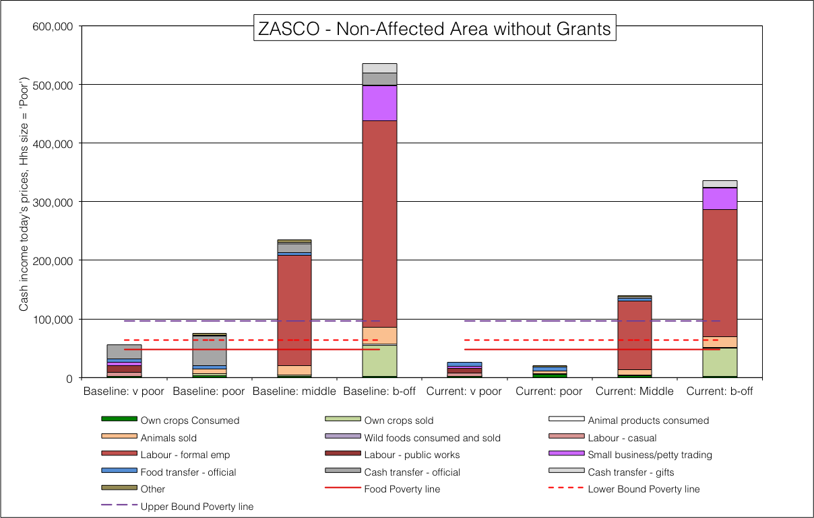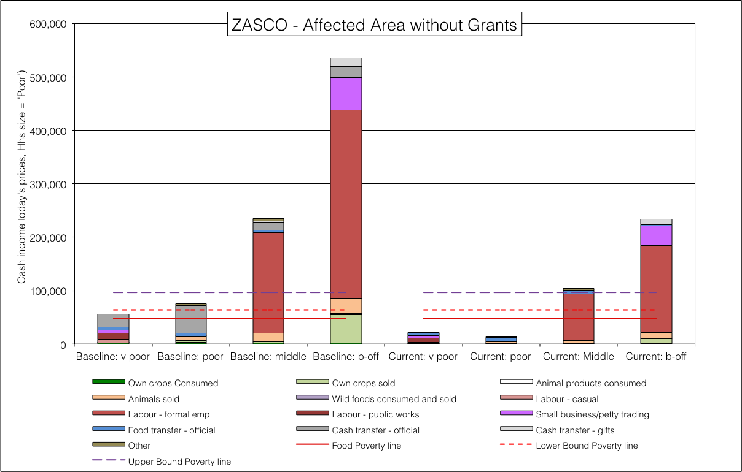**Figure** 55: ZASCO livelihoods for each of the four scenarios

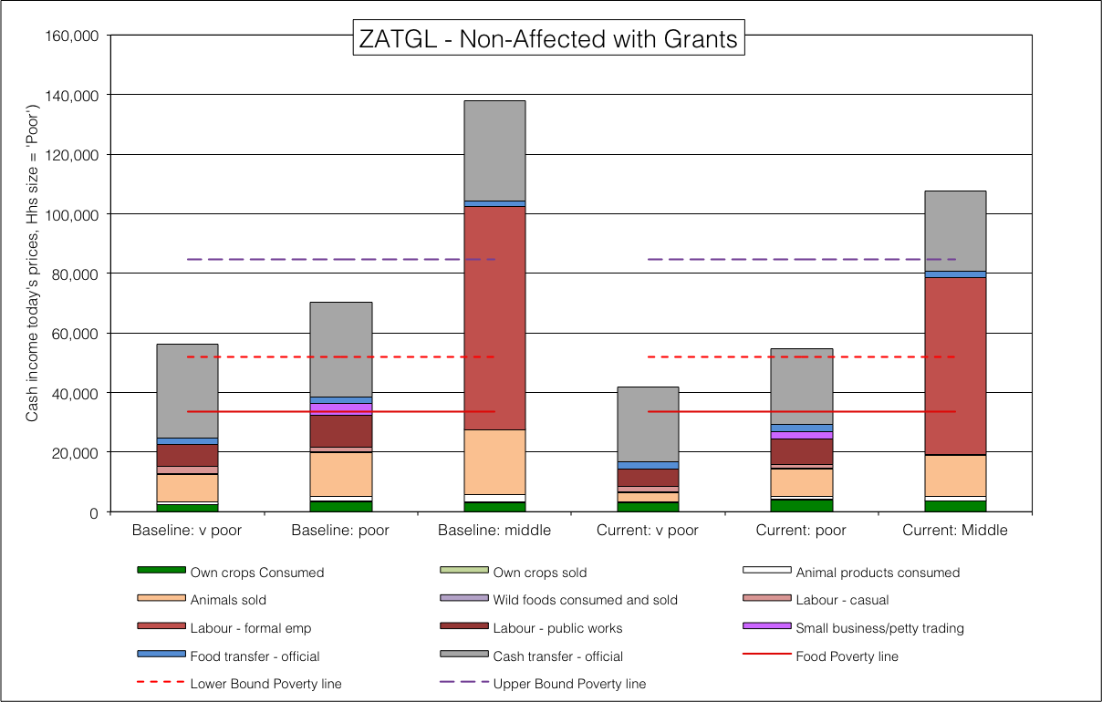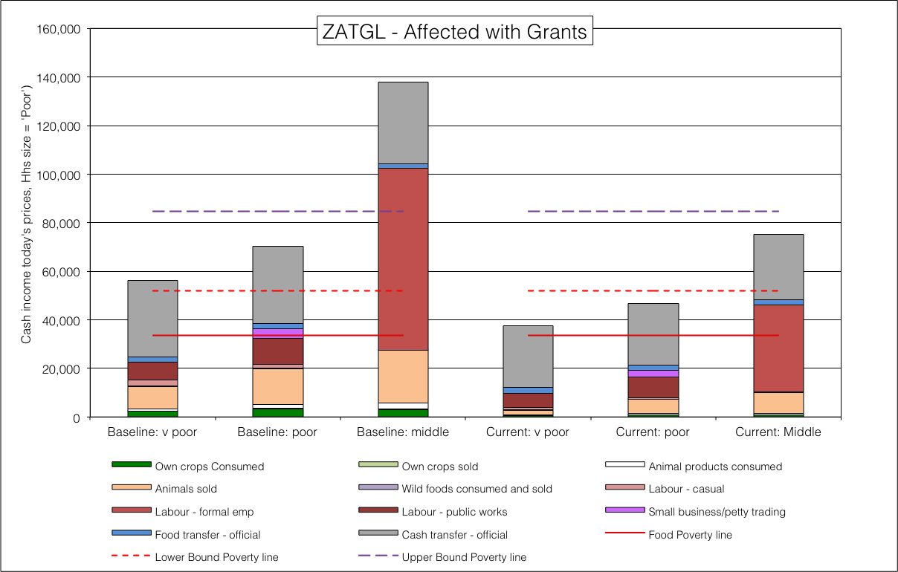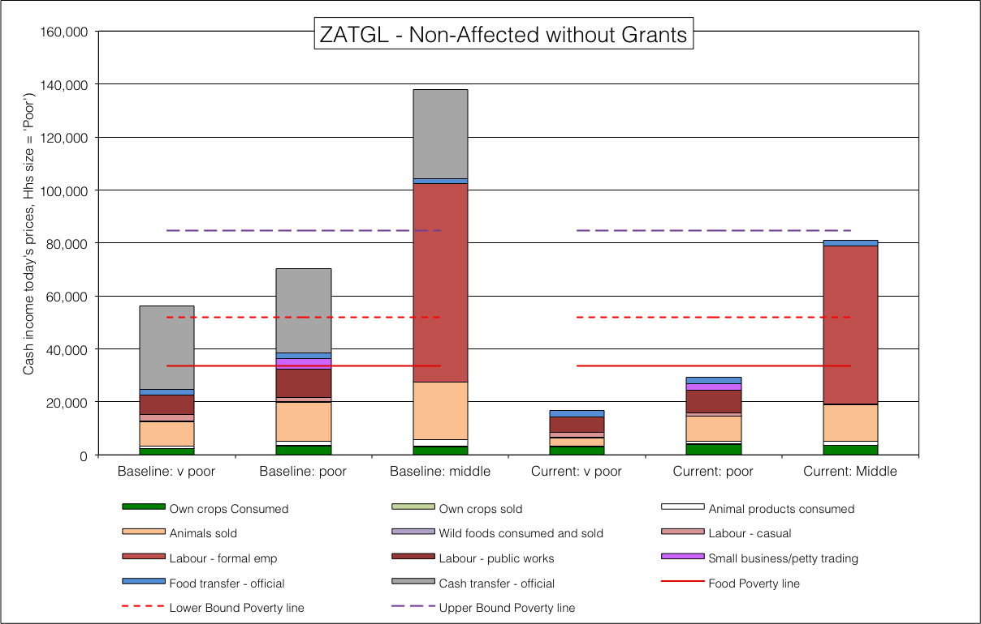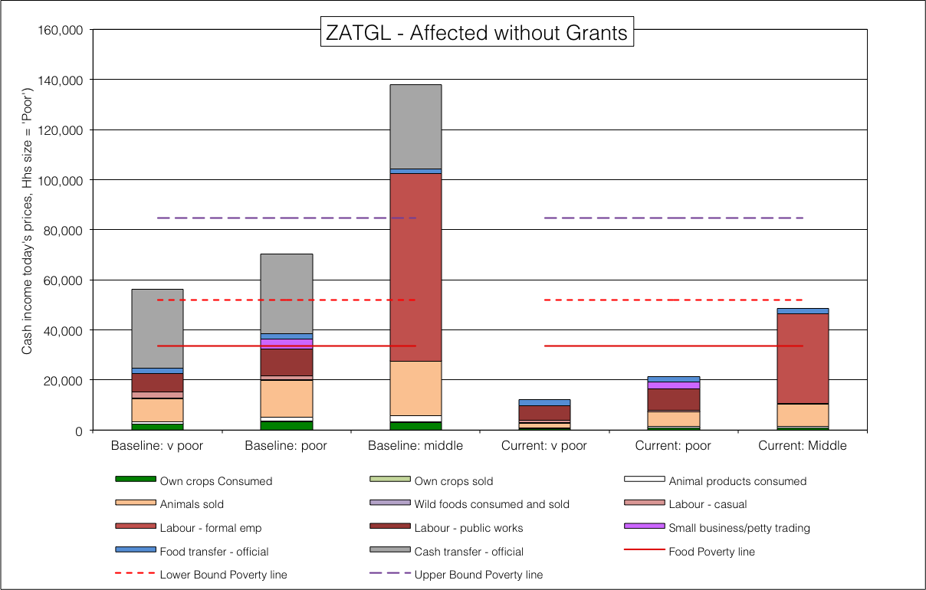**Figure** 56: ZATGL livelihoods for each of the four scenarios

Generic livestock-based open access livelihood zones (ZA1XX, 59100)

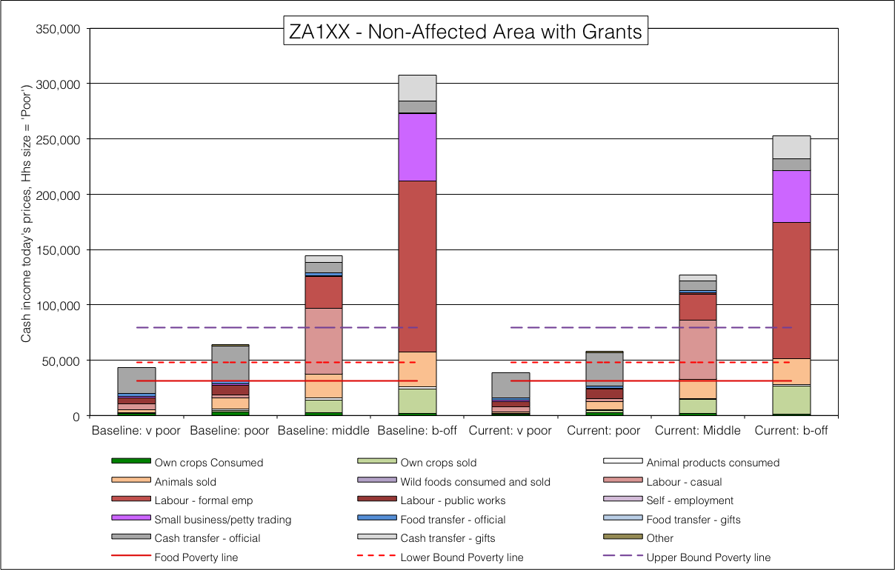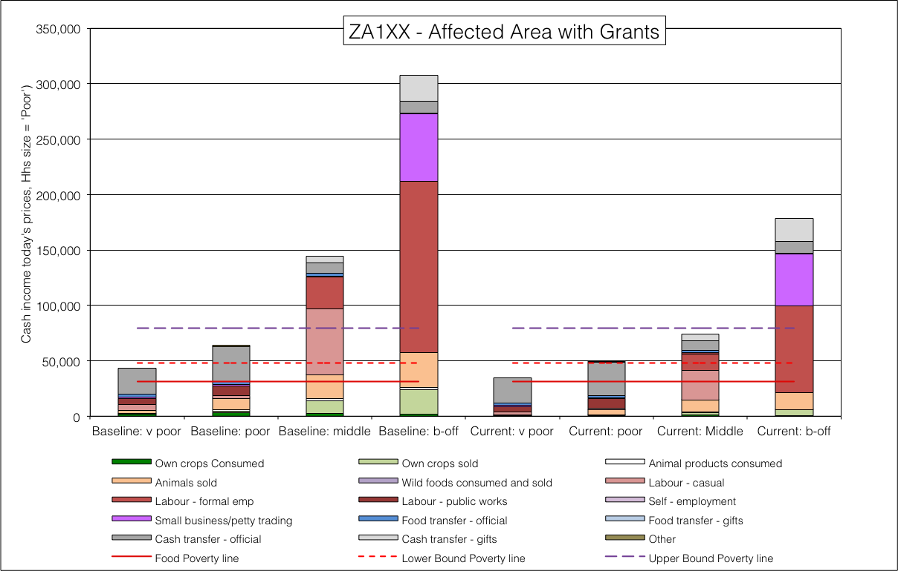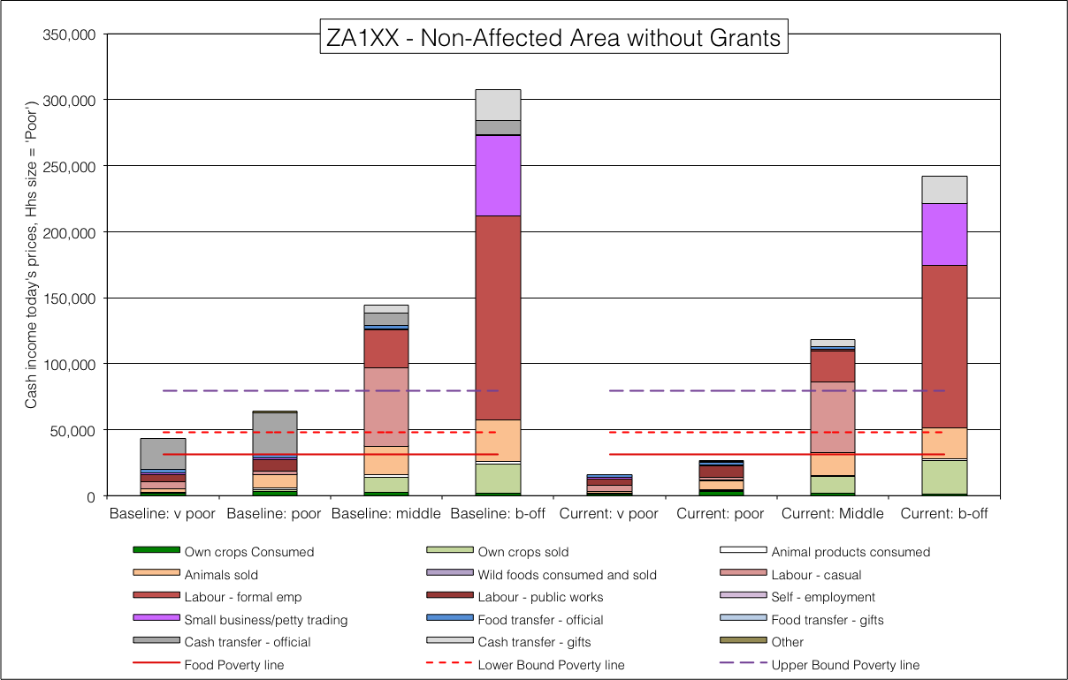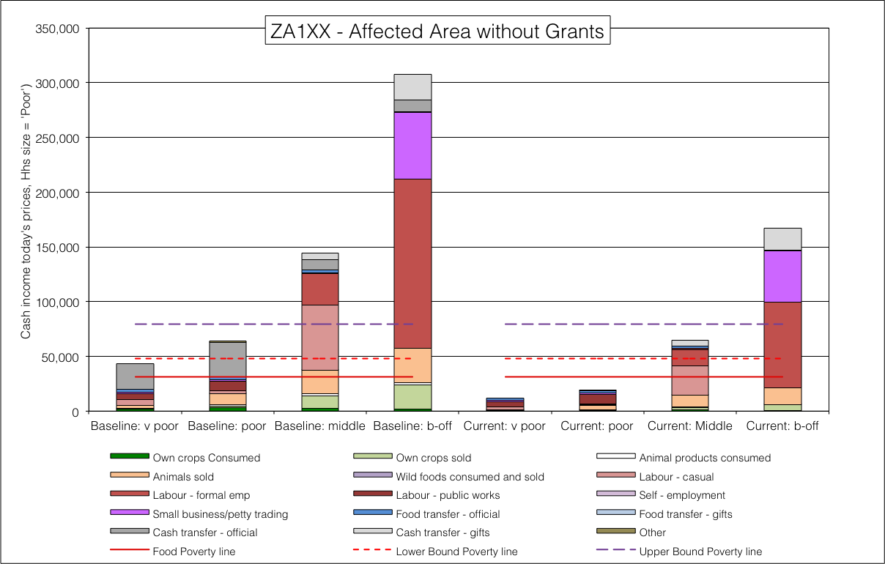**Figure** 57: ZA1XX livelihoods for each of the four scenarios

Generic mixed crops- and livestock-based open access livelihood zones (ZA2XX, 59200)

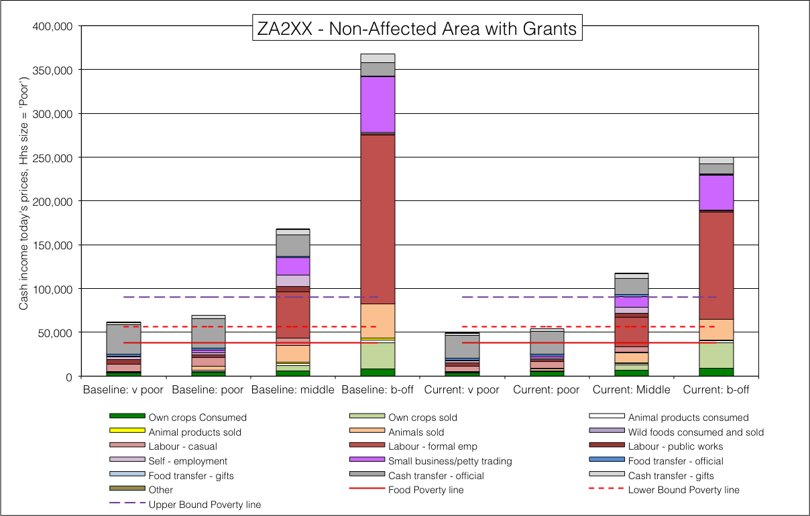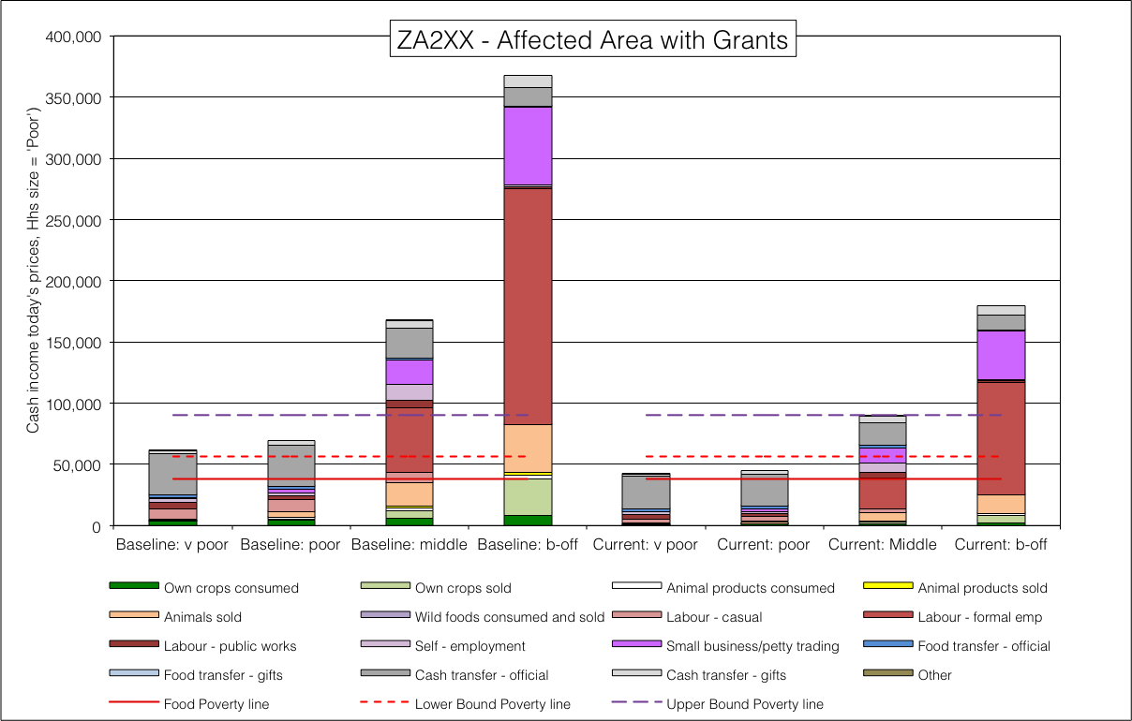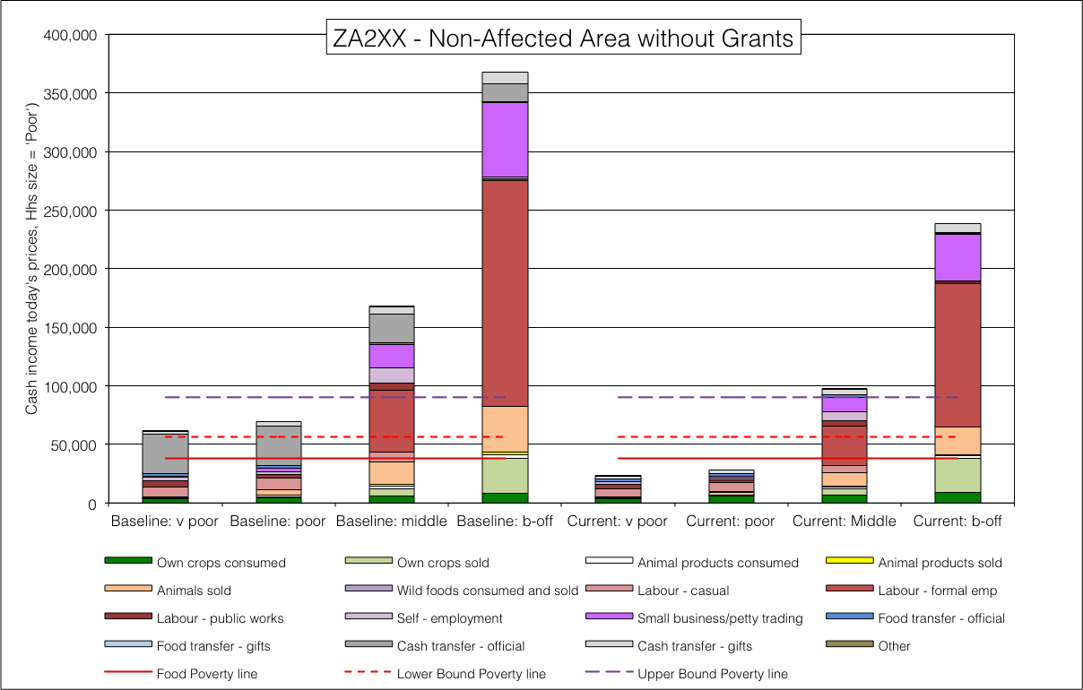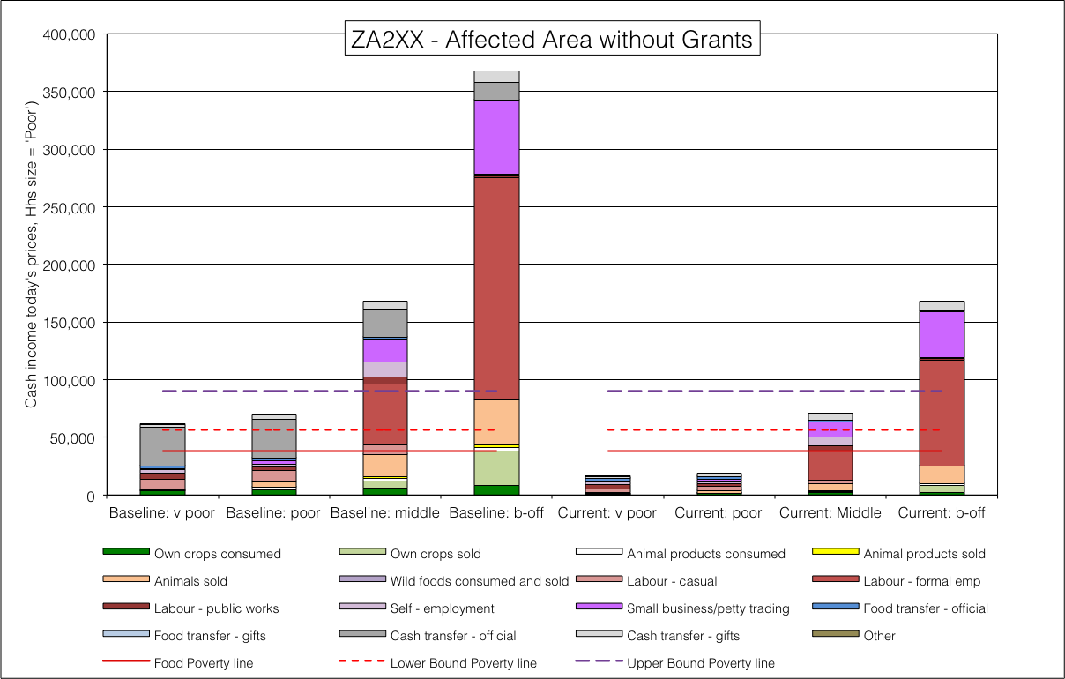**Figure** 58: ZA2XX livelihoods for each of the four scenarios

Generic crops-based open access livelihood zones (ZA3XX, 59300)

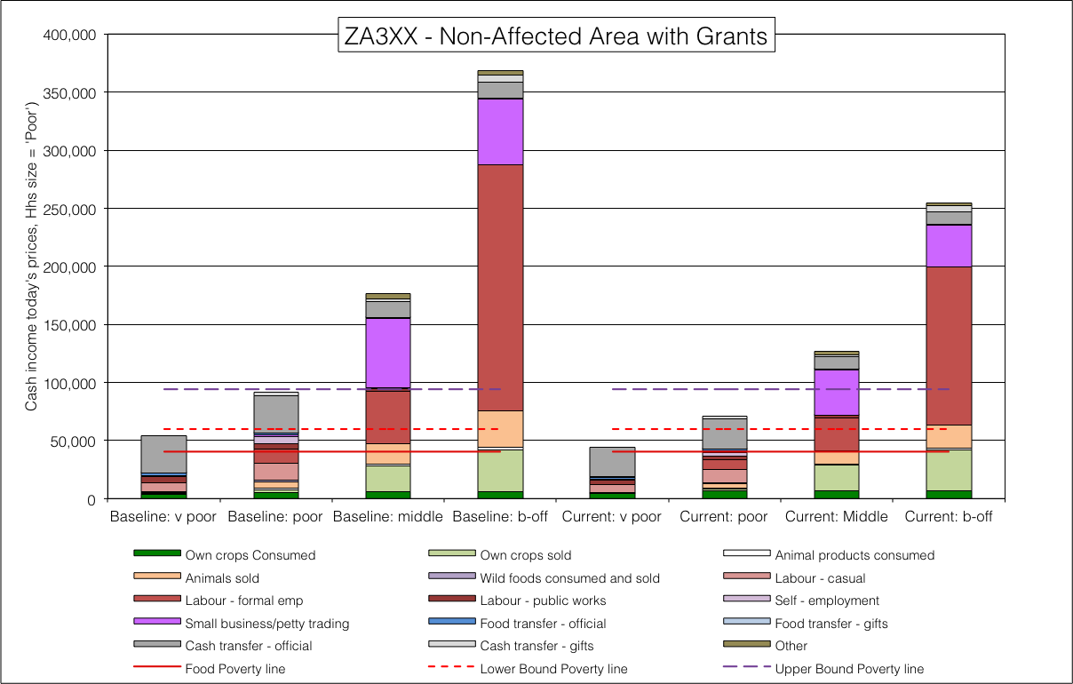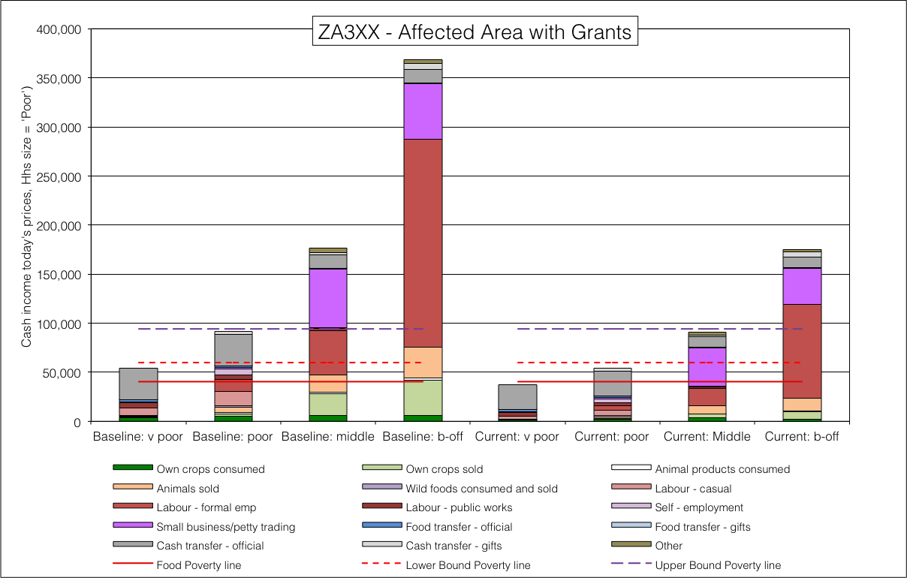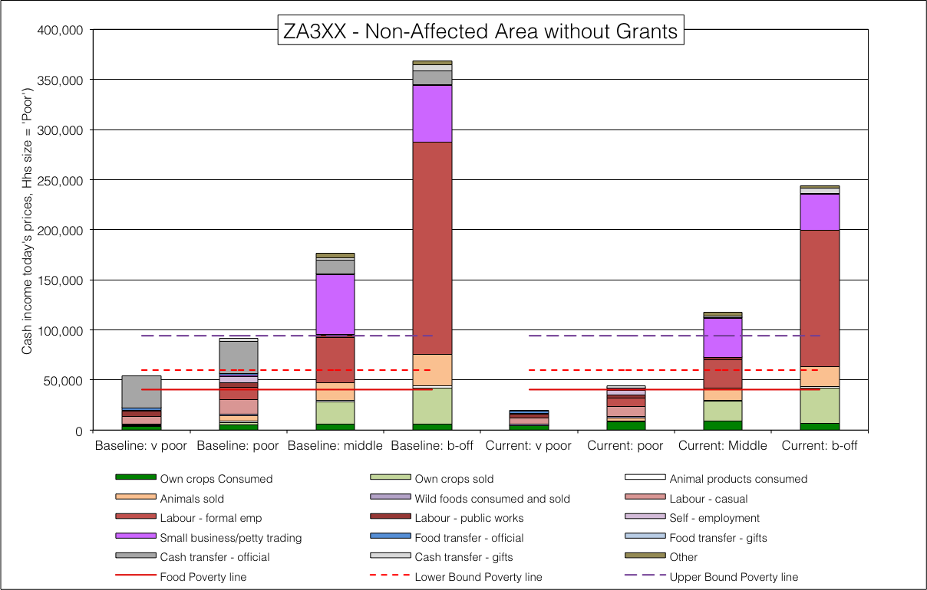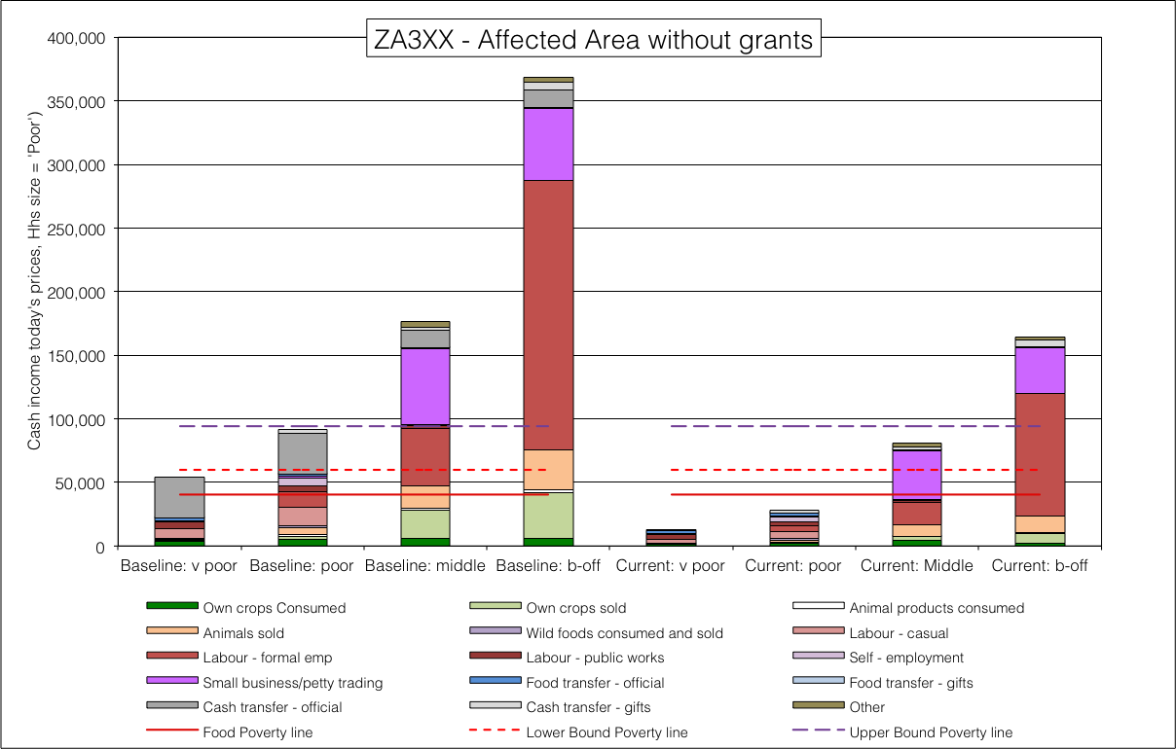**Figure** 59: ZA2XX livelihoods for each of the four scenarios

## Appendix C

#### Javascript for scraping the single zone analysis spreadsheets and loading the outcomes into Postgres/PostGIS.

These routines will run on Node.JS version 4.2 ([www.nodejs.org](http://www.nodejs.org/)), although the xlsx and pg modules will need to be installed via Node Package Manager (NPM), which comes bundled with Node.JS. On the command line, type:

$ npm install xlsx ,

$ npm install pg and

$ node collect_analysis.js

to start the program. You must have an instance of Postgres running with a database called ‘albers_ea’.

/*

* @file_name: collect_oucomes.js

*

*/

var XLSX = require('xlsx'), pg = require('pg');

const fs = require('fs');

/*

* Get any other user input such as user name, required dates or yes/no options. Data format can

* also be defined in the 'format' parameter (using a RegExp).

*

* @param question {String} Optional. Question to be asked on StdIn. If it ends in '?', ':' or ')'

* it will be append with a space only; if it ends with anything else it will be appended with '? '.

* Default 'Enter: '.

* @param format {RegExp}. Displays format as a regexp to the user. Default `/\w+|\s+/`, any number

* of alphanumeric or whitespace characters allowed, nothing not allowed ( ).

* @param callback {Function}. `Function (cancelled, data)` where cancelled is true if user aborts

* (Ctrl-C).

*

*/

function ask(question, format, callback) {

var stdin = process.stdin, stdout = process.stdout;

if (question === undefined) stdout.write("Enter: ");

else if (question.trim().slice(-1) == ':' || question.trim().slice(-1) == '?' || question.trim().slice(-1) == ')') stdout.write(question.trim() + ' ');

else stdout.write(question + '? ');

if (format === undefined) format = /\w+|\s+/;

stdin.setEncoding('utf8');

stdin.resume();

stdin.once('data', function(data) {

if (data.length > 1) {

data = data.toString().trim();

} else {

data = data.toString();

}

if (data == '\u0003') {

callback(true);

stdout.write('\n'); // add a line and quit

process.exit();

}

if (format.test(data)) {

// clear any extraneous single characters in StdOut

stdout.write('\u0008');

stdout.write('\u007F');

stdout.write('\u0008');

callback(false, data);

} else {

stdout.write("It should match: "+ format +"\n");

ask(question, format, callback);

}

});

}

/*

* Get a password from stdin.

* Adapted from <http://stackoverflow.com/a/10357818/122384>.

*

* @param prompt {String} Optional prompt. Default 'Password: '.

* @param callback {Function} `function (cancelled, password)` where

* `cancelled` is true if the user aborted (Ctrl+C).

* [CR]Added in nice fat bullet placeholders ('\u2022').

* [CR]Fixed the backspace to trim off last placeholders and snip password string at end.

* [CR]Fixed Ctrl-C (Quit) to add a line before the exit.

*

*/

function getPassword(prompt, callback) {

var stdin = process.stdin, stdout = process.stdout

if (callback === undefined) {

callback = prompt;

prompt = undefined;

}

if (prompt === undefined) {

prompt = 'Password';

}

if (prompt) {

stdout.write(prompt + ": ");

}

stdin.resume();

stdin.setRawMode(true);

stdin.resume();

stdin.setEncoding('utf8');

var password = '';

stdin.on('data', function (ch) {

ch = ch + '';

switch (ch) {

case '\n':

case '\r':

case '\u0004':

// They've finished typing their password

stdout.write('\n');

stdin.setRawMode(false);

stdin.pause();

callback(false, password);

break;

case '\u0003':

// Ctrl-C

callback(true);

stdout.write('\n'); // add a line and quit

process.exit();

break;

case '\u007F':

// Backspace: BS to backup, DEL to remove character (but moves one forward), so BS again

if (password.length > 0) {

stdout.write('\u0008');

stdout.write('\u007F');

stdout.write('\u0008');

password = password.slice(0, password.length - 1); // snip the password one char at end

}

break;

default:

// Other password characters

stdout.write('\u2022');

password += ch;

break;

}

});

}

/*

* Connects to the DB and selects which analysis (month, year) the user wants load into it.

*

* @param pgClient {Object}. Required. Postgres client object with connection string credentials in

* it must be passed.

*

*/

function connectDB(pgClient) {

// Connect the client to the database

pgClient.connect(function(err) {

if(err) {

return console.error('could not connect to postgres', err);

}

// Query the database to find out how many analyses have been done before

pgClient.query('SELECT ofa_month, ofa_year, count(*) AS result FROM zaf.tbl_ofa_analysis GROUP BY ofa_year, ofa_month ORDER BY ofa_year, ofa_month;', function(err, result) {

if(err) {

return console.error('error retrieving analyses', err);

}

// Success

var months = ['January', 'February', 'March', 'April', 'May', 'June', 'July', 'August', 'September', 'October', 'November', 'December']

console.log('\nYour existing analysis are:');

console.log('OFA Month | OFA Year | results\n----------+----------+-----------');

for (i = 0; i < result.rowCount; i++) {

var pad_month = '';

var pad_result = '';

for (j = 0; j < 9 - (months[result.rows[i].ofa_month - 1]).length; j++) pad_month+= ' ';

for (j = 0; j < 10 - (' ' + result.rows[i].result).length; j++) pad_result += ' ';

console.log(months[result.rows[i].ofa_month - 1] + pad_month + ' | ' + result.rows[i].ofa_year + ' | ' + pad_result + result.rows[i].result);

}

console.log('----------+----------+-----------');

// Get the month and year of the analysis

ask('Which month and year of analysis do you want to assign to these spreadsheets?\nType it in as numbers representing M-YYYY (e.g. 9-2013 or 11-2015) ', /\d{1,2}-\d{4}/, function(cancel, analysisMonth) {

if (!cancel) {

var d = new Date(), check = false, deleteOnly = false;

var ofa = analysisMonth.split('-');

// Force to current month and year if supplied values are out of range

if (ofa[0] * 1 > 12) ofa[0]= 12;

if (ofa[0] * 1 < 1) ofa[0] = 1;

if (new Date(ofa[1], ofa[0]-1, 1) > d || ofa[1] * 1 < 1980 ) {

ofa[0] = d.getMonth() + 1;

ofa[1] = d.getFullYear();

console.log('Analysis reset to ' + ofa[0] + '-' + ofa[1] + '; it cannot be ahead of time or before 1980.');

}

for (i = 0; i < result.rowCount; i++) {

if (ofa[0] == result.rows[i].ofa_month && ofa[1] == result.rows[i].ofa_year) {

var check = true;

break;

}

}

if (check) {

ask('This analysis already exists. Delete only (yes - just delete / no - delete and\nreinsert data)?', /.+/, function(cancel, justDel) {

if (!cancel) {

if (justDel.toUpperCase() == 'Y' || justDel.toUpperCase() == 'YES') deleteOnly = true

ask('Are you REALLY sure you want to delete all your previous data for ' + months[ofa[0] - 1] + ' ' + ofa[1] + '\n(yes - proceed / no - quit before affecting anything)?', /.+/, function(cancel, confirm) {

if (!cancel) {

if (confirm.toUpperCase() == 'Y' || confirm.toUpperCase() == 'YES') {

// Call the loadTable function

loadTable(pgClient, ofa, deleteOnly);

} else {

pgClient.end();

process.exit();

}

}

});

}

});

} else {

loadTable(pgClient, ofa, false);

}

}

});

});

});

}

/*

* Deletes previous record for the same analysis date and uploads the current analysis results

* collected from the spreadsheets.

*

* @param pgClient {Object}. Required. Postgres client connection object must be passed.

* @param ofa {Array} Required. Two elements with numbers representing month ofa[0] ('1' = January)

* and year ofa[1].

* @param deleteOnly {Boolean}. Optional. TRUE when data for analysis are deleted but not reinserted.

* Default FALSE.

*

*/

function loadTable(pgClient, ofa, deleteOnly) {

// Query to first delete existing data in zaf.tbl_ofa_analysis for the desired month and year

pgClient.query('DELETE FROM zaf.tbl_ofa_analysis WHERE ofa_year = ' + ofa[1] + ' AND ofa_month = ' + ofa[0] + ';', function(err, result) {

if(err) {

return console.error('error running DELETE query', err);

}

// Success. Output is something like DELETE: 1168 rows affected

console.log(result.command + ': ' + result.rowCount + ' rows affected');

// Query to insert the new data using the SQL string above

if (!deleteOnly) {

// Create the INSERT SQL String

var sqlString = 'INSERT INTO zaf.tbl_ofa_analysis (ofa_year, ofa_month, lz_code, wg_code, ' + 'lz_affected, wg_affected, threshold, deficit) VALUES \n';

// Read the config files containing info on analysis spreadsheets and deficits.

// Read the config file for the spreadsheet structure

fs.readFile("./config_spreadsheets.json", function(err, sSheetData) {

if (err) {

console.log("LZ and spreadsheet config file missing or corrupt.");

return;

}

// Success. Read the config file for thresholds

fs.readFile("./config_deficits.json", function(err, deficitsData) {

if (err) {

console.log("Deficits config file missing or corrupt.");

return

}

// Success. Parse the files and pass (sic!) them on to the readSpreadSheets function

sqlString = readSpreadSheets(sqlString, JSON.parse(sSheetData.toString()), JSON.parse(deficitsData.toString()), ofa);

pgClient.query(sqlString, function(err, result) {

if(err) {

return console.error('error running INSERT query', err);

}

// Success. Output is something like INSERT: 1168 rows affected

console.log(result.command + ': ' + result.rowCount + ' rows affected');

getDbTime(pgClient);

});

});

});

} else {

getDbTime(pgClient);

}

});

}

/*

* Read all the spreadsheet values and load them into an object, as well as creating an SQL INSERT

* values query string for loading the spreadsheet outputs into a Postgres table.

*

* @param sqlString {string} Required. First part of SQL string to which the results from the

* spreadsheet reads are appended in correct syntax and returned.

* @param ofa {Array} Required. Two elements with numbers representing month ofa[0] ('1' = January)

* and year ofa[1].

*

*/

function readSpreadSheets(sqlString, lzAbbrevs, deficits, ofa) {

console.log('Reading spreadsheets...');

// Object with the LZ affectedness groupings.

var lzAffected = {

normal : {

code : 0,

ext : "_0"

},

drought : {

code: 1,

ext : "_1"

}

};

// Object with the wealth group affectedness groupings.

var wgAffected = {

grants : "",

noGrants : "_nogrants"

}

// Variable for storing outcomes

var outcome = {};

//'name' is the LZ abbrev name in the spreadsheet file name, 'code' is the LZ code (for the DB table), 'wgs' array contains objects with worksheet numbers (in the spreadsheet) and WG IDs from tbl_wgs in each LZ analysis.

for (var i = 0; i < lzAbbrevs.length; i++) {

for (var subLz in lzAffected) {

for (var subWG in wgAffected) {

// Get the workbook

var workbook = XLSX.readFile('./spreadsheets/' + lzAbbrevs[i].name + lzAffected[subLz].ext + wgAffected[subWG] + '.xlsx');

process.stdout.write('./spreadsheets/' + lzAbbrevs[i].name + lzAffected[subLz].ext +

wgAffected[subWG] + '.xlsx\n');

// Get the worksheet and assign it to a variable

for (var j = 0; j < lzAbbrevs[i].wgs.length; j++) {

var sheet_name = workbook.SheetNames[lzAbbrevs[i].wgs[j].sheet];

var worksheet = workbook.Sheets[sheet_name];

//reset the outcome object

outcome = {};

// Find desired cell

for (var thres in deficits) {

var desired_cell = worksheet[deficits[thres].cell];

// Get the value

var desired_value = desired_cell.v;

if (thres === 'food') {

outcome[thres] = Math.round(desired_value * 100, 0) + '%';

} else {

outcome[thres] = Math.round(desired_value, 0);

};

sqlString += '(' + ofa[1] + ', ' + ofa[0] + ', ' + lzAbbrevs[i].code + ', ' + (lzAbbrevs[i].wgs[j].wg) + ', \u0027' + subLz + '\u0027, \u0027' + subWG + '\u0027, \u0027' + deficits[thres].descr + '\u0027, ' + desired_value + '),\n';

}

}

}

}

}

// Query SQL string for inserting data into zaf.tbl_ofa_analysis postgres table

sqlString = sqlString.substring(0, sqlString.length - 2) + '\n;';

return sqlString

}

/*

* Get the database time. Simple routine to throw out the time on the Database when the update

* (INSERT or DELETE) is finished.

*

* @param pgClient {Object}. Required. Postgres client connection object must be passed.

*

*/

function getDbTime(pgClient) {

// Query to get a time stamp from the DB(!) for the succesful completion of the work

pgClient.query('SELECT NOW() AS "theTime"', function(err, result) {

if(err) {

return console.error('error running query', err);

}

// Success. Output is something like Tue Jun 21 2016 10:12:47 GMT+0200 (SAST)

console.log(result.rows[0].theTime);

// end client session*/

pgClient.end();

process.exit();

});

}

/*

* Callers for getting user inputs for connecting to the database. Upon entry of credentials, the

* `connectDB` function is called with the a client object for connecting to the database. No

* authentication/authorisation at this stage.

*

*/

// Get the DB user name

ask('\nYou may need account credentials to connect to Postgres. However, if you\ndownloaded the database dump file from GitHub, you may ignore the user name\nand password below (skip by pressing ENTER twice)\n\nPostgres user name', /.+|\s/, function(cancel, user_name) {

if (!cancel) {

// Get the DB password

getPassword('Postgres password', function(cancel, password) {

// pass the user name and password as a connection string onto Postgres in the main data

// processing function

if (!cancel) {

var client = new pg.Client('postgres://' + user_name + ':' + password + '@localhost:5432/albers_ea');

// Go through to slecting the month and year of analysis

connectDB(client);

}

});

}

});

## Appendix D

### List of PostgreSQL/PostGIS queries and how to run them

These queries will run on PostgreSQL version 9.3 or newer ([www.postgresql.org](http://www.postgresql.org/) and [www.postgis.net](http://www.postgis.net/)). The required data will need to be imported into PostgreSQL/PostGIS, which is available in the DB folder (a completed dataset from this query is available).

#### **buffer_rs.sql** - query for creating a polygon or set of polygons that is the drought affected area

The output is the drought hazard layer, called zaf.rs_vci_16_01_buffer, which covers all the red and dark orange sections on the chosen vegetation condition index image, which will have been vectorised. The query can be called from the command line:

$ psql -d albers_ea -f buffer_rs.sql

#### **crop_specs.sql** - query for determining problem specs for affected vs unaffected regions by breaking down averages

The output is a table, zaf.prob_specs, that contains a list of agricultural regions and provinces and their breakdowns for problem specifications, depending on the ‘normal’ conditions and reported data from the Crop Estimates Committee (CEC).. This query can be run from the command line:

$ psql -d albers_ea -f crop_specs.sql -v analysis=4-2016

Note: the -v switch must be applied for the query to run properly.

#### **hazard_analysis.sql** - Query for assigning drought hazard conditions to enumeration small areas (ESAs)

The output is a new table, zaf.demog_sas_ofa, which contains all the enumeration small areas and their geometries, for every complete analysis (October 2015 in Limpopo Province and April 2016 national). The query can be called from the command line:

$ psql -d albers_ea -f hazard_analysis.sql -v analysis=4-2016

Note: the -v switch must be applied for the query to run properly. It will start running and it takes a long time (> 2 hours) because of the spatial operations involved.

#### **hazard_outcomes.sql** - Query for assigning drought hazard conditions to enumeration small areas (ESAs)

The output is a new table zaf.tbl_ofa_outcomes, that contains a list of enumeration small areas (ESAs), wealth groups, thresholds and affected population sections (wg_affected) for pivoting. The query can be called from the command line:

$ psql -d albers_ea -f hazard_outcomes.sql -v analysis=4-2016

Note: the -v switch must be applied for the query to run properly.

## Appendix E

### List of commodities in the Food Poverty Line

**Table** 18: Commodities and their prices in 2011

|  |  |
| --- | --- |
| Item | Price (cents) |
| Aerated cold drinks | 131 |
| Fresh full cream milk | 96 |
| Large eggs | 219 |
| Poultry (incl heads and feet) | 280 |
| Beef and veal (incl heads and feet) | 594 |
| Boerewors | 452 |
| Canned pilchards | 360 |
| Mealie meal/Maize flour | 44 |
| Brown bread | 101 |
| White bread | 116 |
| Rice | 98 |
| Edible oils (eg cooking oils) | 157 |
| Potatoes | 85 |
| Tomatoes fresh | 150 |
| Onions | 76 |
| Bananas | 70 |
| Cabbage fresh | 65 |
| Burger | 543 |
| Powder soup | 540 |
| Brown sugar | 194 |
| White sugar | 194 |
| Atchaar | 467 |
| Whiteners (Cremora, Ellis Brown) | 277 |

## Appendix F

### Populations and deficits at municipality level for all four thresholds

**Table** 19: Analysis outcomes by municipality, district and province

| Row Labels | Sum of population with a food deficit | Sum of deficit maize eq (MT) | Sum of population with an FPL deficit | Sum of FPL deficit in ZAR | Sum of population with an LBPL deficit | Sum of LBPL deficit in ZAR | Sum of population with a UBPL deficit | Sum of UBPL deficit in ZAR |
| --- | --- | --- | --- | --- | --- | --- | --- | --- |
| Eastern Cape | 588,606 | 61,104 | 588,606 | 1,074,977,708 | 2,311,857 | 4,771,695,802 | 3,403,718 | 17,130,019,769 |
| Alfred Nzo |  |  |  |  |  |  |  |  |
| Matatiele | 28,679 | 3,187 | 28,679 | 47,684,053 | 95,156 | 199,933,797 | 160,168 | 753,414,846 |
| Mbizana | 41,435 | 4,929 | 41,435 | 93,968,049 | 189,835 | 402,881,800 | 252,740 | 1,342,755,863 |
| Ntabankulu | 18,636 | 2,197 | 18,636 | 38,507,493 | 76,432 | 162,541,530 | 110,976 | 563,842,037 |
| Umzimvubu | 26,949 | 3,202 | 26,949 | 60,314,321 | 121,201 | 257,793,955 | 164,977 | 867,709,430 |
| Amathole |  |  |  |  |  |  |  |  |
| Amahlathi | 13,920 | 1,371 | 13,920 | 22,572,651 | 40,029 | 94,183,768 | 62,821 | 314,345,326 |
| Great Kei | 3,711 | 224 | 3,711 | 4,314,450 | 8,952 | 21,051,651 | 12,671 | 69,494,163 |
| Mbhashe | 35,079 | 3,623 | 35,079 | 61,157,369 | 140,947 | 269,655,026 | 191,564 | 982,256,810 |
| Mnquma | 32,608 | 3,381 | 32,608 | 57,165,274 | 128,799 | 251,253,692 | 186,092 | 933,683,640 |
| Ngqushwa | 9,767 | 1,070 | 9,767 | 17,219,670 | 31,778 | 72,629,193 | 53,183 | 255,985,002 |
| Nkonkobe | 12,948 | 1,324 | 12,948 | 20,940,845 | 39,480 | 90,440,503 | 69,847 | 328,812,880 |
| Nxuba | 629 | 40 | 629 | 742,667 | 1,604 | 3,764,031 | 2,777 | 13,610,685 |
| Buffalo City |  |  |  |  |  |  |  |  |
| Buffalo City | 44,806 | 4,090 | 44,806 | 67,889,480 | 135,403 | 322,571,332 | 277,301 | 1,238,821,743 |
| Cacadu |  |  |  |  |  |  |  |  |
| Baviaans | 577 | 33 | 577 | 640,086 | 1,466 | 3,251,007 | 1,935 | 10,935,796 |
| Blue Crane Route | 1,964 | 134 | 1,964 | 2,528,396 | 3,967 | 10,983,086 | 5,968 | 32,465,989 |
| Camdeboo | 854 | 50 | 854 | 926,216 | 2,499 | 5,259,163 | 4,201 | 20,689,600 |
| Ikwezi | 474 | 32 | 474 | 622,802 | 804 | 2,452,064 | 804 | 5,737,724 |
| Kou-Kamma | 539 | 10 | 539 | 187,480 | 3,107 | 4,053,470 | 5,397 | 24,834,093 |
| Kouga | 1,890 | 110 | 1,890 | 1,804,321 | 7,362 | 13,570,059 | 15,728 | 67,740,400 |
| Makana | 2,507 | 171 | 2,507 | 2,890,712 | 7,734 | 16,915,299 | 16,985 | 73,639,117 |
| Ndlambe | 616 | 30 | 616 | 493,932 | 2,681 | 4,467,794 | 5,375 | 23,612,989 |
| Sundays River Valley | 1,951 | 118 | 1,951 | 2,103,178 | 6,023 | 12,502,187 | 11,314 | 52,493,455 |
| Chris Hani |  |  |  |  |  |  |  |  |
| Emalahleni | 6,805 | 301 | 6,805 | 5,726,520 | 26,096 | 43,613,600 | 40,972 | 202,523,979 |
| Engcobo | 21,027 | 2,485 | 21,027 | 49,566,892 | 102,576 | 213,221,402 | 128,781 | 704,614,856 |
| Inkwanca | 760 | 51 | 760 | 940,117 | 1,773 | 4,463,447 | 2,971 | 15,017,047 |
| Intsika Yethu | 21,511 | 2,237 | 21,511 | 41,445,004 | 94,634 | 181,506,066 | 126,527 | 662,706,179 |
| Inxuba Yethemba | 2,612 | 176 | 2,612 | 3,376,892 | 5,040 | 14,271,349 | 6,838 | 39,660,349 |
| Lukanji | 7,926 | 736 | 7,926 | 11,731,079 | 28,266 | 56,474,032 | 47,004 | 222,095,295 |
| Sakhisizwe | 4,983 | 526 | 4,983 | 10,546,567 | 24,408 | 45,635,644 | 28,751 | 161,208,013 |
| Tsolwana | 3,760 | 376 | 3,760 | 6,002,258 | 11,959 | 25,922,863 | 18,152 | 90,040,314 |
| Joe Gqabi |  |  |  |  |  |  |  |  |
| Elundini | 15,508 | 1,899 | 15,508 | 32,739,066 | 60,391 | 137,256,703 | 94,241 | 467,207,890 |
| Gariep | 1,140 | 76 | 1,140 | 1,497,881 | 1,933 | 5,897,384 | 1,933 | 13,799,622 |
| Maletswai | 2,009 | 144 | 2,009 | 2,533,853 | 5,021 | 12,586,817 | 10,370 | 47,042,260 |
| Senqu | 16,868 | 2,103 | 16,868 | 43,005,175 | 80,330 | 187,488,588 | 106,018 | 574,055,286 |
| Nelson Mandela Bay |  |  |  |  |  |  |  |  |
| Nelson Mandela Bay | 21,457 | 1,567 | 21,457 | 25,522,737 | 67,685 | 150,825,388 | 163,635 | 681,061,588 |
| O.R. Tambo |  |  |  |  |  |  |  |  |
| King Sabata Dalindyebo | 47,879 | 5,065 | 47,879 | 90,568,478 | 197,653 | 400,499,558 | 272,744 | 1,406,294,768 |
| Mhlontlo | 26,289 | 3,039 | 26,289 | 59,523,604 | 124,749 | 255,394,849 | 157,386 | 857,083,715 |
| Ngquza Hill | 39,649 | 4,169 | 39,649 | 79,411,341 | 185,534 | 340,673,509 | 224,671 | 1,232,324,870 |
| Nyandeni | 43,900 | 4,619 | 43,900 | 73,042,912 | 160,356 | 325,535,235 | 239,979 | 1,174,916,782 |
| Port St Johns | 23,984 | 2,210 | 23,984 | 33,123,888 | 88,194 | 148,274,965 | 119,921 | 601,485,367 |
| Free State | 102,946 | 8,962 | 102,946 | 150,563,075 | 264,120 | 667,988,403 | 506,271 | 2,366,277,220 |
| Fezile Dabi |  |  |  |  |  |  |  |  |
| Mafube | 1,565 | 109 | 1,565 | 2,006,913 | 3,424 | 9,137,021 | 5,879 | 29,591,742 |
| Metsimaholo | 1,753 | 123 | 1,753 | 2,137,568 | 4,730 | 11,234,007 | 9,915 | 44,361,949 |
| Moqhaka | 6,040 | 412 | 6,040 | 7,814,112 | 11,938 | 33,498,653 | 17,270 | 96,400,021 |
| Ngwathe | 2,435 | 164 | 2,435 | 3,179,423 | 4,430 | 12,995,570 | 5,380 | 33,582,443 |
| Lejweleputswa |  |  |  |  |  |  |  |  |
| Masilonyana | 1,850 | 125 | 1,850 | 2,420,690 | 3,349 | 9,872,507 | 4,073 | 25,444,408 |
| Matjhabeng | 9,966 | 740 | 9,966 | 12,507,529 | 27,153 | 65,944,130 | 62,579 | 268,764,271 |
| Nala | 1,984 | 134 | 1,984 | 2,602,318 | 3,526 | 10,503,192 | 4,070 | 26,341,659 |
| Tokologo | 1,295 | 86 | 1,295 | 1,649,786 | 2,606 | 7,144,183 | 3,648 | 20,642,005 |
| Tswelopele | 2,044 | 138 | 2,044 | 2,675,856 | 3,714 | 10,933,549 | 4,560 | 28,313,853 |
| Mangaung |  |  |  |  |  |  |  |  |
| Mangaung | 21,551 | 1,584 | 21,551 | 26,787,913 | 58,957 | 141,332,475 | 140,635 | 594,270,704 |
| Thabo Mofutsanyane |  |  |  |  |  |  |  |  |
| Dihlabeng | 5,116 | 340 | 5,116 | 6,624,775 | 9,430 | 27,245,016 | 11,073 | 70,437,248 |
| Maluti a Phofung | 31,814 | 3,971 | 31,814 | 60,279,857 | 100,306 | 243,302,045 | 196,088 | 889,196,726 |
| Mantsopa | 1,786 | 119 | 1,786 | 2,338,096 | 3,067 | 9,236,237 | 3,586 | 23,092,217 |
| Nketoana | 2,313 | 151 | 2,313 | 2,892,386 | 4,877 | 12,873,247 | 6,847 | 38,468,127 |
| Phumelela | 2,542 | 167 | 2,542 | 3,086,724 | 6,117 | 14,991,444 | 10,288 | 51,659,395 |
| Setsoto | 3,433 | 235 | 3,433 | 4,480,413 | 6,526 | 18,778,964 | 8,944 | 51,747,690 |
| Xhariep |  |  |  |  |  |  |  |  |
| Kopanong | 1,838 | 123 | 1,838 | 2,408,949 | 3,190 | 9,594,834 | 3,333 | 23,068,564 |
| Letsemeng | 1,501 | 98 | 1,501 | 1,875,194 | 3,178 | 8,368,679 | 4,501 | 25,148,474 |
| Mohokare | 1,336 | 89 | 1,336 | 1,761,352 | 2,272 | 6,934,709 | 2,272 | 16,226,918 |
| Naledi | 784 | 52 | 784 | 1,033,219 | 1,330 | 4,067,941 | 1,330 | 9,518,804 |
| Gauteng | 352,955 | 26,087 | 352,955 | 436,536,551 | 1,004,648 | 2,376,515,067 | 2,348,543 | 9,988,422,398 |
| City of Johannesburg |  |  |  |  |  |  |  |  |
| City of Johannesburg | 97,988 | 7,379 | 97,988 | 122,130,613 | 281,617 | 668,611,599 | 678,897 | 2,849,598,213 |
| City of Tshwane |  |  |  |  |  |  |  |  |
| City of Tshwane | 98,774 | 7,238 | 98,774 | 121,766,334 | 279,742 | 660,851,757 | 644,272 | 2,757,971,065 |
| Ekurhuleni |  |  |  |  |  |  |  |  |
| Ekurhuleni | 84,428 | 6,333 | 84,428 | 103,888,837 | 251,510 | 584,639,117 | 613,000 | 2,554,230,950 |
| Sedibeng |  |  |  |  |  |  |  |  |
| Emfuleni | 20,494 | 1,518 | 20,494 | 25,150,537 | 60,156 | 140,116,242 | 143,122 | 602,947,546 |
| Lesedi | 2,366 | 146 | 2,366 | 2,489,187 | 8,072 | 16,147,837 | 16,790 | 73,902,098 |
| Midvaal | 4,717 | 277 | 4,717 | 5,011,322 | 14,545 | 29,872,330 | 26,396 | 124,380,995 |
| West Rand |  |  |  |  |  |  |  |  |
| Merafong City | 11,072 | 826 | 11,072 | 13,837,089 | 30,893 | 74,199,716 | 72,588 | 308,547,584 |
| Mogale City | 14,971 | 1,055 | 14,971 | 19,227,574 | 33,230 | 88,419,424 | 59,942 | 293,622,255 |
| Randfontein | 8,065 | 565 | 8,065 | 10,400,775 | 17,272 | 46,796,641 | 29,678 | 149,577,331 |
| Westonaria | 10,080 | 749 | 10,080 | 12,634,283 | 27,611 | 66,860,406 | 63,858 | 273,644,360 |
| KwaZulu-Natal | 1,766,923 | 129,689 | 1,799,426 | 2,979,042,673 | 4,513,510 | 10,683,152,361 | 6,029,906 | 34,011,923,331 |
| Amajuba |  |  |  |  |  |  |  |  |
| Dannhauser | 13,790 | 1,570 | 13,790 | 33,043,900 | 80,526 | 143,206,899 | 82,566 | 478,771,878 |
| Emadlangeni | 2,575 | 167 | 2,575 | 3,431,373 | 10,381 | 19,184,187 | 15,123 | 77,245,262 |
| Newcastle | 17,575 | 1,863 | 17,575 | 37,878,388 | 92,190 | 166,086,128 | 104,156 | 573,368,278 |
| Ethekwini |  |  |  |  |  |  |  |  |
| eThekwini | 209,945 | 13,867 | 222,100 | 379,511,159 | 746,497 | 1,727,229,365 | 1,323,023 | 6,426,512,315 |
| Harry Gwala |  |  |  |  |  |  |  |  |
| Greater Kokstad | 1,925 | 112 | 1,925 | 2,361,632 | 4,927 | 11,129,162 | 7,523 | 39,727,298 |
| Ingwe | 85,401 | 7,172 | 85,401 | 138,701,833 | 87,665 | 337,354,965 | 96,199 | 729,991,250 |
| Kwa Sani | 690 | 47 | 690 | 1,193,547 | 2,977 | 6,201,216 | 4,376 | 23,725,128 |
| Ubuhlebezwe | 70,396 | 5,806 | 70,702 | 115,477,751 | 81,733 | 294,989,061 | 93,275 | 673,126,015 |
| Umzimkhulu | 140,322 | 12,516 | 140,322 | 236,500,167 | 148,645 | 569,711,357 | 162,848 | 1,227,382,657 |
| iLembe |  |  |  |  |  |  |  |  |
| KwaDukuza | 19,646 | 1,288 | 19,802 | 24,753,623 | 55,543 | 128,284,611 | 112,965 | 512,752,626 |
| Mandeni | 20,216 | 1,098 | 21,851 | 43,803,171 | 85,924 | 168,247,412 | 102,041 | 583,801,603 |
| Maphumulo | 20,689 | 1,448 | 22,440 | 46,140,226 | 85,212 | 191,914,527 | 102,294 | 607,768,252 |
| Ndwedwe | 22,683 | 1,242 | 26,033 | 62,461,080 | 116,128 | 248,140,712 | 138,131 | 818,272,850 |
| Ugu |  |  |  |  |  |  |  |  |
| Ezingoleni | 21,623 | 1,227 | 21,761 | 31,863,771 | 40,748 | 91,638,012 | 42,280 | 264,820,297 |
| Hibiscus Coast | 60,846 | 3,136 | 61,168 | 86,071,272 | 125,389 | 260,269,897 | 135,223 | 806,212,799 |
| Umdoni | 25,977 | 2,135 | 25,977 | 41,124,095 | 30,848 | 106,506,899 | 38,514 | 258,664,122 |
| UMuziwabantu | 43,848 | 3,068 | 43,930 | 71,251,631 | 70,209 | 189,894,772 | 73,301 | 488,739,576 |
| Umzumbe | 89,109 | 6,236 | 89,695 | 140,505,588 | 135,454 | 377,467,891 | 143,644 | 966,390,535 |
| Vulamehlo | 37,523 | 2,809 | 38,529 | 66,869,107 | 66,478 | 193,818,252 | 75,274 | 504,284,550 |
| Umgungundlovu |  |  |  |  |  |  |  |  |
| Impendle | 10,563 | 577 | 10,563 | 13,150,290 | 17,630 | 53,657,626 | 26,535 | 162,376,297 |
| Mkhambathini | 11,460 | 640 | 12,415 | 23,644,534 | 40,879 | 91,978,678 | 50,676 | 299,622,852 |
| Mpofana | 2,001 | 99 | 2,001 | 2,151,312 | 6,074 | 11,868,240 | 9,008 | 47,287,739 |
| Richmond | 12,852 | 842 | 13,006 | 21,047,406 | 25,027 | 68,521,904 | 30,490 | 196,208,452 |
| The Msunduzi | 85,302 | 6,515 | 88,629 | 154,666,670 | 206,942 | 557,789,151 | 333,503 | 1,777,353,967 |
| uMngeni | 3,415 | 198 | 3,632 | 5,671,136 | 14,764 | 30,596,708 | 25,973 | 125,413,921 |
| uMshwathi | 6,452 | 316 | 7,052 | 12,974,870 | 33,905 | 70,683,207 | 65,929 | 317,016,807 |
| Umkhanyakude |  |  |  |  |  |  |  |  |
| Hlabisa | 10,584 | 1,209 | 10,584 | 24,854,614 | 51,537 | 95,526,163 | 67,667 | 356,802,116 |
| Jozini | 59,634 | 4,026 | 59,723 | 78,040,198 | 128,750 | 308,788,037 | 171,798 | 1,009,828,854 |
| Mtubatuba | 22,459 | 2,587 | 22,459 | 58,716,147 | 126,036 | 229,696,532 | 149,345 | 798,248,534 |
| The Big 5 False Bay | 5,297 | 515 | 5,354 | 7,349,924 | 10,765 | 26,563,006 | 24,215 | 126,138,390 |
| Umhlabuyalingana | 51,764 | 2,847 | 54,669 | 90,241,276 | 142,350 | 358,903,328 | 163,589 | 1,054,589,266 |
| Umzinyathi |  |  |  |  |  |  |  |  |
| Endumeni | 2,451 | 161 | 2,451 | 3,079,399 | 7,900 | 15,735,145 | 14,812 | 67,672,115 |
| Msinga | 28,608 | 2,911 | 28,608 | 57,264,122 | 139,407 | 240,317,998 | 155,252 | 851,664,596 |
| Nqutu | 27,383 | 2,708 | 27,383 | 53,921,087 | 135,060 | 225,668,316 | 139,915 | 788,746,475 |
| Umvoti | 14,336 | 914 | 15,520 | 30,486,936 | 58,016 | 128,247,381 | 75,140 | 429,662,188 |
| Uthukela |  |  |  |  |  |  |  |  |
| Emnambithi/Ladysmith | 22,134 | 2,188 | 22,134 | 46,801,294 | 84,056 | 179,809,748 | 110,666 | 577,149,159 |
| Imbabazane | 43,873 | 2,492 | 43,873 | 55,846,369 | 58,147 | 192,747,229 | 98,818 | 549,822,254 |
| Indaka | 13,673 | 1,614 | 13,673 | 33,717,265 | 81,475 | 145,139,282 | 83,501 | 482,047,559 |
| Okhahlamba | 25,810 | 1,955 | 25,810 | 46,858,388 | 62,305 | 175,419,479 | 91,899 | 521,610,844 |
| Umtshezi | 9,117 | 666 | 9,117 | 13,220,458 | 21,562 | 55,247,894 | 37,877 | 184,878,776 |
| Uthungulu |  |  |  |  |  |  |  |  |
| Mfolozi | 22,299 | 1,566 | 22,299 | 31,958,842 | 63,577 | 106,129,753 | 94,147 | 485,980,505 |
| Mthonjaneni | 15,050 | 917 | 15,141 | 19,175,272 | 27,686 | 73,597,917 | 34,922 | 221,765,873 |
| Nkandla | 61,658 | 3,293 | 61,986 | 77,985,828 | 115,653 | 303,457,349 | 118,855 | 817,503,177 |
| Ntambanana | 20,247 | 1,386 | 20,277 | 27,987,504 | 46,439 | 110,138,447 | 66,779 | 379,544,675 |
| uMhlathuze | 40,176 | 2,330 | 40,508 | 62,879,909 | 132,092 | 212,641,543 | 159,117 | 850,820,674 |
| uMlalazi | 59,536 | 3,779 | 60,243 | 85,154,392 | 141,020 | 325,689,842 | 176,754 | 1,056,281,293 |
| Zululand |  |  |  |  |  |  |  |  |
| Abaqulusi | 24,910 | 2,517 | 24,910 | 52,341,671 | 106,290 | 217,083,650 | 118,267 | 678,452,541 |
| eDumbe | 14,504 | 1,294 | 14,504 | 28,202,605 | 30,137 | 88,728,030 | 55,801 | 253,454,897 |
| Nongoma | 34,774 | 3,366 | 34,774 | 60,157,383 | 110,647 | 226,548,590 | 172,334 | 910,416,961 |
| Ulundi | 79,753 | 4,572 | 79,793 | 97,243,021 | 139,970 | 371,477,447 | 161,621 | 1,066,882,086 |
| UPhongolo | 20,069 | 1,879 | 20,069 | 39,309,233 | 79,938 | 153,479,414 | 91,945 | 505,122,196 |
| Limpopo | 490,543 | 57,060 | 490,543 | 1,066,014,623 | 2,065,161 | 4,320,963,534 | 3,488,656 | 16,873,295,770 |
| Capricorn |  |  |  |  |  |  |  |  |
| Aganang | 20,118 | 2,897 | 20,118 | 62,914,140 | 100,288 | 225,969,931 | 101,919 | 685,853,384 |
| Blouberg | 17,253 | 2,424 | 17,253 | 52,200,268 | 88,707 | 191,892,178 | 107,610 | 654,304,285 |
| Lepele-Nkumpi | 7,918 | 866 | 7,918 | 10,132,820 | 28,606 | 39,920,177 | 152,337 | 520,694,278 |
| Molemole | 15,927 | 1,822 | 15,927 | 38,763,163 | 59,781 | 142,607,984 | 60,344 | 410,488,325 |
| Polokwane | 48,411 | 5,672 | 48,411 | 95,345,134 | 189,610 | 360,580,251 | 305,228 | 1,518,912,630 |
| Greater Sekhukhune |  |  |  |  |  |  |  |  |
| Elias Motsoaledi | 22,265 | 2,255 | 22,265 | 37,120,907 | 95,242 | 156,803,010 | 163,379 | 761,952,310 |
| Ephraim Mogale | 11,386 | 998 | 11,386 | 16,853,208 | 42,526 | 77,501,196 | 70,838 | 345,813,625 |
| Fetakgomo | 4,944 | 522 | 4,944 | 6,429,356 | 16,398 | 24,513,011 | 71,477 | 253,950,816 |
| Greater Tubatse | 4,772 | 466 | 4,772 | 5,666,739 | 17,980 | 26,337,505 | 247,628 | 771,006,688 |
| Makhuduthamaga | 16,502 | 1,868 | 16,502 | 21,404,433 | 60,099 | 81,337,368 | 218,601 | 796,231,190 |
| Mopani |  |  |  |  |  |  |  |  |
| Ba-Phalaborwa | 12,853 | 1,555 | 12,853 | 24,763,627 | 40,067 | 99,451,785 | 72,496 | 341,852,458 |
| Greater Giyani | 40,068 | 4,842 | 40,068 | 88,663,032 | 150,068 | 368,303,086 | 204,464 | 1,120,439,047 |
| Greater Letaba | 27,234 | 3,401 | 27,234 | 65,309,592 | 123,896 | 281,442,887 | 175,202 | 911,879,507 |
| Greater Tzaneen | 47,955 | 5,678 | 47,955 | 90,526,683 | 198,933 | 378,795,933 | 283,609 | 1,425,300,579 |
| Maruleng | 13,452 | 1,477 | 13,452 | 17,236,036 | 48,556 | 67,077,619 | 68,227 | 329,172,715 |
| Vhembe |  |  |  |  |  |  |  |  |
| Makhado | 57,000 | 7,040 | 57,000 | 148,157,535 | 270,476 | 611,914,011 | 393,029 | 2,024,095,601 |
| Musina | 4,330 | 272 | 4,330 | 5,307,327 | 9,178 | 23,687,863 | 11,641 | 69,182,086 |
| Mutale | 12,040 | 1,208 | 12,040 | 24,447,051 | 60,261 | 103,440,619 | 69,298 | 386,329,429 |
| Thulamela | 53,372 | 5,761 | 53,372 | 128,818,583 | 245,303 | 568,429,299 | 427,093 | 1,892,736,661 |
| Waterberg |  |  |  |  |  |  |  |  |
| Bela-Bela | 3,221 | 227 | 3,221 | 4,283,627 | 8,957 | 20,622,912 | 15,065 | 75,573,692 |
| Lephalale | 8,773 | 981 | 8,773 | 20,345,231 | 38,527 | 81,797,590 | 57,012 | 309,512,408 |
| Modimolle | 2,226 | 145 | 2,226 | 2,587,461 | 6,210 | 14,033,215 | 11,973 | 55,474,205 |
| Mogalakwena | 30,281 | 4,113 | 30,281 | 88,675,964 | 143,955 | 322,822,645 | 157,273 | 1,015,485,480 |
| Mookgopong | 780 | 37 | 780 | 700,598 | 2,770 | 4,958,929 | 4,546 | 22,193,057 |
| Thabazimbi | 7,462 | 532 | 7,462 | 9,362,108 | 18,767 | 46,722,528 | 38,367 | 174,861,316 |
| Mpumalanga | 357,777 | 37,900 | 357,777 | 671,195,776 | 1,255,144 | 2,936,190,483 | 2,045,696 | 10,076,232,825 |
| Ehlanzeni |  |  |  |  |  |  |  |  |
| Bushbuckridge | 73,579 | 9,578 | 73,579 | 173,164,864 | 302,388 | 729,112,066 | 468,094 | 2,349,303,645 |
| Mbombela | 65,100 | 7,884 | 65,100 | 121,417,120 | 200,237 | 490,959,232 | 385,312 | 1,764,310,113 |
| Nkomazi | 60,259 | 5,884 | 60,259 | 104,405,090 | 169,857 | 431,636,458 | 254,500 | 1,334,680,421 |
| Thaba Chweu | 4,346 | 313 | 4,346 | 5,762,621 | 19,111 | 30,088,606 | 27,474 | 138,035,536 |
| Umjindi | 1,899 | 128 | 1,899 | 1,965,756 | 6,865 | 12,484,707 | 12,754 | 57,405,503 |
| Gert Sibande |  |  |  |  |  |  |  |  |
| Albert Luthuli | 23,998 | 2,602 | 23,998 | 39,315,895 | 73,889 | 169,011,337 | 138,638 | 632,735,151 |
| Dipaleseng | 1,504 | 105 | 1,504 | 1,721,282 | 4,904 | 10,524,704 | 11,393 | 48,041,234 |
| Govan Mbeki | 1,553 | 88 | 1,553 | 1,563,922 | 5,225 | 10,163,683 | 9,779 | 45,110,072 |
| Lekwa | 2,526 | 142 | 2,526 | 2,417,099 | 9,445 | 17,504,378 | 18,996 | 84,209,274 |
| Mkhondo | 14,996 | 917 | 14,996 | 18,665,867 | 43,609 | 97,711,088 | 71,144 | 362,845,441 |
| Msukaligwa | 5,221 | 325 | 5,221 | 5,336,069 | 19,220 | 37,253,162 | 42,412 | 180,955,234 |
| Pixley Ka Seme | 2,033 | 108 | 2,033 | 3,675,549 | 11,467 | 24,071,251 | 18,819 | 98,538,487 |
| Nkangala |  |  |  |  |  |  |  |  |
| Dr JS Moroka | 43,600 | 4,030 | 43,600 | 78,254,624 | 148,398 | 324,830,941 | 185,252 | 1,032,189,496 |
| Emakhazeni | 908 | 44 | 908 | 725,896 | 3,970 | 6,596,444 | 7,946 | 34,907,289 |
| Emalahleni | 15,613 | 1,135 | 15,613 | 18,803,594 | 46,879 | 106,908,111 | 110,298 | 465,607,776 |
| Steve Tshwete | 5,419 | 348 | 5,419 | 5,730,681 | 19,122 | 38,201,522 | 42,453 | 181,265,444 |
| Thembisile | 33,750 | 4,213 | 33,750 | 87,295,075 | 163,497 | 388,321,033 | 226,984 | 1,206,065,264 |
| Victor Khanye | 1,473 | 58 | 1,473 | 974,774 | 7,061 | 10,811,760 | 13,448 | 60,027,446 |
| North West | 336,226 | 34,668 | 336,226 | 652,102,973 | 1,249,674 | 2,851,366,812 | 1,801,186 | 9,365,714,569 |
| Bojanala |  |  |  |  |  |  |  |  |
| Kgetlengrivier | 5,869 | 410 | 5,869 | 7,527,319 | 12,854 | 34,323,050 | 22,412 | 111,830,730 |
| Madibeng | 57,272 | 6,473 | 57,272 | 131,445,438 | 235,897 | 569,617,187 | 310,802 | 1,703,008,971 |
| Moretele | 26,518 | 3,254 | 26,518 | 63,335,965 | 124,578 | 270,621,960 | 165,415 | 884,146,521 |
| Moses Kotane | 34,618 | 4,103 | 34,618 | 72,225,266 | 142,408 | 306,648,258 | 209,390 | 1,059,806,331 |
| Rustenburg | 45,921 | 4,491 | 45,921 | 81,875,457 | 154,835 | 378,303,809 | 278,440 | 1,318,219,429 |
| Dr Kenneth Kaunda |  |  |  |  |  |  |  |  |
| City of Matlosana | 6,534 | 433 | 6,534 | 8,155,265 | 14,314 | 37,194,466 | 22,029 | 117,117,161 |
| Maquassi Hills | 4,203 | 285 | 4,203 | 5,427,976 | 8,279 | 23,212,064 | 11,699 | 66,178,137 |
| Tlokwe City Council | 5,560 | 378 | 5,560 | 6,906,683 | 13,144 | 33,109,703 | 23,365 | 114,404,785 |
| Ventersdorp | 8,464 | 570 | 8,464 | 11,114,870 | 14,918 | 44,657,196 | 16,820 | 110,638,728 |
| Dr Ruth Segomotsi Mompati |  |  |  |  |  |  |  |  |
| Greater Taung | 25,695 | 2,820 | 25,695 | 40,697,869 | 80,321 | 173,075,655 | 140,209 | 646,829,128 |
| Kagisano/Molopo | 15,410 | 1,788 | 15,410 | 31,337,319 | 52,580 | 130,168,483 | 83,484 | 418,305,426 |
| Lekwa-Teemane | 3,102 | 228 | 3,102 | 3,923,713 | 8,084 | 20,036,527 | 17,816 | 78,331,372 |
| Mamusa | 2,702 | 189 | 2,702 | 3,458,884 | 5,975 | 15,875,742 | 10,589 | 52,349,973 |
| Naledi | 3,437 | 230 | 3,437 | 4,205,891 | 8,323 | 20,502,775 | 14,621 | 71,789,532 |
| Ngaka Modiri Molema |  |  |  |  |  |  |  |  |
| Ditsobotla | 10,204 | 826 | 10,204 | 16,276,437 | 36,822 | 80,307,495 | 54,035 | 280,422,563 |
| Mafikeng | 34,938 | 3,737 | 34,938 | 75,082,190 | 152,327 | 323,734,835 | 189,654 | 1,051,960,596 |
| Ramotshere Moiloa | 16,235 | 1,751 | 16,235 | 35,479,018 | 74,390 | 157,174,001 | 94,105 | 516,981,850 |
| Ratlou | 15,649 | 1,571 | 15,649 | 31,427,580 | 69,112 | 132,895,149 | 79,260 | 454,160,227 |
| Tswaing | 13,895 | 1,130 | 13,895 | 22,199,833 | 40,513 | 99,908,457 | 57,041 | 309,233,108 |
| Northern Cape | 177,314 | 12,778 | 177,314 | 234,940,381 | 399,567 | 1,015,768,406 | 534,993 | 3,046,323,683 |
| Frances Baard |  |  |  |  |  |  |  |  |
| Dikgatlong | 7,100 | 451 | 7,100 | 8,882,160 | 13,923 | 37,803,352 | 15,744 | 101,359,820 |
| Magareng | 5,132 | 341 | 5,132 | 6,711,243 | 8,906 | 26,718,469 | 9,096 | 63,864,848 |
| Phokwane | 4,823 | 334 | 4,823 | 4,600,246 | 19,591 | 31,038,303 | 32,034 | 148,808,402 |
| Sol Plaatjie | 51,867 | 3,437 | 51,867 | 67,678,403 | 90,598 | 270,313,307 | 93,077 | 650,069,434 |
| John Taolo Gaetsewe |  |  |  |  |  |  |  |  |
| Ga-Segonyana | 16,679 | 1,830 | 16,679 | 29,218,421 | 45,084 | 115,478,245 | 79,149 | 382,805,732 |
| Gamagara | 9,826 | 657 | 9,826 | 12,931,315 | 16,677 | 50,912,539 | 16,677 | 119,133,126 |
| Joe Morolong | 14,853 | 1,822 | 14,853 | 27,988,917 | 44,610 | 110,660,827 | 84,088 | 389,239,784 |
| Namakwa |  |  |  |  |  |  |  |  |
| Hantam | 1,435 | 61 | 1,435 | 1,204,319 | 5,238 | 8,969,359 | 7,954 | 40,241,746 |
| Kamiesberg | 1,135 | 66 | 1,135 | 1,290,477 | 2,762 | 6,340,997 | 3,572 | 20,576,740 |
| Karoo Hoogland | 1,285 | 70 | 1,285 | 1,381,111 | 3,438 | 7,336,211 | 4,658 | 25,812,754 |
| Khi-Ma | 1,701 | 103 | 1,701 | 2,024,204 | 3,765 | 9,292,964 | 4,614 | 27,771,922 |
| Nama Khoi | 8,413 | 545 | 8,413 | 10,731,532 | 15,734 | 44,434,874 | 17,136 | 113,918,315 |
| Richtersveld | 269 | 8 | 269 | 150,409 | 1,277 | 1,835,339 | 2,077 | 9,956,113 |
| Pixley ka Seme |  |  |  |  |  |  |  |  |
| Emthanjeni | 8,971 | 592 | 8,971 | 11,649,738 | 15,881 | 46,853,920 | 16,515 | 114,131,712 |
| Kareeberg | 2,474 | 163 | 2,474 | 3,213,170 | 4,380 | 12,922,365 | 4,554 | 31,474,809 |
| Renosterberg | 2,527 | 169 | 2,527 | 3,327,828 | 4,290 | 13,102,159 | 4,290 | 30,658,483 |
| Siyancuma | 3,650 | 192 | 3,650 | 3,783,594 | 10,389 | 21,221,678 | 14,456 | 78,463,127 |
| Siyathemba | 1,500 | 63 | 1,500 | 1,249,777 | 5,516 | 9,396,776 | 8,393 | 42,373,321 |
| Thembelihle | 1,441 | 73 | 1,441 | 1,439,357 | 4,316 | 8,487,849 | 6,130 | 32,707,862 |
| Ubuntu | 1,100 | 40 | 1,100 | 784,441 | 4,598 | 7,197,457 | 7,236 | 35,554,637 |
| Umsobomvu | 4,567 | 284 | 4,567 | 5,599,980 | 9,438 | 24,591,065 | 11,073 | 69,123,634 |
| Z.F Mgcawu |  |  |  |  |  |  |  |  |
| !Kheis | 2,929 | 186 | 2,929 | 3,653,114 | 5,792 | 15,628,384 | 6,593 | 42,242,013 |
| //Khara Hais | 8,094 | 394 | 8,094 | 7,761,942 | 25,578 | 48,415,821 | 37,047 | 194,608,951 |
| Kai !Garib | 6,843 | 374 | 6,843 | 7,370,223 | 18,342 | 39,158,139 | 24,858 | 137,809,315 |
| Kgatelopele | 4,366 | 292 | 4,366 | 5,749,579 | 7,410 | 22,636,961 | 7,410 | 52,969,503 |
| Mier | 1,484 | 98 | 1,484 | 1,935,270 | 2,583 | 7,715,986 | 2,645 | 18,494,717 |
| Tsantsabane | 2,850 | 134 | 2,850 | 2,629,612 | 9,451 | 17,305,059 | 13,917 | 72,152,864 |
| Western Cape | 709,691 | 52,600 | 709,691 | 864,660,857 | 2,135,754 | 4,910,843,053 | 5,146,630 | 21,527,836,623 |
| Cape Winelands |  |  |  |  |  |  |  |  |
| Breede Valley | 19,908 | 1,398 | 19,908 | 23,458,585 | 60,445 | 134,990,335 | 136,459 | 585,605,226 |
| Drakenstein | 35,948 | 2,627 | 35,948 | 43,818,656 | 105,623 | 244,451,335 | 246,370 | 1,046,565,133 |
| Langeberg | 8,528 | 561 | 8,528 | 9,185,623 | 29,913 | 60,559,112 | 67,893 | 287,472,253 |
| Stellenbosch | 13,052 | 858 | 13,052 | 14,344,844 | 43,354 | 89,985,006 | 95,209 | 410,315,011 |
| Witzenberg | 11,473 | 781 | 11,473 | 13,051,158 | 36,701 | 78,747,262 | 82,107 | 352,126,719 |
| Central Karoo |  |  |  |  |  |  |  |  |
| Beaufort West | 8,298 | 616 | 8,298 | 10,164,479 | 24,536 | 56,965,874 | 58,805 | 246,824,741 |
| Laingsburg | 1,370 | 99 | 1,370 | 1,674,596 | 3,906 | 9,137,956 | 8,856 | 38,118,202 |
| Prince Albert | 1,887 | 127 | 1,887 | 2,196,222 | 5,537 | 12,346,619 | 11,554 | 51,398,177 |
| City of Cape Town |  |  |  |  |  |  |  |  |
| City of Cape Town | 479,152 | 36,370 | 479,152 | 593,484,341 | 1,429,017 | 3,338,613,834 | 3,537,565 | 14,652,342,517 |
| Eden |  |  |  |  |  |  |  |  |
| Bitou | 5,224 | 370 | 5,224 | 6,026,480 | 17,085 | 36,872,537 | 40,448 | 169,358,075 |
| George | 24,221 | 1,783 | 24,221 | 29,256,046 | 73,997 | 168,271,981 | 178,097 | 744,291,379 |
| Hessequa | 3,329 | 215 | 3,329 | 3,513,703 | 11,882 | 23,643,341 | 26,681 | 113,183,292 |
| Kannaland | 1,359 | 70 | 1,359 | 1,214,971 | 5,296 | 9,394,790 | 10,326 | 46,193,827 |
| Knysna | 9,800 | 733 | 9,800 | 11,918,283 | 30,206 | 68,869,121 | 74,267 | 307,654,213 |
| Mossel Bay | 11,277 | 832 | 11,277 | 13,642,338 | 34,323 | 78,260,367 | 82,889 | 345,871,930 |
| Oudtshoorn | 13,000 | 938 | 13,000 | 15,377,872 | 40,827 | 90,686,980 | 97,037 | 406,746,155 |
| Overberg |  |  |  |  |  |  |  |  |
| Cape Agulhas | 4,298 | 305 | 4,298 | 5,180,545 | 12,393 | 28,580,625 | 27,611 | 119,626,636 |
| Overstrand | 7,239 | 540 | 7,239 | 8,785,356 | 22,259 | 50,743,046 | 54,675 | 226,560,798 |
| Swellendam | 4,901 | 344 | 4,901 | 5,741,718 | 15,125 | 33,479,665 | 34,366 | 146,913,979 |
| Theewaterskloof | 9,284 | 657 | 9,284 | 10,911,111 | 28,804 | 63,849,582 | 66,473 | 282,239,408 |
| West Coast |  |  |  |  |  |  |  |  |
| Bergrivier | 3,673 | 210 | 3,673 | 4,037,809 | 9,878 | 21,447,234 | 14,610 | 77,275,245 |
| Cederberg | 2,981 | 171 | 2,981 | 3,080,006 | 9,614 | 19,170,841 | 17,632 | 82,365,326 |
| Matzikama | 6,568 | 415 | 6,568 | 7,153,362 | 21,098 | 43,773,898 | 43,200 | 192,287,298 |
| Saldanha Bay | 15,037 | 1,093 | 15,037 | 18,125,108 | 45,165 | 103,018,592 | 106,054 | 448,260,523 |
| Swartland | 7,884 | 487 | 7,884 | 9,317,647 | 18,770 | 44,983,122 | 27,446 | 148,240,560 |
| Grand Total | 4,882,981 | 420,848 | 4,915,484 | 8,130,034,617 | 15,199,435 | 34,534,483,922 | 25,305,599 | 124,386,046,186 |

1. As opposed to just obtaining the single most important strategy, which is grossly misleading since poor households invariably have more than one source of livelihood.
2. Wealth is defined in terms of asset holdings and incomes
3. This baseline, which is essentially just a *reference* point for on-going temporal and monitoring analysis, must be distinguished from a *programmatic baseline*, which is the existing situation before an intervention, which is obviously hoping to achieve some long term change from the baseline.
4. There is a lot more to the analysis calculations than what is presented in this formula—for instance, it includes aspects of switching expenditure, which is the preference a more efficient source over another.
5. FEM Research, Western Cape Government, 2015.
6. The NIDS data is available on the DataFirst data portal ([https://www.datafirst.uct.ac.za](https://www.datafirst.uct.ac.za/)), which is maintained by the School of Economics in the University of Cape Topwn: [https://www.datafirst.uct.ac.za/dataportal/index.php/catalog/571/datafile/F34/?limit=100&offset=200#page=F36&tab=data-dictionary](https://www.datafirst.uct.ac.za/dataportal/index.php/catalog/571/datafile/F34/?limit=100&offset=200" \l "page=F36&tab=data-dictionary)
7. Daniels Reza C., Finn Arden and Musundwa Sibongile, 2012/6, *Wealth in the National Income Dynamics Study Wave 2*, Working Paper Series Number 83
8. The general shape of continental South Africa (i.e., excluding Marion and Gough Islands), being somewhat wider (east-west dimension) than its height (north-south dimension) makes it suited to a conical projection. If the standard parallels are chosen correctly, Albers Equal Area gives a good representation of land area throughout the country, at the expense of distorting directional accuracy (except along the longitude of centre) and polygon shapes. The standard parallels used in all national maps with this projection have been chosen at 24.2º S and 32.8º S, with the longitude of centre at 25.1º E. The projection uses the World Geodetic Survey 1984 datum and ellipsoid, while map measurements and coordinates are in metres.
9. It must be remembered that total maize production in these two provinces is very small, so this seemingly high problem specification has little bearing on outcomes in these two provinces.
10. Website: <http://www.siq.co.za/pices.php>
11. Grants are considered in the section below as they are a special case and they also have enormous impact on the outcomes for rural people.
12. The routine is published in Appendix C, along with instructions on how to run it.